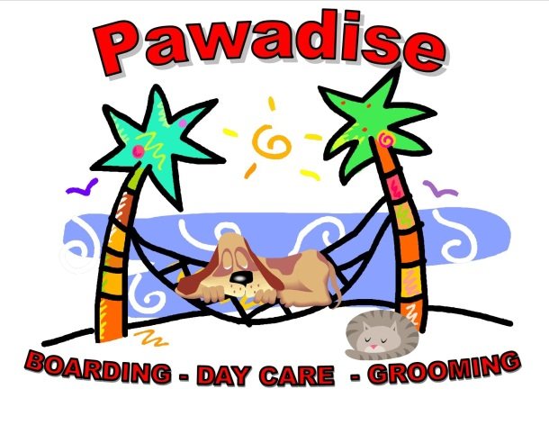

GROOMING/BATHING APPOINTMENT ACKNOWLEDGMENT

Dear valued customer,

We understand that sometimes unforeseen circumstances may arise that prevent you from keeping your scheduled grooming appointment. However, we kindly ask that you give us at least 24 hours' notice if you need to cancel or reschedule your appointment. This allows us to offer the appointment slot to another customer who may be waiting for a booking.

If you fail to show up for your scheduled appointment without notifying us 24 hours in advance, you will be subject to a no-show fee. This fee helps us cover the cost of the groomer's time and the missed opportunity to fill the appointment slot.

- First missed appointment fee. Twenty-five dollars ($25)
- Second missed appointment fee. Full price of the groom/bath.
- Third missed appointment. Full price of the groom/bath. Unable to book grooming/bathing appointments.

We appreciate your understanding and cooperation in respecting our no-show policy.

Thank you for choosing our grooming services, and we look forward to serving you in the future.

Owner’s Printed Name:
Signature of Owner: | Date:
Reviewing Staff Member: | Date:

