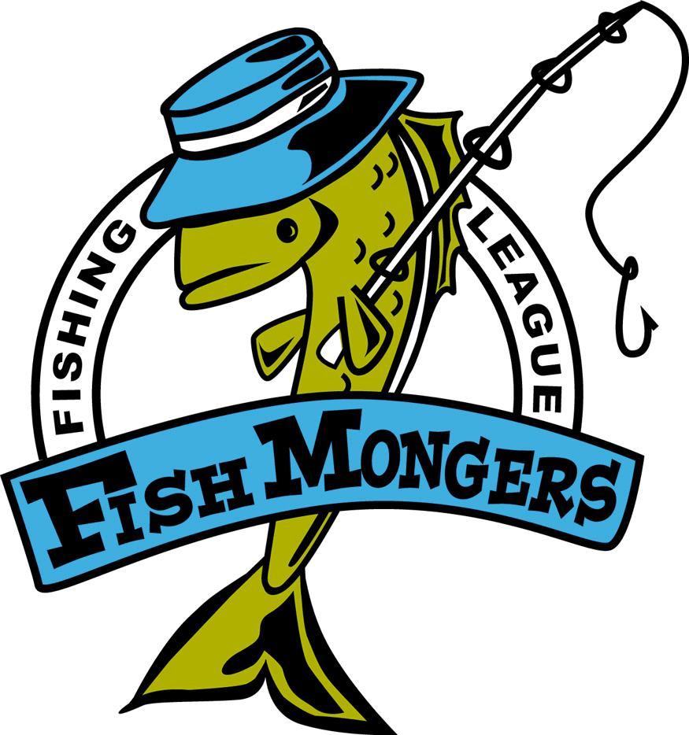
Final Gull 2008
Team | Skunk | Walleye  22 7/8 MS Gull | Northern  37 DJ N Long | Black Bass  20 DR Sibley | Rock Bass 11 Shane Rnd | Weekly Points | Total Points
Robertson/ Sundquist |  | 22 7/8 |  | 16 16 |  | 12 | 103
Anderholm/  Nelson/Rud |  |  | 25.75 | 18.5 16 | 10.5 | 11 | 83
Bryan Raguse/ Kratochvil |  | 14.75 15.25 | 28 | 15.5 13.5 |  | 15 | 74
Johnson/ Lueck |  | 14 |  |  |  | 2 | 49
Weinkauf/ Nelson | NS |  |  |  |  | 0 | 19
Ford/ Bertram | NS |  |  |  |  | 0 | 9
Greatens/  Stahl | NS |  |  |  |  | 0 | 6
Jeremy/ Worden | NS |  |  |  |  | 0 | 0

