6/2/2018 Symmetry and Trump’s Jerusalem Announcement

6/7/2018 will be the 51st anniversary of the taking of Jerusalem by the Israeli Defense Forces on 6/7/1967, and also 1st day of the 52nd year from 6/7/1967.

51 inclusive years from 6/7/1967 will culminate on 6/6/2018.

The graphic below illustrates how a one year period from the announcement by USA President Donald Trump to recognize Jerusalem as Israel's capital on 12/6/2017 centers on the completion of 51 inclusive years from the taking of Jerusalem in 1967.

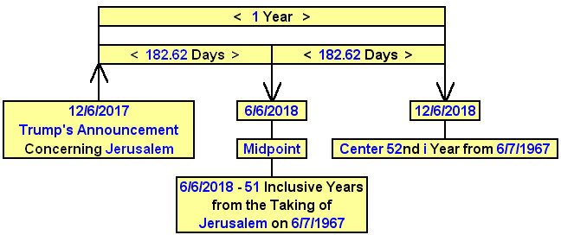

The Celebrate Israel Parade

Tomorrow, 6/3/2018, there will be a large parade on 5th Avenue in New York City in honor and support of the first 70 years of the modern State of Israel. Short video link: https://www.youtube.com/watch?v=daa12sRrxVo

Justify

Something odd happened at the 144th running of the Kentucky Derby on 5/5/2018. For the first time in 136 years (100 + 36 years), since the year 1882, a horse won the race, not running as a two year old.

Note that the number 144 has do with perfect government in the bible. There will be 144,000 governmental administrators working with YaHuShua Messiah in His coming earthly kingdom.
Since 1882 every winner of the Kentucky Derby had been running as a 2 year old. But in 2018 a 3 year old won the Kentucky Derby. The name of the horse that won is Justify.

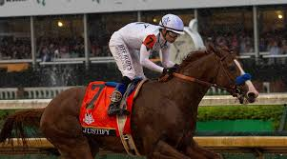

Above: Justify in the Kentucky Derby
Image courtesy Sports Illustrated

Note that Justify above wore the number 7 in the 144th Kentucky Derby.

Information link: https://en.wikipedia.org/wiki/Justify_(horse)

Perhaps bells will begin to ring in the minds of some readers when they remember that the last article authored on 5/24/2018 concerned the king of modern Babylon, President Donald Trump, now being weighed in the balances.

President Trump will be declared to be either justified or guilty by our Creator, YaHuWaH Elohim, who knows all things.

The word justify means "to declare or make righteous in the sight of God".

The Previous Non 2 Year Old Winner

The last horse to win the Kentucky Derby who wasn't 2 years old was a colt by the name of Apollo, the name of a Greek god.

The name Apollo is mentioned in the bible as Apollyon, Abbadon in Hebrew, the angel from the bottomless pit.

Revelation 9:11 And they had a king over them, which is the angel of the bottomless pit, whose name in the Hebrew tongue is Abaddon, but in the Greek tongue hath his name Apollyon.

The colt Apollo won the Kentucky Derby in 1882, 136 years ago.

Note that 1882 + 100 years (100 = perfect perfection in the bible) = 1982, the 2520th year from the Handwriting on the Wall event in ancient Babylon in 539 BC. The number 36 has been explored in recent articles concerning the 36 gods of ancient Babylon.

Because it had been so long that other than a two year old had won the Kentucky Derby, over 100 years, the long period of constant 2 year old winners became known as the "Curse of Apollo".

So we have hints of modern Babylon being linked with ancient Babylon and with other biblical information.

Justify, the Triple Crown Contender

The three year old horse Justify is undefeated so far in its career.

On 6/9/2018 the Belmont Stakes will take place. Justify has already won the Kentucky Derby and the Preakness. If the horse wins the Belmont Stakes, it will become a Triple Crown winner.

There was a Triple Crown winner in 2015 who's name was American Pharoah. American Pharoah was born on 2/2/2012, Celtic Imbolc.

Note that Pope Francis wears a triple crown. Pope Francis was the first ever Pope to visit with a sitting U.S. President. He visited President Obama in the White House on the Hebrew Day of Atonement in 2015.

Below: Pope Benedict exhibits the triple crown.

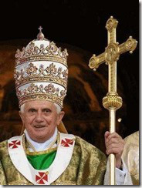

President Obama was sort of an American Pharaoh in that he was anti-Israel, as was the Pharaoh of ancient Egypt.

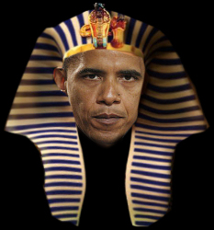

Below: The American Pharaoh above did this ungodly thing to the White House on 6/26/2015, 21 inclusive days after the horse American Pharoah won the Triple Crown on 6/6/2015.

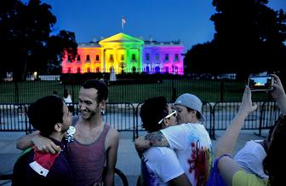
The Symmetry

Here's a graphic showing a symmetrical relationship among some of the above information. It's a 1 year period beginning with Donald Trump's announcement to recognize Jerusalem as Israel's capital city.

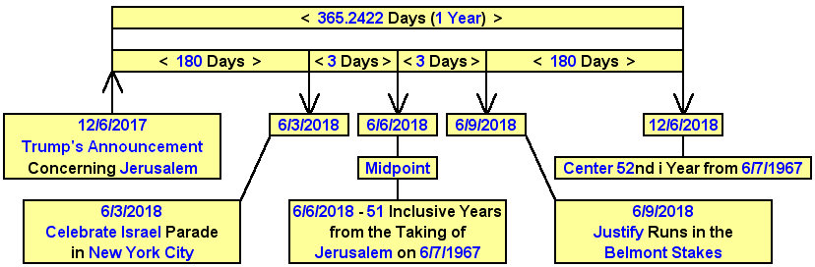

The horse Justify may or may not win the Triple Crown in 2018. President Trump may or may not be justified by YaHuWaH Elohim.

YaHuWaH Elohim will determine Babylon's judgment. We know that it eventually doesn't turn out well for modern Babylon, but perhaps the outpouring of YaHuWaH 's wrath upon Babylon will be delayed by our repentance (turning away) from the ungodly actions of previous governmental administrators.

