Saturday/Sunday,
March 29 & 30, 2025
Fourth Sunday In Lent


Christ Lutheran Church
“A Place Where You are Always Welcome”
Services: Saturday 5:30 pm and Sunday 10:00 am
Sunday School: 9:00 am (September- May)
600 North Main Street, Stockton, IL 61085 Office: 815-947-2033
Email:christlutheranchurch70@gmail.com http://www.christlutheranstockton.com
Ministers: ALL members of the congregation
Pastor: Rev. Chrissy Salser chrissytherev@att.net 815-988-9450
From Sundays and Seasons.com. Copyright 2017 Augsburg Fortress. All rights reserved. Reprinted by permission under Augsburg Fortress Liturgies Annual License #40643.New Revised Standard Version Bible, copyright 1989, Division of Christian Education of the National Council of the Churches of Christ in the United States of America. Used by permission. All rights reserved.
WELCOME: Thank you for joining us for worship today. We are glad you are with us. Communion will be served in the aisle or in your pew. All are welcome to share this meal. Jesus is our host and invites everyone. Those who would like to come forward, bread and wine will also be available in the front. When directed by the usher, come forward down the center aisle, Pr Chrissy will give you bread (she will be masked and wearing cloves) and then you will take a cup of wine (grape juice) from the tray. After taking communion, you will return to your seat by the side aisle. For those who are unable to come forward, communion elements can be found as you entered worship. At that part of the service, you are invited to take the bread and wine (or grape juice) when Pr. Chrissy leads. On Saturday’s offering is collected as you enter or leave worship. On Sunday we will pass the plate as a response to God’s grace. Online giving is available. Please see QR code on back of bulletin or visit our website.

Introduction: The psalm sets the tone this day: “Happy are they whose transgressions are forgiven, and whose sin is put away!” Happy are those who have “become the righteousness of God” in the merits of Christ Jesus. Happy are those for whom the forgiveness of God has “rolled away . . . the disgrace” of former times. Happy is the father at the return of his prodigal son. Happy are we that our sins are forgiven for Jesus’ sake. Rejoice!
Gathering: The Holy Spirit calls us together as the people of God.
PRELUDE
WELCOME AND ANNOUNCEMENTS
All may make the sign of the cross, the sign that is marked at baptism, as the presiding minister begins.
P: Blessed be the holy Trinity, ☩ one God, who forgives all our sin, whose mercy endures forever. C: Amen.
P: Let us return to God, confessing our sin in the assurance of God’s abiding love.
Silence is kept for reflection.
Compassionate One,
C: you are slow to anger and abounding in steadfast love, but our lives do not always reflect you and your love for the world. We do not show others the tender compassion you have shown to us. We do not welcome others with the radical hospitality you grant to all people. We oppress others, even though you have set us free again and again. We squander the abundant gifts of the earth. Transform our lives and guide us again in the way of the cross. Amen.
P: Beloved in Christ, God’s arms are always stretched open wide to welcome the wandering one’s home. In ☩ Christ your sins are forgiven. You have a place in God’s house forever. C: Amen.
GATHERING HYMN Come Thou Fount of Everything Blessed ELW 807
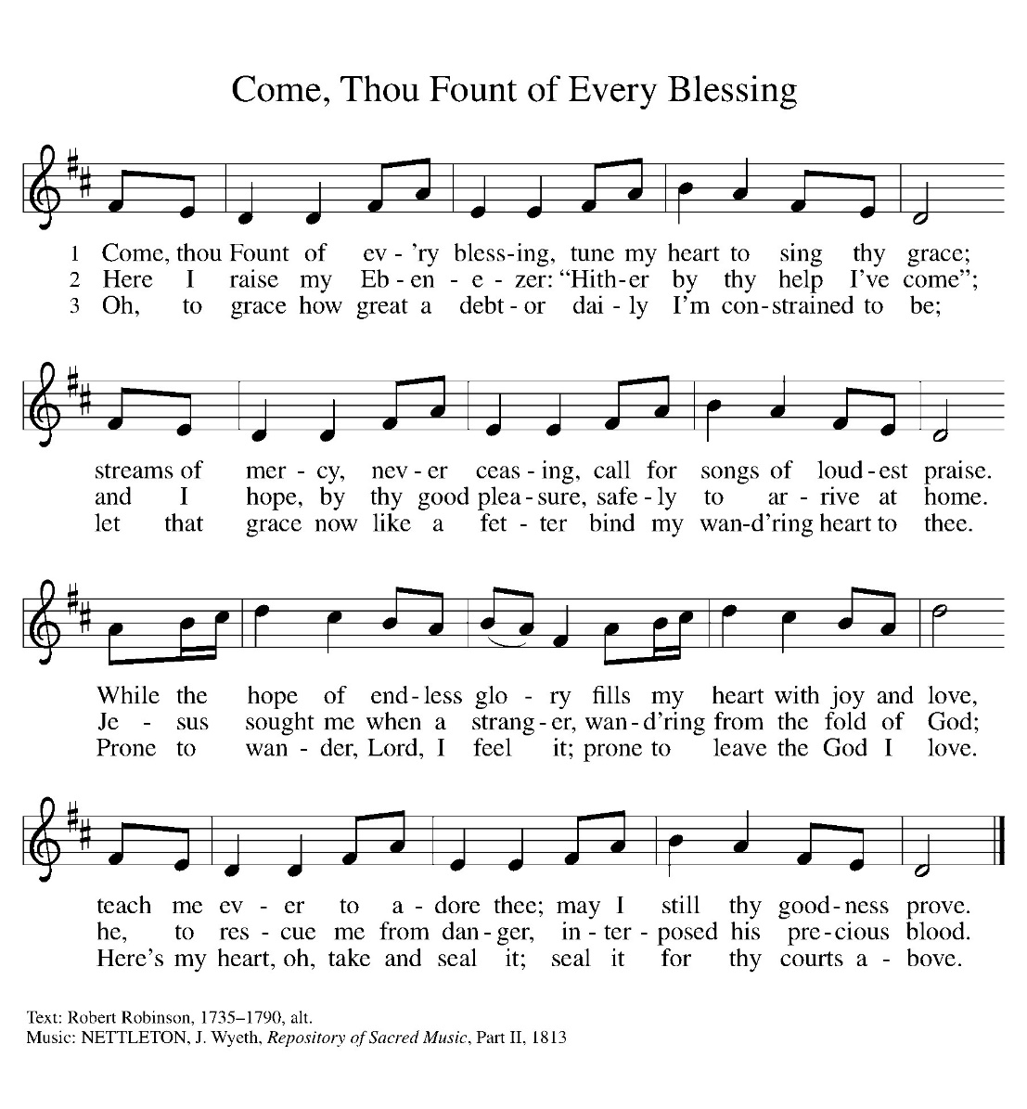

Greeting:
P: The grace of our Lord Jesus Christ, the love of God, and the communion of the Holy Spirit be with you all. C. And also with you.
PRAYER OF THE DAY
P: God of compassion, C: you welcome the wayward, and you embrace us all with your mercy. By our baptism clothe us with garments of your grace, and feed us at the table of your love, through Jesus Christ, our Savior and Lord, who lives and reigns with you and the Holy Spirit, one God, now and forever.
Amen.
Word: God speaks to us in scripture reading, preaching, and song.
First Reading: Joshua 5:9-12
By celebrating the Passover and eating the produce of the promised land instead of the miraculous manna that had sustained them in the desert, the Israelites symbolically bring their forty years of wilderness wandering to an end at Gilgal.
⁹ The Lord said to Joshua, “Today I have rolled away from you the disgrace of Egypt.” And so that place is called Gilgal to this day. ¹⁰ While the Israelites were camped in Gilgal they kept the Passover in the evening on the fourteenth day of the month in the plains of Jericho. ¹¹ On the day after the Passover, on that very day, they ate the produce of the land, unleavened cakes and parched grain. ¹² The manna ceased on the day they ate the produce of the land, and the Israelites no longer had manna; they ate the crops of the land of Canaan that year.
L: The word the Lord C. Thanks be to God.

Psalm: Psalm 32

¹ Happy are they whose transgressions are forgiven, and whose sin is put away!
² Happy are they to whom the Lord imputes no guilt,
and in whose spirit there is no guile!
³ While I held my tongue, my bones withered away,
because of my groaning all day long.
⁴ For your hand was heavy upon me day and night;
my moisture was dried up as in the heat of summer.
⁵ Then I acknowledged my sin to you, and did not conceal my guilt. I said, “I will confess my transgressions to the Lord.” Then you forgave me the guilt of my sin.
⁶ Therefore all the faithful will make their prayers to you in time of trouble;
when the great waters overflow, they shall not reach them.
⁷ You are my hiding-place; you preserve me from trouble;
you surround me with shouts of deliverance.
⁸ “I will instruct you and teach you in the way that you should go;
I will guide you with my eye.
⁹ Do not be like horse or mule, which have no understanding;
who must be fitted with bit and bridle, or else they will | not stay near you.”
¹⁰ Great are the tribulations of the wicked;
but mercy embraces those who trust in the Lord.
¹¹ Be glad, you righteous, and rejoice in the Lord;

Second Reading: Corinthians 5: 16-21
One way to describe the gospel is the promise that in Christ everything is transformed into newness. All mistakes, all deliberate sins, all old history is reconciled with Christ’s resurrection. This is Paul’s strong message to the congregation in the city of Corinth.
¹⁶ From now on, therefore, we regard no one from a human point of view; even though we once knew Christ from a human point of view, we know him no longer in that way. ¹⁷ So if anyone is in Christ, there is a new creation: everything old has passed away; see, everything has become new! ¹⁸ All this is from God, who reconciled us to himself through Christ, and has given us the ministry of reconciliation; ¹⁹ that is, in Christ God was reconciling the world to himself, not counting their trespasses against them, and entrusting the message of reconciliation to us. ²⁰ So we are ambassadors for Christ, since God is making his appeal through us; we entreat you on behalf of Christ, be reconciled to God. ²¹ For our sake he made him to be sin who knew no sin, so that in him we might become the righteousness of God.
L: The word the Lord C. Thanks be to God.

GOSPEL ACCLAMATION Restore Us, O God ELW 328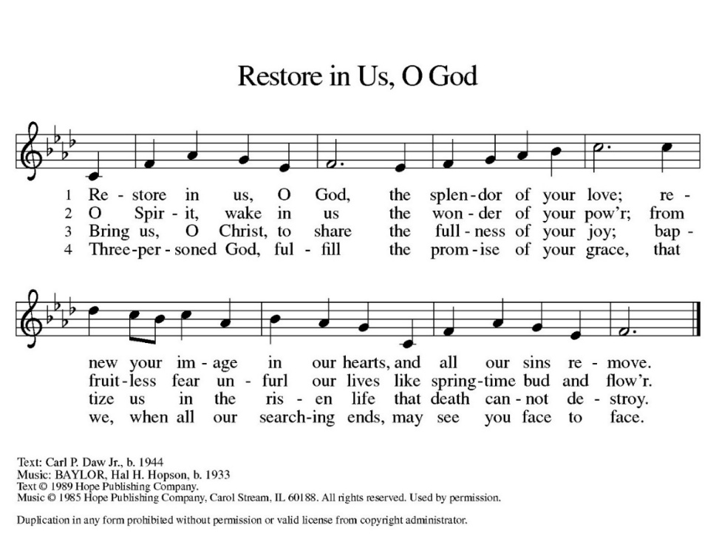

Gospel: Luke 15:1-3, 11b-32

P: Jesus tells a parable about a son who ponders his father’s love only after he has spurned it. The grace he receives is beyond his hopes. That same grace is a crisis for an older brother who believes it is his obedience that has earned his place in the father’s home.

¹ Now all the tax collectors and sinners were coming near to listen to [Jesus.] ² And the Pharisees and the scribes were grumbling and saying, “This fellow welcomes sinners and eats with them.”
³ So he told them this parable: ^{11b} “There was a man who had two sons. ¹² The younger of them said to his father, Father, give me the share of the property that will belong to me.’ So he divided his property between them. ¹³ A few days later the younger son gathered all he had and traveled to a distant country, and there he squandered his property in dissolute living. ¹⁴ When he had spent everything, a severe famine took place throughout that country, and he began to be in need. ¹⁵ So he went and hired himself out to one of the citizens of that country, who sent him to his fields to feed the pigs. ¹⁶ He would gladly have filled himself with the pods that the pigs were eating; and no one gave him anything. ¹⁷ But when he came to himself, he said, ‘How many of my father’s hired hands have bread enough and to spare, but here I am dying of hunger! ¹⁸ I will get up and go to my father, and I will say to him, “Father, I have sinned against heaven and before you; ¹⁹ I am no longer worthy to be called your son; treat me like one of your hired hands.” ’ ²⁰ So he set off and went to his father. But while he was still far off, his father saw him and was filled with compassion; he ran and put his arms around him and kissed him. ²¹ Then the son said to him, ‘Father, I have sinned against heaven and before you; I am no longer worthy to be called your son.’ ²² But the father said to his slaves, ‘Quickly, bring out a robe—the best one—and put it on him; put a ring on his finger and sandals on his feet. ²³ And get the fatted calf and kill it and let us eat and celebrate; ²⁴ for this son of mine was dead and is alive again; he was lost and is found!’ And they began to celebrate. ²⁵ “Now his elder son was in the field; and when he came and approached the house, he heard music and dancing. ²⁶ He called one of the slaves and asked what was going on. ²⁷ He replied, ‘Your brother has come, and your father has killed the fatted calf, because he has got him back safe and sound.’ ²⁸ Then he became angry and refused to go in. His father came out and began to plead with him. ²⁹ But he answered his father, ‘Listen! For all these years I have been working like a slave for you, and I have never disobeyed your command; yet you have never given me even a young goat so that I might celebrate with my friends. ³⁰ But when this son of yours came back, who has devoured your property with prostitutes, you killed the fatted calf for him!’ ³¹ Then the father said to him, ‘Son, you are always with me, and all that is mine is yours. ³² But we had to celebrate and rejoice, because this brother of yours was dead and has come to life; he was lost and has been found.’ ”
P: The Gospel of Our Lord. C. Praise to you, O Christ.
CHILDREN’S MESSAGE
MESSAGE
HYMN OF THE DAY: Softly and Tenderly Jesus is Calling ELW 608
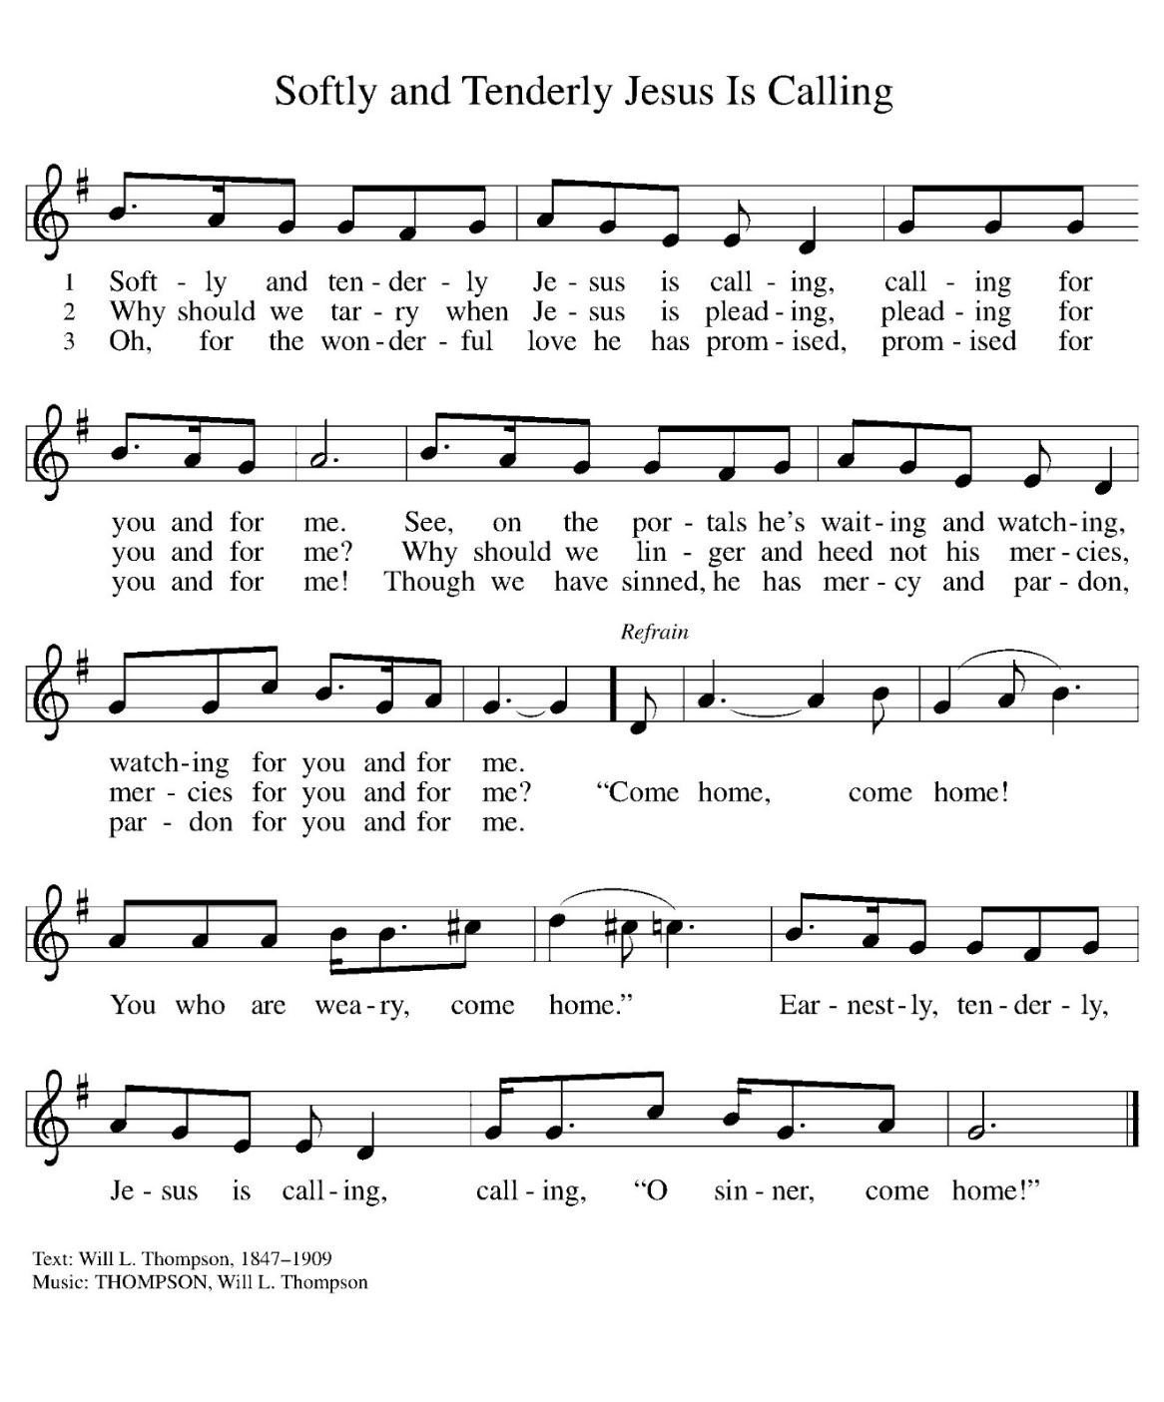
APOSTLES’ CREED:
I believe in God, the Father almighty, creator of heaven and earth.
I believe in Jesus Christ, God’s only Son, our Lord, who was conceived by the Holy Spirit, born of the virgin Mary, suffered under Pontius Pilate, was crucified, died, and was buried; he descended to the dead. On the third day he rose again; he ascended into heaven, he is seated at the right hand of the Father, and he will come to judge the living and the dead.
I believe in the Holy Spirit, the holy catholic church, the communion of saints, the forgiveness of sins, the resurrection of the body, and the life everlasting. Amen.
PRAYERS OF INTERCESSION:
P. God, in your mercy, C: receive our prayer.
PEACE
P: The peace of Christ be with you always. C. And also with you.

OFFERING: Our offering is a significant act of worship; we worship God through our giving. The ministry of this congregation is completely dependent upon your partnership and generosity. Offering is collected as you enter worship on Saturday. We will pass the offering plate on Sundays. Online giving is available.
OFFERING HYMN: Create In Me ELW 186
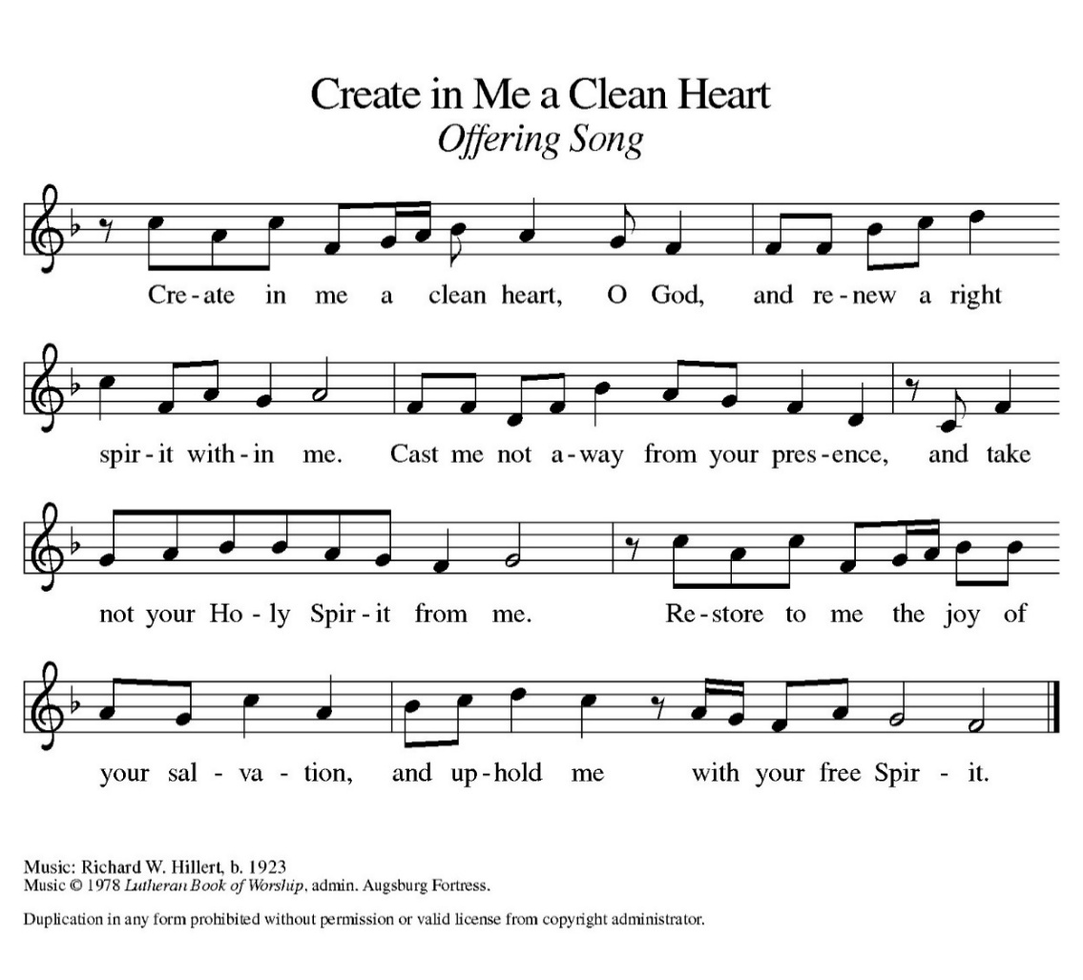
OFFERING PRAYER:
P: Gracious Provider, C: you set your immense treasures among us, opening your heart to the world. As we prepare to feast on your bountiful love, deepen our commitment to sharing those treasures with others, through our Savior, Jesus Christ. Amen.
COMMUNION LITURGY:
In the night in which he was betrayed, our Lord Jesus took bread, and gave thanks, broke it and gave it to his disciples, saying: take and eat; this is my body, given for you. Do this for the remembrance of me. Again, after supper, he took the cup, gave thanks and gave it for all the drink, saying: this cup is the new covenant in my blood, shed for you and for all people for the forgiveness of sin. Do this for the remembrance of me.
THE LORD’S PRAYER:
Our Father, who art in heaven, hallowed be thy name, thy kingdom come, thy will be done on earth as it is in heaven. Give us this day our daily bread; and forgive us our trespasses, as we forgive those who trespass against us; and lead us not into temptation but deliver us from evil. For thine is the kingdom, and power, and the glory, forever and ever. Amen
INVITATION TO COMMUNION:
P: All who are hungry, come! The feast of grace is spread.
Please come down the center aisle, take the bread, then receive a cup (wine is dark, juice is light, return to your seats via side aisle.) Those who prefer to take communion in your pews, we will take all together after all is served.
DISTRIBUTION OF COMMUNION
P: This is the body of Christ given for you. (All take bread).
P: This is the blood of Christ shed for you. (All take the wine).
COMMUNION HYMN Amazing Grace, How Sweet the Sound ELW 779
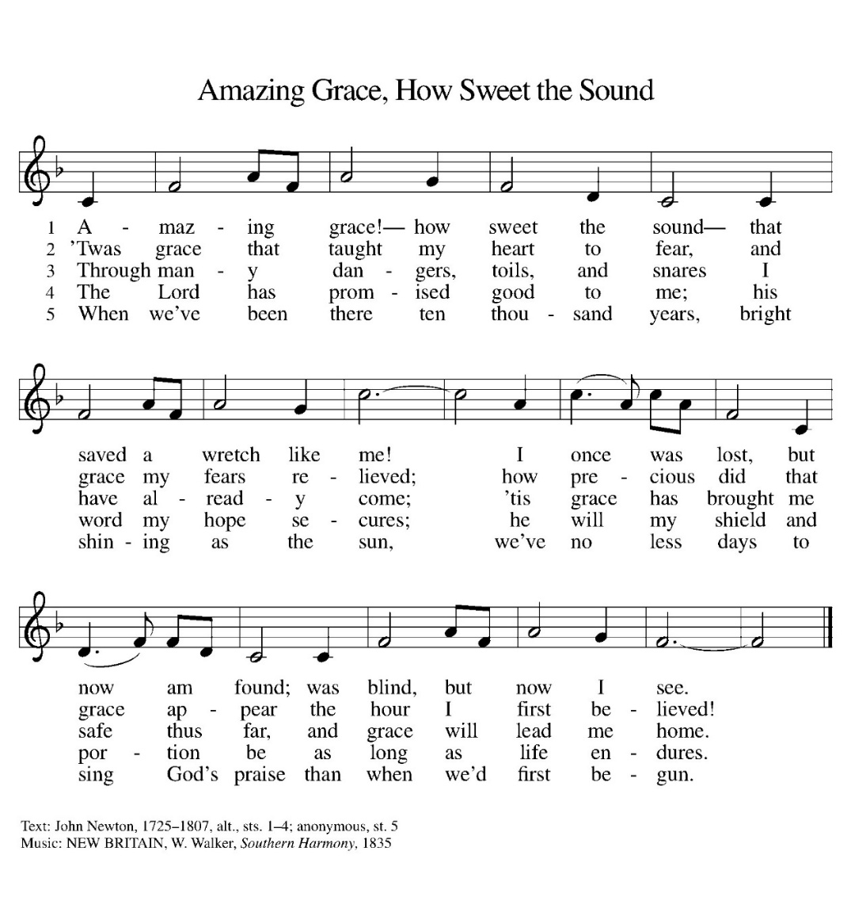

TABLE BLESSING:
P. May the body and blood of our Lord Jesus Christ strengthen you and keep you in his grace. C. Amen.
PRAYER AFTER COMMUNION:
P: Generous Host, C: you have shared your feast with us and made us new. Send us now to set tables of love and grace in our communities, that your liberating love might nourish the world into freedom, in the name of the crucified one, Jesus Christ our Lord. Amen.
SENDING: God blesses us and sends us in mission to the world.
BLESSING: God our tender parent, God the crucified one, God the reconciling Spirit,
☩ bless you now and forever.
C: Amen.

SENDING HYMN My Life Flows on Endless Song ELW 763
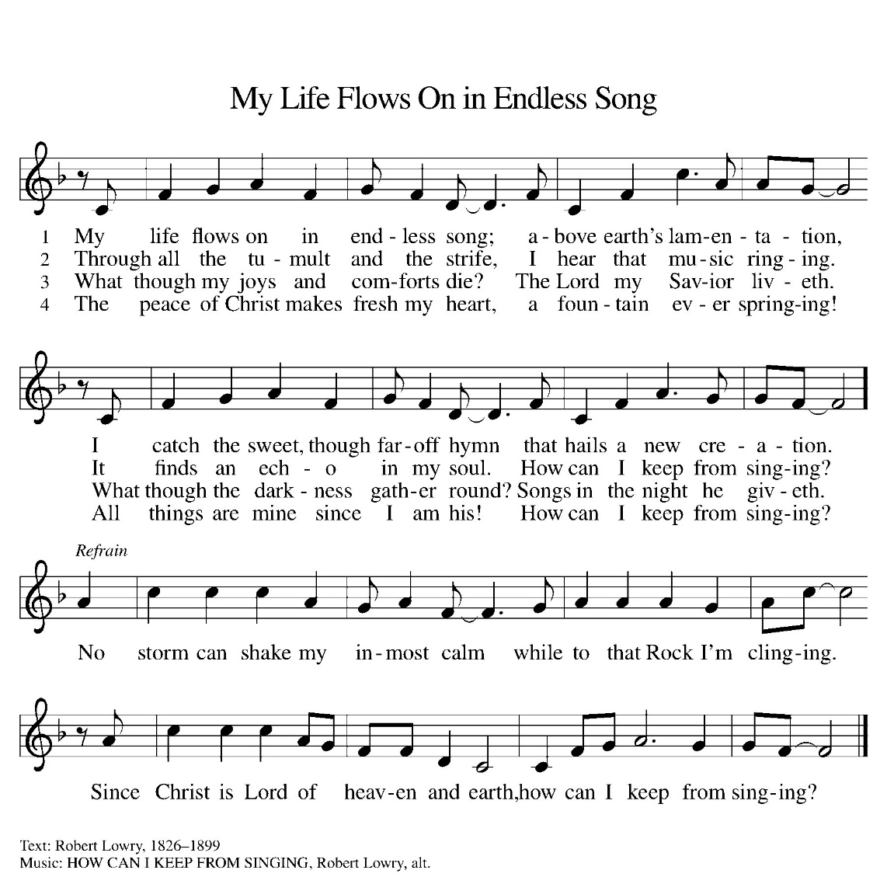
DISMISSAL:
P. Go in peace. Care for others as God cares for you.
C: Thanks be to God!
POSTLUDE
IN OUR PRAYERS TODAY: Gunnar Stich, Darlene and Walt Steffes, Bob Schreck, Delores Wampfler, Marge and Gerald Arnold, Josie Bonjour, Elaine Schlichting, Don Brudi, James Dieter, Christine Happ, Kay Hesselbacher, Mary Lou Bunker, Lillian Sefford, Howard Doubler, Judy Wilson, Jody Dascher, Russ Synder, family and friends of Aleta Lawfer, Emilee Wolf Schiling, Esther Wand, Howard Doubler To add someone to the prayer list please contact Pastor Chrissy
Updated addresses: Elaine Schlichting Josie Bonjour
(cell number 815-656-1153) Room 316
Oakly Courts Room 132 Manor Court at Liberty Village
3117 Kunkle Blvd 2170 W. Navajo Drive
Freeport, IL 61032 Freeport, IL 61032
CELEBRATING BIRTHDAYS / ANNIVERSARIES: Debra Noller, Oaklanyn Wilson, Pat Dascher, Lydia Schmidt, Janet Haas, Stephanie Curtiss, Kenton Raab, Jerry and Pam Dascher, Bob and Jennifer Kehl
ANNOUNCEMENTS
Thanks be to God for your gifts for the ministry of  Christ Lutheran Church *these numbers do not reflect online giving- only offering in worship |  |  |  | Offering/ Attendance  March 22 & 23
Current Expense | $900.00 | Building Fund | $10.00 | March 22 | 19
Benevolence | $15.00 | Lent | $41.00 | March 23 | 16
Sunday School | $20.00 | Total | $1006.000 | Sunday School | 16
Flowers | $20.00 | March 19 total: | $136.00 | Lenten | 19

February Totals: As a way to improve communication around finances, we are sharing the following information: *these numbers reflect online giving contribution
2025
 | February | Year to date
Offerings: | $6,716 | $15,734
Expenses: | $10,285 | $20,512
Overall Gain / Loss | ($3,569) | ($4,778)

ONLINE GIVING: Your gift has a big impact on our ministries and those we serve. Scan this code or visit our website to give online today.
AMAZON WISH LIST: did you know that everyday items used at the church are items you could contribute? Find our list here or on our Facebook page. Thank you! https://www.amazon.com/hz/wishlist/ls/TWP5U0RAGGAY?ref_=wl_share
COWORKERS IN THE GOSPEL: Consider being a part of one our leadership teams. As of this month, three teams will be helping connect council and congregation as we work together to do ministry together. Three teams have formed; Worship Team, Building Team and Education Team. If you are interested in being a part of one of the teams, please see Pr Chrissy or someone on the team.
- Worship team leader is Janet Haas -anyone who is interested in serving in any area of worship, especially baking communion bread, communion set up, serving or clean up.
- The building team will access and address issues related to the building. Please see a Cory Haas, team leader, if you would like to help out with the building. We are also looking for people interested in helping with mowing the lawn come spring. Special thank you to those who helped clean up the church yard.
- The Education Team over sees Confirmation, Sunday School and Vacation Bible School. Vacation Bible School is going to happen June 2-6. from 9-11:30. If you would like to be a part of the education team please see Leisa Hubb (team leader) VBS Planning team meeting Sunday, April 6 at 11 am.
CRAFTY? : Jan Zarn is putting a group together to make a craft that will be sold at an upcoming fundraiser this summer. If you are interested, the group will gather Saturday, March 29th at 1 pm at Christ. Questions, call Jan at 815-297-4331.
Upcoming Events
- March 29- 1 pm Craft group
- March 29- 5:30 pm worship
- March 30- 9 Sunday School (all ages)
- March 30- 10 am Worship
- March 30- 11:30 Confirmation class (8th graders only)
- April 6- 11 am VBS planning meeting
- April 17-7pm Maundy Thursday Worship
- April 18- 7 pm Good Friday Worship
- April 19- 5:30 pm- Easter Vigil
- April 20- EASTER
- April 26- WELCA Retreat at LOMC
- May 4- 10 am Confirmation Sunday
- May 25- LSSI Good Shepherd Sunday
- June 2-6 Vacation Bible School

