***Know Christ! Grow in Faith! Serve Others!***

**Mission Statement** of LTUMC (adopted 6/5/2024)

**WELCOME—ANNOUNCEMENTS Mary Fulton**

**JOYS AND CONCERNS**

**INVITATION TO WORSHIP/OPENING PRAYER Pastor Rod**

**PRELUDE Jenny Claybaugh, Jane Wildermuth**

**SONG LEADER Diane Lewis, Jason Brunson**

**LITURGIST Roberta Hart**

**\* Indicates To Please Stand If Able**

\***Call to Worship (responsive)** *Based on 1 Corinthians 1:18-31 modified*

Leader: The message of the cross is foolishness to those who are perishing,

***People:*** ***but to us who are being saved it is the power of God.***

Leader: We preach Christ crucified, buried, and resurrected: a stumbling block to many, and foolishness to others.

***People: But to those whom God has called, Christ is the power of God and the wisdom of God.***

Leader: This Power supersedes logic; this Wisdom overcomes strongholds; by Faith in Christ we proclaim these Truths:

***All: Christ has died! Christ is Risen! Christ will come again!***

\***Hymn** *Christ the Lord Is Risen Today*  **#302 UMH**

*Up from the Grave He Arose* **#322 UMH**

**Unison Prayer:**

***Father, in Jesus Christ, lifted up on the cross, you opened for us the path to eternal life, baptizing us into your death by your Spirit.***

***Help us to deny ourselves and to persevere in trusting your promises, humbly taking up our cross to serve you in newness of life, and faithfully walking in your holy ways full of faith, hope, and joy in belonging to you and in bearing the glory of your holy name. Amen***

**SCRIPTURE**  *1 Timothy 2:1-2*

**PRAYERS OF THE PEOPLE Mary Fulton**

**LORD’S PRAYER: *Our Father who art in heaven, hallowed be thy name. Thy kingdom come, thy will be done on earth as it is in heaven. Give us this day our daily bread, and forgive us our trespasses as we forgive those who trespass against us. Lead us not into temptation, but deliver us from evil. For thine is the kingdom, and the power, and the glory forever. Amen.***

**\*WORSHIPPING GOD WITH TITHES & OFFERINGS/DOXOLOGY**

**\*Prayer of Thankfulness: *Accept these gifts, O God, as testimonies of our love for You and our desire to serve You. Let these offerings be an affirmation that we are bound to one another as Your people. In Your generous name we pray. Amen.***

**Special Music:** *Adam Brunson**Watch The Lamb*

**\*Hymn** *He Lives* **#310 UMH**

**Prayer of Illumination:** *Prayer by Andy James*

***O Risen Christ, open us to the power of Your resurrection as we hear it proclaimed anew this day, that we too might rise to new life in You. Amen.***

**Scripture Reading***Luke 24:1-9,12; Acts 1:11a; 1 Corinthians 15:1-26*

**Message:** *“**Urge Urgent Urgency!” Pastor Rod Brower*

**Response to the Word**  *As the Holy Spirit leads*

**Special Music:** *Bill Fulton & Adam Brunson He’s Alive!*

\***BENEDICTION & SENDING** *Our “World” Is Our Mission Field*



**THOSE ASSISTING IN CREATING OUR SERVICE:**

**Musicians: Jenny Claybaugh, Jane Wildermuth**

**Sound/Video: Andy Wildermuth, Kathy Berg**

**Online: Tracey Notestine, Sandy Shaner**

***http://www.facebook.com/LewistownTrintyUnitedMethodistChurch***

**Ushers: Don Lewis, Bill Fulton, Denny Stryker, Lynn Snipes, Mike Brunson, Jason Brunson**

**Internet Prayer Chain: Lorna** [**Brunson—doone53@centurylink.net**](mailto:Brunson—doone53@centurylink.net)

**All-Call Prayer Chain: Julia Armstrong—Call her at 937-844-7964**

**Bulletin Insert Items: Rosemary Levan—937-722-7935 or** [**rlevan1338@gmail.com**](mailto:rlevan1338@gmail.com)

**Internet logins: Church Building—Curlybox238 (on N*etgear 29*)**

***Because of a change in internet equipment for the church building, the WIFI is now on Netgear 29 and the password is Curlybox238.  We apologize for any inconvenience in connecting.  Please change your WIFI setting to reflect this change in service.***

**Adult Sunday School Class Leader/Lay Leader: Mary Fulton**

**Sunday School Superintendent/VBS/God’s Team: Diane Lewis**



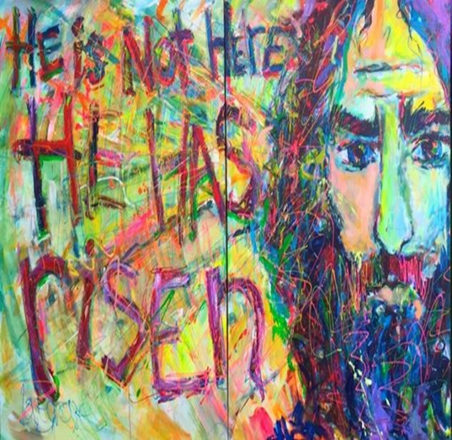

***Christ The Lord Is Risen Indeed!***

***April 20, 2025***

*Thank You for Choosing to Worship Christ*

*with Us Today!*

**LEWISTOWN-TRINITY UNITED METHODIST CHURCH**

**In-Person Worship Service – 11:00 – 8088 CR 54, Lewistown**

**Address: P.O. Box 90, Russells Point, Ohio 43348**

**Worship with us on Facebook**

***http://www.facebook.com/LewistownTrintyUnitedMethodistChurch***

**Rod Brower, Pastor**

**His Contact Info: 740-727-9999 –** [**pastorrodb@gmail.com**](mailto:pastorrodb@gmail.com)

***Know Christ! Grow in Faith! Serve Others!***