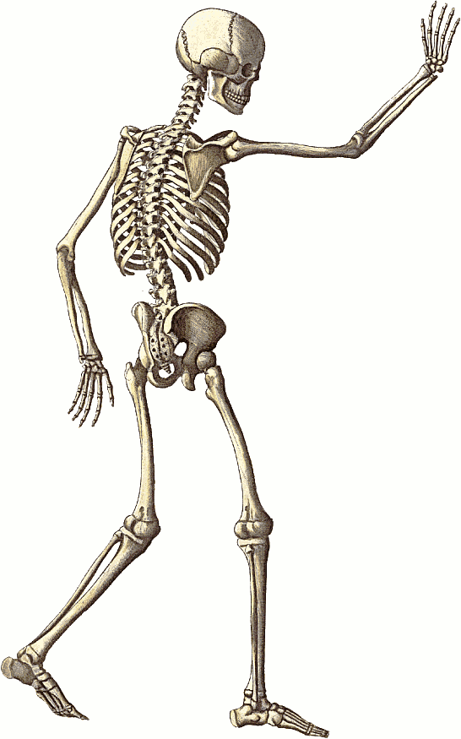
Name
ID Number
Date of Birth
Date patient arrived
ORTHOPAEDICS & SPINAL
/ /
INCIDENT: mechanism and circumstances
INCIDENTAL information: past history and personal circumstances
INJURIES: precise anatomical descriptions
SPINE | Consultant:
LIMBS including shoulder & pelvic girdles |  | Consultant(s):
OTHER INJURIES in brief (these will be described in detail by other specialties) & relevant negative findings
Name ID Number
Date patient arrived

/ /

INTERVENTIONS
COMPLETED OPERATIONS (with surgeon’s name and grade) & other physical interventions (e.g. manipulation or cast)
PLANNED OPERATIONS & other physical interventions (with time scale and surgeon responsible)
ADJUNCT TREATMENT (e.g. instructions for anticoagulants, antibiotics, positioning and mobilising)
Comments and issues
Appendix: CQUIN – BOAST 4 data for open lower limb fractures
Is the open fracture heavily contaminated? YES / NO / NOT KNOWN
If yes: Contamination Type: MARINE / AGRICULTURAL / SEWAGE MATTER / AQUATIC
Combined orthopaedic & plastic surgery management plan? YES / NO
Systematic assessment of vascular and neurological status? YES / NO
Is there vascular impairment? YES / NO
Antibiotics given? YES / NO Date & time of antibiotics: ____ /____ /_____ ___ : ___
Antibiotic type: NON IV / IV COAMOXICLAV 1.2g 8 hrly / IV CEFUROXIME 1.5g 8 hrly / IV CLINDAMYCIN 600mg 6 hourly / OTHER IV
Wound dressing (post-operative)? YES / NO Date & time of dressing: ____ / ____ /_____ ___ : ___
If yes: Wound dressing type: SIMPLE DRESSING / VACUUM FOAM DRESSING / ANTIBIOTIC BEAD POUCH / SALINE SOAKED GAUZE
Limb splint? YES / NO Date & time of splint: ____ /____ /_____ ___ : ___
Ankle and knee splint: YES / NO
Has the fracture been surgically stabilised? YES / NO Was definitive soft tissue cover achieved? YES / NO
(Describe the surgical stabilization/soft tissue cover procedures in the ‘COMPLETED OPERATIONS’ section above)

Grade

Surgeon completing sheet
/ / :
Signature
Date & time

