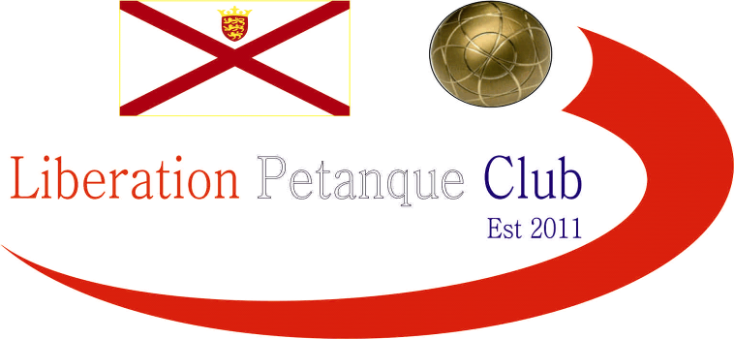

WINTER 2025/26 SEASON
WEEK 18 – 28th February 2026
DOUBLES LEAGUE

Laurent and Toby played their final two matches, drawing both to hand the title on a plate to Andrew and Callum who now only need a draw in their final match against Geoffroy & James to retain their Winter League title. This was after they beat both Katrina & Trevor and Keith & Mo.

Despite Keith & Mo getting a draw against Laurent & Toby they are now relegated.

Whilst Jake & Ross win over Brian & Colin means they are safe from relegation.
Gary & Wendy win over Katrina & Trevor puts them back into the top three.

NEXT WEEK - DOUBLES LEAGUE

Club email address - liberationpc@gmail.com

Club Website - www.liberationpetanque.co.uk

Kind Regards

Toby Northern

Chairman

Liberation Petanque Club

