Good Readers MONITOR and CLARIFY confusing parts as they read.
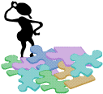    FIX UP STRATEGIES  What do you do when you come to words or parts you do not know? | www.kbumreading.com
   | Get Ready...try a popper.  What does it look like it says?  What am I reading?  What word could this be?  I can get my mouth ready and try something.
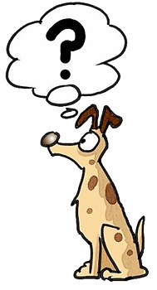   | DOES IT MAKE SENSE?  What would make sense here?  Does this fit in?  Does this text fit the pictures?
  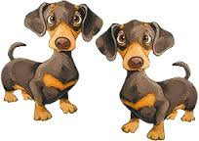  fantastic | Look for familiar word parts  in unknown words.  Find word parts you know. Chunk the word. Look for root words. Look for onsets and rimes. Break it into parts.
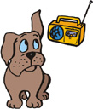   | DOES IT SOUND RIGHT?  Does that letter make that sound?  Does this word part sound like this?  Should this be a noun or verb?  Would that word(s) make sense?
  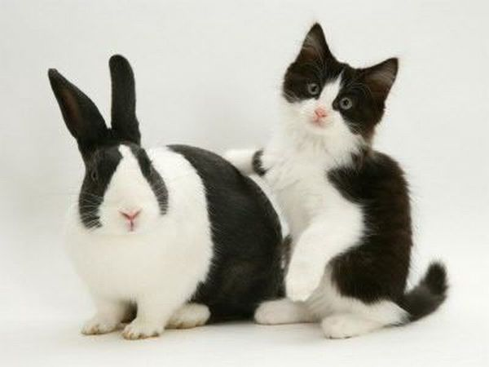 | Look for similarities.  Have I seen or heard this word before?  Does it look like a word I’ve already read?  Is there just a different ending or letter?
 | DOES IT LOOK RIGHT?  Do the letters in the words match what you believe the word is? How many letters? What are they?
  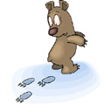 | Skip it and go on…  Don’t give up! Read on….THINK…  Then…BACK TRACK and  REREAD again.  www.kbumreading.com

