NNY Bassmasters - Open Tournaments

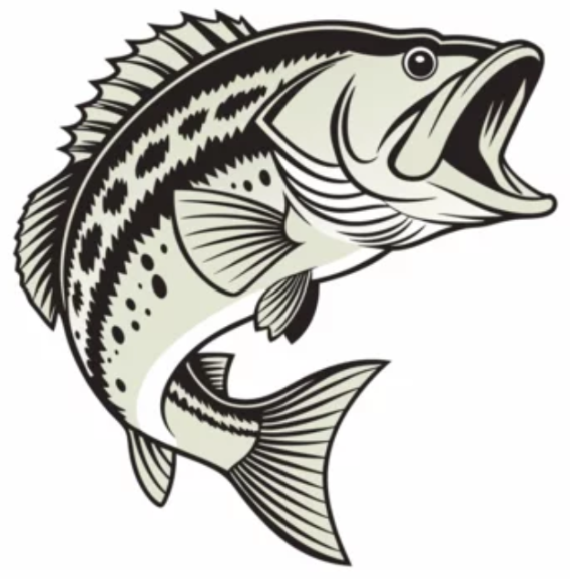

Schedule (FRIDAYS)
July 3rd – Black Lake @ State Boat Launch
July 17th – Cranberry Lake @ State Boat Launch
August 7th – Waddington @ Whitaker Park

Tournament Rules:
Open to the public – no membership required
2- person team format (anglers may choose to fish alone)
$200 entry fee
5 fish limit
Sign-ups occur morning of tournament beginning @ 5:30am at the ramp
Tournament hours 6:30am – 3pm
100% Payout (4 places) – 40%, 30%, 20%, 10%

Contact: Jason Bell (315) 528-6318

