Join the Save Richview Plaza campaign!
Rezoning will be reviewed at Etobicoke York Community Council Nov. 26th!

Urgent Community Zoom Meeting
Tuesday November 11 @ 6:30–8:30 PM

Visit SaveRichviewPlaza.ca to:
- Get the link to the Nov. 11 Community Zoom meeting
- Write to, attend or speak at Nov. 26 Etobicoke York Community Council
- Sign the petition
- Request your FREE lawn sign
- Join the letter-writing campaign to elected officials
- Join our email list
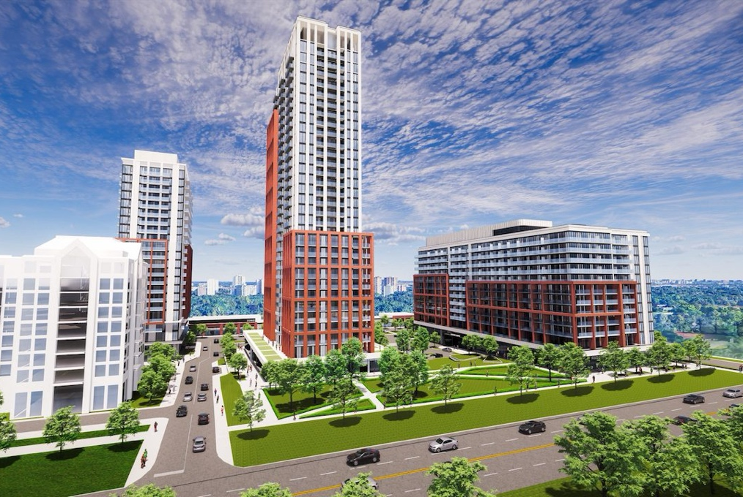
Trinity has approval for three buildings of 11, 11, and 12 storeys and are asking to DOUBLE and TRIPLE heights to 29, 24 and 14 storeys
AND CUT:
Retail space and parking, the grocery store, and resident and visitor parking
AND DEMAND:
A private road shared by 3-4 developers instead of a City-owned public road

What’s at stake:
Richview Plaza is the only walkable retail hub in our neighbourhood and it’s a vital retail destination for thousands of Etobicoke residents. Losing it would destroy our local access to essential goods and services, and community connection.

We’re asking for ONE Site, ONE Plan:
SAVE our Stores!
BUILD a City Road!
NO to 29 and 24 Floors!

Richmond Gardens Ratepayers and Residents Association and Princess Anne Community

