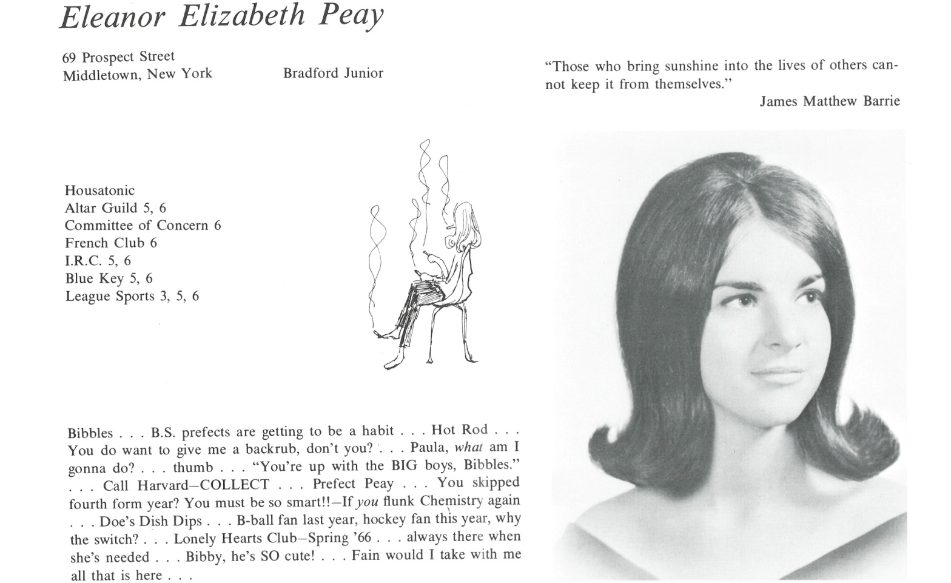

Eleanor E. Peay Whittaker

I’m still working for the publishing company I joined back in 1973 when I came to London, though only doing three days a week now to make time for our three grandchildren who are totally delish!



______________________________________________________________

______________________________________________________________ ______________________________________________________________ ______________________________________________________________ ______________________________________________________________ ______________________________________________________________ ______________________________________________________________ ______________________________________________________________ ______________________________________________________________

Attach Picture in .jpg Format

______________________________________________________________

______________________________________________________________

___________________________________________________________________________________ _________________________________________________________________________________________________________________________________________________________________________________________________________________________________________________________________________________________________________________________________________________________________________________________________________________________________________________________________________________________________________________________________________________________________________________________________________________________________________________________________________________________________________________________________________________________________________________________________________________________________________________________________________________________________________________________________________________________________________________________________________________________________________________________________________________________________________________________________________________________________________________________________________________________________________________________________________________________________________________________________________________________________________________________________________________________________________________________________________________________________________________________________________________________________________________________________________________________________________

___________________________________________________________________________________