6/8/2017 The Micro Moon and Taormina

6/8/2017

The graphic below indicates a few recent events that are significant:

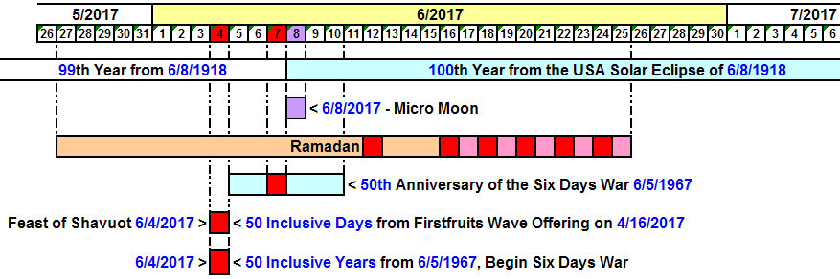

Note that today, 6/8/2017, there will be what is known as a Micro Moon. Most people know that there are Super Moons when the moon appears larger than normal. The moon's orbit isn't circular, it's egg shaped. A Micro Moon occurs 2 or 3 times per year when the moon is at a far distant point in its orbit, more distant than normal. The moon will appear smaller during a Micro Moon. Micro Moons usually don't occur exactly on a full moon or new moon, but displaced from the full moon or new moon by a few hours to a day or so.

Note also in the graphic above that today, 6/8/2017, will be the 99th anniversary of the last total solar eclipse to cross the United States from coast to coast. Today will also be the 1st day of the 100th year from that solar eclipse. The solar eclipse of 6/8/1918 links the United States with Jerusalem because:

1. It crossed the entire United States

2. Jerusalem was captured by Israel in the Six Days War 17,897 days, or exactly 49 inclusive years from 6/8/1918.

The Meaning of Italy and Sicily

President Trump attended his first meeting of the G-7 summit in Taormina, Sicily, on 5/26-27/2017 as part of his first overseas tour. We know that Donald Trump was calculated to have been conceived on the Day of Trumpets in 1945 by subtracting 280 days from his date of birth. This is an oddity that should shunt our attention to a man who our Creator Elohim have pointed to for some reason by associating both his name and his date of conception with a special once per year Sabbath, the Day of Trumpets.

Sicily occupies a geographically significant place on the face of the earth. Our Creator Elohim have placed the boundaries of the seas. Sicily and Italy appear to present a graphic representation of the coming of Messiah described in Daniel chapter 2.

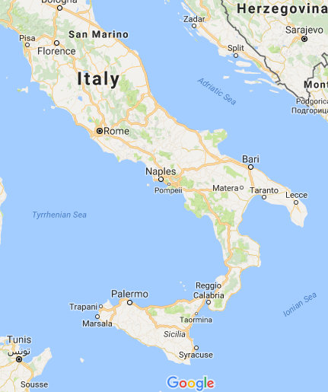
Image courtesy Google Maps

Above: The ancient Roman Empire, which was centered in Italy, is identified with the iron legs of the image mentioned in Daniel chapter 2. Sicily geographically symbolizes The Rock, Israel's Messiah, arriving from heaven and smashing the toes of the feet of that image mentioned in Daniel 2:34

Daniel 2:31 Thou, O king, sawest, and behold a great image. This great image, whose brightness was excellent, stood before thee; and the form thereof was terrible.
32 This image’s head was of fine gold, his breast and his arms of silver, his belly and his thighs of brass,
33 His legs of iron, his feet part of iron and part of clay.
34 Thou sawest till that a stone was cut out without hands, which smote the image upon his feet that were of iron and clay, and brake them to pieces.

Investigating Taormina

The name Taormina consists of Taor and Mina. Taor means Taurus, or bull. Mina is an Aramaic quantity of weight, 50 shekels.

The word mina is found in the Handwriting on the Wall event of the evening of 10/11/539 BC when ancient Babylon was captured by Persia.

The bull, or the ox, is the 1st letter of the ancient Hebrew alphabets. It's the letter "A" today in the English alphabet. You can see the horns of the bull pointing downward in the letter "A".

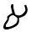
Above: The Ancient Pictorial Hebrew Aleph from 1400 BC

The Modern Hebrew letter “Aleph” can be used as a number and it carries the numeric value of "1".

The mina, being 50 shekels, carries the numeric value of 50. The ancient shekel could be broken down into 20 gerahs, like the American dollar today can be broken down into 20 nickels.

Fifty shekels would equal 1,000 gerahs.

The name Taormina therefore carries the numeric equivalent of 1 + 50 or 1 + 1,000.

There are probably many ways to interpret the name Taormina in relation with our current world. There are 50 states in the United States of America, and 1 separate Federal District, Washington, D.C.

If we add 50 days on to 5/26-27/2017 when President Trump was in Sicily, we arrive at 7/15-16/2017. This is significant because 7/16/2017 is 120 days before 11/13/2017, a date previously identified as referring to some sort of a flood. Note that according to Genesis 6:3 the Nephilim were on the earth for 120 years prior to Noah's flood.

The Ox was one of the four faces of each of the four Cherubim that Ezekiel saw in his vision of Elohim, and the Calf was one of the four creatures of Revelation 4:7 that would say to the apostle John, "come and see" as the 4 horsemen began going forth.

Here's what the Ox in the sky showed us on 5/26/2017 when President Trump entered Sicily:

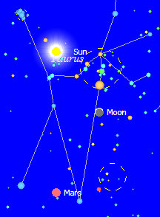

Above: The constellation Taurus, signifying the Taor in Taormina, on 5/26/2017

On 5/26/2017, the Sun was between the horns of the bull, a sign of the ancient Egyptian god Apis which represented strength and fertility.

The information presented above is part of the puzzle of the last days. The months ahead are arriving quickly, and we'll soon live through what happens (we hope).

