RSAI 2022 Legislative Priority:
Rural School Staff Shortage and Educator Quality

Background: Although rural Iowa schools have traditionally been full of excellent teachers dedicated to student success, conditions in rural Iowa are making it difficult to attract and retain great teachers, indeed school employees in many different job roles, and it’s getting worse.
Many content areas are experiencing a shortage, but especially at the secondary level. The Iowa DE compiles a list, which for 2021-22 included deaf or hard of hearing impaired, visually impaired, industrial technology, special education (both II BD/LD and ID and I mild/moderate K-8 and 5-12), family consumer sciences 5-12, all world language, agriculture (5-12), all science (5-12), business (5-12), school counselor (K-8 and 5-12), mathematics (5-12), teacher librarian (K-8, 5-12 and K-12), early childhood education, east science, physics (5-12) and all social studies. https://educateiowa.gov/pk-12/educator-quality/practitioner-preparation/teacher-shortage-areas
Rural school leaders would add music art, physical education and even elementary positions. Almost all districts in Iowa are struggling to find bus drivers, paraprofessionals, office staff, and food service workers.
When there are shortages, the market tends to draw teachers from rural areas lacking social amenities to higher-paying urban and suburban districts. Fewer qualified candidates, and sometimes no candidates at all, are applying to fill vacant and mandated positions. Private-sector competition is also compelling. Iowa’s employers are looking for a strong work ethic, communication skills, and the ability to get to work on time. The Future Ready Workforce list of High-Demand Jobs includes educators. All of this information predates the COVID-19 global pandemic, which has encouraged earlier than planned retirement, reluctance for retired teachers to return as substitutes, needs for qualified staff to cover when teachers are out sick or in quarantine, and greater educational and mental health needs of students.

Teacher Shortage Data:
- The gap between Iowa Average Teacher Salary and the National Average, as reported in the 2020 Iowa Condition of Education Report, in 2019 was $4,815 (in 1988, the gap was $3,182). Higher pay for teacher leaders, paid as much as $10,000 more for additional work through TLC plans, has helped to improve our average pay ranking since 2015. Iowa ranked 22 in 2018, however, slipped to 23 in 2019. Updates in the 2021 Iowa Condition of Education Report: “Iowa’s average regular teacher salary increased slightly to $58,771 in 2020-2021 compared to $58,110 in 2019-2020. Iowa’s average salary is 24th in national rankings and 6th when compared to other Midwest states in the 2019-2020 school year.” RSAI’s concern is that the gap widened, with Iowa teacher pay now $5,829 lower than the national average, nearly $1,000 more than in the prior year.
- With significant teacher shortages across the nation, beginning teacher pay is critical in keeping Iowa graduates in Iowa and attracting graduates from other states. Iowa is in the second to lowest quintile, ranking 30th in starting teacher pay. Source: A State-by-State Analysis of the Factors Influencing Teacher Supply, Demand, and Equity, https://learningpolicyinstitute.org/product/understanding-teacher-shortages-interactive
- Fewer teacher preparation candidates are graduating from colleges and universities of education, as reported in Teacher Retention and Recruitment: Shortages in Iowa/Nation, 50-state Comparison of Strategies, Education Commission of the States. In the Midwest states alone, between 2008-2017, there were 8,183 fewer graduates, for a loss of 17%. The following chart, compiled by Iowa School Finance Information Services, ISIFS, Inc., shows the nationwide data, which is even more drastic and predates COVID pandemic stressors on teacher supply.
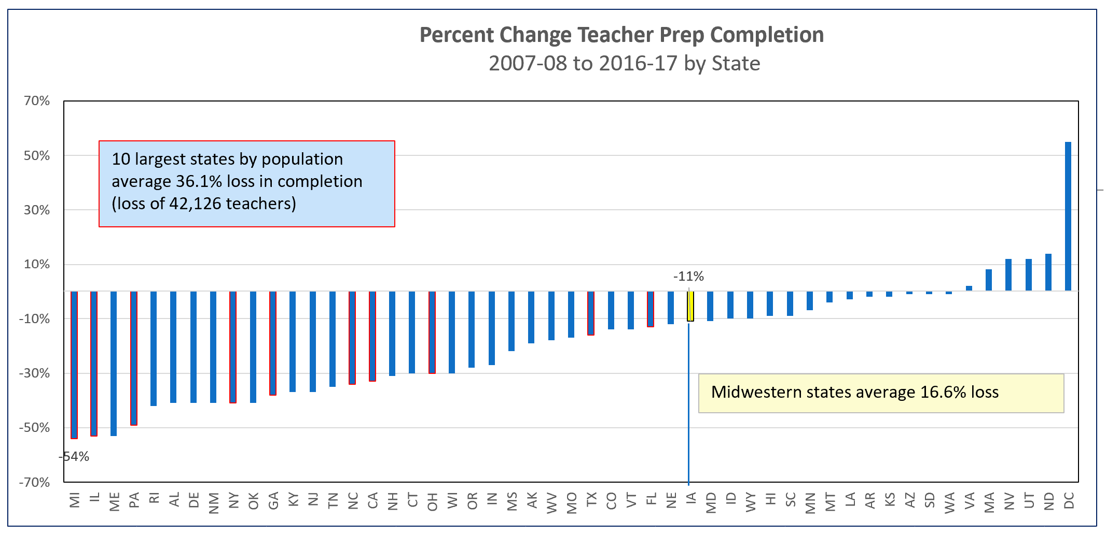
Current Reality: The qualified worker challenge is more difficult in rural Iowa:
- The implementation of the teacher leadership and compensation system increased demand for teachers to fill vacant positions to replace teacher leaders. TLC may also have slowed the pipeline of individuals willing to take on the work of school administration.
- Teachers in rural areas have multiple preps. A teacher in a rural district may teach and prepare lessons and activities across an entire content area, such as Algebra I, Geometry, Algebra II, Trigonometry, Calculus and a Statistics course. Despite lower class sizes, multiple preps increase the workload.
- Some rural schools have been able to help a willing and capable teacher obtain certification in a shortage area of content, but the rules limit provisional licensure status to two years. Access to fewer colleges and universities within a short distance adds to this burden. Tuition and costs of coursework may be unaffordable for lower-paid rural teachers and nearly unattainable for new teachers given the level of starting pay in a rural area and ongoing college loan payments.
- Some community members, dedicated to the rural area, may be willing to teach in areas of their expertise but can’t afford to quit working for two years to become certified. Some programs in CTE areas have provided avenues to on-the-job training, which is a good model which could be expanded.
- Beginning January 1, 2021, educators new to the state receive licensure reciprocity for their teaching, administrator or coaching license with 1 year of experience. Although welcome relief, this does not allow new college graduates from other states to begin their teaching careers in Iowa without having to take courses not required in their university’s school of education program.
Educator Shortage and Quality Instruction: maximum flexibility to hire staff to provide great instruction, including several strategies to attract and retain quality staff; flexibility to meet offer and teach requirements, loan forgiveness programs, a special education generalist credential, creation of a Public Service CTE strand, hire retirees without IPERS impact, and elimination of barriers to licensure.

