Control valve tester
Brief History:
Dunn’s Valve Testers Inc have been manufacturing Valve Testers since 1978. We were the first to introduce valve testers and set the standard for all valve testing. We strive to maintain that level of Durability Value and Technology well into the future.
Our Valve Testers provide a method of accurately and speedily testing valves at a relatively low cost per unit and designed with the test operator in mind.

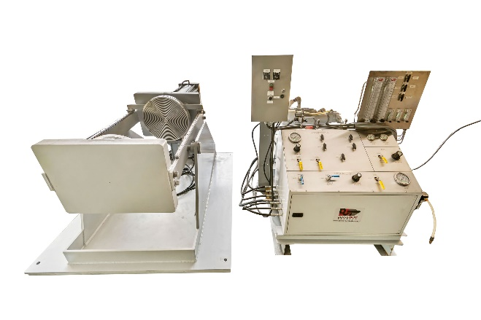
MODEL – Key Features
- Dual hydrostatic test system for filing, draining, venting or testing to one end or both ends of the valve being tested.
- Auxiliary test port for calibration and / or gas testing
- Hydraulic Cylinders for 90 degrees tilting of tester to remove air from the valve being tested.
- Using quick dynamic of hydraulic accusation secures the valve on the uniquely designed table of pressure seals immediately, saving on setup and breakdown
- Stainless Seal Plate Patient # xxx2227
- Regulated High Pressure Air Inlet for seal tightness test
- 3000 or 6000 PSI Hydrostatic test capability
- Control valve 50 PSI air seat valve classification system ½” full flow system
- Flow meter panel of 5 manual flow meters – 0.05 to 1800 SCFH
build Specifications
Our Control Valve Tester machines
- Valve Types – Control
- End Connections – Flange
NOTE: Each unit is adapted and built to specific client requirements from these base models
Optional Extras Available – A 10,000 PSI system can be available, Data Acquisition System, Water Recycle System, Safety Shield, Dual Test System allows testing for both ports and the shell in one clamping step, Regulated Air Test, Auxiliary Port, Seat-Tightness and Back-Pressure test clamps.

control valve tester TYPES | valve range | Test system (PSI) | clamping Force
CV004 | 2” to 6” | 3,000 and up | 60
cv005 | 2” to 12” | 3,000 and up | 100
CV200 | 2” to 16” | 3,000 and up | 200
Height – 42” ; length – 60” ; table height – 33”
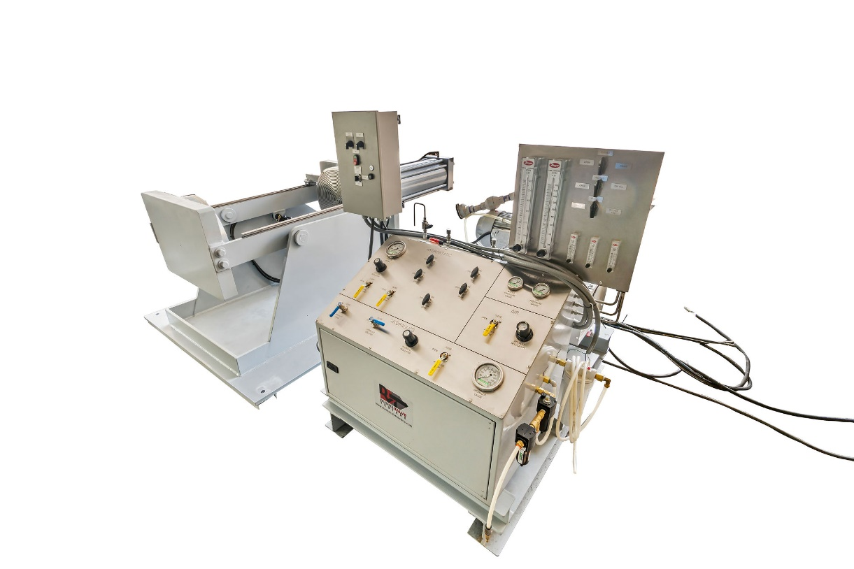
Standards - All Dunn’s Valve Testers are built to test valves in accordance with USA and International Standards – API 526 ; ANSI/API RP 576 ; API 520 & 527 ; API 6D

Data Acquisition Module – will provide a report certificate that will be compliant with ISO 9000

Delivery – Approx. 10 to 14 work weeks

Start Time - based on payment terms being agreed and complete technical specifications.

Guarantee – All parts, machined parts for 12 months

DVT Range of Testers – Roll Frame; Control Valve; Vertical and Horizontal Press; Flange Tester; Portable Testers

