REGULAR MEETING

MARCH 20, 2025

The Regular Meeting of the Town Board of the Town of Hampton, County of Washington and the State of New York was held at the Town Hall, 2629 State Route 22A, Hampton, New York, on the 20th day of March 2025.

PRESENT: David K. O’Brien-------------Supervisor

Donald Sady------------------Councilman

Tamme Taran-----------------Councilwoman

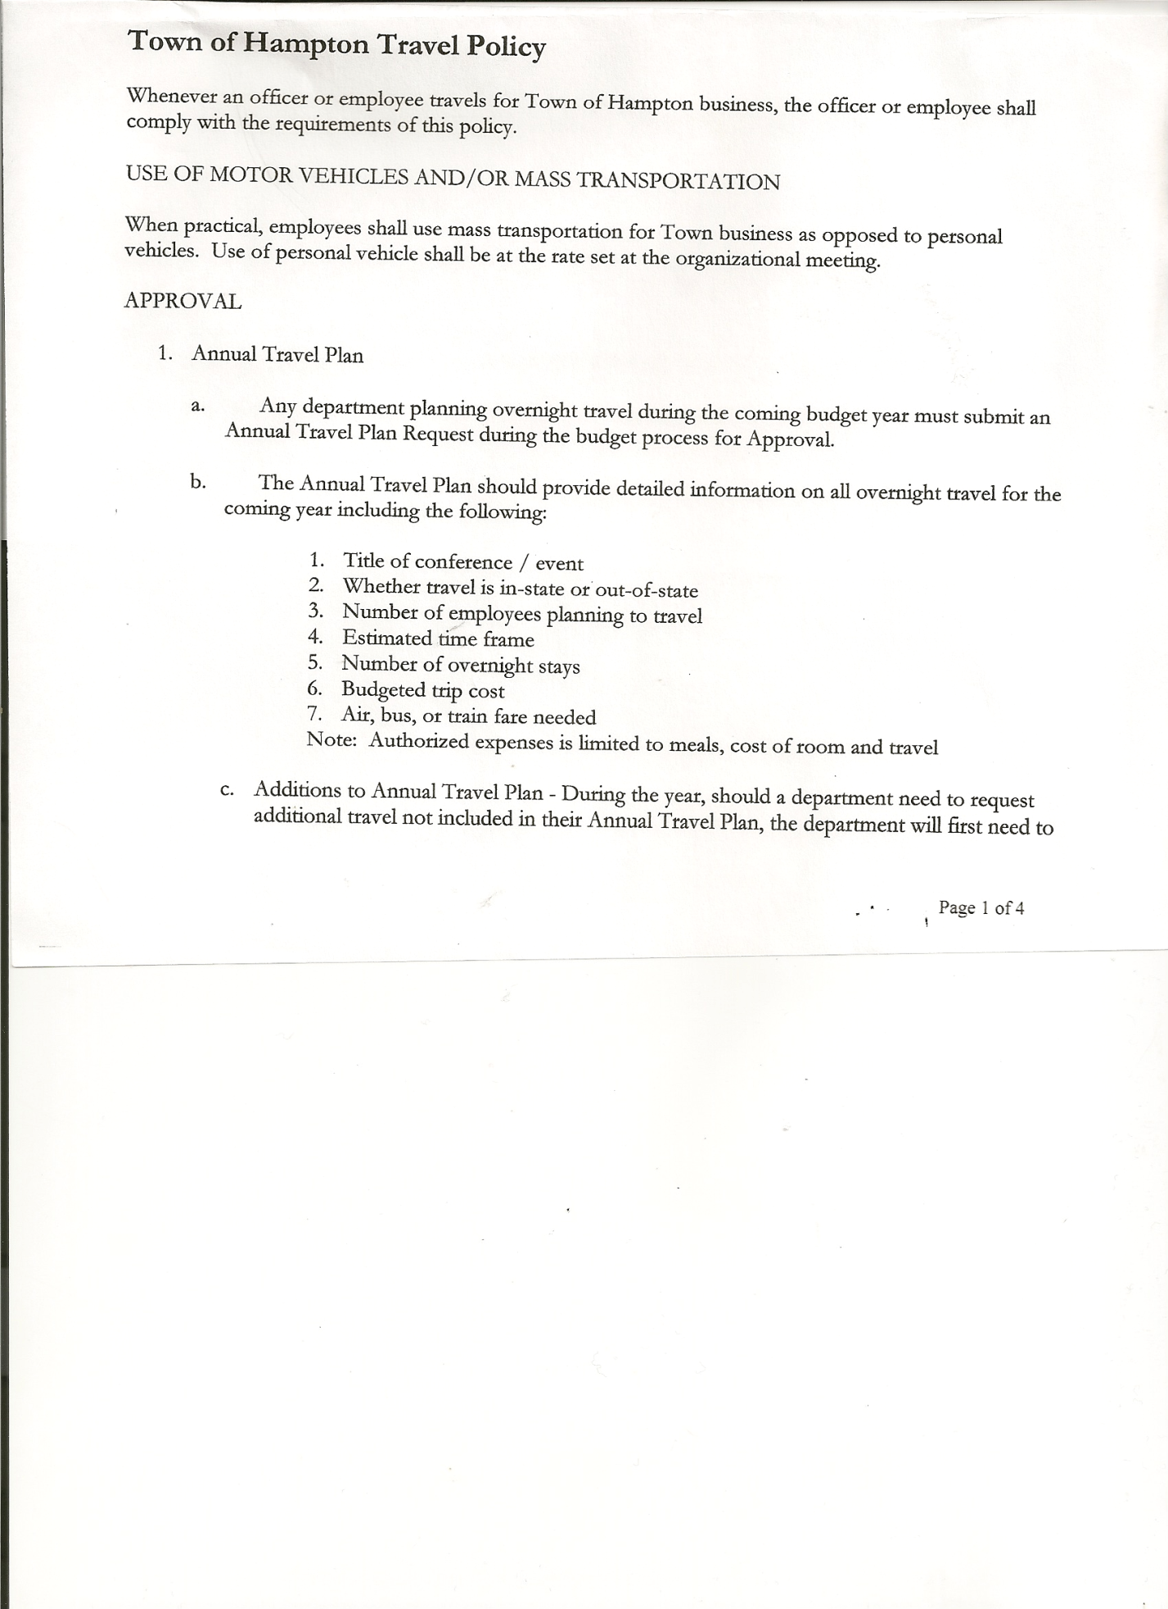 Michael Pietryka-------------Councilman

Andrea Kugler----------------Councilwoman - absent

Rebecca Jones----------------Town Clerk

Camilla Shaw-----------------Deputy Town Clerk - absent

Tyler McClure----------------Highway Superintendent

Planning Board Member (s):… Bonnie Hawley, Chair and Matthew Pratt

Others present at the Town Hall: EJ Conzola (NYVT Media Reporter), Thomas Edwards, Artie Pratt and Leonard Reed.

The Regular Meeting was called to order by Supervisor O’Brien at 7:30pm, followed by the Pledge of Allegiance. Location of Fire Exits was given. Quorum of board members present.

**RESOLUTION NO. 32-2025**

**APPROVAL OF THE MINUTES**

On a motion of Councilwoman Taran, seconded by Councilman Sady, the following resolution was ADOPTED: AYES 4 O’Brien, Sady, Pietryka, Taran

NAYS 0

ABSENT 1 Kugler

RESOLVED, the Regular Town Board Meeting Minutes for February 27, 2025 are approved.

Dog Control Officer….no report

Tax Collector Report….February 2025 Report attached. 114 Second Notices were mailed for unpaid taxes. As of March 15th, 98 parcels still remain unpaid. This is comparable to last year.

I will have hours at the Town Hall on Monday, March 31st. This is the last day I can accept payments. Tax Collecting is then turned over to Washington County Treasurer’s Office. The Town Clerk/Collector had Board Members review and sign bank reconciliation statements for the Tax Collector Account dated February 28th, 2025.

Bonnie Hawley, Chair Planning Board….Planning Board Meeting was held March 12th, 2025, copy of the minutes is attached. Next meeting will be April 9th, 2025 @7:00 at the Town Hall.

Tyler McClure, Highway Superintendent…submitted his report, copy of which is attached.

TOWN BOARD MEETING

MARCH 20, 2025 PAGE 2

**SUPERVISOR’S REPORT/COUNTY UPDATES/COMMUNICATIONS**

**RESOLUTION NO. 33-2025**

**APPROVAL OF THE SUPERVISOR’S MONTHLY REPORT**

On a motion of Councilman Sady, seconded by Councilwoman Taran, the following resolution was ADOPTED: AYES 5 O’Brien, Sady, Pietryka, Taran

NAYS 0

ABSENT 1 Kugler

RESOLVED that, the Supervisor’s Monthlyreport be accepted as submitted for **FEBRUARY.**

ACCOUNT 02/01/25 Receipts Disbursed 02/28/25

Citizens Cemetery $ 3,028.97 $ .12 $ .00 $ 3,029.09

Citizens Total $ 3,028.97 $ .12 $ .00 $ 3,029.09

GFNB Fire, Trust & Agency $ 0.00 $ 67,718.82 $ 66,718.00 $ 1,000.82

GFNB Fire, Trust & Agency ICS $ 0.00 $ 66,718.00 $ 0.00 $ 66,718.00

GFNB Health Insurance $ 2,591.23 $ $ $ 2,591.23

GFNB Trust & Agency $ 10,058.89 $ 4,805.21 $ 6,665.87 $ 8,198.23

GFNB General Fund $ 3,312.62 $194,117.30 $177,160.91 $ 20,269.01

GFNB General Fund ICS $ 83,482.28 $ 5,435.38 $ 21,000.00 $ 67,917.66

GFNB Total $ 99,445.02 $338,794.71 $271,544.78 $166,694.95

GFNB Highway Fund $ 14,611.48 $200,272.87 $190,319.98 $ 24,564.37

GFNB Highway Fund ICS $ 368,486.34 $103,280.70 $ 97,000.00 $374,767.04

GFNB Capital Reserve $ 1,005.02 $ 70,000.00 $ 70,000.00 $ 1,005.02

GFNB Capital Reserve ICS $ 66,819.21 $ 70,443.88 $ $137,263.09

GFNB Total $ 450,922.05 $443,997.45 $357,319.98 $537,599.52

TOTALS $553,396.04 $782,792.28 $ 628,864.76 $707,323.56

All Board Members present signed Supervisor’s Report.

**OLD BUSINESS**

Supervisor O’Brien handed out a copy of a proposed resolution to Board members at the February monthly meeting for them to consider at this meeting. The resolution is in regard to “Imposing a Moratorium on locating a Battery Energy Storage System” in the Town. After a discussion, the following resolution was introduced:

**RESOLUTION NO. 34-2025**

MOTION BY: COUNCILMAN DONALD SADY

SECONDED BY: COUNCILWOMAN TAMME TARAN

**RESOLUTION INTRODUCING A PROPOSED LOCAL LAW IMPOSING A MORATORIUM ON LOCATING BATTERY ENERGY STORAGE SYSTEMS IN THE TOWN OF HAMPTON**

**WHEREAS**, pursuant to Section 10 of the NYS Municipal Home Rule Law and Sections 264, 274-a, and 64 of the NYS Town Law, the Town Board of the Town of Hampton (the “Town”) has the authority to adopt local laws amending the Site Plan Review Local Law of the Town of Hampton and to enact land use regulations governing the Town of Hampton; and

TOWN BOARD MEETING

MARCH 20, 2025 PAGE 3

**WHEREAS**, a sudden increase in developmental pressures within Washington County and the Town of Hampton with respect to development of large scale solar energy generating facilities, and the related battery energy storage systems, have raised the prospect that the existing Site Plan Review Local Law may not be adequate for the review of the impacts and mitigation of the consequences of such uses and the approval thereof; and

**WHEREAS**, battery energy storage systems present unique fire and safety concerns requiring additional research to evaluate these risks and mitigate potential negative impacts; and

**WHEREAS,** a proposed local law enacting a moratorium on locating battery energy storage systems in the Town of Hampton has been prepared to address the concerns; and

**WHEREAS**, the Town Board is desirous of proceeding with the review and consideration of this proposed Local Law.

**NOW, THEREFORE BE IT RESOLVED THAT:**

Section 1. The proposed local law imposing a moratorium on locating battery energy storage systems in the Town of Hampton is hereby introduced. A public hearing shall be noticed and held by the Town Board on April 17th, 2025 at 7:15 p.m. to consider the proposed local law. Copies of the Local Law shall be available at the Town Clerk’s office for review.

Section 2. The Town Clerk is hereby directed to publish and post the requisite public hearing notices in accordance with the law.

Section 3. This resolution shall take effect immediately.

**RESOLUTION NO. 35-2025**

**TOWN HALL USE**

On a motion of Councilman Sady, seconded by Councilman Pietryka, the following resolution was ADOPTED: AYES 4 O’Brien, Sady, Pietryka, Taran

NAYS 0

ABSENT 1 Kugler

RESOLVED, to approve the request of Rebecca Jones to use the Town Hall on Saturday, April 5th, 2025 from 4 to 8 pm for Board Game Night.

**RESOLUTION NO. 36-2025**

**AUDIT OF CLAIMS**

On a motion of Councilman Pietryka, seconded by Councilman Sady the following resolution was ADOPTED:

AYES 4 O’Brien, Sady, Pietryka, Taran

NAYS 0

ABSENT 1 Kugler

RESOLVED that the bills have been reviewed by the Town Board and are authorized for payment in the following amounts.

General Fund No. 27 through No 41 $ 3,669.30

Highway Fund No. 27 through No.37 $ 12,909.90

Total both funds $ 16,579.20

TOWN BOARD MEETING

FEBRUARY 27, 2025 PAGE 4

The Town Clerk’s report for February 2025 was submitted to the Board. The Town Clerk had Board Members review and sign bank reconciliation statements for the Town Clerk Account and Special Town Clerk Account dated February 28th, 2025.

**RESOLUTION NO. 37-2025**

**MEETING ADJOURNED**

On a motion of Councilwoman Taran, seconded by Councilman Sady the following resolution was ADOPTED:

AYES 4 O’Brien, Sady, Pietryka, Taran

NAYS 0

ABSENT 1 Kugler

RESOLVED that the meeting adjourned at 8:17pm.

Respectfully submitted,

Rebecca S. Jones, RMC

Town Clerk