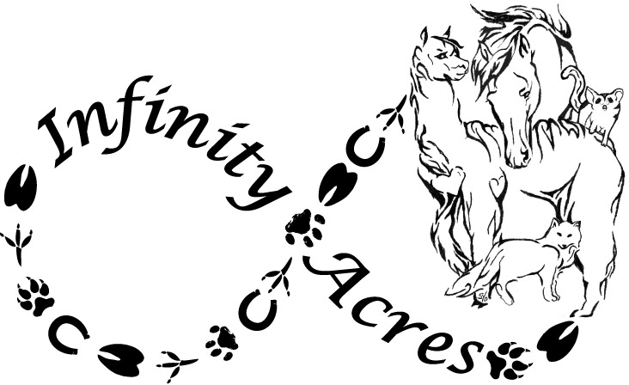
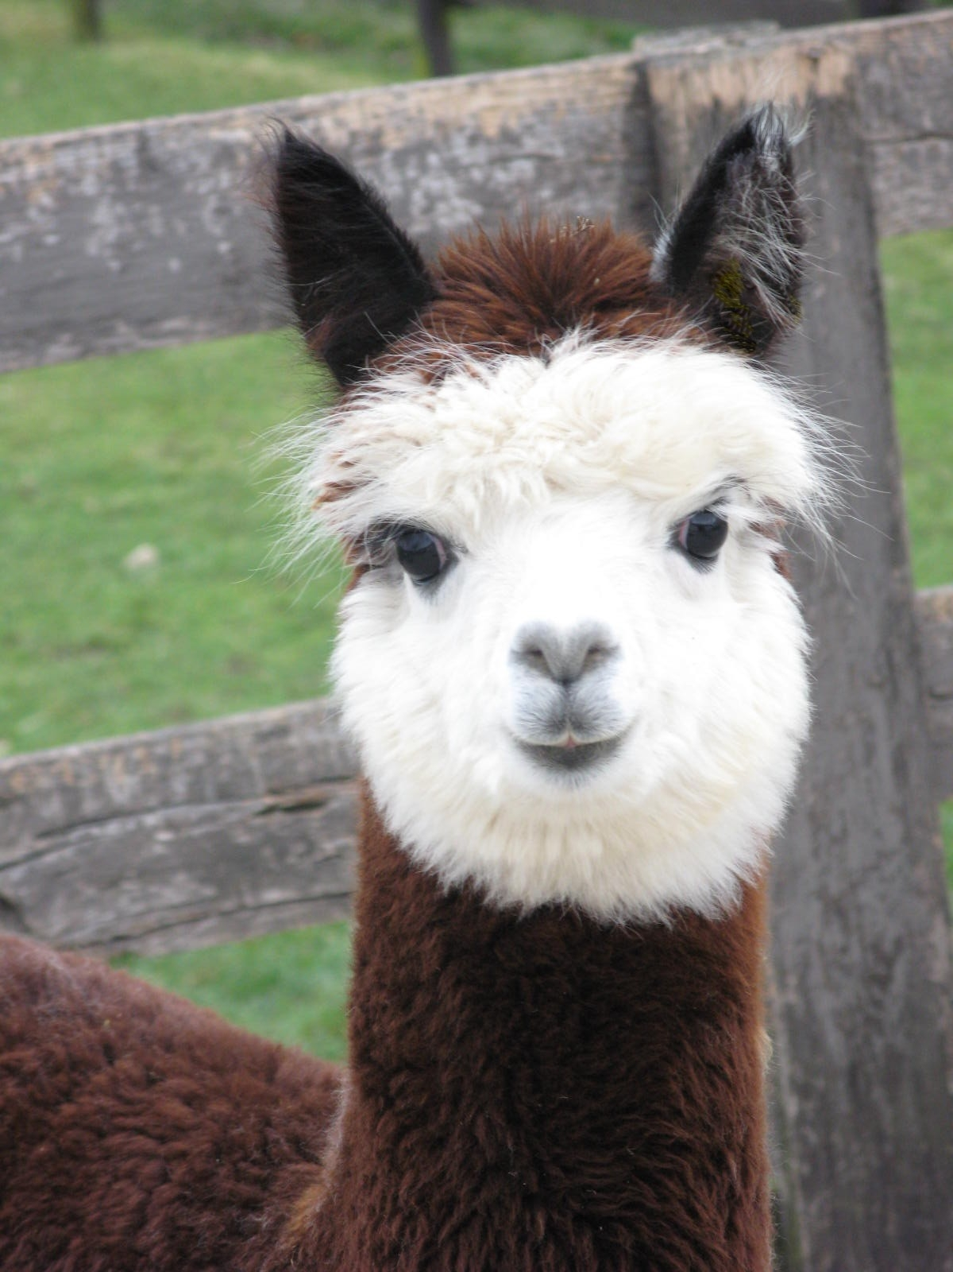
Rick & Laura Steere
136 Joppa Rd
Ridgeway, VA 24148
276-358-2378
infinityacresva@gmail.com
www.InfinityAcres.org
501-C-3 Non-Profit Love Grows Here
TAX EIN # 47-2390562

The Friends of Infinity Acres Ranch (FOIAR) Mission is to provide educational and interactive opportunities to individuals utilizing animal assisted therapies with both domestic and exotic animals to encourage physical, emotional and psychological well-being. FOIAR will promote stewardship and social responsibility within our community towards animals and their habitat while placing an emphasis on recycling and conservation using “Green Practices” to preserve our environment for future generations.

Friends of Infinity Acres Ranch
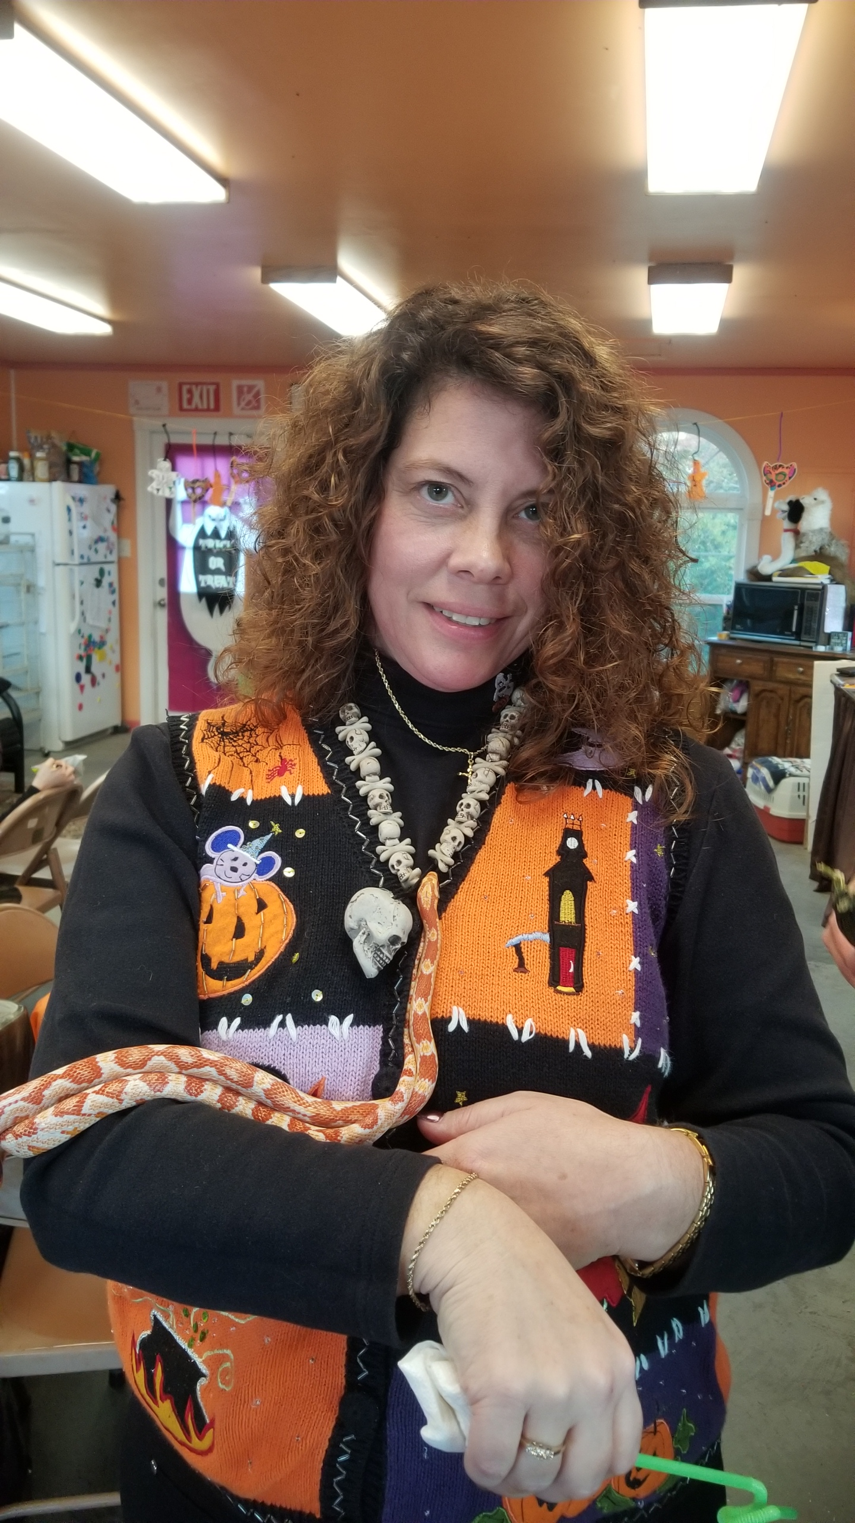
Board of Directors 2020

President: Roberta Wright: Patrick Henry Community College Facility Director,
and 4-H parent
1922 Cox Rd, Ridgeway, VA 24148

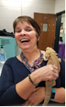

Vice-Pre: Susan Roupe: Retired Henry County School Teacher of 38 years and Volunteer
197 Round Hill Rd, Martinsville, VA 24112

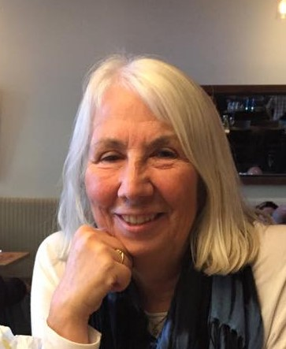

Secretary: Cherie English Reisinger: Retired Architectural Engineer & Virtual Volunteer
2490 Eastshore Place, Unit 605, Reno, NV 89509


Treasurer: Harry Rhett: Owner of Commonwealth Professional Accounting and Tax Services
15 Cleveland Ave STE 8, Martinsville, VA 24112

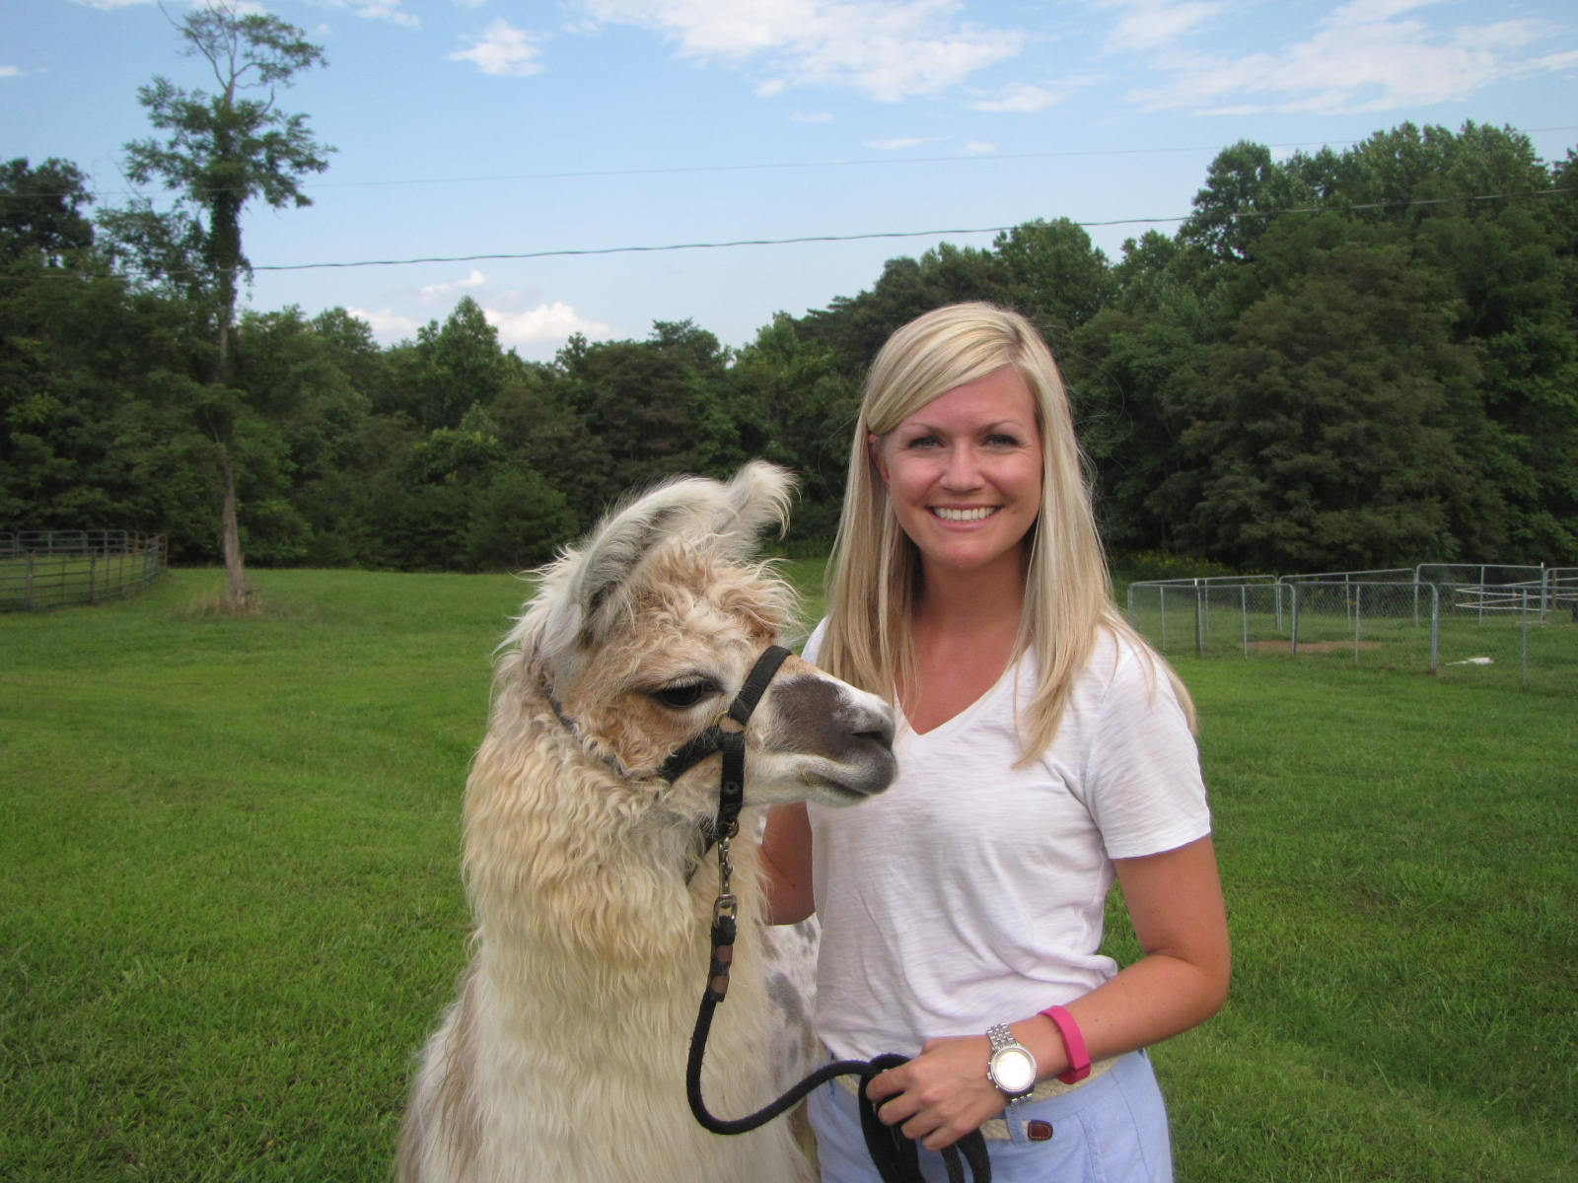
Honorary Board Dr. Nicole DeShon Nelson: Jones & DeShon Orthodontics
1204 Corn Tassel Trail, Martinsville, VA 24112

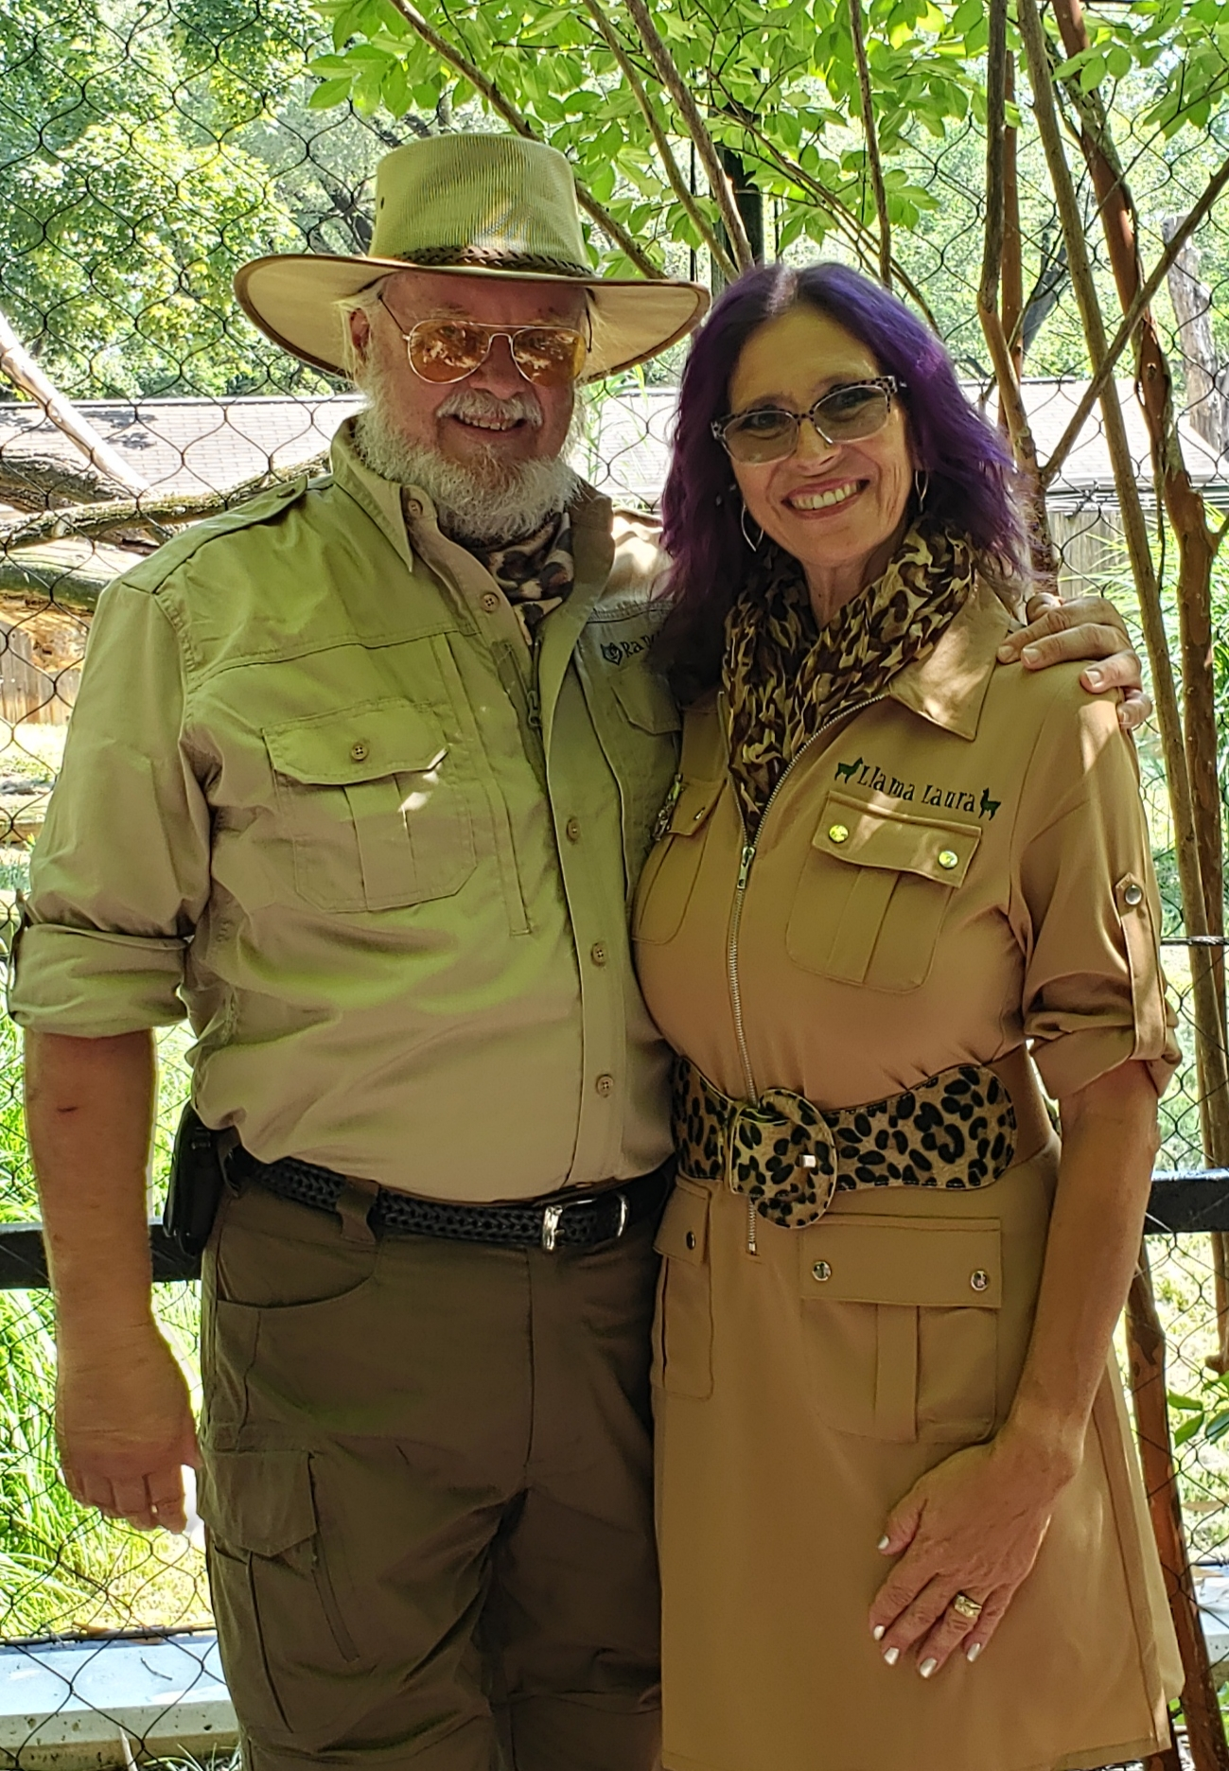

Rick Steere: FOIAR Co-Founder, Retired Nuclear Warehouse Supervisor
136 Joppa Rd, Ridgeway, VA 24148

Laura Steere: FOIAR Co-Founder, Exc. Director & Psychiatric RN
136 Joppa Rd, Ridgeway, VA 24148

