STRATHMERE IMPROVEMENT ASSOCIATION
Minutes of the General Meeting
Saturday, August 5, 2023

The meeting was called to order by Janice Connell, President. This was followed by the Pledge of Allegiance to the Flag. Attending the 10:30 a.m. meeting at the Strathmere Firehouse were Janice Connell, President;
Terence Buckley, Treasurer; Rosemarie Whelan, Secretary; Donna Diefenderfer, Member-at-Large; and Jessica Kohles, Newsletter Editor.
There were 45 members and guests present at the meeting. Refreshments were served.

AGENDA

Welcome/Introduction of the Board
Janice Connell warmly welcomed everyone to the meeting. Following this, members of the Board greeted everyone and introduced themselves.

Treasurer’s Report
Terence Buckley presented the highlights of his report. As of July 31, 2023, our total assets are $12,168.00. Our total income was $8,885.00. Last year’s dues increased by 57%.
Janice Connell called for a member to make a motion for the treasurer’s report to be approved.
Ken Weaver made a motion to accept the financial report. This was seconded by Jon Miller. The motion carried unanimously.

Secretary’s Report
Rosemarie Whelan stated that the minutes of the July 7, 2023 meeting had been posted online for members to review. She asked if there were any questions pertaining to the minutes. As none were forthcoming, the Secretary then called for a member to make a motion for the minutes to be approved. Ken Weaver made the motion to accept. This was seconded by Linda Cox. The motion carried unanimously.

Bergus-Laurence –Service to Strathmere Award

Karen Mitchell

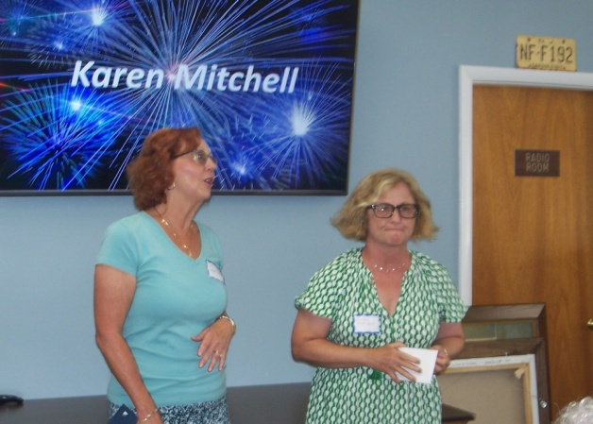

Karen Mitchell is the first recipient of this Award, which honors a resident, visitor or friend of Strathmere who has gone above and beyond to serve and/or improve our community. In accepting this Award Karen remarked, “I love Strathmere. I am honored by this Award. Elizabeth Bergus and her husband were at the epicenter of what this Award is about.”

A wooden plaque will be placed in the Rita Schiavo Library in Strathmere bearing Karen Mitchell’s name and the names of all future recipients.

Focus Groups’ Action Items
Of the 58 action items from all Strathmere Vision Focus Groups –
33 - completed
5 - planned for completion by year’s end
2 - in the planning stage (Playground Project and the Pollinator
Garden Project)
5- ongoing

Dues Increase
An increase in dues is under consideration to determine if it is warranted.

Proposed Bylaws’ Revision
Revisions to the bylaws include adding two additional Executive Officer positions. These include a Communications Officer and a second Member-at-Large position. The Executive Board determined that the Communications Officer position should be a voting Board member.
A special meeting and vote on the bylaws will be conducted through Zoom. Members will be notified.

PROGRAM

Darby Lee Brant

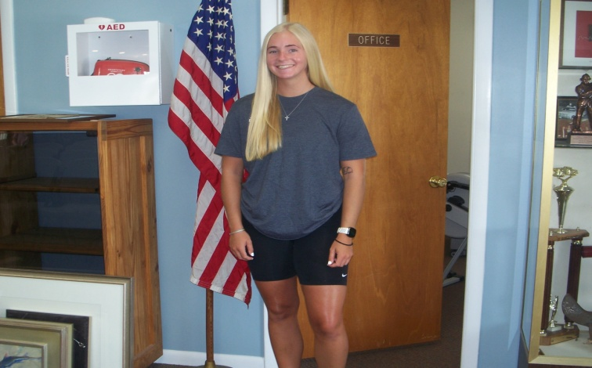

In recognition of the accomplishments of young adults, the Conservation Focus Group has developed the “Young Adult Presentation Program.”
Our primary presenter in this program is Darby Lee Brant, the granddaughter of Donna Diefenderfer. Darby is a junior at Stockton College majoring in Environmental Science. Her academic achievements include being named to the dean’s list, and her athletic achievements include being a member of the Stockton softball team.
This summer, Darby was selected as an intern at the Wetlands Institute in Stone Harbor. She works on research projects at the Wetlands within their Coastal Conservation Research Program.
In her presentation, Darby described the research projects in which she has taken part.
Monitoring turtle activity on the Avalon and Sea Isle Boulevards, caring for “head starters” with egg box checks and setting up nest enclosures are road projects in which she has participated.
Darby stated that diamondback terrapins have been monitored at the Wetlands since 1997. They are micro chipped, measured, weighed and added to the data base.
Other research projects include caring for Cope’s Gray Tree Frogs which are found in abundance in Stone Harbor’s maritime forest. Their color ranges from mottled gray to gray green resembling the bark of trees.
An outreach activity in which Darby participated was the Strathmere Fishing and Environmental Club’s Turtle Release.
Osprey nest checks, horseshoe crab surveys, eastern box turtles, and bird identification are other experiences that her internship afforded her.
At the conclusion of her presentation, Darby answered questions from the audience.
Darby was presented with a Strathmere by the Sea towel to commemorate her visit.

Gregory Bennett

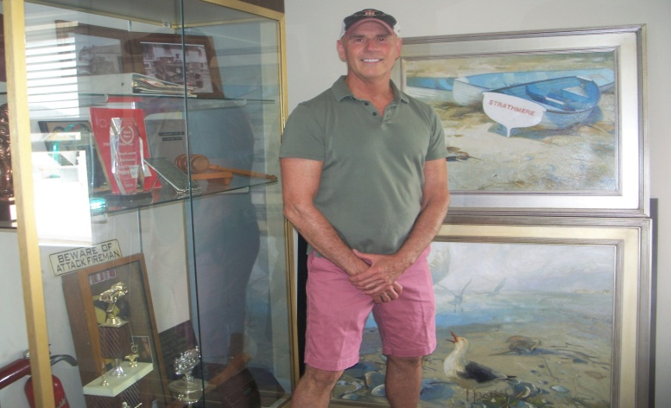

From Concept to Art – the Creative Foundation Transferred to Canvas

Greg Bennett was born in Bridgeton, New Jersey and came to Strathmere in 1967. He became a year-round resident in 1989. Greg studied at the York Academy of Fine Arts in Pennsylvania and at the Gloucester Academy of Fine Arts in Massachusetts.
As an artist, Greg gave a most interesting presentation from an artist’s perspective on elements that enhance the composition of paintings.
Greg’s presentation itself was enhanced with the large number of paintings that he exhibited.
Greg discussed taking photographs. He takes lots of pictures and creates the paintings later, by pulling it all together with his imagination. He only works from his own photographs. Greg also works on two to three paintings at a time. In his Boy and Turtle painting, there was a span of five years from picture to painting.
Another element of painting which Greg discussed was lines. Horizontal lines lower the ceiling of a space. In his painting, L’Amuse de Goshen, the lines are vertical which gives it a sense of height.
In giving a title to a painting, another enhancing element would be to use a foreign language. The title of his painting, L’Amuse de Goshen, is written in French.
Other remarks that Greg shared were –
He likes “plein air” painting (painting outside), as they are finished in a day.
Greg also said that water color is a pure joy for him to use.
Greg likes to use Masonite panels as every little brush stroke stands out.
He doesn’t like to write in length about his paintings. He wants us to connect with his art work.
He also advised us to visit museums when we can, to absorb culture and art appreciation.
To the delight of attendees, Grey paid homage to past Strathmerians. He recalled Betty Discher, who introduced him to shore birds. Greg also mentioned Trader Al, having done a cover for Trader’s magazine, Panorama.

Greg Bennett will be exhibiting his art work at the Art Gallery at Ferry Park at the Cape May Ferry Terminal on October 6. The title of his show is
You Should Paint This.

Greg was presented with a “Strathmere by the Sea towel to commemorate his visit.
Rosemarie Whelan
Secretary

