

10 Players took part this year on an unusual Tuesday evening.

Round 1 saw several close matches with Callum beating Brian 7-6, Jean beating Keith 6-5 Geoffroy beating Trevor 5-4.

Katrina started off well beating Jim 8 – 2 in the biggest win of the round and Alex beat Toby 6-5.

Round 2 saw Brian beat Geoffroy 6-4 and big wins for Keith 9-2 over Alex. Toby 7-4 over Jim and 8-4 win for Jean over Trevor.

Round 3 saw Callum lose -4 to Jean who made it three straight wins., Alex was the first player to reach double figures winning 10-3 over Trevor.

Round 4 saw Jean beat Geoffroy 7-3 whilst Toby matches that score over Callum. Trevor got his first win over Jim and Katrina beat Keith.

Round 5 saw Toby beat Keith for four straight wins Geoffroy beat Alex and Jim got his first win over Brian 5-4.

Round 6 saw Jean make it six from six winning 9-5 over Alex whilst Toby slipped up against Trevor giving Geoffroy a chance as he won against Jim.

Round 7 saw Jean make it a clean sweep this time 7-6 over Jim, to become only the second player to make it seven from seven.

Geoffroy massive 10 -0 win over Katrina put him on 5 wins +10 but toby 9 – 1 win over Brian saw him make the final against Jean with 5 wins + 13. Keith White took fourth on points difference over Alex and Katrina.

The this place play-off saw Keith take the honours over Geoffroy 6-5. In the final Jean placing was superb as she took her maiden title winning 5-4 over Toby.

Rankings

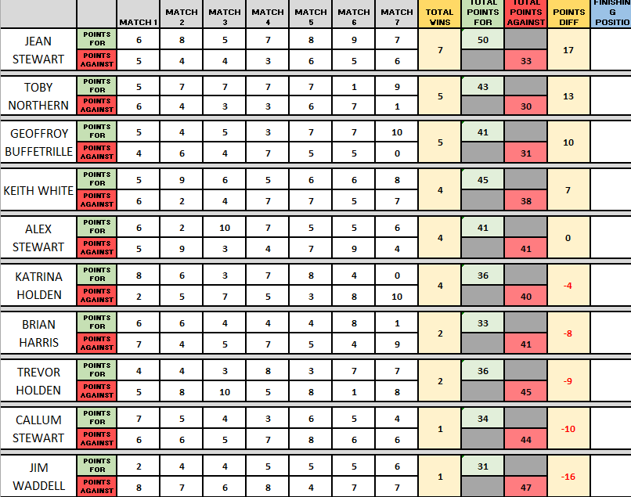

2025 Winner

Jean Stewart


Thanks to Toby again for running the competition anyone who helped Toby tidy at the end.

NEXT WEEK - SINGLES LEAGUE

Club email address - liberationpc@gmail.com

Club Website - www.liberationpetanque.co.uk

Toby Northern

Chairman - Liberation Petanque Club

