**EIS and Kroger Community Rewards**

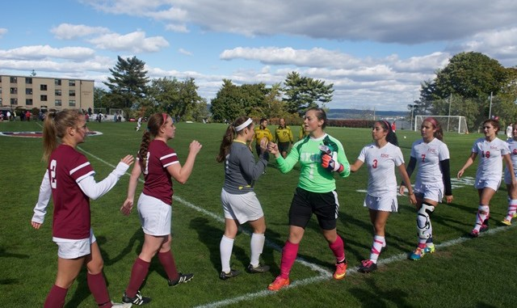

Excellence in Sportsmanship for Central Ohio Soccer (EIS) has joined the Kroger Community Rewards Program. As a qualified not-for-profit charitable organization, EIS is eligible to receive contributions from Kroger to fund our scholarship program. Kroger contributes to eligible organizations based on customer designation and use of the Kroger Plus Card at checkout.

Our referee community, friends and other supporters can generate significant annual contributions from Kroger Community Rewards simply by registering their Kroger Plus Card and enrolling in Kroger Community Rewards through the following website:

<https://www.kroger.com/account/enrollCommunityRewardsNow/>

There is no cost or obligation to referees or friends to enroll in Kroger Community Rewards. Please encourage those that you know to support EIS through Kroger rewards.

The process is simple. Visit the website above to begin. If you have already registered your Kroger Plus Card, sign in by clicking “My Account” in the upper right corner of the page. If your card hasn’t been registered, click “My Account” and click “Create New Account” under the Sign In button and follow the steps to register.

After signing in, click on the button under “I’m a Customer”.

The next screen will have a button to “Change Organization”.

Select Change Organization

In the search bar, type “SS607”.

You can also search “EXCEL” and our organization should appear.

Click Enroll and you will have completed the process.

The full information for EIS on the Kroger Community Rewards is as follows:

Organization Name: EXCEL IN SPORTMENSHIP FOR CENTRAL OH HS SOCCER COR

Organization Number: SS607

**Kroger misspelled our name in the set-up process.**