The YMCA of Acadiana

800 E. Farrel Road

Lafayette, LA 70508

**Phone:** 337-993-9622

**Fax**:337-993-9632

**E** [Jaime@TheYofAcadiana.com](mailto:Jaime@TheYofAcadiana.com)

[Phyllis@TheYofAcadiana.com](mailto:Phyllis@TheYofAcadiana.com)

[Teri@TheYofAcadiana.com](mailto:Teri@TheYofAcadiana.com)

[www.TheYMCAofAcadiana.com](http://www.TheYMCAofAcadiana.com)

www.Facebook.com/TheYofAcadiana

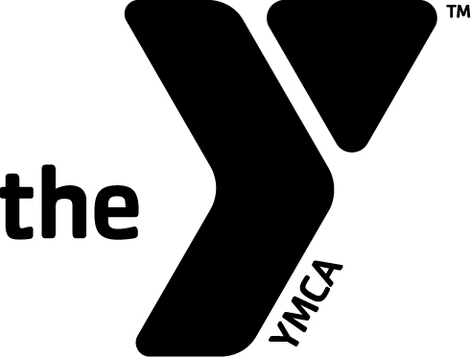

*Registration Information*\*\*Pre-Registration is *required* for your  
child to attend summer camp**

**Registration Start Date:**

Monday, March 6, 2017

Registration & Activity Fees are due the time of signup.

**All current YMCA participants**

**(as of August 2016) can register** [here](https://www.myprocare.com/Default/Index?aWtuPTQ3NTk1ODUyNjk=)

**All first time YMCA participants can register** [**here**](https://www.myprocare.com/Default/Index?aWtuPTQ3NTk1ODUyNjkmc2NoSWQ9MQ==)

*Prices for Summer Camp 2017  
**ALL FEES NON-REFUNDABLE\*\**

• **Registration: (due at signup)**

1st Child: $70

2nd Child+: $50

**• Weekly Fee:**

1st Child: $110.00

2nd Child:$100.00

3rd Child+: $100.00

• **Activity Fee: (due at signup)**

Per Child: $240.00

(This fee includes field trips, daily snacks, Friday Lunches, camp T-shirt)

**• Absentee Fee**

$55 Per Child

(This fee will hold your child’s place in camp in the event of extensive absences/vacations)

The 4 Ws of Camp

Who: Children ages 5 to 12 years old

*\*\*Your child must be 5 years old by May 30, 2017 in order to attend camp\*\**

**What:** We engage our campers through our values of healthy mind, body and spirit within various activities throughout the summer, ensuring a fun-filled, active summer camp that is guaranteed to make long-lasting memories!

* Field Trips
* Sports
* Crafts
* Character Development
* Cooking
* Science Projects
* Reading
* Friendships
* Water Activities

When: May 30th – August 11th (tentatively)

(additional weeks are contingent upon the LPSS calendar)

Camp Hours: 7:00 am to 6:00 pm

Where: Our YMCA Facility is located at:

800 East Farrel Road   
Lafayette, LA 70508

The YMCA of Acadiana Summer

Camp 2017