THE LORD’S PRAYER
(We ring the bell throughout the Lord’s Prayer at all services to
invite those in the community to join in praying the Lord’s Prayer.)
V. May we now join with one another and pray together as Jesus has taught us.
C. Our Father, who art in heaven, hallowed be thy name, thy kingdom come,
thy will be done, on earth as it is in heaven. Give us this day our daily
bread; and forgive us our trespasses, as we forgive those who trespass
against us; and lead us not into temptation, but deliver us from evil. For
thine is the kingdom, and the power, and the glory, forever and ever.
Amen.

LAMB OF GOD

(We invite you to be seated.)

HOLY COMMUNION
V. We invite you to be seated. We extend the invitation to Communion to all who are
baptized and believe in Jesus Christ.

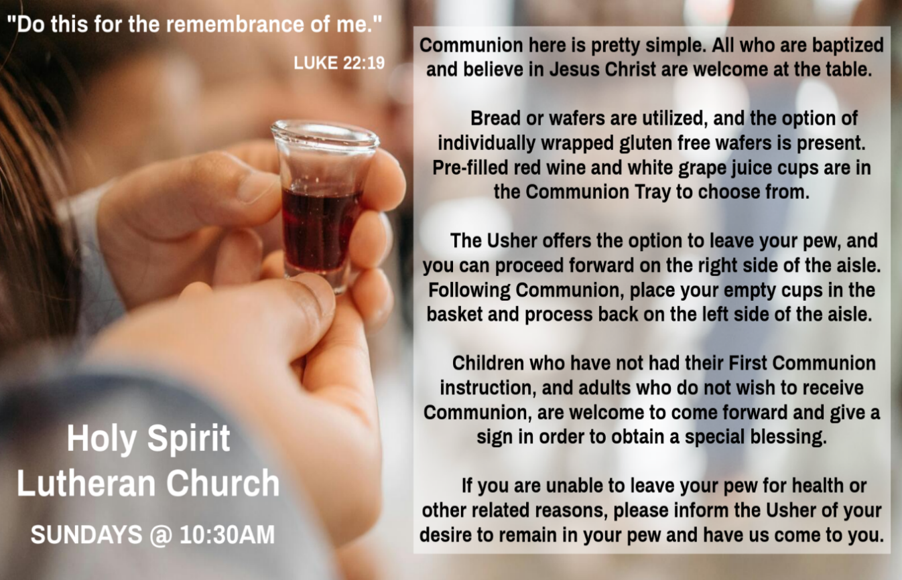

INVITATION TO COMMUNION
V. Come to the table.
Feast on God’s goodness and mercy.
C. Amen.

(Distribution of Holy Communion)

COMMUNION HYMN
(Please enjoy various music offered by our Organist during your
quiet time, prayer, and reflection following Holy Communion.)

(Vicar and Assistant remove Communion Vessels from the Altar.)

V. We invite you to stand as you are able.

POST COMMUNION BLESSING
V. May the body and blood of our Lord Jesus Christ strengthen us and keep us
always in His grace.
C. Amen.
POST COMMUNION CANTICLE
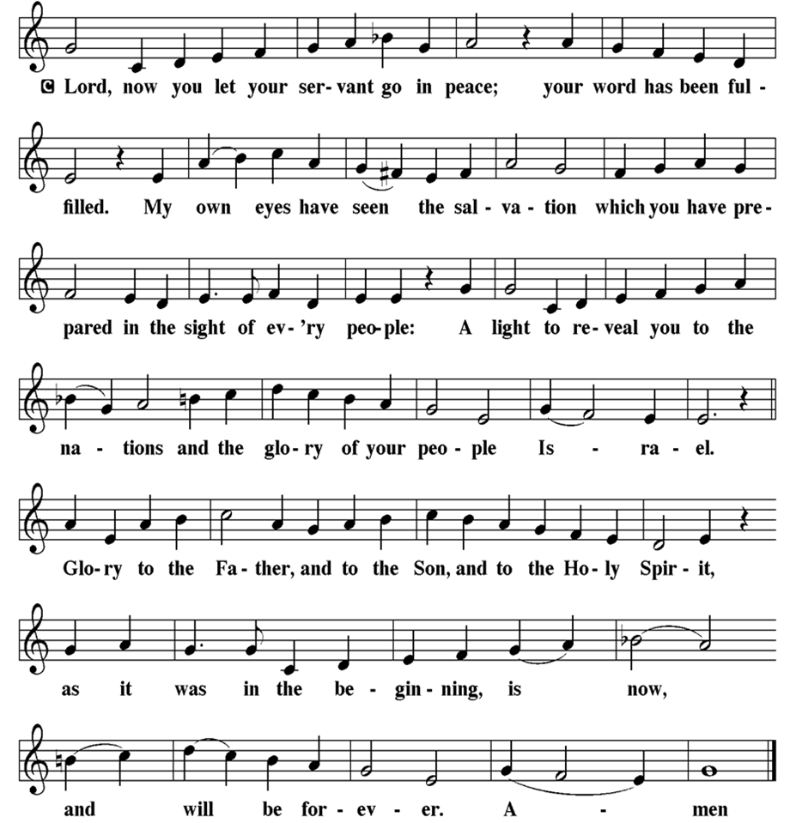

SANCTUS
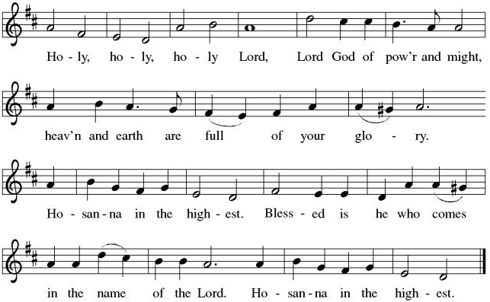

THE EUCHARISTIC PRAYER
V. Blessed are you, Lord of heaven and earth, in mercy for our fallen world you gave
your only Son, that all those who believe in Him should not perish, but have
eternal life. We give thanks to you for the salvation you have prepared for us
through Jesus Christ. Send now your Holy Spirit into our hearts that we may
receive our Lord with a living faith as He comes to us in His holy supper.
C. Amen. Come, Lord Jesus.

V. In the night in which he was betrayed our Lord Jesus took bread,
he gave thanks; broke it, and gave it to his disciples, saying:
Take and eat; this is my body, given for you.
Do this for the remembrance of me.

V. Again, after supper, He took the cup, he gave thanks,
and gave it for all to drink, saying:
This cup is the new covenant in my blood,
shed for you and for all people for the forgiveness of sin.
Do this for the remembrance of me.

V. We invite you to stand as you are able.

OFFERING PRAYER
V. Let us pray,
O God, maker of heaven and earth,
your steadfast love embraces all creation.
You send rain and sunshine to nourish the earth
and bring forth its bounty.
Through these gifts of bread and wine,
draw us into the death and life of your Son,
who calls us to bear witness to his saving work.
We ask this in Jesus’ name.
C. Amen.

GREAT THANKSGIVING
V. The Lord be with you.
C. And also with you.

V. Lift up your hearts.
C. We lift them to the Lord.

V. Let us give thanks to the Lord our God.
C. It is right to give him thanks and praise.

V. It is indeed right and salutary that we should at all times and in all places offer
thanks and praise to you, O Lord, holy Father, through Christ our Lord; who rose
beyond the bounds of death and, as he promised, poured out your Spirit of life
and power upon the chosen disciples. At this the whole earth exults in boundless
joy. And so, with the Church on earth and the hosts of heaven, we praise your
name and join their unending hymn:

PRAYER AFTER COMMUNION
A. Let us pray,
God of our salvation,
we give you thanks for this meal that restores our souls,
reconciles us to you, and strengthens us for the journey.
Through the body and blood of your Son,
may we become Christ’s body in the world,
bearing witness to your love for all creation,
through Jesus Christ, our Savior and Lord.
C. Amen.

GRACE
V. Please join me in saying a prayer over our Food & Fellowship time together.

V. Let us pray,
Bless, O Lord, your gifts to our use
and to us your service; for Christ’s
sake. Every good and perfect gift
comes from you, O God. Bless this
food, and help us to receive it with
thankful hearts. By your Spirit
nourish our love for one another
and for our neighbor in need;
through Jesus Christ,
our Savior and Lord.
C. Amen

BLESSING
V. Receive the blessing of the holy Trinity:
God, who calls all things into existence,
Jesus Christ, who redeems us,
and the Holy Spirit, whose breath sustains creation,
☩ bless you now and always.
C. Amen.

SENDING HYMN
(We invite you to sing along.)
Lutheran Book of Worship—Green Book
327—Rock of Ages, Cleft for Me

(Assistant extinguishes the Altar Candles half way through the Sending Hymn.)

(Vicar processes out once the Altar Candles have been extinguished.)

(We invite you to be seated.)

BIRTHDAYS, ANNIVERSARIES, & ANNOUNCEMENTS
(Offered by Assistant and Congregation.)

BIRTHDAYS
12th Carly McGinn
13th Mary Pacher

DISMISSAL
A. Go in peace. Believe the good news.
C. Thanks be to God.

POSTLUDE
(Music offered by our Organist as we depart following our Worship Service.)
Lord Dismiss Us With Thy Blessing

LICENSES & EXPIRATION DATES
Worship Service Content is used via permission through Augsburg Fortress Liturgies Annual License #SB144368. The next Subscription Renewal Date is 2/28/2027.
Our Hymns and Worship Music are used via permission through CCLI One
License #11327166. The next Subscription Renewal Date is 1/31/2027.

OFFERING SONG
(We invite you to sing along.)
Worship & Praise
156—What Have We to Offer?
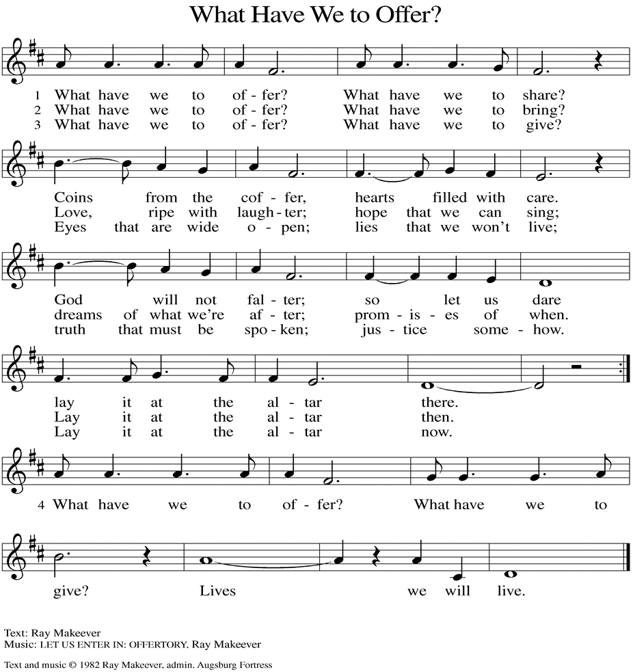
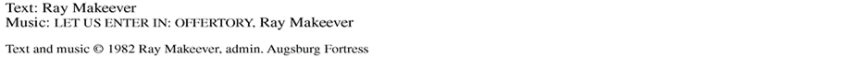

(Usher(s) brings the Tithes and Offerings up front to the Assistant.)
V. Watch over all of us who are worried and suffering, and especially those whose
names we now say aloud or hold within our hearts (pause). Hear us, O God.
C. Your mercy is great.

V. Receive our prayers, O God, through Jesus Christ, our strength and salvation.
C. Amen.

SHARING OF THE PEACE
V. May the peace of the Lord be with you always.
C. And also with you.
V. Now, let us share God’s Peace with one another.



(Please respect your neighbor if they desire to still only offer a peace sign or wave.)

(Following the Sharing of the Peace, we invite you to be seated.)

OFFERING
V. We now worship God with our tithes and offerings, wine and bread for use in holy
communion, and monetary gifts to support our ministry for service in God’s name.
Our Ushers will be around to your pews to pass the Offering Plates.

(Ushers come forward to get the Offering Plates from the Assistant.)

(Vicar and Assistant prepare the Altar for Communion.)



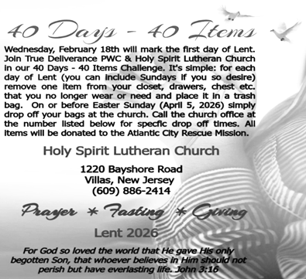

CONFIRMATION & SUNDAY SCHOOL
“Here We Stand” allows our young folks to go through a 2-year process focusing on the Bible and Luther’s Small Catechism. Classes are on Sundays from 9-10AM.

WORSHIP MINISTRY
The most important thing we do each week is gather together as God's people to Worship. God is the center and focus of everything we do. Participating in Worship is active, as Liturgy means the work and actions of the people gathered. Everything we do during the week to prepare for Worship, and everything we do as we Assist in leading Worship is important. We are thankful for all the wonderful work being done. If you have questions, or are interested in any position, reach out to Vicar Vince.
Sign-up sheets are located on the bulletin board between the church offices.

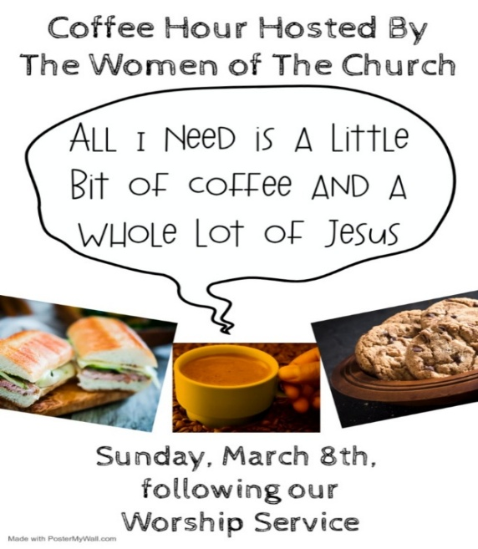

SUNDAY AT BROOKDALE
Vicar Vince will be preaching at Brookdale Senior Living in Cape May Court House, TODAY, Sunday, March 8th, at 1PM. Holy Communion will follow the service. True Deliverance Praise & Worship center will be there for some special music too.

Ann Wieckouski (Theresa & Kim McGinley's Family)
Rich (Kim McGinley's Friend)
Amy Johnson (Ted Bell's Sister)
Jerry & Marlana (Carol Amundsen's Friend)
Theresa Dolan (Joan Kilcoyne's Family)
Sandy Bloomberg (Judy Brannan's Family)
Simon (Carol Amundsen's Family)
Bill Ransing & Family (Frank Ford’s Friends)
Barbara Brosius (Philomena Noak's Friend)
Barbara Schmiedel (Bob Fritsch's Family)
Cathy Bell (Ted & Diane Bell's Family)
Doreen Kinzler (Church Member)
Linda Stonelake (Kathy & Butch Poehler's Friend)
Anne Pfaff (Bonnie Millard & Vicki Rinier's Friend)
Tom Keywood (Gloria Sutton's Family)
Celeste (Community Member)
Robin (Community Member)
Anna Perez (Bob Fritsch's Family)
Denise Graham (Mary Melnicoff's Friend)
Ann Duhadway (Community Member)
Louise Helmes (Wayne & Eleanor Rand's Family)
Barry & Kathy (Kathy & Butch Poehler's Friends)
Marion & Ernie Rink (Fran Green's Friends)
Paul Rand (Wayne & Eleanor Rand's Family)
Donna Oliver (Carol Amundsen's Friend)
(Additional Names Added Prior to the Worship Service.)
A. Hear us, O God.
C. Your mercy is great.

A. When we gather to worship, send us your Spirit. Renew our hearts through the
joyful noise we make and bless the work of our church musicians and musical
ensembles. Hear us, O God.
C. Your mercy is great.

A. O God, when death draws near, we rejoice in the promise of life with you. We
remember all who have entered eternal rest, and we pray that you bring us the
hope of sharing in your glory. Hear us, O God.
C. Your mercy is great.

(Here other intercessions may be offered.)

Bill Lodge (Skip & Bonnie Millard's Friend)
Ron Anderson (Bill Kelly's Friend)
Bud Brearey (Judy Brannan & Mary Melnicoff's Friend)
Mary Skain (Kathy Poehler's Friend)
Robert Chaplin (Mary Melnicoff's Friend)
Jack Wieckouski (Theresa & Kim McGinley's Family)
Carolyn Santarpio (Bob Fritsch's Friend)
Harry (Judy Brannan's Friend)
Janet K (Philomena Noak's Friend)
Michael Hart (Diana DeNote's Friend)
Rocco Leonard DeNote (Diana DeNote's Family)
Sherri Lynn (Bob Fritsch's Friend)
John Bannco (Bob Fritsch's Friend)
Nancy Pazarinie (Bob Fritsch's Family)
Jane & Paul Eiben (Rose Lang's Friend)
Joe DiMassimo (Judy Brannan & Mary Melnicoff's Friend)
Denny Papst (Rose Lang’s Friend)
Mike & Alice Rhoades (Rose Lang’s Friends)
Chris (Judy Brannan's Friend)
Helen Ehlers (Judy Brannan's Friend)
Leanne Bueth (Joan Kilcoyne's Family)
Janett MacFarlane (Carol Amundsen's Friend)
Thish Kelly (Theresa & Kim McGinley's Family)
Edward Chapleski (Allison Call's Family)
Scott Levin (Rose Lang's Friend)
Alice Ann Dennis (Diana DeNote's Family)
Nancy Taylor (Ted & Diane Bell's Family)
Santa Isabel Lutheran Church (Elizabeth, NJ)
Messiah Lutheran Church (Oakland, NJ)
Joyce Thompson (TDPWC Member)
Barbara Paynter (Leon Stitt’s Family)
Ruth (Anthony & Vincent Bruno's Family)
William T Hodgetts (Pastor William Hodgetts’ Family)
Paul Bowker (Church Member)
BettyAnn & Bill Whitman (Mary Melnicoff's Friends)
Bob Poole (Kathy Poehler's Family)
David Smith (Heather & Vicar Vince Piekarski’s Family)
Barbara Hoitink (Lucas & Sabrina Munson's Family)
Kathy Raynor (Philomena Noak & Mary Melnicoff’s Friend)
Jordan (Carol Amundsen's Friend)
Jeremy Pochatko (Vicar Vince Piekarski's Friend)
BIBLE STUDY & FAITH DISCUSSIONS
Bible Study & Faith Discussions focuses on various readings, books, Bible verses, people of faith, and other general topics. Group Members offer various points of view while being respectful and supportive of one another. Join us on Tuesdays at 6PM.

VICAR VINCE AT SEMINARY
TEEM Worship Class will be held in Gettysburg, PA on the Campus of United Lutheran Seminary from Wednesday, March 11th to Saturday, March 14th.

FOOD PANTRY
Open every Thursday, and the last Saturday of every month, from 10AM to 1PM. 106 people were served in February and 240 people have been served in 2026. Donations can be dropped in the outdoor drop-box, in the money jug in the back of the Church, mailed into the Church Office, or placed in the Offering Plate. Volunteers are needed. Sign-up sheets are located on the bulletin board between the church offices. If you have questions or need training see Heather, Vicar Vince, or Bonnie.
A special thank you goes out to all who donate, pray, and help in any way!

Thursday, 3/12 | Thursday, 3/19 | Thursday, 3/26
Garnet & Joe | Volunteers Needed | Volunteers Needed

COMMUNITY FOOD DONATIONS, DELIVERIES, & MORE
North Cape May Acme provides us with Expiring, Recently Expired, and Slightly Damaged Food and Items. Kathy delivers on Saturdays in the community, brings items to church and the food pantry, and to the Branches Outreach in Rio Grande.

BULLETIN ENTRY DEADLINE
The Bulletin is printed on Thursdays during Church Office Hours. Changes need to be submitted to Vicar Vince no later than Thursday by 4PM. Thank you!

CHURCH OFFICE HOURS
Open Thursdays from 6PM to 8PM. It is open to serve the Congregation, the Community, and to handle the business of the Church. Feel free to stop in to talk, pick-up or drop off something, pray in the Sanctuary, or for whatever reason.

CHURCH DIRECTORY
2025 Church Directories are by the Church Office on the bookshelves. We continue keeping it updated, but we undoubtedly miss a few changes or have made a few errors. If you have changes or updates, please inform the Church Office to keep us up to date. Our 2026 Directory will be made available to everyone soon!!!
SPECIAL PREACHER FOLLOWING SEMINARY WEEK
Heather Piekarski is looking forward to Preaching NEXT, Sunday, March 15th, following Vicar Vince’s week of Intensive Class at Seminary. There will be Holy Communion as Vicar Vince will be back from Seminary and Leading Worship.

NEWSLETTER
Collect information, stories, pictures, and reports for our next publication. Everything needs submitted to Vicar Vince in-person or via email at vpie8282@gmail.com.
The deadline for information to be submitted for Spring is Sunday, March 15th.

CHURCH COUNCIL
Share your comments, concerns, questions, or joys with one of our Church Council Members who can bring them back to our meetings. Visitors are always welcome to attend and listen to what is going on in and around the church. Join us In- Person or on our Conference Call at our next Meeting on Tuesday, March 17th, at 6PM.

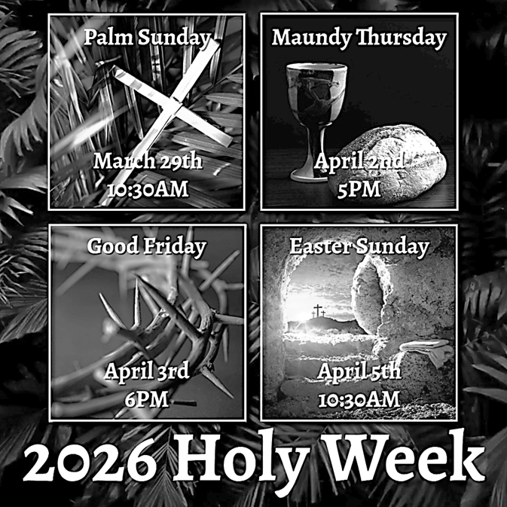

DONATION STATION
Get on the train and place all purchased items in the specified project donation bins located on the counter by the front doors. See Heather for more information.

A. O God, when suffering arises, preserve your church. Give to pastors, vicars,
deacons, bishops, and all servants of your gospel the endurance that produces
character and the hope that will never disappoint. Hear us, O God.
C. Your mercy is great.

A. When the waters run dry, sustain this earth. Send water to places languishing
with drought, and bring relief to places damaged by floods. Hear us, O God.
C. Your mercy is great.

A. When quarrels ensue, soften our hearts. Quell hostilities between nations and
peoples, and reconcile all humans across the lines of race, class, nationality,
moral conviction, religion, and all else that divides or oppresses. Hear us, O God.
C. Your mercy is great.

A. When your people thirst, satisfy their needs. Send water and food to all who need
nourishment. Grant welcome to all who are excluded. Show your mercy to any in
need; especially:
BettyAnn Rich-White (Church Member)
Chip & Marie Hand (Church Members)
Lynn Bargstadt (Church Member)
Frank Ford (Church Member)
Carol Amundsen (Church Member)
Kim McGinley (Church Member)
Anthony DeLuca (Church Member)
Frank Brunner (Church Member)
Joan Sommerman (Church Family)
Arleen Kinka (Church Family)
Rick Lang (Church Family)
Suzie Clark (Rose Lang's Friend)
Francis Clock (Dianna DeNote’s Family)
Andrew Hudak (Rose Lang’s Friend)
Viena Murtha (Bob Fritsch’s Friend)
Sharon Waicus (Skip & Bonnie Millard's Friend)
Karen O'Brien (Paul Bowker's Friend)
Dustin Irizzary (Mary Melnicoff's Family)
The Bryan Family (Wanda Bryan's Family)
Craig Brearey (Judy Brannan & Mary Melnicoff's Friend)
Sarah Dutton (Frank Ford's Family)
Christina McNasby (Fran Green’s Family)
Mark Stephen Dennis (Diana DeNote's Family)
SERMON
(Delivered by Vicar Vince Piekarski.)

(Following the Sermon, we invite you to stand as you are able.)

HYMN OF THE DAY
(We invite you to sing along.)
Lutheran Book of Worship—Green Book
356—O Jesus, Joy of Loving Hearts

APOSTLES’ CREED
V. God has made us his people through our Baptism into Christ. Living together in
trust and hope let us confess our faith together using the Apostles’ Creed.
C. I believe in God, the Father almighty,
creator of heaven and earth.

I believe in Jesus Christ, God’s only Son, our Lord,
who was conceived by the Holy Spirit,
born of the Virgin Mary,
suffered under Pontius Pilate,
was crucified, died, and was buried;
he descended to the dead.
On the third day he rose again;
he ascended into heaven,
he is seated at the right hand of the Father,
and he will come to judge the living and the dead.

I believe in the Holy Spirit,
the holy catholic church,
the communion of saints,
the forgiveness of sins,
the resurrection of the body
and the life everlasting.
Amen.

PRAYERS OF INTERCESSION
V. Reconciled by God’s mercy and sustained by God’s presence, let us pray for the
world and its needs.

(A brief silence.)


WOMEN OF THE CHURCH
Their next meeting is on Monday, April 6th, at 6PM. New members are always invited and welcome to attend! Contact Judy for more information.


Our NJ Synod Assembly transitions back to a one-day event on Saturday,
May 30th, 2026. Wayne & Judy are considering attending with Vicar Vince.
Registration is now up and will need completed and paid for soon.


Confirmation is a journey of faith filled with new questions and answers, new discoveries, new relationships, new responsibilities, and new possibilities. Clearly confirmation is intended to be a milestone, not a destination; it is not graduation! Rather, Confirmation is a tool that equips for the life-long process of living out Christian identity. Traditionally we would be celebrating Confirmation on Pentecost Sunday. However, due to it falling on Memorial Day Weekend, and the schedules of our young folks, we will be moving it to Sunday, June 14th, during our 10:30AM Worship Service. Please come out and join Caylee Thomas and Robert Thomas on this special day and celebrate with them at the Coffee Hour afterwards.
TITHES, OFFERINGS, & ENVELOPES
We worship God with our tithes and offerings. We hear in scripture, “Each of you must give as you have made up your mind, not reluctantly or under compulsion, for God loves a cheerful giver.” (2 Corinthians 9:7) Envelopes can be dropped in the offering plate, mailed to the church, or dropped in the locked mailbox. Thanks for your support in the mission of our church, its ministries, the NJ Synod, etc!

SPACE AVAILABLE
​​​​​Interested in utilizing our Fellowship Hall for a Party or Event? There is a suggested $50 refundable security deposit, and it is $250 for facility use. No alcohol or games of chance permitted due to ELCA policy. Please contact Vicar Vince for more info.

ED GREEN CAPITAL IMPROVEMENT FUND
We are seeking out a new fundraiser at this time. We also have the donation bin in the back of the church and we have our Annual Church Rummage Sale to raise funds. Thanks for your continued donations, prayers, and support!

HOME COMMUNION MINISTRY
A Minister is available if you have a loved one, or if you desire services. We look forward in sharing the Word and Holy Communion! Please inform Vicar Vince, Kathy, or the Church Office so plans can be made for visits.

PRAYER SHAWL MINISTRY
Prayer Shawls, Lap Quilts, Scarves, and other items have been made with love. Blessed items are located in the Narthex, and are free for anyone. Members of the group continue working at home on new stitches and patterns. We are blessed to be able to continue collecting new items. We have a donation station of yarn and other items located in the Narthex. You can find some new supplies for your next creation!

PRAYER LIST
Our Prayer List continues to lengthen and we realize the important need for prayers and healing. Sometimes the unfortunate result is that someone has passed away, and the words “The Family & Friends of” appear before someone’s name. However, sometimes we forget names are still on the list and their health has improved and they can be removed. Please share various stories as we continue to pray for strength and healing. Names can be added or removed from the list on the clipboard in the Narthex prior to the Worship Service, by calling the church office, or addressing it on the Conference Call. Please let us know the relation to the person(s) you listed so we can be more mindful with our prayers.

we worship what we know, for salvation is from the Jews. 23 But the hour is
coming and is now here when the true worshipers will worship the Father in spirit
and truth, for the Father seeks such as these to worship him. 24 God is spirit, and
those who worship him must worship in spirit and truth.” 25 The woman said to
him, “I know that Messiah is coming” (who is called Christ). “When he comes, he
will proclaim all things to us.” 26 Jesus said to her, “I am he, the one who is
speaking to you.”

27 Just then his disciples came. They were astonished that he was speaking with
a woman, but no one said, “What do you want?” or, “Why are you speaking with
her?” 28 Then the woman left her water jar and went back to the city. She said to
the people, 29 “Come and see a man who told me everything I have ever done!
He cannot be the Messiah, can he?” 30 They left the city and were on their way to
him.

31 Meanwhile the disciples were urging him, “Rabbi, eat something.” 32 But he
said to them, “I have food to eat that you do not know about.” 33 So the disciples
said to one another, “Surely no one has brought him something to eat?” 34 Jesus
said to them, “My food is to do the will of him who sent me and to complete his
work. 35 Do you not say, ‘Four months more, then comes the harvest’? But I tell
you, look around you, and see how the fields are ripe for harvesting. 36 The
reaper is already receiving wages and is gathering fruit for eternal life, so that
sower and reaper may rejoice together. 37 For here the saying holds true, ‘One
sows and another reaps.’ 38 I sent you to reap that for which you did not labor.
Others have labored, and you have entered into their labor.”

39 Many Samaritans from that city believed in him because of the woman’s
testimony, “He told me everything I have ever done.” 40 So when the Samaritans
came to him, they asked him to stay with them, and he stayed there two days.
41 And many more believed because of his word. 42 They said to the woman, “It
is no longer because of what you said that we believe, for we have heard for
ourselves, and we know that this is truly the Savior of the world.”

V. This is the Gospel of the Lord,
C. Praise to you, O Christ.

(We invite you to be seated.)

V. I invite you to announce the Gospel Acclamation with me.

GOSPEL ACCLAMATION
C. Lord, you are truly the Savior of the world; give me this living water that I
may never thirst again. (John 4:42, 15)

GOSPEL READING
Jesus defies convention to engage a Samaritan woman in conversation. Her
testimony, in turn, leads many others to faith.

V. The Holy Gospel According to John, the 4th Chapter (Verses 5-42).
C. Glory to you, O Lord.

V. 5 [Jesus] came to a Samaritan city called Sychar, near the plot of ground that
Jacob had given to his son Joseph.6 Jacob’s well was there, and Jesus, tired out
by his journey, was sitting by the well. It was about noon.

7 A Samaritan woman came to draw water, and Jesus said to her, “Give me a
drink.” 8 (His disciples had gone to the city to buy food.) 9 The Samaritan woman
said to him, “How is it that you, a Jew, ask a drink of me, a woman of Samaria?”
(Jews do not share things in common with Samaritans.) 10 Jesus answered her,
“If you knew the gift of God and who it is that is saying to you, ‘Give me a drink,’
you would have asked him, and he would have given you living water.” 11 The
woman said to him, “Sir, you have no bucket, and the well is deep. Where do you
get that living water? 12 Are you greater than our ancestor Jacob, who gave us
the well and with his sons and his flocks drank from it?” 13 Jesus said to her,
“Everyone who drinks of this water will be thirsty again, 14 but those who drink of
the water that I will give them will never be thirsty. The water that I will give will
become in them a spring of water gushing up to eternal life.” 15 The woman said
to him, “Sir, give me this water, so that I may never be thirsty or have to keep
coming here to draw water.”

16 Jesus said to her, “Go, call your husband, and come back.” 17 The woman
answered him, “I have no husband.” Jesus said to her, “You are right in saying, ‘I
have no husband,’ 18 for you have had five husbands, and the one you have now
is not your husband. What you have said is true!” 19 The woman said to him, “Sir,
I see that you are a prophet. 20 Our ancestors worshiped on this mountain, but
you say that the place where people must worship is in Jerusalem.” 21 Jesus said
to her, “Woman, believe me, the hour is coming when you will worship the Father
neither on this mountain nor in Jerusalem. 22 You worship what you do not know;
LIBRARY
New books are added to our library from time to time. Several are borrowed and read and exchanged. Who knows, you might find one particularly interesting and share that with someone as well. Reading is a great way to pass spare time, learn, and explore. You may find some fresh ideas for prayer, ways to grow more spiritually, ways to grow closer to God, or some opportunities to understand our faith more. We also have an extended library located in Vicar Vince’s office. There are Bibles of various translations, books from his personal collection, books inherited from Pastor Leah, movies, past Bible Study Curriculums, and more. Visit the library between the church offices or just ask to be able to check things out.

FAVORITE HYMNS
Carol is willing to play some of your favorite hymns for the Prelude & Postlude each Sunday during our Worship Service. Feel free to let her know of your suggestions.

INTERESTED IN BECOMING A NEW MEMBER
Have you been attending our church for a while? Have you just recently returned to church after being away for a bit? Maybe you transitioned from another church,
or just started to recently attend our church. We are glad to have you, and would love to have you as a member of our Congregation. See Vicar Vince for more info.

BAPTISM
We are a church whose unity is in Jesus Christ, who gathers us around word and water, wine and bread. Baptism is a significant part of our faith journey as we come from the baptismal waters to live a new life as children of God. Our baptism sets us out on a lifelong journey that is characterized by our relationship to God, our relationship to our faith community, our relationships in our community and the wider world. Living our baptismal covenant means living a life of growth in the faith practices of discipleship. Please see Vicar Vince for more information.

FIRST COMMUNION
Although no particular age for first communion is prescribed by The Use of the Means of Grace, one guideline is offered. Because admission to the Sacrament is by invitation of the Lord to the baptized, "baptized children begin to commune on a regular basis at a time determined through mutual conversation that includes the pastor/vicar, the child, and the parents or sponsors involved, within the accepted practices of the congregation.” Each congregation is encouraged to ask the question of readiness for first communion, establish their own policies regarding age and practice, and accompany that practice with catechesis appropriate to the age of the communicant. If anyone has questions, please see Vicar Vince.
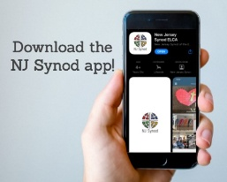
There is a weekly e-newsletter connecting our synod together with weekly prayer, upcoming events, synod and churchwide activities, mission stories, congregational activities, & more. Sign up at www.njsynod.org/stay-connected or download the app.

VICAR APPOINTMENT ON MARCH 19TH, 2023
A Memorandum of Understanding on the Matter of Pastoral Appointment
In Theological Education for Emerging Ministries (TEEM) Candidacy
TO: Congregation Council, Holy Spirit Lutheran Church, Villas
FROM: The Rev. Tracie L. Bartholomew, Bishop, New Jersey Synod

Dear Brother and Sisters in Christ,
This memorandum is in support of your discussions with Vincent Piekarski as pastor of Holy Spirit, Villas. Because this is not the usual pattern for completing the educational and candidacy requirements for ordination, it is my hope that this memorandum will both provide guidelines and engage in conversation with those who are invested in this process.

I would say at the outset that because Vincent is an outstanding candidate for the Ministry of Word and Sacrament, we will all want to do whatever is necessary to assure that his placement serves the mission of the church in the best possible fashion.

The following notes reflect my own understanding of this matter:
(1) The appointment for Vincent will begin on April 1, 2023. At this time, Vincent
will assume all responsibilities of a regularly called pastor, including presiding at
the Sacrament of Holy Communion and Baptism at Holy Spirit, Villas.
(2) A pastoral appointment in the TEEM process is an option for completing
seminary educational requirements and the steps of the candidacy process.
Upon completion of the candidacy process and seminary education, the
candidate may receive and accept a call to ordained ministry from the
congregation where the appointment is being served.
(3) This appointment is jointly supervised by the Office of the Bishop and the TEEM
pastor’s seminary. A mentoring relationship with a local pastor is required for the
length of this appointment.
(4) The synod of candidacy origin will be responsible for the approval process.
9 There your ancestors tested me,
they put me to the test, though they had seen my works.
10 Forty years I loathed that generation, saying,
‘The heart of this people goes astray; they do not know my ways.’
11 Indeed I swore in my anger,
‘They shall never come to my rest.’ ”
C. Let us shout for joy to the rock of our salvation. (Ps. 95:1)

SECOND READING
Though we often hear that God helps those who help themselves, here Paul tells
us that through Jesus’ death God helps utterly helpless sinners. Since we who
had been enemies are reconciled to God in the cross, we now live in hope for our
final salvation.

R. Our Second Reading is from the 5th Chapter of Romans (Verses 1-11).

R. 1 Since we are justified by faith, we have peace with God through our Lord Jesus
Christ, 2 through whom we have obtained access to this grace in which we stand,
and we boast in our hope of sharing the glory of God. 3 And not only that, but we
also boast in our afflictions, knowing that affliction produces endurance, 4 and
endurance produces character, and character produces hope, 5 and hope does
not put us to shame, because God’s love has been poured into our hearts
through the Holy Spirit that has been given to us.

6 For while we were still weak, at the right time Christ died for the ungodly.
7 Indeed, rarely will anyone die for a righteous person—though perhaps for a
good person someone might actually dare to die. 8 But God proves his love for us
in that while we still were sinners Christ died for us. 9 Much more surely,
therefore, since we have now been justified by his blood, will we be saved
through him from the wrath of God. 10 For if while we were enemies we were
reconciled to God through the death of his Son, much more surely, having been
reconciled, will we be saved by his life. 11 But more than that, we even boast in
God through our Lord Jesus Christ, through whom we have now received
reconciliation.

R. This is the Word of the Lord.
C. Thanks be to God.

(We invite you to stand as you are able.)

R. 1 From the wilderness of Sin the whole congregation of the Israelites journeyed
by stages, as the Lord commanded. They camped at Rephidim, but there was no
water for the people to drink. 2 The people quarreled with Moses and said, “Give
us water to drink.” Moses said to them, “Why do you quarrel with me? Why do
you test the Lord?” 3 But the people thirsted there for water, and the people
complained against Moses and said, “Why did you bring us out of Egypt, to kill us
and our children and livestock with thirst?” 4 So Moses cried out to the Lord,
“What shall I do for this people? They are almost ready to stone me.” 5 The Lord
said to Moses, “Go on ahead of the people and take some of the elders of Israel
with you; take in your hand the staff with which you struck the Nile and go. 6 I will
be standing there in front of you on the rock at Horeb. Strike the rock, and water
will come out of it, so that the people may drink.” Moses did so, in the sight of the
elders of Israel. 7 He called the place Massah and Meribah, because the
Israelites quarreled and tested the Lord, saying, “Is the Lord among us or not?”

R. This is the Word of the Lord.
C. Thanks be to God.

PSALM
R. Our Responsorial Psalm is from the 95th Psalm.
C. Let us shout for joy to the rock of our salvation. (Ps. 95:1)

R. 1 Come, let us sing to the Lord;
let us shout for joy to the rock of our salvation.
2 Let us come before God’s presence with thanksgiving
and raise a loud shout to the Lord with psalms.
3 For you, Lord, are a great God,
and a great ruler above all gods.
4 In your hand are the caverns of the earth;
the heights of the hills are also yours.
5 The sea is yours, for you made it,
and your hands have molded the dry land.
6 Come, let us worship and bow down,
let us kneel before the Lord our maker.
C. Let us shout for joy to the rock of our salvation. (Ps. 95:1)

R. 7 For the Lord is our God, and we are the people of God’s pasture
and the sheep of God’s hand.
Oh, that today you would hear God’s voice!
8 “Harden not your hearts,
as at Meribah, as on that day at Massah in the desert.
(5) Upon approval for ordination, the congregation would be expected to extend a
call to the pastoral appointee.
(6) Compensation for the TEEM pastor will be according to the guidelines of the New
Jersey Synod. All normal forms of compensation should be in place for the term
of the appointment, including stipulation that base salary and housing shall be in
accord with synod guidelines for first call at time of ordination.
(7) The ELCA Portico benefit plan for lay persons in full-time church service should
be used for the pastoral appointee up to the time of ordination, whereupon the
benefit package is to be converted to the plan for ELCA clergy.
(8) A decision for Pastoral Appointment is made with the agreement of a synod and
its candidacy committee, and the ELCA, normally represented by the regional
staff person of each in consultation with the seminary and its Director for
Contextual Education.
(9) Pastoral Appointment in a TEEM Candidacy is an option that is to serve the
mission of the Church in a particular and vital way and is not to be viewed or
used as a means to circumvent the normal candidacy process and/or first call
placement process.

In the specific case of Vincent, the New Jersey Synod remains responsible for the candidacy and approval process, and has agreed to this proposal for Appointment at Holy Spirit, Villas.

Continued blessings to both Holy Spirit and Vincent Piekarski as you embark on this journey of mutual ministry. As partners in ministry, we walk with you and rejoice in this new relationship.


VICAR VINCE’S DAY OF REST
A day of rest can have physical, mental, and spiritual benefits. “Mittwoch,” German for mid-week, or Wednesday, is the day that Vicar Vince will use to recharge and do some other things. Please do not hesitate to reach out if there is an emergency!

VICE PASTOR UPDATE
Pastor William Hodgetts continues to attend our Church Council Meetings
and provides Supervision and Support to Vicar Vince.
WHAT IS THE EVANGELICAL LUTHERAN CHURCH IN AMERICA?
The ELCA was formed in 1987 by the merger of three Lutheran Church bodies –
the ALC (American Lutheran Church), the LCA (Lutheran Church in America), and the AELC (Association of Evangelical Lutheran Churches). Learn more at elca.org.

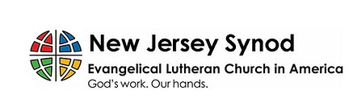
The New Jersey Synod is a geographical grouping of Evangelical Lutheran Church in America (ELCA) congregations that share the mission and ministry of the Church on the New Jersey territory. It is one of 65 synods in the ELCA. The NJ Synod is comprised of 143 congregations, which include over 45,000 baptized members.

2026 FINANCIAL STANDING
FEBRUARY INCOME | $8,570.00
FEBRUARY SPENDING | $6,702.26
FEBRUARY GAIN OR (LOSS) | $1,867.74
2026 INCOME | $11,480.00
2026 SPENDING | $12,124.07
2026 GAIN OR (LOSS) | ($644.07)
ED GREEN CAPITAL IMPROVEMENT FUND | $2,958.55
FOOD PANTRY FUND (SOCIAL MINISTRY) | $13,515.13
CD | $26,414.45

TRUE DELIVERANCE PRAISE & WORSHIP CENTER
TDPWC utilizes our facilities from 1-4PM on Sundays. TDPWC hosts or assists with other events. TDPWC hosts a Prayer Line on Mondays, Wednesdays, & Fridays at 5PM on the Conference Call 1-657-390-7957; & Bible Study on Thursdays at 6:30PM on Zoom. See Rev. Brooks for more information.

JUST FRIENDS
The group promotes a spirit of fellowship among adults 50 years and older. Bring your own lunch, beverages and deserts are provided. Everyone is welcome. The group meets in Our Lady Star of The Sea Parish Hall on the last Wednesday of the month from 12Noon to 2PM from September through May. For information, please call Martine Simonis 609-884-5312 x 110.

KYRIE
V. In peace, let us pray to the Lord.
C. Lord, have mercy.

V. For the peace from above, and for our salvation, let us pray to the Lord.
C. Lord, have mercy.

V. For the peace of the whole world, for the well-being of the church of God,
and for the unity of all, let us pray to the Lord.
C. Lord, have mercy.

V. For this holy house, and for all who offer here their worship and praise,
let us pray to the Lord.
C. Lord, have mercy.

V. Help, save, comfort, and defend us, gracious Lord.
C. Amen.

PRAYER OF THE DAY
V. The Lord be with you.
C. And also with you.

V. Let us pray,
Merciful God, the fountain of living water, you quench our thirst and wash away
our sin. Give us this water always. Bring us to drink from the well that flows with
the beauty of your truth through Jesus Christ, our Savior and Lord, who lives and
reigns with you and the Holy Spirit, one God, now and forever.
C. Amen.

(We invite you to be seated for our Readings and Psalm.)

FIRST READING
Because the thirsty Israelites quarreled with Moses and put God to the test,
Moses cried out in desperation to God. God commanded Moses to strike the rock
to provide water for the people. The doubt-filled question—“Is the Lord among us
or not?”—received a very positive answer.

R. Our First Reading is from the 17th Chapter of Exodus (Verses 1-7).

V. For desiring self-reliance instead of hungering for your word:
Gracious God,
C. have mercy on us according to your steadfast love.
V. For failing to recognize your coming reign,
and for hindering the work of the Spirit:
Gracious God,
C. have mercy on us according to your steadfast love.
V. For drawing from the well of self-serving ambition,
and for disdaining the living water Christ offers:
Gracious God,
C. have mercy on us according to your steadfast love.
V. For disregarding voices from the margin,
and for distrusting signs of your healing and hope in the world:
Gracious God,
C. have mercy on us according to your steadfast love.
V. For dwelling in tombs of self-pity and discontent,
and for disregarding Christ’s call to come forth to life:
Gracious God,
C. have mercy on us according to your steadfast love.

V. God’s steadfast love, grace, and forgiveness abound.
Through faith, the free gift of God,
you have been clothed in the righteousness of Christ.
In the name of ☩ Jesus Christ, your sins are forgiven.
The Spirit of the One who raised Christ from the dead dwells in you,
pours God’s love into your hearts,
and gives you life and peace.
C. Amen.

GATHERING HYMN
(We invite you to sing along.)
Lutheran Book of Worship—Green Book
482—When I Survey The Wondrous Cross

APOSTOLIC GREETING
V. May the grace of our Lord Jesus Christ, the love of God,
and the communion of the Holy Spirit be with you all.
C. And also with you.

ADDITIONAL OFFERINGS FROM OUR FRIENDS & NEIGHBORS
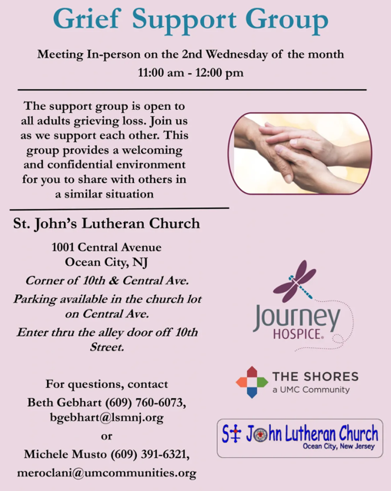

CHURCH STAFF & VOLUNTEERS
VICAR
Vicar Vince Piekarski
VICE PASTOR
Pastor William Hodgetts
ORGANIST & PIANIST
Carol Amundsen
CHURCH OFFICE, SUNDAY SCHOOL, & FOOD PANTRY
Heather Piekarski
CHURCH COUNCIL PRESIDENT & CHURCH PROPERTY
Wayne Rand
CHURCH COUNCIL VICE PRESIDENT & WOMEN OF THE CHURCH
Judy Brannan
CHURCH COUNCIL TREASURER
Bonnie Millard
CHURCH COUNCIL SECRETARY
Vicki Rinier

CONFERENCE CALL CHECK-IN, WELCOME, & ANNOUNCEMENTS
(Vicar (V), Assistant (A), Reader (R), and Congregation (C).)

INTRODUCTION
A. In today’s gospel the Samaritan woman asks Jesus for water, an image of our
thirst for God. Jesus offers living water, a sign of God’s grace flowing from the
waters of baptism. The early church used this gospel and those of the next two
Sundays to deepen baptismal reflection during the final days of preparation
before baptism at Easter. As we journey to the resurrection feast, Christ comes
among us in word, bath, and meal—offering us the life-giving water of God’s
mercy and forgiveness.

PRELUDE
(Music offered by our Organist at the start of our Worship Service.)
Jesus Priceless Treasure

CHIMES
(Music offered by our Organist at the start of our Worship Service.)
Sweet Hour of Prayer

(We invite you to stand as you are able.)

CONFESSION & FORGIVENESS
(All may make the sign of the cross, the sign that is marked at baptism.)
V. Blessed be the holy Trinity, ☩ one God,
who forgives all our sin,
whose mercy endures forever.
C. Amen.

V. Let us confess our sin before God, who removes our guilt
and blots out all offenses.

(Silence is kept for reflection.)

V. Gracious God,
C. have mercy on us according to your steadfast love.
V. For seeking worldly delights that deceive us and dishonor you:
Gracious God,
C. have mercy on us according to your steadfast love.


We, the Evangelical Lutheran Church of the Holy Spirit, are People of God, who
are called by the Holy Spirit to pray, worship, joyfully proclaim Jesus Christ,
and compassionately witness and serve others in Christian Love.


We are glad that you joined us for Worship today! Thank you for enriching our time together! We would like to get to know you better, and for you to get to know us better too. Brochures, welcome gifts, prayer shawls, Bibles, and other items are available throughout the church. We would be happy to show you around and share about our ministries. Please do not hesitate to speak up and ask questions.
Also, please make sure you sign-in on our clipboard on the podium in the lobby.


Our Worship Services are conducted in coordination with our Conference Call.
Join us at 657-390-7423 or 701-802-5170, with access code 8221190#.
You may need to dial 1 first depending on your phone plan. After logging in please announce your name and feel free to talk with others until we get started.


SANCTUARY CANDLE FOR MARCH
Given to the Glory of God & In Memory of DOROFFEY KIROW
by Rose Lang, Vicar Vince & Heather Piekarski.
ALTAR CANDLES FOR MARCH
Given to the Glory of God & In Memory of DONNA GAIN
by Jean, Phil, & Bob Zimmerman.

“Come and see.”

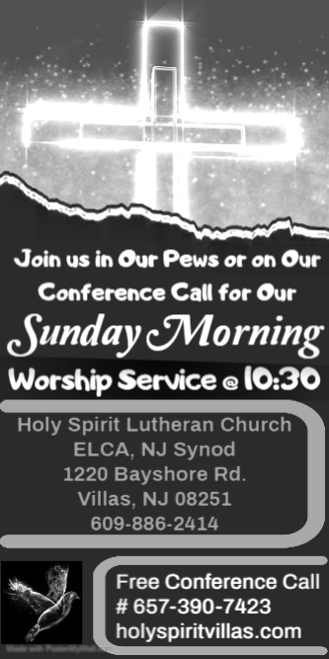

WELCOME TO
HOLY SPIRIT LUTHERAN CHURCH
A Member of the Evangelical Lutheran Church in America, New Jersey Synod
1220 Bayshore Rd., Villas, NJ 08251, 609-886-2414,
holyspiritlutheran@comcast.net, holyspiritvillas.com, facebook.com/holyspiritvillas
Vicar Vince Piekarski can be contacted at any time for conversation or prayer through call or text at 412-225-0287, or through email at vpie8282@gmail.com.
SUNDAY, MARCH 8TH, 2026
THIRD SUNDAY IN LENT
10:30AM WORSHIP SERVICE WITH HOLY COMMUNION


