On 1/18/18 through 1/20/18 on three field trips put on by the Quartzsite rock club during the Quartzsite Pow Wow. On the 18th we went for green banded rhyolite outside of town by Bouse. On the 19th we went for chipboard rhyolite also near Quartsite and on the 20th we drove about 30 miles to the town of Salome (rhymes with home) for marble.
On the 17th I went to the main building at the Quartzsite Pow Wow to take a look at the field trip showcase. I was told that they had examples of the material and finished cabs for the target minerals for each day. The showcase helped me to decide which trips to go on.
Green banded rhyolite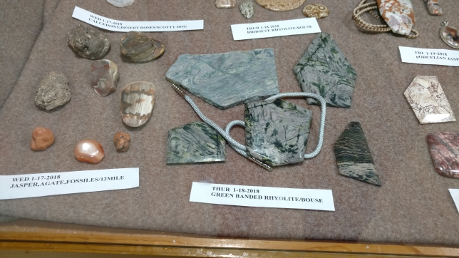
Chipboard rhyolite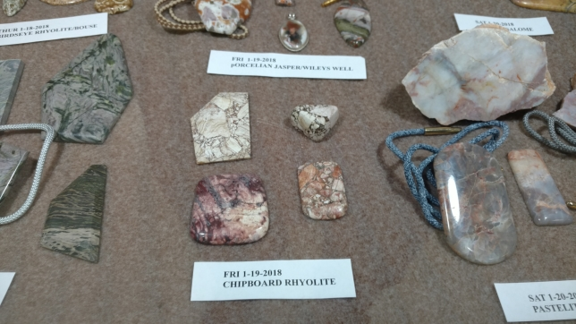
Salome marble 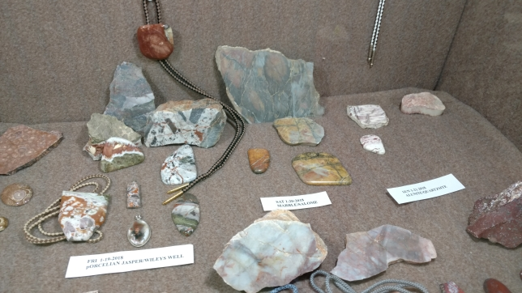
The morning of the 18th started out with a beautiful sun rise. I could smell the good rocks calling to me
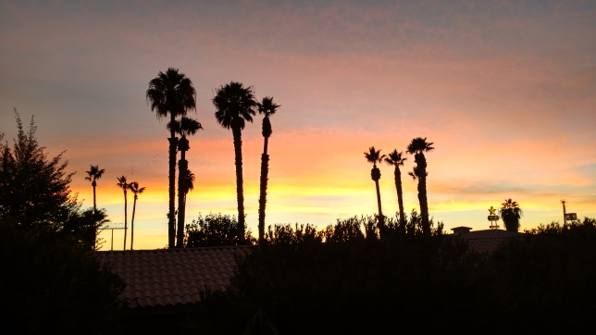

The trip to Bouse was all on highway and we pulled just off the road to walk to the collecting site. It was pretty easy. From here we walked into the canyon just beyond the last cars in this photo and started finding good material.
Parking lot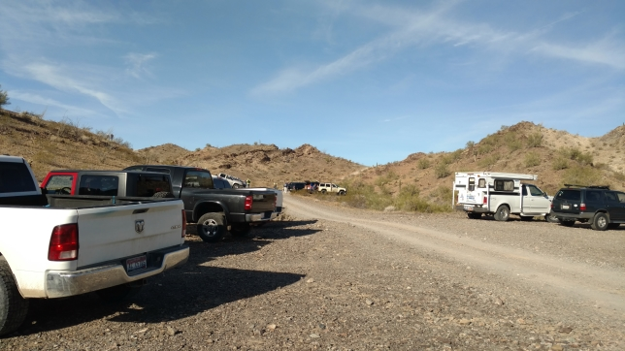
Inside the canyon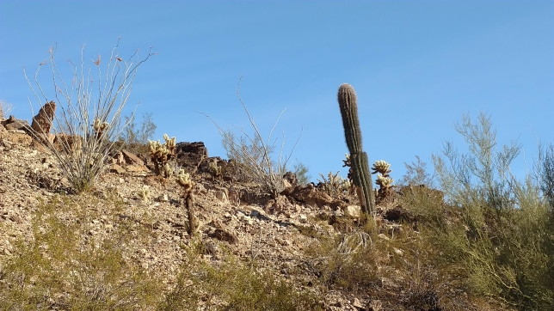
Lots of green banded rhyolite on the ground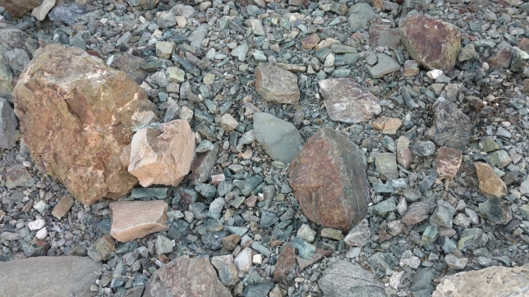
In no time at all I filled my buckets. I was told the green is epidote. This material is very hard and polishes well. Rhyolite, by the way, is a kind of magma that has a high silica (quartz) content, which is why it polishes well.
Green banded rhyolite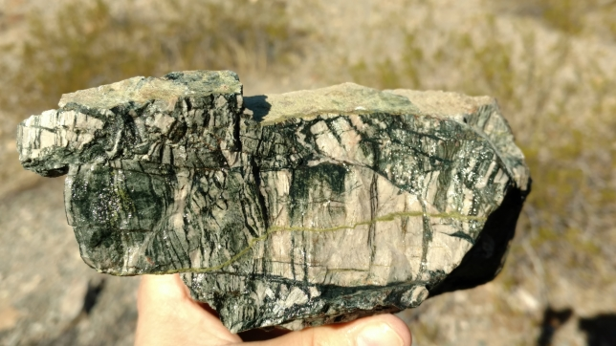
Love those waves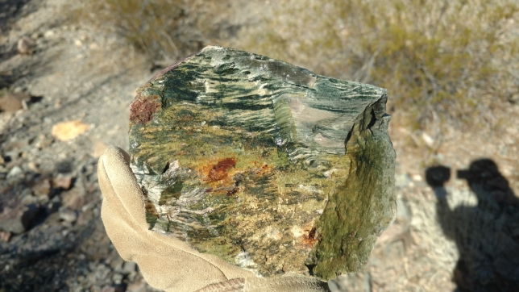
My monster piece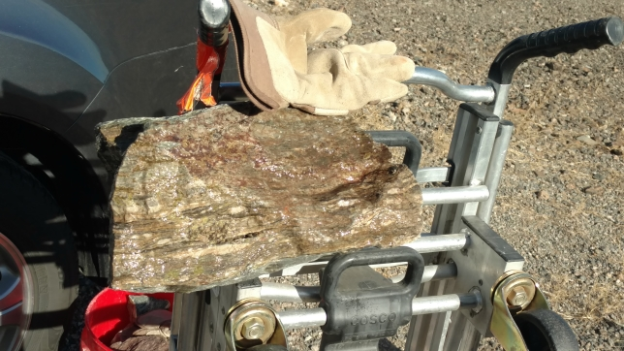
Inside of about 30-45 minutes I had all the material I wanted so I headed back to town to check out more of the vendors.

The 19th started out a bit cold, but for company I had Wes Boney with me. It was good to have someone to share the ride with. Our host brought out some cabs the club made with the chipboard rhyolite.
Cabs of chipboard rhyolite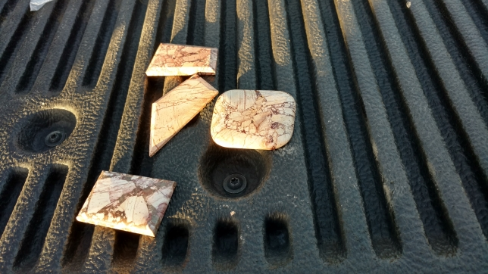
The drive out to the site was not too bad, the dirt road was a bit bumpy, but nothing outrageous. Our guide did remind us not to pet the cactus.
Chipboard rhyolite area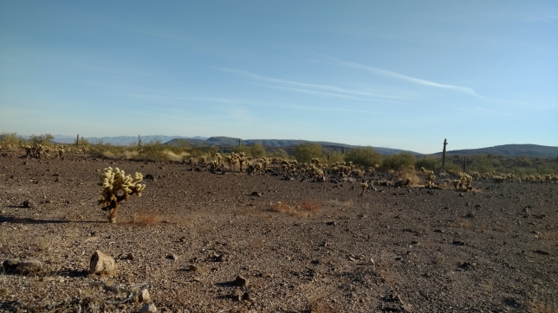
Lots of cactus on the hill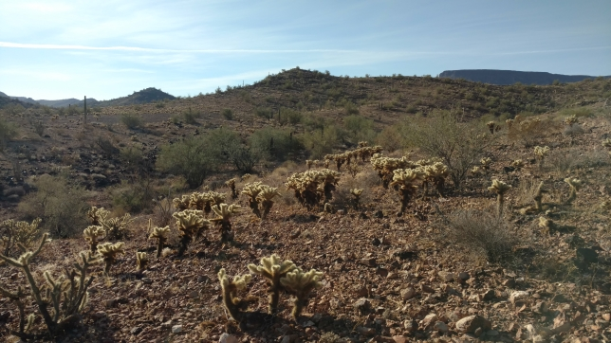
One of the chipboard rhyolite hills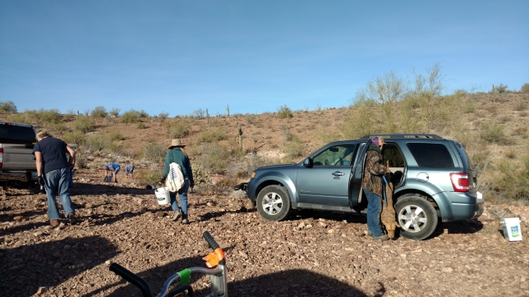
There were two main hills where they found the chipboard rhyolite. There are probably more in the area, but this is where people go. There is not really anything to distinguish this hill from any other in the area. There were enough pieces on the surface for everyone to get some, but to get good hard material it was hammer and chisel time. Unfortunately I did not bring my sledgehammer and my rock hammer was not cutting it. The desired color combination is blocks of cream on a wine red background. There were varying ratios of red and white. I preferred a lot of red. I did find one piece of rhyolite that had a pattern on it that reminded me of leopard skin jasper.
Chipboard rhyolite in the ground (can’t see much)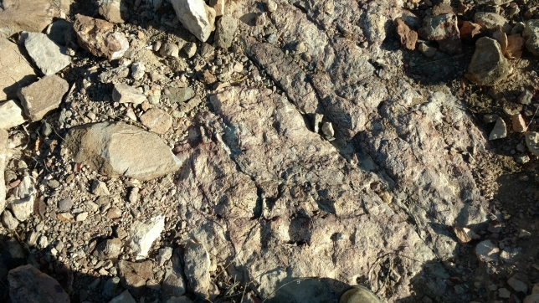
Lots of red here (wet)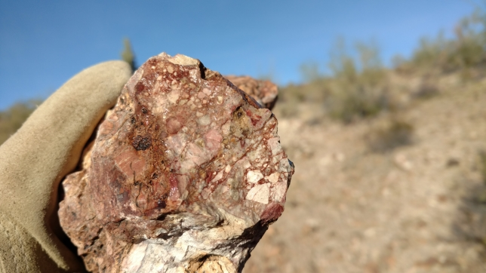
Red here also (dry)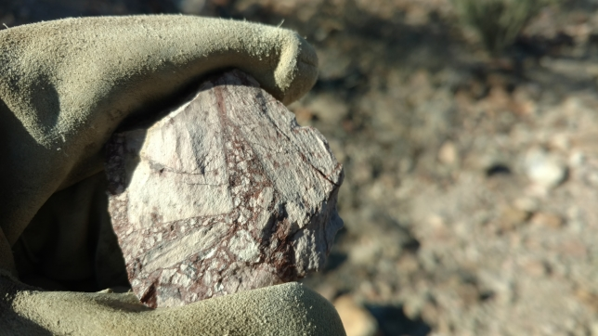
Leopard skin rhyolite?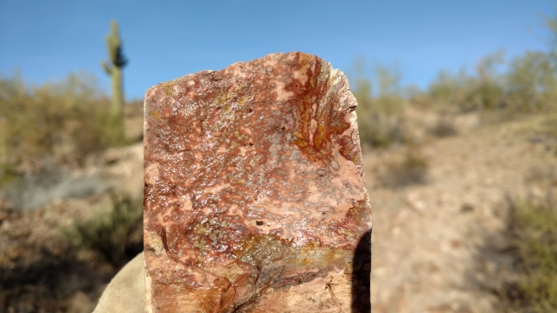
Again, it did not take too long to fill our buckets so it was another very successful outing.

A nice slice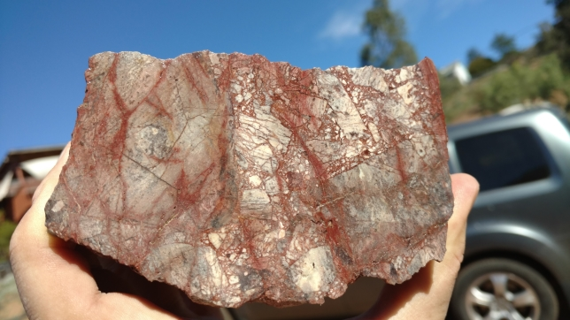
Salome is a little town about 30-45 miles from Quartzsite. After we drove through this small town it was another 45 minutes on a pretty bumpy dirt road, not recommended for autos. We stopped by a rocky hill and my first impression was “why would anyone stop here”? It is a pile of boring rocks. Upon closer inspection someone saw patches of color and started digging. When you say marble most of us think of soft stuff used in statues. This marble is not like that. For one thing it is very sharp and very hard. The soft parts on the surface have been eaten away leaving a rough surface with lots of teeth to bite you.
Dig here?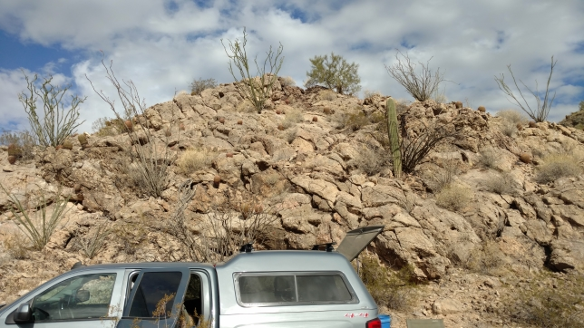
Attack that hill!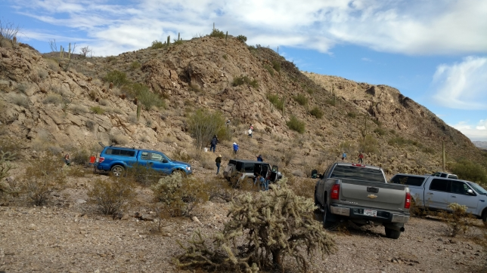
Our guide’s piece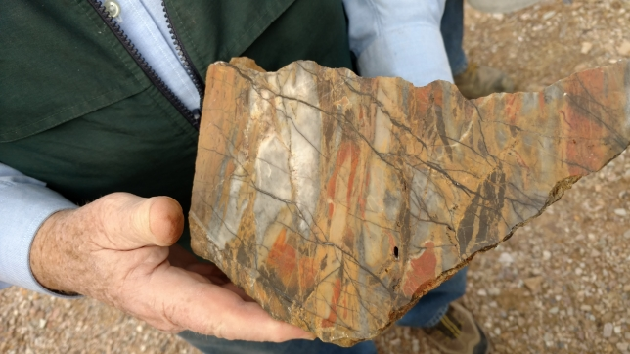
Looking at the hill I found a patch of red/orange. Some nice folks loaned me a gad and I commended to pounding on the hill. It took about three blows to figure that I was not going to create a crack in anything. Fortunately the piece I wanted had a large crack on one side. After about 30 minutes of hammering and digging I freed a large piece of colorful marble and some smaller pieces from the hill.
I see red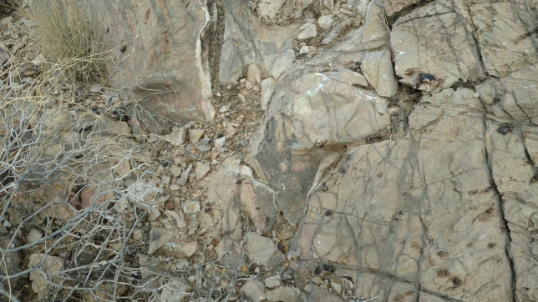
You are coming home with me big boy!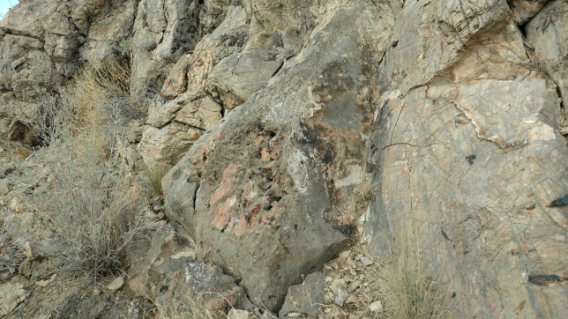
My prize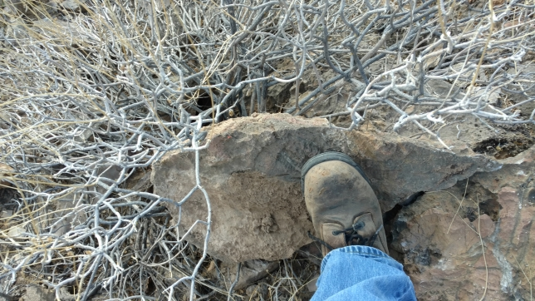
Salome marble slab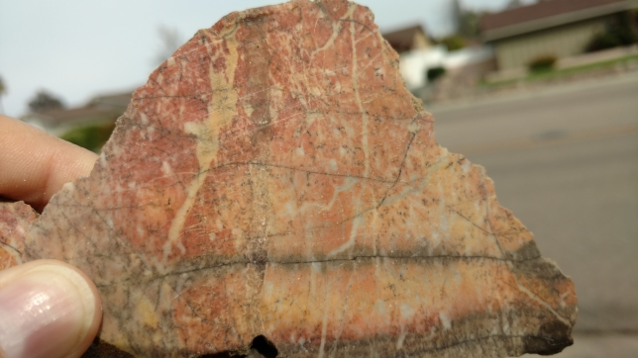
Salome marble slab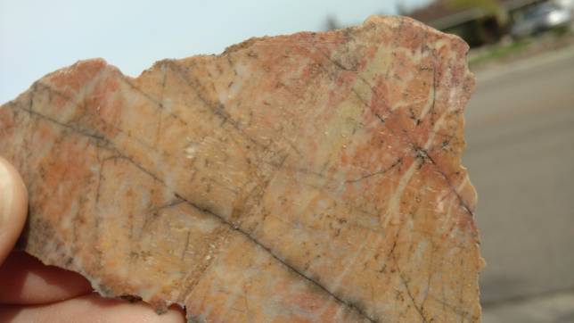
My trusty dolly helped me cart my prize back to my Pilot. Now it was lunch time and time to appreciate Mother Nature around me.
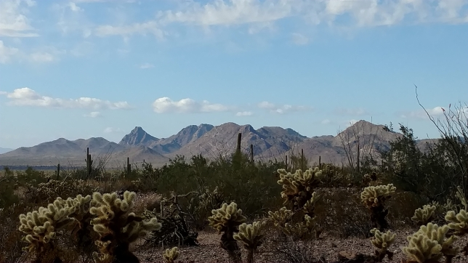

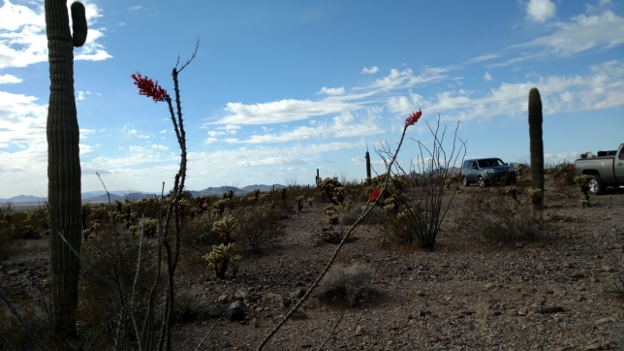
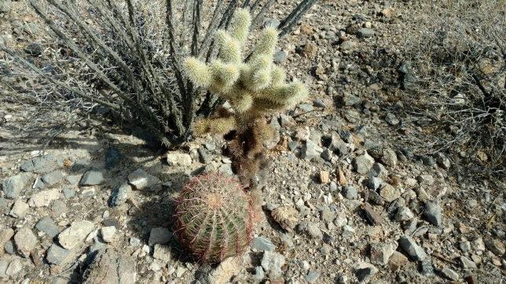
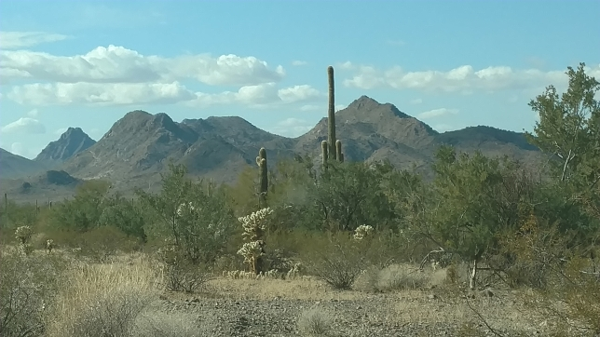
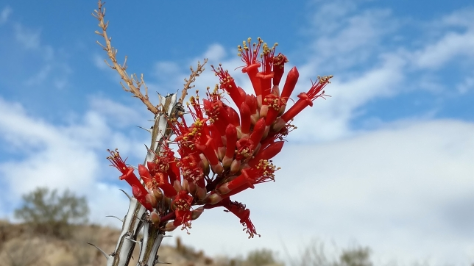
The End

