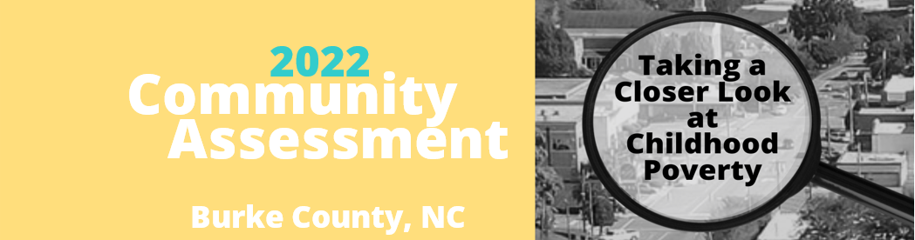

Poverty in Burke County, NC
One measure of poverty at the county level is set by the Center for Women’s Welfare and Sufficiency Standard at the University of Washington. The Center for Women’s Welfare Self-Sufficiency Standard defines the income working families need to meet a minimum yet adequate level, taking into account family composition, ages of children, and geographic differences in costs. The Standard is an affordability and living wage economic security measure that provides an alternative to the official poverty measure.
The Self-Sufficiency Standard for Burke County, NC, 2020
Monthly Costs | Adult & infant | 2 Adults & infant | Adult, infant & preschooler | 2 Adults, infant & preschooler | Adult, school-age & teenage | 2 Adults, school-age & teenage
Housing | $766 | $766 | $766 | $766 | $766 | $766
Child Care | $680 | $680 | $1,310 | $1,310 | $469 | $469
Food | $324 | $514 | $434 | $608 | $576 | $744
Transportation | $281 | $535 | $281 | $535 | $281 | $535
Health Care | $656 | $708 | $665 | $717 | $701 | $753
Miscellaneous | $271 | $320 | $346 | $394 | $279 | $327
Taxes | $555 | $642 | $770 | $829 | $466 | $538
Earned Income Tax Credit (-) | ($32) | ($4) | $0 | $0 | ($211) | ($185)
Child Care Tax Credit (-) | ($55) | ($50) | ($100) | ($100) | ($113) | ($99)
Child Tax Credit (-) | ($167) | ($167) | ($333) | ($333) | ($265) | ($284)
Self-Sufficiency Wage
Hourly | $18.63 | $11.21 | $23.51 | $13.43 | $16.76 | $10.12
Monthly | $3,279 | $3,945 | $4,138 | $4,726 | $2,950 | $3,564
Annual | $39,344 | $47,337 | $49,658 | $56,710 | $35,400 | $42,763
Emergency Savings Fund  (Monthly Contribution) | $67 | $36 | $105 | $45 | $79 | $42
Source: Center for Women's Welfare, University of Washington.
For more information see http://www.selfsufficiencystandard.org/NorthCarolina

The U.S. Census Bureau's Small Area Income and Poverty Estimates (SAIPE) program provides annual estimates of income and poverty statistics for all school districts, counties, and states. The main objective of this program is to provide estimates of income and poverty for the administration of federal programs and the allocation of federal funds to local jurisdictions. In addition to these federal programs, state and local programs use the income and poverty estimates for distributing funds and managing programs.
In 2010, the percentage of children under the age of 18 living in poverty in Burke County was 26.6%; in 2020, the estimated percentage increased 3.5 points to 30.1%. Compared to 2020 estimates for North Carolina and the United States, 17.9% and 15.7% respectively, Burke County’s 2020 estimate is 12.2 points above the state poverty rate and 14.4 points above the national poverty rate (SAIPE).
SAIPE program estimates for the poverty at county, state, and nation level
Age Group | Year | Burke County |  |  | North Carolina Poverty Percent | United States Poverty Percent
 |  | Total Population | Poverty Count | Poverty Percent
All Ages Combined | 2020 | 87,662 | 16,166 | 18.4 | 12.9 | 11.9
 | 2015 | 86,681 | 14,434 | 16.7 | 16.4 | 14.7
 | 2010 | 87,762 | 16,377 | 18.7 | 17.4 | 15.3
 | 2005 | 85,418 | 12,441 | 14.6 | 14.9 | 13.3
 | 2000 | 86,781 | 9,534 | 11.0 | 11.7 | 11.3
Under Age 18 | 2020 | 15,690 | 4,730 | 30.1 | 17.9 | 15.7
 | 2015 | 16,833 | 3,981 | 23.6 | 23.4 | 20.7
 | 2010 | 19,412 | 5,167 | 26.6 | 24.6 | 21.6
 | 2005 | 20,204 | 4,086 | 20.2 | 20.8 | 18.5
 | 2000 | 21,282 | 3,358 | 15.8 | 16.5 | 16.2
Ages 5 to 17 in Families | 2020 | 11,407 | 3,663 | 32.1 | 17.0 | 14.9
 | 2015 | 12,576 | 2,736 | 21.8 | 21.9 | 19.5
 | 2010 | 14,352 | 3,524 | 24.6 | 22.6 | 19.8
 | 2005 | 15,123 | 2,765 | 18.3 | 19.3 | 17.0
 | 2000 | 15,398 | 2,178 | 14.1 | 14.8 | 14.6
Under Age 5 | 2020 | -ª | - | - | 19.6 | 16.8
 | 2015 | - | - | - | 26.4 | 22.8
 | 2010 | - | - | - | 28.7 | 25.0
 | 2005 | - | - | - | 23.3 | 21.3
 | 2000 | - | - | - | 18.9 | 18.7
ªNot provided at the county level

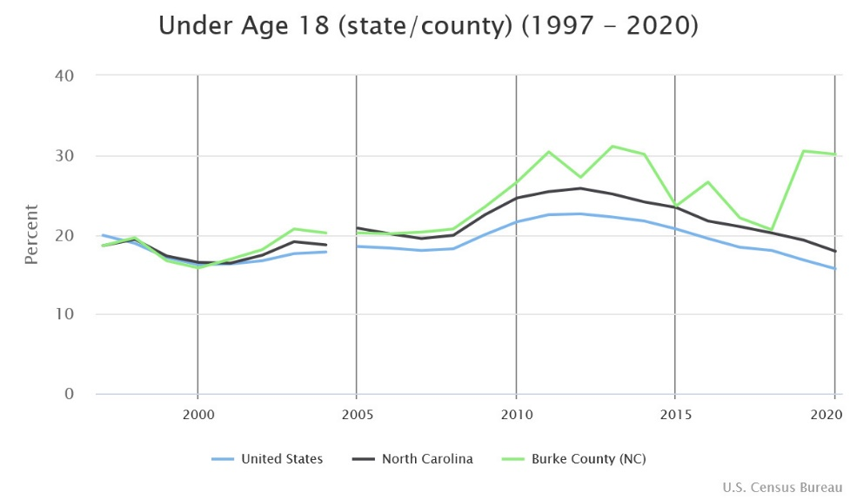
Figure 1. Under Age 18 Percentage in Poverty 2020 Estimates from Census SAIPE

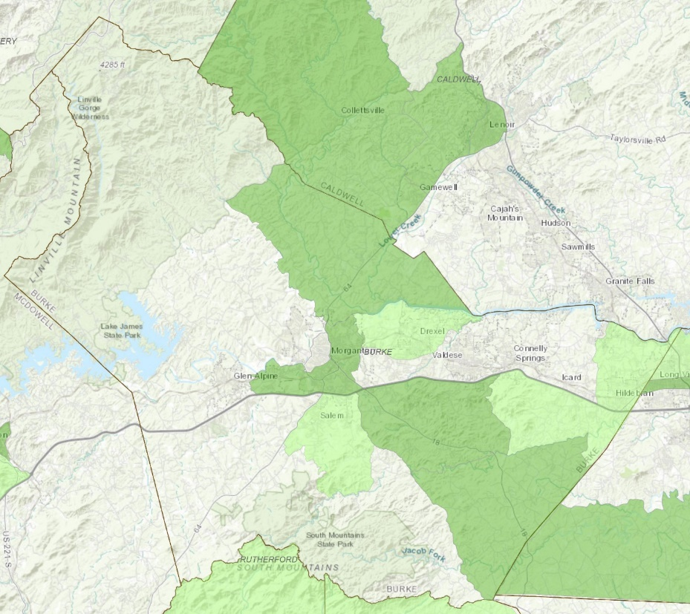
Locating North Carolina’s High-Poverty Areas for Title I Workforce Innovation and Opportunity Act (WIOA) https://www.arcgis.com/apps/webappviewer/index.html?id=fbbce8e6df1b4c8aaf6929918f3ce469

North Carolina High Poverty Rate Census Tracts Application allows users to identify high-poverty areas for Title I WIOA youth programs. Youth living in high-poverty areas have been determined to qualify as "low income" for WIOA youth eligibility purposes. A high-poverty area is classified as a Census tract, a set of contiguous Census tracts, Indian Reservation, tribal land, or Native Alaskan Village or county that has a poverty rate of at least 25 percent as set every 5 years using American Community Survey 5-Year data.
Addresses within a green (either dark-green or light-green) shaded census tract qualifies as a high-poverty area. Dark green color area means the address is in high poverty census tracts and automatically qualifies as "High-Poverty Geographic Areas" even by itself (single census tract). Light green color area means the address is in a census tract which is part of a large set of contiguous census tracts with a weighted poverty rate of 25% or above. The tract qualifies as “High-Poverty Geographic Areas” based on the area it is bordering.

Burke Township Data
Poverty metrics are also reported on the township level within Burke County. The map below shows the 13 townships that make up Burke County and the tables that follow show the poverty metrics for each township.

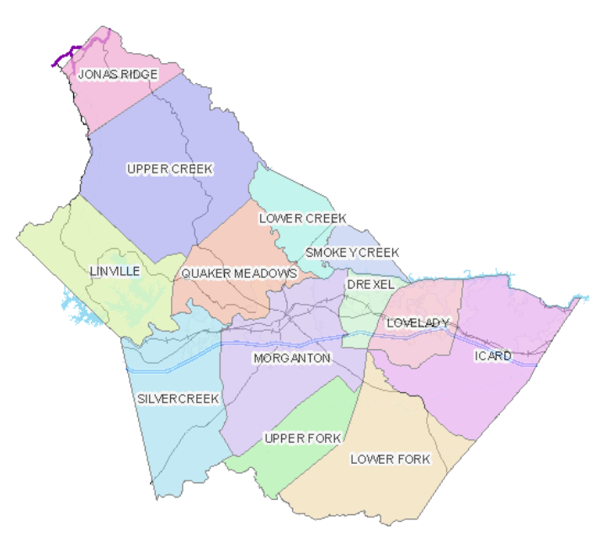

Estimated Total and Under Age 18 Percentage in Poverty 2020 by Burke County, NC Townships
 | Total Population |  |  |  | Under Age 18
Township | N | Below poverty level | % Below poverty level |  | N | Below poverty level | % Below poverty level
Drexel | 6,846 | 795 | 11.6 |  | 1,051 | 123 | 11.7
Icard | 17,086 | 2,813 | 16.5 |  | 3,271 | 523 | 16.0
Jonas Ridge | 556 | 40 | 7.2 |  | 37 | 17 | 45.9
Linville | 1,570 | 51 | 3.2 |  | 142 | 2 | 1.4
Lovelady | 8,193 | 1,304 | 15.9 |  | 1,685 | 437 | 25.9
Lower Creek | 3,207 | 1,212 | 37.8 |  | 719 | 308 | 42.8
Lower Fork | 3,121 | 514 | 16.5 |  | 539 | 166 | 30.8
Morganton | 24,684 | 5,818 | 23.6 |  | 4,868 | 2,236 | 45.9
Quaker Meadows | 7,667 | 1,443 | 18.8 |  | 1,443 | 403 | 27.9
Silver Creek | 11,494 | 1,871 | 16.3 |  | 2,044 | 511 | 25.0
Smoky Creek | 643 | 95 | 14.8 |  | 89 | 19 | 21.3
Upper Creek | 1,220 | 41 | 3.4 |  | 246 | 7 | 2.8
Upper Fork | 1,355 | 240 | 17.7 |  | 139 | 9 | 6.5
New Census ACS data out 3/17/22 added 3/17/22 to report
Source: U.S. Census Bureau, 2016-2020 American Community Survey 5-Year Estimates https://data.census.gov/cedsci/table?q=acs&t=Income%20and%20Poverty&g=0500000US37023%240600000&y=2020&tid=ACSST5Y2020.S1701

New Census ACS data out 3/17/22 added 3/18/22 to report
Estimated Under Age 18 Percentage in Poverty 2020 by Race/Ethnicity and Burke County, NC Townships
 | Under Age 18 |  |  | Number below poverty level in past 12 months
Township | N | Below poverty level |  | White alone | Hispanic or Latino alone | Asian alone | Black or African American alone | American Indian and Alaska Native alone | Some other race alone | Two or more races
Drexel | 1,051 | 123 |  | 98 | 25 | 0 | 0 | 0 | 0 | 0
Icard | 3,271 | 523 |  | 495 | 0 | 28 | 0 | 0 | 0 | 0
Jonas Ridge | 37 | 17 |  | 17 | 0 | 0 | 0 | 0 | 0 | 0
Linville | 142 | 2 |  | 0 | 0 | 0 | 2 | 0 | 0 | 0
Lovelady | 1,685 | 437 |  | 410 | 12 | 0 | 0 | 0 | 15 | 0
Lower Creek | 719 | 308 |  | 308 | 0 | 0 | 0 | 0 | 0 | 0
Lower Fork | 539 | 166 |  | 88 | 0 | 78 | 0 | 0 | 0 | 0
Morganton | 4,868 | 2,236 |  | 710 | 711 | 102 | 38 | 158 | 368 | 149
Quaker Meadows | 1,443 | 403 |  | 110 | 9 | 0 | 198 | 0 | 0 | 86
Silver Creek | 2,044 | 511 |  | 451 | 0 | 24 | 0 | 1 | 0 | 35
Smoky Creek | 89 | 19 |  | 19 | 0 | 0 | 0 | 0 | 0 | 0
Upper Creek | 246 | 7 |  | 7 | 0 | 0 | 0 | 0 | 0 | 0
Upper Fork | 139 | 9 |  | 9 | 0 | 0 | 0 | 0 | 0 | 0
Source: U.S. Census Bureau, 2016-2020 American Community Survey 5-Year Estimates

Estimated family status of children whose family income in the past 12 months was below poverty level
 |  |  | In married-couple family |  |  |  | Male householder,  no spouse present |  |  |  | Female householder,  no spouse present
Township | Number of children |  | Total | 5 years & under | 6 to 17 years |  | Total | 5 years & under | 6 to 17 years |  | Total | 5 & under | 6 to 17 years
Drexel | 89 |  | 0 | 0 | 0 |  | 11 | 0 | 11 |  | 78 | 17 | 61
Icard | 512 |  | 144 | 62 | 82 |  | 128 | 44 | 84 |  | 240 | 184 | 56
Jonas Ridge | 0 |  | 0 | 0 | 0 |  | 0 | 0 | 0 |  | 0 | 0 | 0
Linville | 0 |  | 0 | 0 | 0 |  | 0 | 0 | 0 |  | 0 | 0 | 0
Lovelady | 420 |  | 98 | 31 | 67 |  | 70 | 54 | 16 |  | 252 | 167 | 85
Lower Creek | 308 |  | 294 | 9 | 285 |  | 0 | 0 | 0 |  | 14 | 3 | 11
Lower Fork | 166 |  | 88 | 78 | 10 |  | 0 | 0 | 0 |  | 78 | 14 | 64
Morganton | 2,209 |  | 770 | 313 | 457 |  | 313 | 74 | 239 |  | 1,126 | 338 | 788
Quaker Meadows | 403 |  | 293 | 47 | 246 |  | 85 | 54 | 31 |  | 25 | 0 | 25
Silver Creek | 511 |  | 411 | 186 | 225 |  | 88 | 0 | 88 |  | 12 | 0 | 12
Smoky Creek | 19 |  | 11 | 0 | 11 |  | 0 | 0 | 0 |  | 8 | 8 | 0
Upper Creek | 7 |  | 7 | 0 | 7 |  | 0 | 0 | 0 |  | 0 | 0 | 0
Upper Fork | 9 |  | 0 | 0 | 0 |  | 0 | 0 | 0 |  | 9 | 9 | 0
Source: U.S. Census Bureau, 2016-2020 American Community Survey 5-Year Estimates
https://data.census.gov/cedsci/table?q=acs&t=Income%20and%20Poverty&g=0500000US37023%240600000&y=2020&tid=ACSDT5Y2020.B17006

