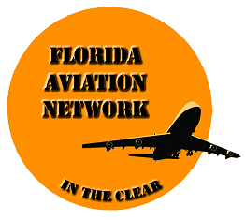 | MODEL RELEASE  FORM

I, __________________________(Print)_, do hereby give the Florida Aviation Network, and the National Aviation Safety Foundation, his/her assigns, licenses, and legal representatives the irrevocable right to use my name (or any fictional name), picture, portrait, or photograph in all forms and media and in all manner, including composite or distorted representations, for advertising, trade, or any other lawful purposes, and I waive any right to inspect or approve the finished product, including written copy, that may be created in connection wherewith. I am of full age. * I have read this release and am fully familiar with its contents.

Signed: _____________________________ Date: ________________________

Phone: __________________________ email: ___________________________

Witness: ___________________________

If available please attach business card.

*Delete this sentence if the subject is a minor. The parent or guardian must then sign the consent below.

CONSENT
(If Applicable)

I am the parent and /or guardian of the minor named above and have the legal authority to execute the above release. I approve the foregoing and waive any rights in the premises.

Signed: ______________________________ Date: ________________________

Phone: _______________________ Witness: ___________________________

MODEL FAN.DOC/OSY/04-24-2013/F/OBIE PRIMARY/SPM/ PROCRW/ HANDBOOK/ 4-FORMS

