Spring Creek Association Weed Management Plan
Adopted by Board of Directors, May 2019
The purpose of the Spring Creek Association Noxious Weed Management Plan is to strengthen, support, and coordinate private, county, state, and federal weed management efforts within Association boundaries, and promote implementation of ecologically-based integrated weed management programs. The plan is organized into five focal areas: Coordination, Prevention, Detection, Rapid Response and Monitoring/Maintenance.
Coordination
- Expand long term funding sources for private, county, state and federal land managers to implement a comprehensive weed management program that includes all aspects of integrated weed management.
- Utilize current prevention and Early Detection and Rapid Response (EDRR) strategies to reduce the introduction, establishment and spread of noxious weeds. Support statewide noxious weed coordination.
Prevention
- Increase public education and awareness about environmental impacts and management of noxious weeds.
- Promote and support noxious weed research based on needs determined by land managers.
- Research and develop a current noxious weed economic impact assessment.
Detection
- Expand the use of EDDMapS West database system by land owners for noxious weed inventories on Association and private properties.
Rapid Response
- Develop strategies for new noxious weed infestations.
Monitoring and Maintenance
- Strengthen and expand cooperative weed management areas that include private, municipal, university, county, state, tribal and federal land interests.
- Prioritize and implement ecologically based integrated weed management programs.
- Combine invasive plant control with the establishment of desired plant species to help improve the chance of restoration success.

Location and Land Status

Spring Creek is located in a large valley between the Elko Hills to the northwest, and the Ruby Mountains to the southeast. The community was developed in the 1970s by C. V. Wood, president of McCulloch Oil, as three large housing sections… Need info.

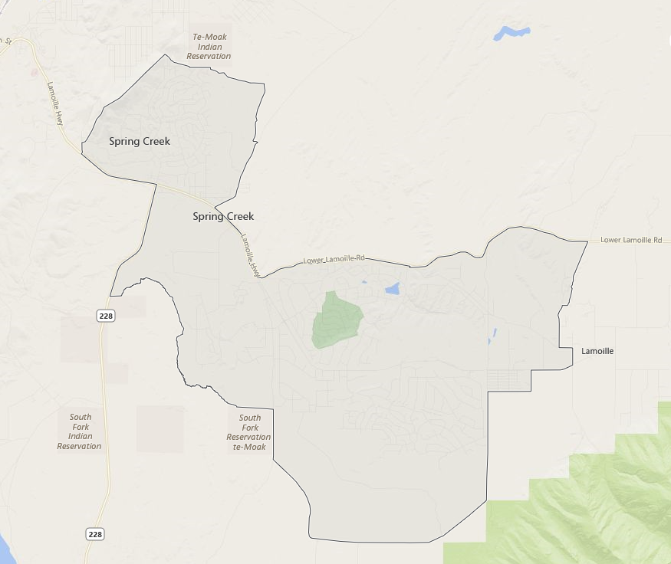

Severity of Noxious Weeds Within the Association Boundaries
The Nevada Revised Statutes (NRS) defines a noxious weed as "any species of plant which is, or likely to be, detrimental or destructive and difficult to control or eradicate." Per NRS 555.005 "The State Quarantine Officer may declare by regulation the weeds of the state that are noxious weeds, but a weed must not be designated as noxious which is already introduced and established in the State to such an extent as to make its control or eradication impracticable in the judgment of the State Quarantine Officer." All noxious weeds are regulated by the Nevada Department of Agriculture (Appendix A).
At the present time, the Spring Creek Association (SCA) has areas that range from weed free to totally infested. If existing weed infestations are not controlled, a major weed problem could develop in a very short period of time without prompt identification and diligent control. Increased vegetation and soil disturbance resulting from subdivision of land into residential and recreational areas, as well as increased use of public and private lands will likely result in increased levels of weed seed transportation, and subsequent establishment of weed populations in un-infested areas. It is imperative that the SCA with coordination from landowners continues to monitor weed populations throughout the HOA and initiate control programs before weed densities become unmanageable or create irreversible damage to ecosystems and economies.
The spread of noxious and invasive weeds across the landscape has been compared to an explosion in slow motion. Unlike other forms of pollution that dissipate or accumulate, weeds reproduce themselves exponentially. Without sufﬁcient action, the weed infestation problem is rapidly growing worse. Highly damaging to agriculture, rural landscapes, and the natural environment, these plants are “out of place” and interfere with beneﬁcial uses of the land.

Plan of Work

Objectives and Goals
- Develop and implement a comprehensive noxious weed management program
- Educate the public concerning weed management issues, and importance of EDRR
- Foster a spirit of cooperation among federal, state and local government agencies, private landowners and neighboring communities, ie. Jiggs and Lamoille Conservation Districts
- Work with other government agencies and departments to institute “Best Management Practices” and/or policies that stress prevention as a weed management tool
- Promote and use integrated management techniques
- Establish and maintain healthy plant communities with native or beneficial vegetation
- Restore and maintain desirable plant communities, healthy ecosystems, and productive agricultural lands within the Spring Creek Association jurisdictional boundaries
- Stop the spread of noxious weeds to un-infested lands
- Contain heavily weed-infested areas
  - Management Goals for Weed Species
Management goals will vary from species to species, by location, and over time. For some species, such as Scotch thistle and poison hemlock, complete eradication of existing infestations and total suppression of newly identified infestations is feasible and appropriate. Containment of existing intentional plantings, exclusion of seed from new wild land or open space mixes, and elimination of targeted escaped infestations are three different management goals for certain ornamentals such as oxeye daisy. Spotted knapweed, thistles, and Dyer’s woad infestations are so widespread that they must be managed, in many cases, merely for containment and reduction in the rate of spread. Eradication of these stands may only be viewed as impossible in some instances or as long range objectives.
- SCA Treatment Priorities
  - Sports Complex
  - Green Belts
  - Rights-of-Way
  - Campground and Shooting Range
  - Horse Palace
  - Marina
  - Schuckmann's Sports Complex And Vista Grande Park

Prevention and Detection
Prevention is the highest priority weed management technique on non-infested lands. Among government officials, land managers, farmers, ranchers, and the general public there is growing recognition that protecting weed-free plant communities is the most economical and efficient land management practice. The benefits are obvious. Weed-free plant communities:
- Provide essential wildlife habitat and forage.
- Saves ranchers, farmers, taxpayers, landowner, etc. many billions of dollars in labor costs and lost production.
- Ensure aesthetic and recreational qualities of an area.
- Prevent soil erosion and improve water quality.
The spread of noxious weeds is most likely to occur where soil has been disturbed either by human activities (road and trail cuts, construction sites, the spread of gravel, road fill and topsoil contaminated with noxious weed seed, or overgrazing) or by natural disturbances (fire, avalanches, mudslides, flooding). Disturbed land provides opportunity for noxious weeds. All soil disturbances should be monitored by the appropriate entity for noxious weed outbreaks, regular monitoring enables the practice of EDRR.
Exotic plants and seeds such as oxeye daisy, purple loosestrife, chicory, toadflax, and Russian olive escape from our yards and gardens. Since they are attractive and establish themselves quickly, they are popular with landscapers and gardeners for ornamental planting and may be purchased through nurseries. They have the same ability to dominate and spread, however, as other better known noxious weeds.
Still other known methods of weed introduction include:
- Contaminated seed, feed grain, hay, straw, and mulch.
- Movement of contaminated equipment, cars, bikes, etc. across uncontaminated lands.
- Animal fur, fleece, human clothing.
- Dried flower arrangements.
Prevention is best accomplished by ensuring that new weed species seed or vegetative reproductive plant parts of weeds are not introduced into new areas and by early detection and management of any new weed species before they become widespread.
STRATEGIES to prevent the introduction or establishment of noxious weeds into new un-infested areas include:
- Identification and eradication of small, new infestations.
- Continuous monitoring and evaluation to prevent recurrence.
- Identification of existing conditions, disturbances, and activities that represent a potential threat to native habitat.
- Identification of recently introduced weed species that represent a future threat.
- Timely revegetation and reclamation of disturbed sites using appropriate native plant species.
- The use of weed free seeds and mulch.
- Countywide promotion of the Nevada Weed Free Hay and Forage program.
- Prioritization of weed management along areas of entry and dispersal.
- Discouraging the sale of weedy ornamental plants and seed packets that contain weeds.

Education and Awareness:
Education must play a major role in implementing this weed management plan. Groups targeted for public education include the following: farmers and ranchers, homeowners, recreational users, youth groups and schools.
A partnership of the public and private sectors, along with awareness of what noxious weeds are and the problems they cause, is essential to maintain or create plant communities that are free of noxious weeds. Knowledge about how to identify weeds, how and where weeds are spread, and what it takes to manage weeds is needed. Continuation and expansion of current educational programs as well as the development of new programs is a priority of the South Fork Tribe Noxious Weed Management Plan. Workshops will be held throughout the year to enhance public awareness.
OPPORTUNITIES for education include:
- Widespread distribution of informative printed material.
- Offering weed tours and talks to the public.
- Private applicator certification, applicator safety, and laws/regulations.
- Proper calibration of spraying equipment.
- Contacting area nurseries, landscapers, and landscape architects, to emphasize the problems created by escaped ornamentals.
- Cooperation with local media to disseminate weed information.
- Custom weed management recommendations for individual landowners.

Land Stewardship
The Nevada Noxious Weed Law requires that all property owners use integrated methods to manage noxious weeds. Weed management must be widespread and ongoing, requiring an integrated approach in which proper land stewardship practices are utilized. Most weed species, if detected early, can be managed.
STRATEGIES of good stewardship include:
- Identification of your plants.
- Understand the target weed. Does it reproduce by seed or roots or both?
- Maintain weed inventory maps through the online inventory database EDDMapS.
- Develop a noxious weed database.
- Develop site specific weed management plans in cooperation with other individual landowners and public agencies.
- Develop a decision-making process that uses site-specific information to make decisions about treatment choices.
- Develop a long-term strategy including regular monitoring of treatment areas.
- Alleviate the situation, or practices, that allowed the weeds to spread.
- Take the necessary action to prevent further spread.

Revegetation and Rehabilitation
A crucial part of any weed management plan is the reintroduction of site appropriate vegetation. Establishing a desirable plant community after noxious weeds have been removed from a highly infested area requires timely cultivation and reseeding. Since the seeds from noxious weeds may lay dormant for many years, removing all visible signs of the noxious weeds does not ensure against their return. Revegetation can help prevent the germination of weed seeds. It is important to inspect the land regularly to identify and treat small, new infestations. For proper reclamation, managed irrigation of dry areas, fertilization, and reseeding are essential to establish desirable plant communities.
Native plants may or may not be the most appropriate when trying to establish desirable plants that will compete with the noxious weeds. When the goal is restoration to a native plant community, it may still require the use of some non-natives that can eventually be replaced with natives once the noxious weeds have been outcompeted and eradicated on the site. Weed-free seeds of native Nevada grasses, wildflowers or plant species appropriate to the site may be purchased, but the best source for seeds is from native species that grow in the immediate vicinity of the infestation. They will be best adapted to local conditions and will help maintain local integrity and genetic viability. Using native plants or seeds to reclaim disturbed land reduces degradation of native ecosystems, reduces the need for herbicides and conserves water resources. Native plants will provide a broad biological diversity and help keep Nevada looking like Nevada with a unique regional landscape that sets us apart from other areas of the country.
When the goal is reclamation (reseeding for quick ground cover establishment or erosion control), it may be appropriate to use introduced, non-aggressive grasses and forbs. Contact the HWCWMA or one of their partners for seeding recommendations. The Native Plant Revegetation Guide for Nevada, published by the Nevada State Parks Natural Areas Program, is an excellent guide for native plant reseeding.
STRATEGIES for successful rehabilitation and revegetation include:
- Study all vegetation in the area and surrounding areas.
- Preserve the beneficial plant species native to Nevada.
- Test the soil for pH balance. Try to retain and utilize as much on-site topsoil as possible.
- Select a predominant species that is appropriate to the site. Then choose a few complimentary species to provide a balanced plant community.
- Choose plants that are healthy, vigorous and pest free.
- Use weed-free seeds. Use non-hybrid seeds. Avoid commercial seed packets containing exotic plant species.
- Consider Weed Free forage and other materials (gravel, mulch, etc.)
- Choose plants that are horticulturally appropriate, i.e. plant species that are adaptable to climate, soil and topographical conditions of the designated area.
- Consider the use of water, its availability and the vegetative requirements.
- To landscape for wildlife, choose native plants that provide cover, forage, browse, seeds for birds and rodents, and shade.
- Be site-specific; revegetation strategies may vary for small lots, farms, ranches or construction sites.
- Establish a vegetative cover that is diverse, effective and long lasting, capable of self-regeneration.
- Stabilize the soil surface.

Land Disturbance Requirements (Soil Plan, Revegetation Plan & Security)
At the discretion of the Spring Creek Association Board, as part of the Planning and Zoning approval process for land disturbances, the following items may include:

Soil Plan for Contractors or Ground Disturbance (Appendix B):
- Provisions for salvaging on-site topsoil.
- A timetable for eliminating topsoil and/or aggregate piles.
- A plan that provides for soil cover if any disturbances or stockpiles will sit exposed for a period of 90 days or more.

Revegetation Plan:
- Plant material list (be specific, scientific and common names required).
- Planting schedule (to include timing, methods, and provisions for watering, if applicable).
- A map of the area impacted at preliminary plan (where the soil will be disturbed).
Revegetation of newly disturbed sites will be approved and monitored by SCA staff and site-visits may be performed by HWCWMA staff, if necessary:

Reclamation Standards

Site stability
The reclaimed area shall be stable and exhibit none of the following characteristics:
- Large rills or gullies.
- Perceptible soil movement or head cutting in drainages.
- Slope instability on or adjacent to the reclaimed area.
  - Slopes shall be stabilized using appropriate reshaping and earthwork measures, including proper placement of soils and other materials.

Soil Management
- Topsoil shall be salvaged from the areas to be disturbed, and properly managed for later use during reclamation.

Erosion Prevention
The surface area disturbed at any one time during the development of a project shall be kept to the minimum necessary and the disturbed areas reclaimed within ninety days to prevent unnecessary or undue degradation resulting from erosion.
- The soil surface must be stable and have adequate surface roughness to reduce run off, capture rainfall and snow melt, and allow for revegetation.
- Application of certified noxious weed free mulch or erosion netting may be necessary to reduce soil movement, retain soil moisture, and promote revegetation.
- Soil conservation measures, including surface manipulation, reduction in slope angle, revegetation, and water management techniques, shall be used.
- Sediment retention structures or devices shall be located as close to the source of the sediment generating activities as possible to increase their effectiveness and reduce environmental impacts.

Revegetation
When the final landform is achieved, the surface shall be stabilized by vegetation or other means to reduce further soil erosion from wind or water, provide forage and cover, and reduce visual impacts. Specific criteria for evaluating revegetation success may be site specific.
- Vegetation production, species diversity, and cover, shall support the post-disturbance land use. Areas where the post-disturbance land use does not include lawns, gardens, and flower beds; shall approximate the surrounding undisturbed area or be re-vegetated to a desired plant community with a composition of species and plant cover typical to that site.
- The vegetation shall stabilize the site and support the planned post-disturbance land use, provide natural plant community succession and development, and be capable of renewing itself. This shall be demonstrated by:
    - Using certified noxious weed free seed.
    - Successful onsite establishment of the species included in the planting mixture and/or other desirable species.
    - Evidence of desirable vegetation reproduction, either spreading by rhizomatous species or seed reproduction.
    - Evidence of overall site stability and sustainability.
- The revegetation plan shall provide for the greatest probability of success in plant establishment and vegetation development by considering environmental factors such as seasonal patterns of precipitation, temperature and wind; soil texture and fertility; slope stability; and direction of slope faces.
- To insure the establishment of a diverse and long-lasting vegetative cover, the Spring Creek Association landowners shall employ appropriate techniques of site preparation and protection. Species diversity should be selected for long-term land uses and to provide for a reduction in visual contrast.
- Where revegetation is to be used, a diversity of vegetation species shall be used to establish a resilient, self-perpetuating ecosystem capable of supporting the post- disturbance land use. Species planted shall include those that will provide for quick soil stabilization, provide litter and nutrients for soil building and are self-renewing.
- Integrated Weed Management (IWM) methods shall be employed for all weed species on the NDA noxious weeds list. Weed management methods shall be used whenever the inhabitation of the reclaimed area by noxious weeds threatens nearby areas.
- Where revegetation is impractical or inconsistent with the surrounding undisturbed areas, other forms of approved surface stabilization shall be used.

Weeds to Watch (Appendix C)
- Russian knapweed
- Spotted knapweed
- Hoary cress
- Perennial pepperweed
- Scotch thistle
- Canada Thistle
- Medusahead
- Dyer’s woad
- Black henbane
- Leafy spurge
- Ventenata
- Burr buttercup
- Poison Hemlock

Mapping and Inventory
Inventory and weed mapping come first and are a valuable tool in integrated weed management. As such, the HWCWMA Coordinator will train SCA staff how to map and inventory noxious weeds as well as establish and maintain accurate visual maps of past and present infestations of known noxious weeds on public and private land, if landowner is willing to cooperate. This process will provide a graphic representation of weed management progress and needs. The primary goal of mapping will be to record the noxious weed species present, areas infested, density of infestations, and other site factors pertinent to successful management of the infestation. The data will be periodically updated and compared to establish trends, and to evaluate the success of management methods being employed.

Monitoring
Even after apparently successful weed control, reinvasion by weeds from buried seeds or other underground organs may occur before any native plant species occupy the area. Monitoring is required to assess the effectiveness of weed management and the expected recovery of native vegetation following weed removal or suppression. Without monitoring, we cannot learn about the impact of a management program or how it might be modified in the future, if necessary, for improved results. In planning a monitoring procedure, the SCA should consider the aims of the management program which is simply the removal of weeds and an increase in native (or other desired) species. When appropriate, the SCA will decide what to measure, how to measure and record it and the time-frame: the frequency of repeated measurements and the duration of the program. The monitoring procedure should be easily repeated and not subjective, so it could be done by different people over time and the same accuracy can be achieved.
Data collected during monitoring events would include: the noxious weed species, location information (GPS documentation and accompanying map products), the extent of the infestation, results of previous control measures implemented (if any), and recommendations for further control (if needed). Estimates would be made for the entire problem area, comparing disturbed and adjacent areas, and include the range of species cover and density values. SCA will consult with local weed districts and land management agencies to determine the most appropriate control measures. All noxious weeds identified within the Spring Creek Association jurisdictional boundaries will be delineated via GPS units or mapping capable cell phones (sub meter accuracy).

Appendix A: Nevada Department of Agriculture Designated Noxious Weeds Lists
Under the Nevada Revised Statutes (NRS 555), the Nevada Department of Agriculture maintains three different categories of noxious weed listings and the specific management goals for each category. The categories are as follows:

Category "A" Weeds
Weeds that are generally not found or that are limited in distribution throughout the State. Such weeds are rare and subject to active exclusion from the State and active eradication wherever found.
- African rue (Peganum harmala)
- Austrian fieldcress (Rorippa austriaca)
- Austrian peaweed (Sphaerophysa salsula)
- Barbed goatgrass (Aegilops triuncialis)
- Buffelgrass (Pennisetum ciliare)
- Camelthorn (Alhagi maurorum)
- Common crupina (Crupina vulgaris)
- Curlyleaf pondweed (Potamogton crispus)
- Desert knapweed (Volutaria tubuliflora)
- Dyer’s woad (Isatis tinctoria)
- Eurasian water-milfoil (Myriophyllum spicatum)
- Flowering rush (Butomus umbellatus)
- Giant salvinia (Salvinia molesta)
- Goats rue (Galega officinalis)
- Green fountain grass (Pennisetum setaceum)
- Houndstongue (Cynoglossum officinale)
- Hydrilla (Hydrilla verticillata)
- Iberian starthistle (Centaurea iberica)
- Jointed goatgrass (Aegilops cylindrical)
- Klamath weed (Hypericum perforatum)
- Malta starthistle (Centaurea melitensis)
- Mediterranean sage (Salvia aethiopis)
- Purple loosestrife (Lythrum salicaria, L. virgatum & cultivars)
- Purple starthistle (Centaurea calcitrapa)
- Rush skeletonweed (Chondrilla juncea)
- Squarrose knapweed (Centaurea virgata)
- Stinkwort (Dittrichia graveleons)
- Sulfur cinquefoil (Potentilla recta)
- Syrian bean caper (Zygophyllum fabago)
- Ventenata (Ventenata dubia)
- Yellow starthistle (Centaurea solstitialis)
- Yellow toadflax (Linaria vulgaris)

Category "B" Weeds
Weeds that are generally established in scattered populations in some counties of the State. Such weeds are subject to eradication, containment or suppression in order to stop their continued spread.
- Black henbane (Hyoscyamus niger)
- Carolina horse nettle (Solanum carolinense)
- Dalmatian toadflax (Linaria dalmatica)

Diffuse knapweed (Centaurea diffusa)

Giant reed (Arundo donax)

Leafy spurge (Euphorbia esula)

Mayweed chamomile (Anthemis cotula)

Medusahead (Taeniatherum caput-medusae)

Perennial sowthistle (Sonchus arvensis)

Sahara mustard (Brassica tournefortii)

Spotted knapweed (Centaurea maculosa)

White horse nettle (Solanum elaeagnifolium)

Category "C" Weeds
Weeds that are generally established and generally widespread in many counties of the State. Such weeds are subject to improved management.
- Canada thistle (Cirsium arvense)
- Hoary cress (Cardaria draba)
- Johnson grass (Sorghum halepense)
- Musk thistle (Carduus nutans)
- Perennial pepperweed (Lepidium latifolium)
- Poison hemlock (Conium maculatum)
- Puncture vine (Tribulus terrestris)
- Russian knapweed (Acroptilon repens)
- Salt cedar (tamarisk) (Tamarix spp.)
- Scotch thistle (Onopordum acanthium)
- Water hemlock (Cicuta maculata)

Appendix B: NRCS Web Soil Survey for Spring Creek, NV
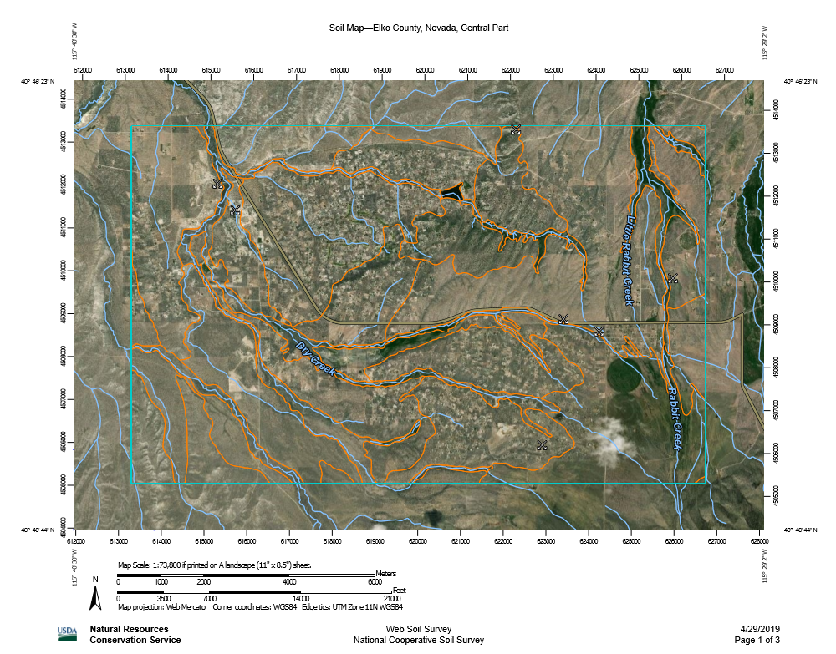

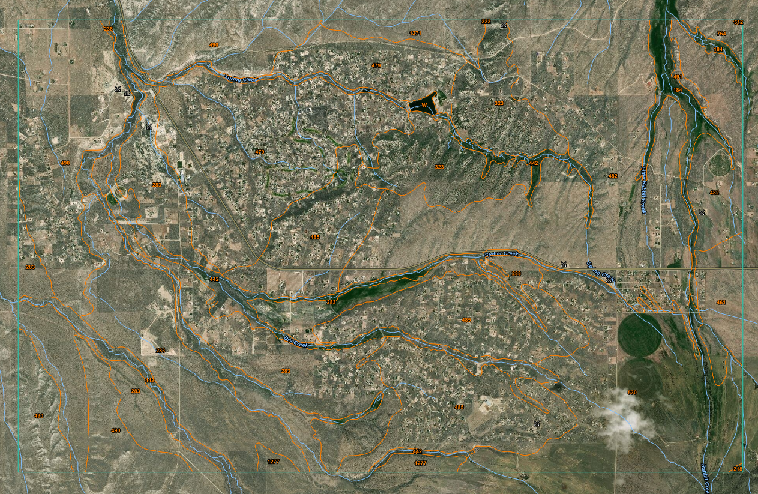

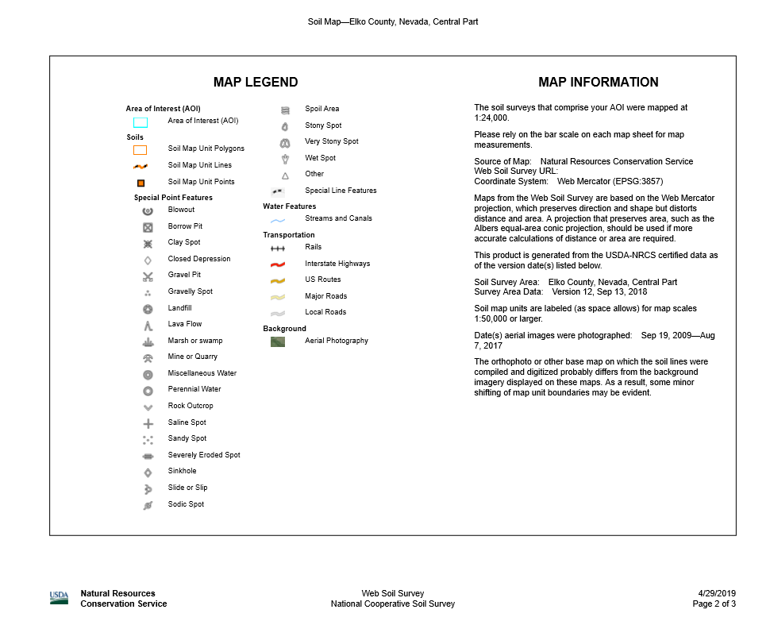

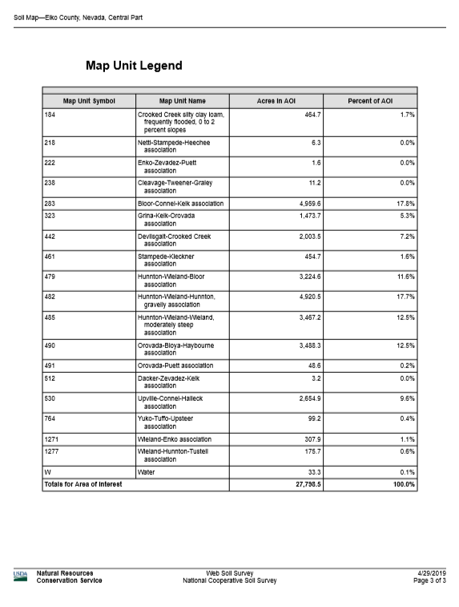

Appendix C: Most Prominent SCA Noxious Weeds

Russian Knapweed (Acroptilon repens)
Biology
Russian knapweed is a long-lived, relatively shade intolerant plant with a maximum height of about 3 feet. Widespread reproduction from seed is possible but seldom occurs. Most populations typically increase from vegetative reproduction by rapidly expanding lateral roots. Russian knapweed plants rapidly develop a large root system, reaching depths of 8 feet their first growing season and 23 feet their second growing season. A single Russian knapweed plant can produce about 1,200 seeds, but typical seed production is several hundred per plant. Most of the seed is viable for only 2 to 3 years, but a small percentage may remain alive in the soil for about 8 years.
Control
Russian knapweed typically invades degraded areas, dominating the plant community and desirable plants (e.g. perennial grasses). Seeding competitive, perennial grass species (cultural control) after Russian knapweed has been stressed by other control measures (set-up treatments) is essential. A single treatment that cuts Russian knapweed’s roots does not kill the plant and typically increases the number of new plants, therefore mowing is not an effective method of removal, unless it’s in conjunction with an herbicide treatment.

Herbicide | Application  timing | Comments
Glyphosate  (Round-Up) | Late summer or fall | Apply at late bud to flower stage. Repeated applications are required. Nonselective, kills desirable vegetation including lawn and trees. Use surfactant.

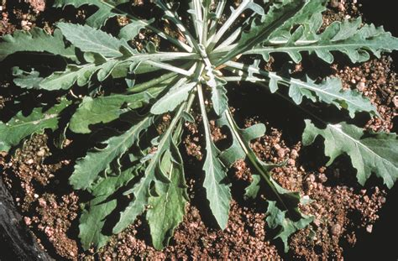
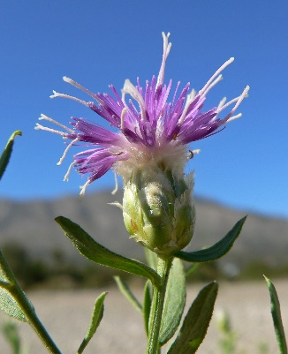
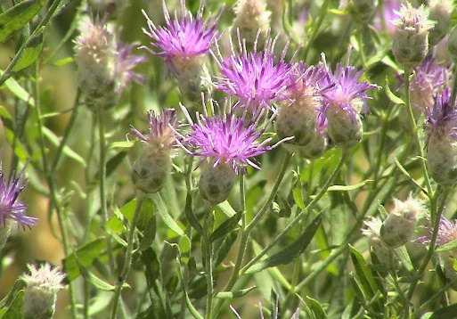

Spotted Knapweed (Centaurea maculosa)

Biology
Spotted knapweed is a perennial with several branched upright stems growing from a stout taproot; usually to 5 feet tall. Leaves become smaller as they advance up the stem; heads of pink to purple (sometimes white) flowers grow at the ends of the branches; excluding flowers, the heads are about 1/4" in diameter by 1/2" tall. Bracts around the flower heads have obvious vertical veins below the black triangular spot on the bract tip. It flowers continuously from early summer into the fall, as long as moisture and temperatures permit. Seeds can remain viable in the soil for up to 7 years.
Control
Landowners are advised to be watchful for spotted knapweed, and keep it in check while it is only along roads and not out in pastures. If not controlled, it can rapidly invade pastures and fields and cause a serious decline in forage and crop production. Once the plant blooms, herbicides are rather ineffective. The plants should then be pulled out of the ground, and landowners are advised to wear gloves to avoid skin irritation from the weed contact. Herbicides in the table below are effective at controlling spotted knapweed when used in a timely manner.
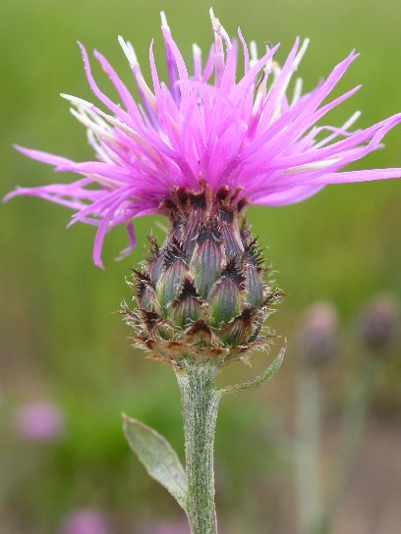
Herbicide | Application  timing | Comments
Glyphosate  (Round-Up) | Late summer or fall | Apply at bolting or flower bud stage. Repeated applications are required. Nonselective, kills desirable vegetation including lawn and trees. Use a surfactant.
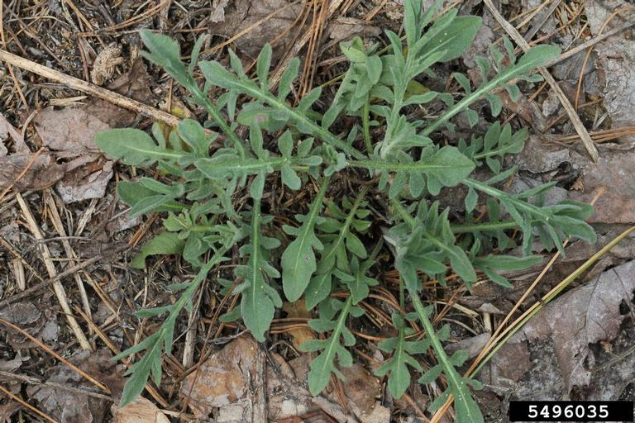
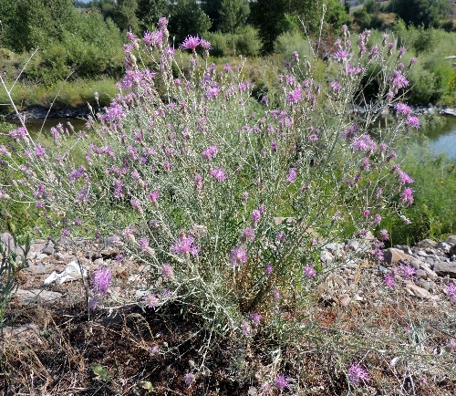

Hoary Cress (Carderia draba)

Biology
Hoary cress, commonly known as whitetop, is a creeping perennial that is a member of the mustard family and native to Europe. The stems, in the rosette stage, may grow up to 2 inches in height and produce grayish-green leaves that are lance-shaped. The leaves are alternate and 3/4 to 4 inches long. The upper leaves have 2 lobes that clasp the stem. The plant has numerous small, white flowers with 4 petals on stalks radiating from a stem. Seed capsules are heart-shaped with two small, flat, reddish-brown seeds. One plant can produce from 1,200 to 4,800 seeds. The plants emerge in early spring with stems emerging from the center of each rosette in late April. Hoary Cress flowers from May to June and plants set seed by mid-summer.
Control
Mechanical removal is strongly discouraged. Small, broken root fragments that are left behind will form a new plant that will produce many more plants. Mowing followed by an herbicide application on regrowth is likely the most feasible method of control. Where possible, shrub establishment may provide long-term suppression of whitetop colonies. Regardless of the control method, an intensive management process is required in heavily infested areas.

Herbicide | Application  timing | Comments
Glyphosate  (Round-Up) | Late spring, early summer | Apply at late rosette stage to flowering. Repeated applications are required. Nonselective, kills desirable vegetation including lawn and trees. Use a surfactant.
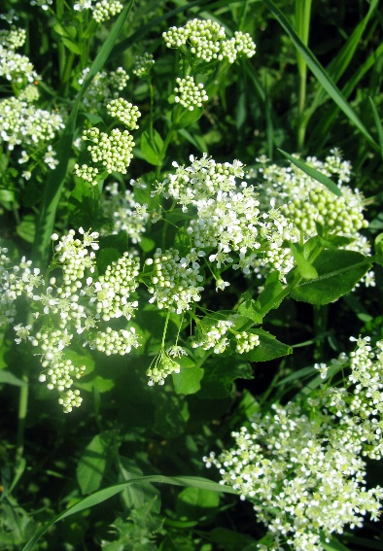
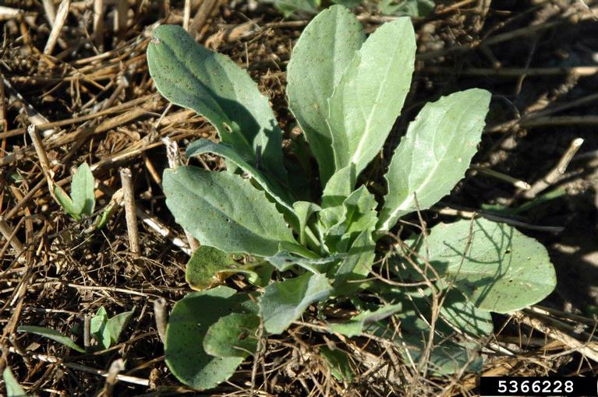
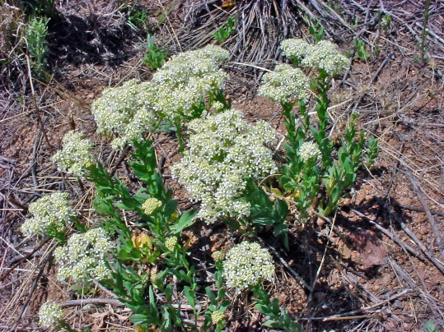

Perennial Pepperweed (Lepidium latifolium)

Biology
Perennial pepperweed is an extremely invasive perennial forb introduced from Europe and Asia in 1900 as a containment in sugar beet seed. Pepperweed reproduces both by seed and vegetatively by roots and shoots. Root fragments as small as 0.5 inches can grow into new plants. A serious threat, pepperweed alters ecosystems by acting as a “salt pump” absorbing salts from deep in the soil. The plant then excretes the salt through the leaves and deposits it on the surface soil. Since most desirable plants do not tolerate high saline concentrated soils, the entire plant composition, and diversity of the area changes.
Control
Eradication of perennial pepperweed is no longer an option in western North America, and control efforts for perennial pepperweed have been largely unsuccessful. Perennial pepperweed can store large amounts of resources in its roots and can sprout stems following cutting, grazing, or herbicide treatments. Therefore, early detection and quick removal of perennial pepperweed populations increases the probability of successful control. Disking alone is also not effective because new plants sprout from root fragments. Grazing with goats and sheep is most effective in long term suppression of perennial pepperweed if started before all perennial grasses are lost from the community.
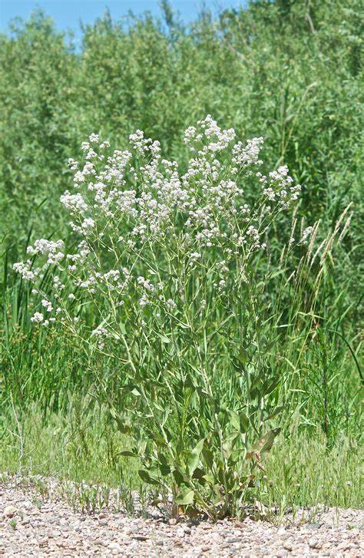
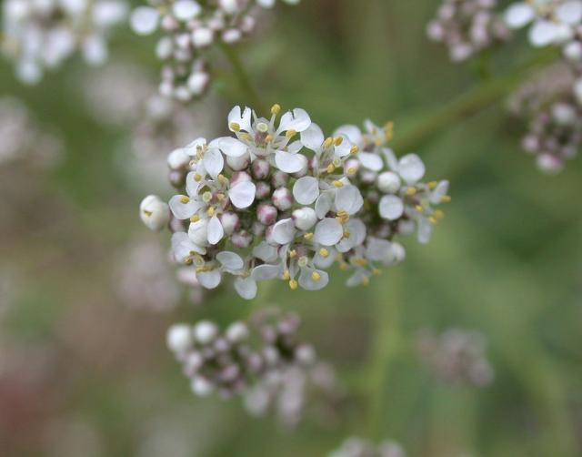
Herbicide | Application  timing | Comments
Glyphosate  (Round-Up) | Late spring, early summer | Apply at bud to early bloom stage. In established infestations, woody stalks from previous growing seasons will need to be removed prior to herbicide applications in order to achieve effective coverage. The site will need to be re-checked in the fall and any re-growth sprayed to achieve control. Nonselective, kills desirable vegetation including lawn and trees. Use surfactant.
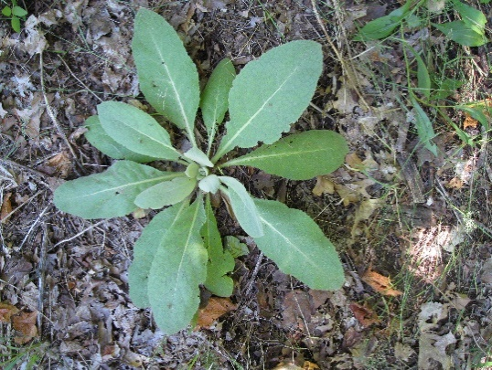

Scotch Thistle (Onopordum acanthium)

Biology
Scotch thistle is a non-native biennial forb that reproduces solely by seed. Scotch thistle is a branched, biennial or annual with a broadly winged stem that can grow up to 8 feet or more in height and 6 feet in width. During the first year of growth, Scotch thistle appears as a rosette in spring or fall. Rosettes can be 1 to 2 feet in diameter. During the second year in mid to late spring the stem bolts, flowers, sets seed, and the plant dies. A prolific seed producer, Scotch thistle can produce up to 14,000 seeds per plant. Infestations of Scotch thistle reduce forage production and virtually prohibit land utilization for recreation and any other type of use.
Control
As much as Scotch thistle information makes them out to be true monsters of the plant world, they’re surprisingly easy to control in a small scale, which is typically how you’ll find them in your yard. A few Scotch thistles won’t put up much of a fight, but make sure if you cut them down once they’ve started flowering to burn or bag that flower. Unlike most plants, Scotch thistle flowers can produce ripe seeds even after being severed from the stem.
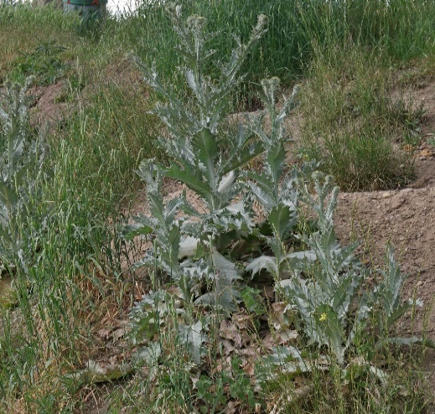
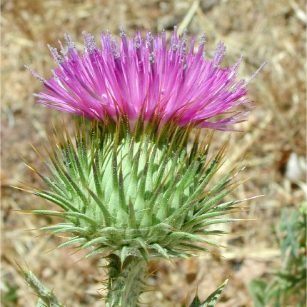
Herbicide | Application  timing | Comments
Glyphosate  (Round-Up) | Early spring or fall | Apply at rosette to bolt stage. In established infestations, woody stalks from previous growing seasons will need to be removed prior to herbicide applications in order to achieve effective coverage. The site will need to be re-checked in the fall and any re-growth sprayed to achieve control. Add a surfactant to herbicide. Nonselective, kills desirable vegetation including lawn and trees.
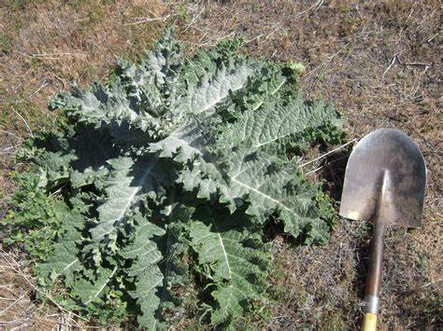

Canada Thistle (Cirsium arvense)

Biology
Canada thistle is a cool season perennial which spreads by seed and vegetatively by creeping roots. Canada thistle is an aggressive, creeping perennial weed that infests crops, pastures, rangeland, roadsides and non-crop areas. Generally, infestations start on disturbed ground, including ditch banks, overgrazed pastures, tilled fields or abandoned sites. Canada thistle is a colony-forming perennial forb from deep horizontal roots. Stems are 1 to 4 feet tall. Canada thistle differs from other thistles in that there are separate male and female plants. Purple flowers of 1/2 to 3/4 inch in diameter are produced during July or August. Seeds can survive burial in the soil for 20 years or more.
Control
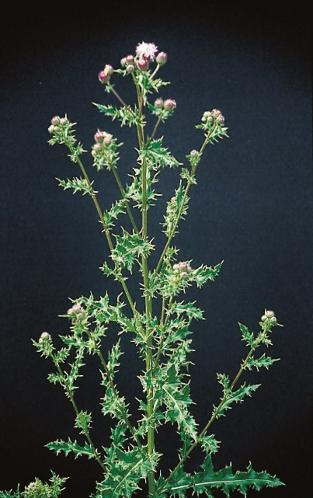
When starting a Canada thistle control program, it is best to first understand what makes Canada thistle such a difficult weed to control. Canada thistle grows on an extensive root system that can go quite deep into the ground, and the plant can grow back from even a small piece of root. Because of this, there is no one and done method of Canada thistle eradication. Whether you are controlling Canada thistle with chemicals or organically, you will need to do so repeatedly. The best time to treat Canada thistle with foliarly applied herbicides which move down through the plant is in early June after the first flower buds are formed and before the first flowers open and/or on fall regrowth during September and early October.
Herbicide | Application  timing | Comments
Glyphosate  (Round-Up) | Late spring to early summer | Apply at bud to early bloom stage. The site will need to be re-checked in the fall and any re-growth sprayed to achieve control. Add a surfactant to herbicide. Nonselective, kills desirable vegetation including lawn and trees.
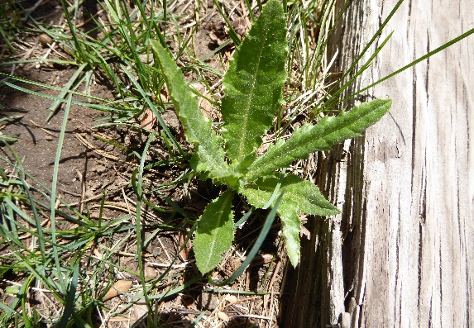
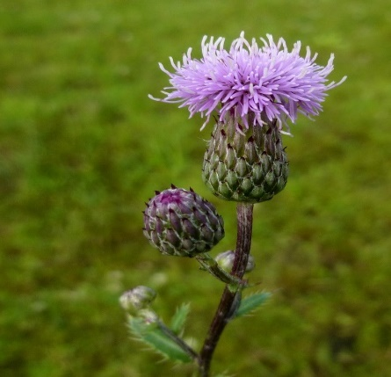

Medusahead (Taeniatherum caput-medusae)

Biology
Like cheatgrass, this is a winter annual grass. Height ranges from 6 to 24 inches tall and it has a seed head with long awns that are stiff and slightly barbed. The name medusahead is due to these wiry awns. The mature plant has a slender stem with narrow leaves. Roots can grow at cold temperatures and seeds mature quickly. Medusahead plants are rich in silica, and its litter breaks down more slowly than most other grass species.
The growth habit, life cycle, and adaptations of medusahead and cheatgrass are similar, and they often grow together. In some areas, medusahead out-competes cheatgrass to become the dominant vegetation. This has occurred on disturbed sites with clay soils that have high moisture-holding capacities.
Control
Treatment options for medusahead are somewhat limited, as any herbicide that will control one grass species will likely affect most other species. When herbicide is used, pre-emergent herbicide applications are commonly made in the fall, following controlled burns that remove the duff layer. It is very important to have a good re-vegetation plan in place following any chemical or mechanical (physical) treatment. In many cases where pre-emergent herbicide has been used, revegetation occurs about one year after the treatment.
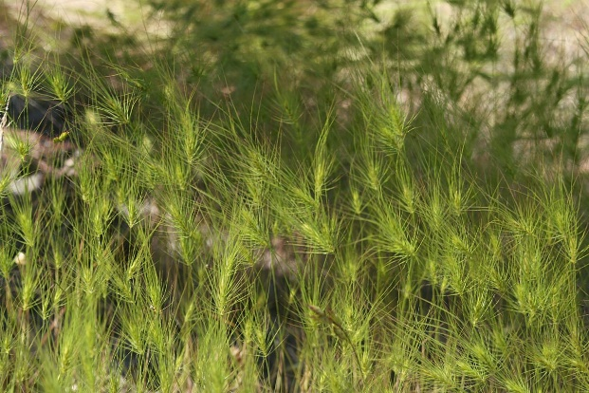
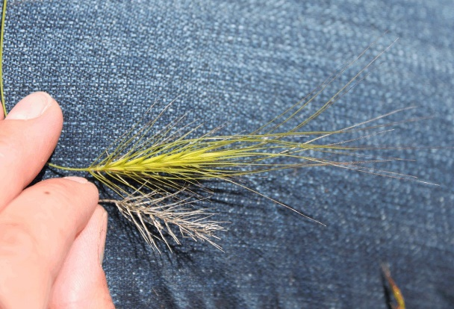
Herbicide | Application  timing | Comments
Glyphosate  (Round-Up) | Early to late spring | Apply before seed heads form. The site will need to be re-checked in the fall and any re-growth sprayed to achieve control. Add a surfactant to herbicide.
Imazapic  (Plateau) | Late summer to early fall | Apply before seed heads form. The site will need to be re-checked in the spring and any re-growth sprayed to achieve control. Add a surfactant to herbicide.

Dyer’s Woad (Isatis tinctoria)

Biology
Dyer’s woad is a non-palatable, aggressive weed with allelopathic properties (it produces chemicals which inhibit growth in other plants close by.) This invasive plant is a biennial mustard that grows up to 3 feet tall. The stem is waxy and varies in color from blue-to-purple green. The leaves are long and simple with prominent white veins. The yellow flowers have four petals and occur in clusters toward the top of the plant. The seed, its primary mechanism of spread, is ½ inch long, oval, flat, and black to brown. Each seed pod only contains one seed. This plant’s tap root makes it easy to control mechanically, but make sure to wear gloves whenever pulling any noxious weeds.
Control
The most effective control measure for dyer’s woad is prevention. Careful monitoring and sanitation, especially when moving animals or equipment from infested areas, are important. In established infestations, it is critical to prevent plants from producing seed to prevent further spread. Germination assays have shown that some seeds are capable of germinating even when the seedpods are still green. Similarly, plants treated with an herbicide during the flowering period may still produce some viable seed. Therefore, ensure that springtime control measures are in place before plants begin flowering.
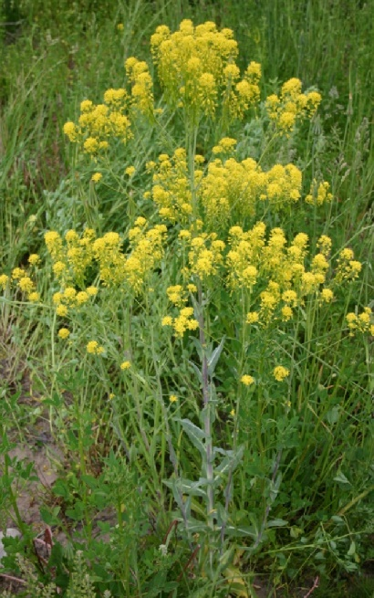
Herbicide | Application  timing | Comments
Glyphosate  (Round-Up) | Late spring to early summer | Apply to rosettes or early growth stage of plant. Nonselective, kills desirable vegetation including lawn and trees. Add a surfactant to herbicide.
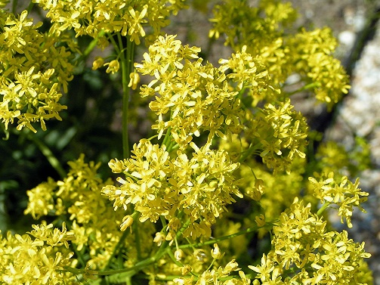
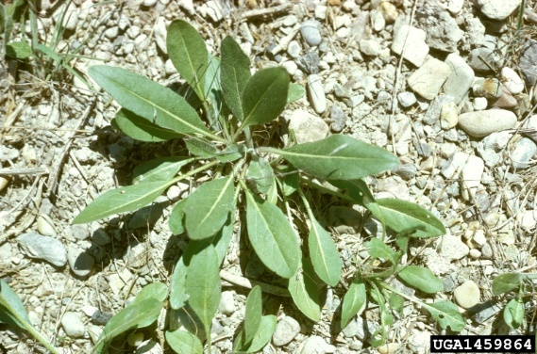

Black Henbane (Hyoscyamus niger)

Biology
Black henbane is an annual or biennial of the nightshade family that reproduces solely through seed production. Seeds germinate and develop into a rosette in late May. The plant grows 1 to 6 feet tall. It flowers from June to September, with peak flowering usually in July. The 5-lobed, funnel-shaped flowers are brownish-yellow in appearance with dark purple veins. Black henbane produces 10,000 to 500,000 seeds per plant. The plant has an unpleasant odor at all growth stages, especially when it is crushed. All parts of the plant are poisonous.
Control
Management objectives for black henbane control should involve preventing seed production and periodically monitoring populations. Field observations suggest the seeds of black henbane can remain viable in the soil for a period of five years; therefore, particular attention is required for several consecutive growing seasons to control newly emerging plants. Good vegetative cover of desired plants considerably reduces the chance of black henbane infestation.

Herbicide | Application  timing | Comments
Glyphosate  (Round-Up) | Late spring to early summer | Apply from rosette to bolting stage. Nonselective, kills desirable vegetation including lawn and trees. Add a surfactant to herbicide.

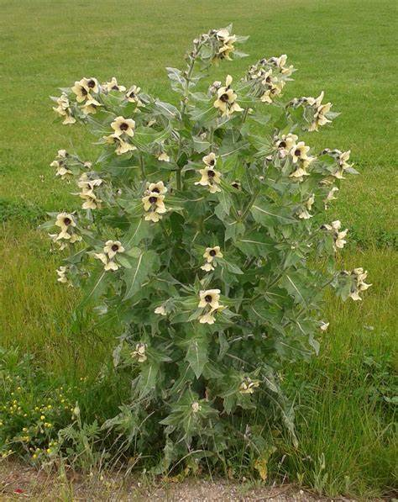
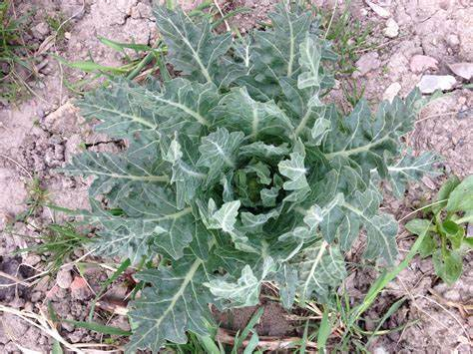
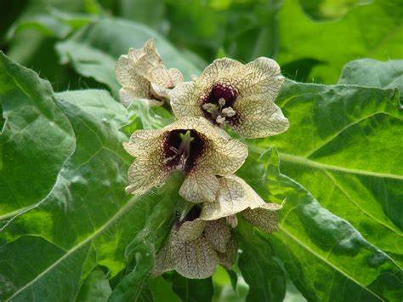

Leafy Spurge (Euphorbia esula)

Biology
Leafy spurge is a non-native deep-rooted perennial that spreads by seed and extensive, creeping roots. The roots can extend as deep as 30 feet into the soil and are extremely wide-spreading. Leafy spurge can grow from 1 to 3 feet in height. The stems are smooth, pale green, and thickly clustered. Leaves are narrow and 1 to 4 inches long. The flowers are very small and yellowish-green. The entire plant contains white, milky sap that exudes readily upon a stem or leaf breakage. This sap can damage eyes and sensitive skin. Leafy spurge is one of the earliest plants to emerge in the spring. Flower clusters develop 1 to 2 weeks after stem emergence which is from mid-April to late May. One large leafy spurge plant can produce up to 130,000 seeds. Three-sided seed capsules explode when ripe and project the seeds up to 15 feet away from the parent plant.
Control
Leafy spurge is difficult to manage and can recover from almost any control effort. Therefore, a management scheme that combines control methods over four to five years is recommended. Even after that time, monitor infestations for recurrence and adopt a maintenance program. For optimum leafy spurge control, proper timing of herbicide application is imperative.
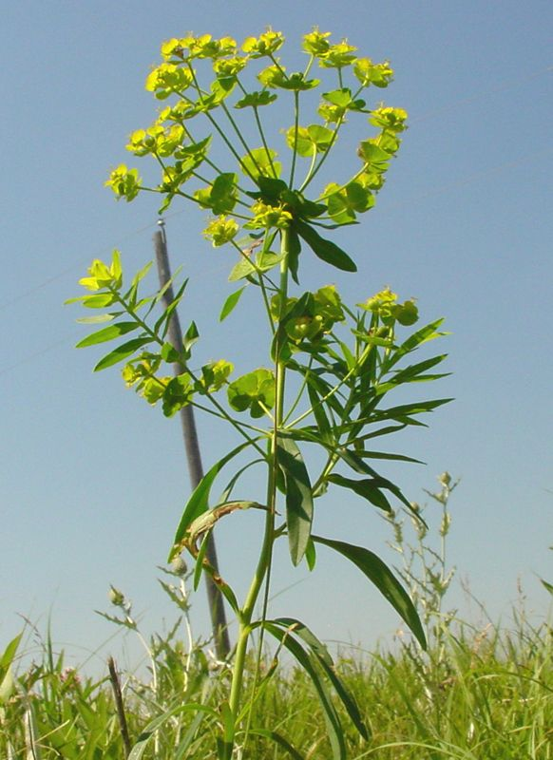
Herbicide | Application  timing | Comments
Glyphosate  (Round-Up) | Late spring to early summer | Apply at flowering growth stage. A subsequent treatment one month after initial treatment is recommended. Nonselective, kills desirable vegetation including lawn and trees. Add a surfactant to herbicide.
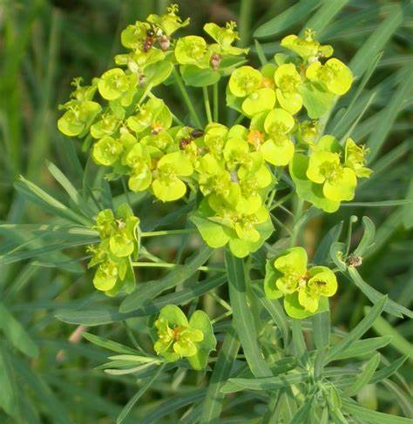
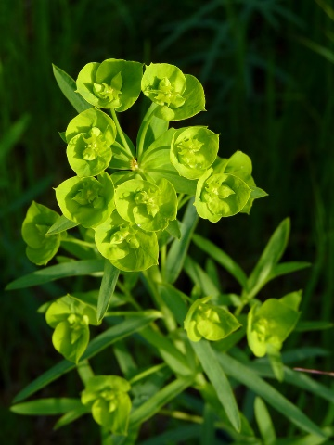

Ventenata (Ventenata dubia)

Biology
Ventenata is a nonnative, invasive, annual grass that has rapidly expanded in perennial grass systems, in disturbed areas and managed areas in the past two decades. Ventenata is a basally branched, tufted winter annual grass that has rolled or folded leaves. The plant’s stems are slim, upright and 4 to 18 inches tall, though they can grow up to 29.5 inches tall. Ventenata grows in a variety of dry, open and often disturbed habitats, tending to prefer sites that are inundated in early spring but dried out by late spring. It is commonly found on south-facing hillsides with shallow, rocky clay soils.
Control
Ventenata can be difficult to eradicate, and an integrated approach will be needed for effective control and to promote and support healthy communities. It is important to prevent spreading Ventenata to new locations. When working around this grass, make sure to clean equipment and clothing to prevent dispersing seed to new locations. Due to at least some seed surviving in the seedbank up to 3 years, at least 3 to 4 years of intensive integrated management methods will be needed to reduce effects on grass systems.

Herbicide | Application  timing | Comments
Glyphosate  (Round-Up) | Early to late spring | Apply before seed heads form. The site will need to be re-checked in the fall and any re-growth sprayed to achieve control. Add a surfactant to herbicide.
Imazapic  (Plateau) | Late summer to early fall | Apply before seed heads form. The site will need to be re-checked in the spring and any re-growth sprayed to achieve control. Add a surfactant to herbicide.
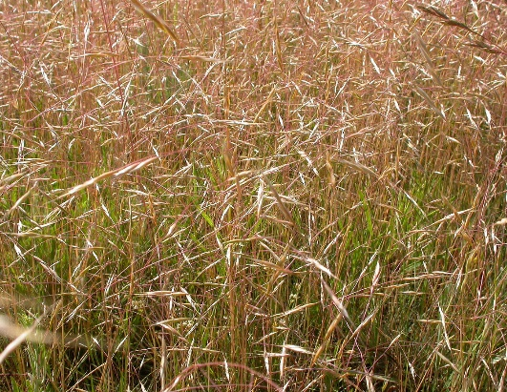
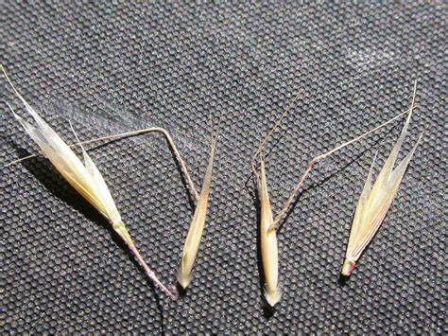
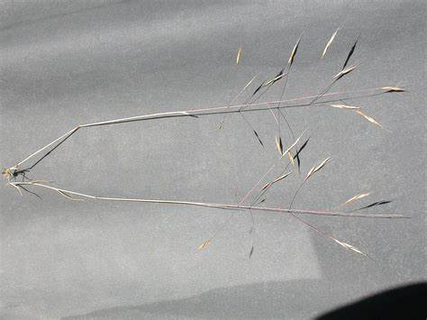

Burr Buttercup (Ranunculus testiculatus)

Biology
Bur buttercup is a winter annual that emerges, flowers, and forms fruits in the spring, when temperatures climb into the 45 to 50-degree range. It reproduces only from seeds. Bur buttercup can flower within 3 weeks of first leaf emergence. Plants often occur in dense mats that cover large areas of the ground. Bur buttercup has a small root system. The stem is short and leafless, growing 2 to 3 inches tall. Leaves are divided into fingerlike segments resembling a birds foot and are covered with fine hairs. Leaves are 2 to 5 inches long. Flowers are small (less than a quarter inch long), yellow, and 5-petaled. At maturity each flower develops into a bur 1/2 to 3/4 inch long that dries and turns brown.
Control
Bur buttercup does not compete well with established grasses. Planting competitive grasses or other cover crops can control bur buttercup. Cultivation such as hoeing, pulling, digging, or tillage can also work if it can be done before seed production.

Herbicide | Application  timing | Comments
Glyphosate  (Round-Up) | Late March to early April | Apply at rosette stage before flower develops. Nonselective, kills desirable vegetation including lawn and trees. Add a surfactant to herbicide.
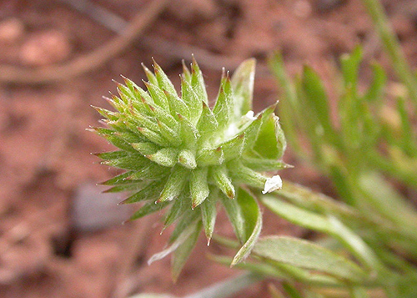
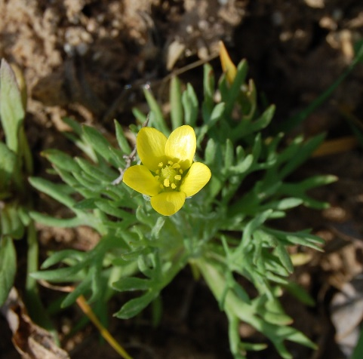
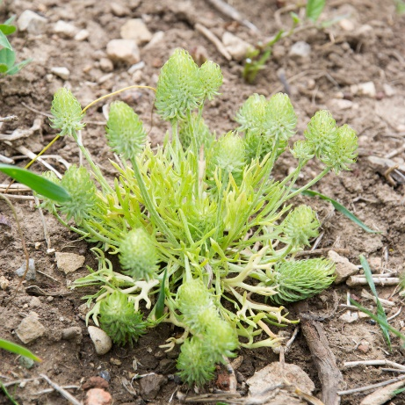

Poison Hemlock (Conium maculatum)

Biology
Poison hemlock grows throughout the United States. It is very toxic to livestock and other domestic animals can be poisoned by eating small amounts of green or dried plant. It is also extremely poisonous to humans. Poison hemlock is a biennial herb with hollow, purple spotted stems that can reach eight feet in height. Plants begin as a rosette of fern-like leaves and flower in the second year of growth. The small, white flowers are borne in umbrella-shaped clusters. A single poison hemlock plant can produce over 30,000 seeds. These seeds can adhere to recreational vehicles, fur and clothing, as well as be carried by water, and to a limited extent, wind. Poison hemlock is capable of rapid establishment, particularly in disturbed sites.
Control
Because of the high toxicity of the plant to humans, hand-pulling and mechanical removal is not recommended. Seed dispersal generally occurs when the plants are mowed. The key to the chemical control of poison hemlock plants in any setting is to apply the herbicide when plants are young and in the rosette stage of growth, rather than when bolting and stem elongation has occurred. Once the central stems are present that will eventually support flower and seed production, control of these plants with any herbicide is likely to diminish.
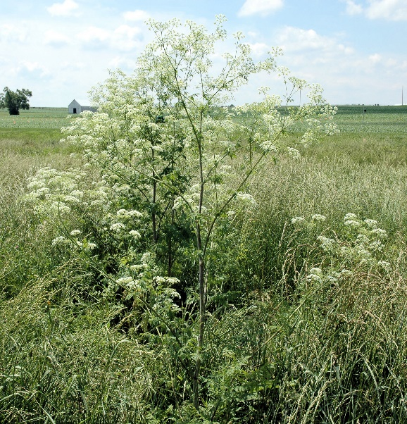
Herbicide | Application  timing | Comments
Glyphosate  (Round-Up) | Late spring to early summer | Apply at young rosette stage before plants bolt. Nonselective, kills desirable vegetation including lawn and trees. Add a surfactant to herbicide.
