**

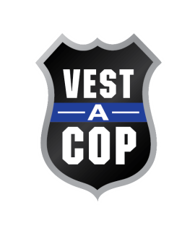VEST-A-COP

7th ANNUAL GOLF OUTING

|  |
| --- |
| Monday, May 12, 2025 at Rock Manor, Wilmington, DE  *Proceeds benefit Vest-A-Cop, to provide bulletproof vests to police officers*  *4 Man Scramble – Best Ball* |

Thank you for your support. Should you have any questions, please feel free to contact either

Marc Hanly at [mhanly@vestacop.com](mailto:mhanly@vestacop.com) – 484-840-3621 or

Carole Nasella at [cnasella@vestacop.com](mailto:cnasella@vestacop.com) – 610-637-1179.

_______ **Level III Sponsor - $2,000.00** includes: 2 Foursomes, Name/Logo on the website and social media, 4 hole signs. Banner at lunch

________ **Level II Sponsor-** **$1,000.00** includes: 1 Foursome, Name/Logo on the website and social media, 2 hole signs - Banner at lunch

________ **Level I Sponsor - $750.00** includes: 1 Foursome, Sign at putting green or driving range.

________ **Blue Line Sponsor - $500.00** includes**:** CompanyName/Logo on website and social media; 1 hole sign

________ **Players Award Sponsor - $500.00** includes: Name/Logo on website; Signage on podium

________ **Hole Sponsor - $150.00** includes: Name/Logo on signage at tee box

SPONSORSHIP NAME TO BE DISPLAYED:_________________________________________________

(If applicable, please e-mail your logo to [cnasella@vestacop.com](mailto:cnasella@vestacop.com))

**ALL SPONSORSHIP FORMS MUST BE RETURNED BY MAY 1, 2024**

**Checks payable to Vest-A-Cop and mailed to P.O. Box 461, Ridley Park, PA 19078**