12/9/2017 The Transiting of Jerusalem and the Sun

The 100th anniversary of First Viscount Allenby entering Jerusalem on foot as a conqueror releasing Jerusalem from 400 years of Muslim rule will occur on 12/11/2017. General Allenby's act was symbolic of the arrival of Israel's Messiah King.

First Viscount Allenby entered Jerusalem from the west. Israel's Messiah will enter Jerusalem from the east after passing over Mt. Sinai, the land of Edom, and descending from the sky over the mount of Olives just east of Jerusalem as a massive earthquake shakes the land.

Precisely 200 years after General Allenby entered Jerusalem the planet Venus is scheduled by our Creator Elohim to transit the sun. Transits of the sun by Venus are relatively rare events. The last transit of Venus occurred on 6/5-6/2012, the 45th anniversary of the beginning of the Israeli Six Days War on 6/5/1967 in which Israel took sovereign control of Jerusalem again after over 2,000 years of occupation and control by foreign powers. The next transit by the planet Venus will occur over 105 years after 6/5/2012 on 12/11/2117.

Below is a graphic that indicates the timing relationships of these two rare transit events and the central date of 12/11/2017:

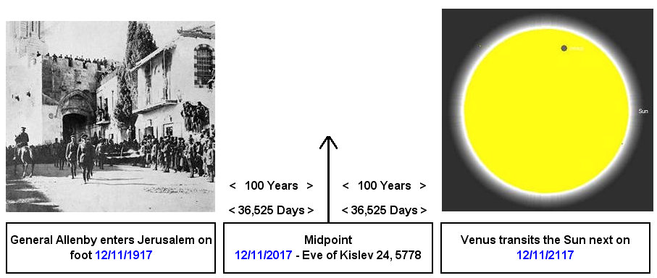

Another rare event concerning the city of Jerusalem was the announcement by President Donald Trump on 12/6/2017 that the United States would move its embassy from Tel Aviv to Jerusalem. This announcement on 12/6/2017 by President trump was ordained by YaHuWaH Elohim.

The signature of YaHuWaH Elohim is evident in the timing of the announcement, as there were exactly 26 weeks (26 x 7 days) from the 50th anniversary of the taking of Jerusalem on 6/7/2017 to the announcement of the Embassy move by President Trump on 12/6/2017.

Below: The signature of YaHuWaH Elohim is equivalent to the number 26 in Hebrew.

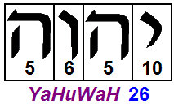

Below: The signature of YaHuWaH Elohim in ancient pictorial Hebrew from the time of Moses:

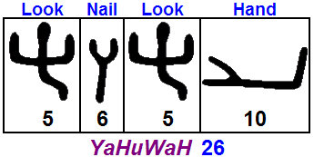

The ancient Hebrew Name of YaHuWaH Elohim above is read from right to left and means "look at the nail print in My hand".

Quadrature

We can further divide the 200 year graphic of General Allenby and the Sun far above into four equal 50 year parts and arrive at the additional dates of 12/11/1967 and 12/11/2067.

The 12/11/1967 date is exactly 187 days after the taking of Jerusalem by Israel in the Six Days War on 6/7/1967. The 187 days reduces to 180 days + 7 days. 180 days is exactly 1/2 of a prophetic year.

Jerusalem was taken by Israel during the 50th year from 12/11/1917 when First Viscount Allenby entered the city. There were 49 years, 5 months, and 27 days from 12/11/1917 to 6/7/1967.

