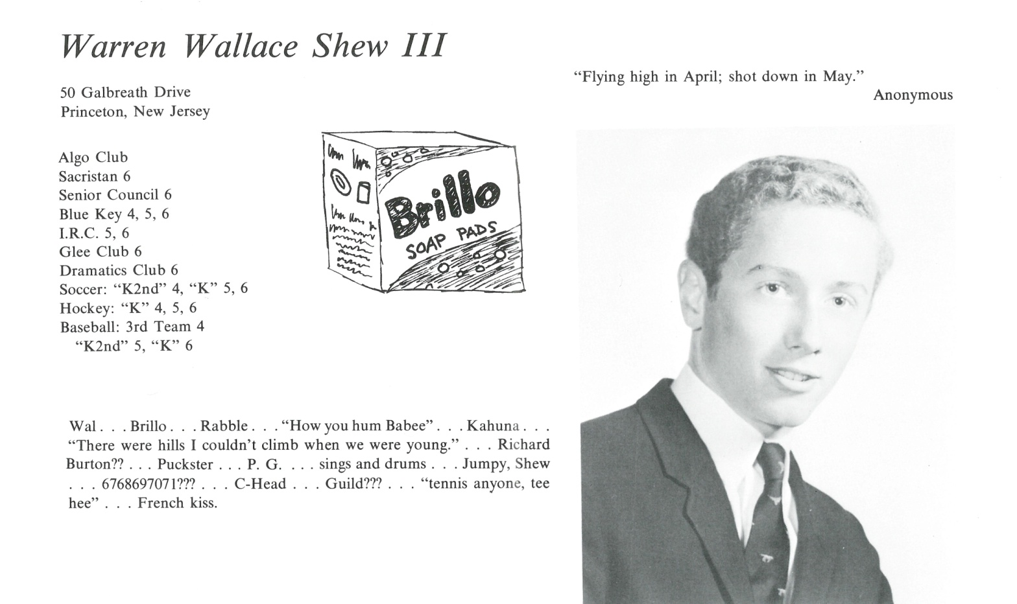

Warren W. Shew III

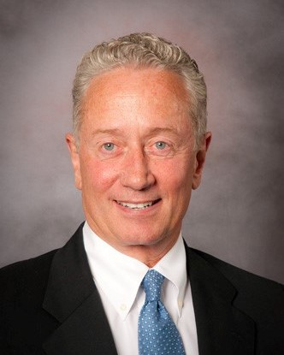So happy to be with you all! We shared a unique experience together and are forever bonded by it.

After a PG year at Kent, I attended Bowdoin until I ran into a little problem with a Shakespeare course half way through my junior year. That led to a four-year working experience and a calling to the restaurant business, leading me to the Hilton College at The University of Houston to complete my B.S in 1977.

A job transfer to Chicago led to marriage and working for Bennigan’s in the early 80’s. And that led to the first of three children and owning my own restaurant in 1987. I left the business in 2008 after 21 years serving the many. And now I work in financial services with my old advisor of 25 years.

Greatest accomplishment; my three kids. Kirstin, Warren IV and Eric are all I could ask for, so proud. Though we all still have work to do to become the best version of ourselves, I am filled with gratitude for all that has been given.

To the future!



______________________________________________________________

______________________________________________________________ ______________________________________________________________ ______________________________________________________________ ______________________________________________________________ ______________________________________________________________ ______________________________________________________________ ______________________________________________________________ ______________________________________________________________

Attach Picture in .jpg Format

______________________________________________________________

______________________________________________________________

___________________________________________________________________________________ _________________________________________________________________________________________________________________________________________________________________________________________________________________________________________________________________________________________________________________________________________________________________________________________________________________________________________________________________________________________________________________________________________________________________________________________________________________________________________________________________________________________________________________________________________________________________________________________________________________________________________________________________________________________________________________________________________________________________________________________________________________________________________________________________________________________________________________________________________________________________________________________________________________________________________________________________________________________________________________________________________________________________________________________________________________________________________________________________________________________________________________________________________________________________________________________________________________________________________

___________________________________________________________________________________