Mars UP Church
Come Holy Spirit, Come
Before the Service – Speak to God!
During the Service – Let God speak to you!
After the Service – Speak to each other!

(*Please stand, if able)
Welcome and Mars Messages

Prelude

Apostles’ Creed
I believe in God the Father Almighty, Maker of heaven and earth; and in Jesus Christ His only Son our Lord; who was conceived by the Holy Ghost, born of the Virgin Mary, suffered under Pontius Pilate, was crucified, dead and buried; He descended into hell; the third day He rose again from the dead; He ascended into heaven, and sitteth on the right hand of God the Father Almighty; from thence He shall come to judge the quick and the dead. I believe in the Holy Ghost, the holy catholic church; the communion of saints; the forgiveness of sins; the resurrection of the body; and the life everlasting. Amen.

Gloria Patri
Glory be to the Father, and to the Son, and to the Holy Ghost. As it was in the beginning, is now and ever shall be,
world without end.
Amen. Amen.

The Call to Worship

Leader: Praise the Lord! Praise the Lord, O my soul!

People: We will praise the LORD as long as we live;
we sing praises to God all lifelong.

Leader: Happy are those whose help is God, whose hope is
in the LORD their God,

People: God made heaven and earth, the sea, and all
that is in them; God keeps faith forever;

Leader: The LORD opens the eyes of the blind. The LORD
lifts up those who are bowed down;

People: The LORD watches over the strangers; and
upholds the orphan and the widow,

Leader: The LORD will reign forever

People: The LORD reigns for all generations. Praise
the LORD!

Pastoral Invocation

*Hymn 11
“Come, thou Fount of Every Blessing”

Passing of the Peace
The
Lord’s Prayer

Our Father,
who art in heaven,

hallowed be Thy
name,

Thy kingdom come,
Thy will be done,
on earth
as it is in heaven.

Give us this day
our daily bread;

and forgive us
our debts,
as we forgive
our debtors;

and lead us not
into temptation,
but deliver us
from evil.

For Thine
is the kingdom,
and the power,
and the glory,
forever. Amen.

The Doxology

Praise God
from whom
all blessings flow;
praise Him
all creatures
here below;
praise Him above,
ye heavenly host;
praise Father, Son,
and Holy Ghost.
Amen.

Leader: May the peace of Jesus Christ, the love of God, & the fellowship of the Holy Spirit be with you all.
People: and also with you

Children’s Chat

Offering
*Doxology

*Hymn 431 “Shine, Jesus Shine”

Scripture 1 Timothy 6:6-19
Luke 16:19-31

Morning Message Rev. Brian Hauser
“A Christmas Carol”

Baptismal Hymn Michael Berg
“Bless this Child”

The Sacrament of Baptism
Holland Jean Medsger
Daughter of Bradley and Hannah (Govan) Medsger
Born July 10, 2022

Affirmation of Faith Apostles Creed

Prayers of the People and Lord’s Prayer

*Hymn 562
“Be Thou My Vision”

*Benediction

*Postlude

MUP Session

Class of 2024 Class of 2023 Class of 2022
Alma Staskiewicz Lisa Barbour Mike Bocheff
Louise Fox Mary Ann Croop Sally Olsen
Marie Matthews Don Lewis Susan Cox
Herb Wellman Linda Lees

Clerk of Session: Herb Wellman

MUP Deacons

Class of 2024 Class of 2023 Class of 2022
Steve Martin Sharon Gibbs Jay Wilson Nancy
Marge Nicklas Carol Kopar Jenny Ivory
Pat Auld Alice Leonberg Pat Jackson

Moderator: Steve Martin

Church Staff
Rev. Brian Hauser
Pastor
pastor@mars-up.org
724-689-3412

Mrs. Shelly Bocheff
Administrative Assistant
marsup@mars-up.org

AV TEAM
Alma Staskiewicz, Lisa Barbour, Marie Matthews, Bill Guesman, John Ivory, Keith Nichols, Mike Bocheff, Herb Wellman

Mars United Presbyterian Church

232 Crowe Ave
PO Box 805
Mars, Pennsylvania 16046
724-625-1365
www.mars-up.org
marsup@mars-up.org

Church Office Hours:
Mon -Thurs from 9 a.m. -2:30 p.m.
MUP Music Committee
Keith Nichols – Chair
Sally Olsen – Clerk
Alma Staskiewicz
John Ivory
Linda Lees
Karl Kennedy

Mars United Presbyterian Church
Morning Worship:
10:00 am

16th Sunday after Pentecost

Prayer of Preparation
Lord, we come to you today with so many things on our hearts.

You call us to be in relationship of trust and love with you and you offer healing to us for those portions of our lives that are broken and injured.

Help us to be open to your mercy and healing love. For we ask this in Jesus’ Name.
AMEN.

Welcome!

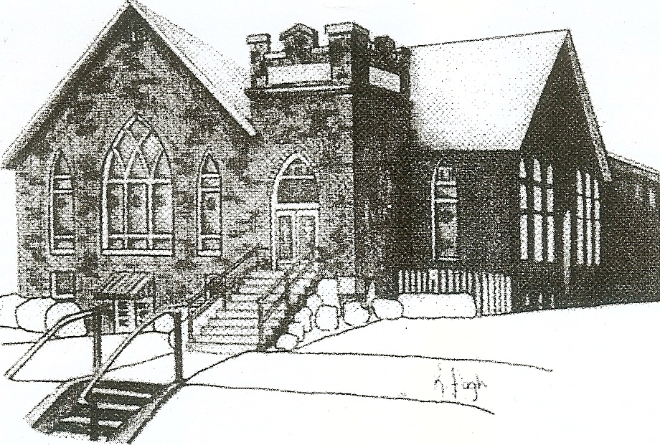
We are your hometown church: Faithful to Tradition, Loving in Fellowship, & Reaching for Tomorrow!

September 25, 2022

We welcome you and we are glad you’ve chosen to Worship with us today!

CALENDAR: Sept 25th, 2022 – Oct 2nd, 2022

Church Office Hours: Monday -Thursday from 9 a.m. – 2:30 p.m.

Today, September 25, 2022
VOLUNTEERS☺

LAST SUNDAY’S In-House ATTENDANCE: 44

LAST SUNDAY’S OFFERING:
Operating Funds: $5335.00
Mission.: $10.00
Kindness: $290.00
Youth Group: $30.00
Total: $5665.00

Tarry N Talk Hosts
Stewardship Committee
9:00 a.m. Sunday School Hour
10:00 a.m. THE MORNING WORSHIP SERVICE
Monday, September 26, 2022
6:30 pm Griefshare
Tuesday, September 27, 2022
9:00 am A team
4:00 pm BBP Meeting/Dinner
Wednesday, September 28, 2022
9:00 am Material Girls
Thursday, September 29, 2022
Friday, September 30, 2022
Saturday, October 1, 2022
10:00am Mars Applefest
Sunday, October 2, 2022
9:00 am Sunday School Hour
10:00 am THE MORNING WORSHIP SERVICE
1:00 pm Youth Group
Welcome to all who are Worshiping with us today!
Guests
We sincerely hope our service is a blessing to you. We ask that our guests please take a few minutes to complete one of the Connect Cards found in the pew holder.

Should you have questions regarding any aspect of our church, including membership, please contact Pastor Brian or the church office during the week at 724-625-1365. Thank you for being with us today.

PRAYER – JOYS & CONCERNS

Patty Jackson Paige Barbour (daughter of Andrew and Steph Barbour
Reid Christopher Hall (June Stirling’s nephew) Isabel Boynton
Lindy McCartney (Lisa Barbour’s Sister)

ANNOUNCEMENTS
Bulletins are printed Thursday mornings; let us know if you have an announcement…

MISSION FROM MARS Our Youth Group will be packing bags on Saturday, October 8th from 9:30am until 12 noon. These bags will be handed out through the Mission From Mars organization to help homeless and low income families in the Pittsburgh Area. Most items have already been collected, but there is a need for the following items should you wish to donate them: deodorant, peanut butter, toilet paper. Items can be donated from now until September 25th by placing them in the plastic container in the Tarry N talk labeled Mission From Mars. (We will be packing 100 bags)

NEW KIDS CLUB Calling all 2nd – 5th graders!! Mars UP Church and St. John Lutheran Church are hosting a New Kids Club. Starting Sunday, October 2nd at 1:00 until 2:30pm Kids of the Mars area will have time with old and new friends as they play, learn, and grow in their faith. Kid’s club will meet twice per month. For more info, please see Pastor Brian or contact the office at 734-625-1365

APPLEFEST will again be held in Mars on the 1st Saturday of October, this year it is October 1st. This is an important event in our community and has always been an exciting opportunity for MUP to be involved in. Christian Education/Mission and Outreach is the committee tasked with spearheading the effort, but many, MANY hands are needed for this effort to be a success! Applefest is officially from 10:00 am to 4 pm on Saturday, October 1st, but we need people to help with set up and clean up as well as help during the actual Applefest hours. This year we will once again share out booth with My School Preschool volunteers. They will have a craft for children. We will be making our (famous) walking tacos and the ever-popular pixie stix.
PLEASE SEE THE SIGN-UP SHEET IN THE TARRY ‘N TALK AREA TO VOLUNTEER SOME OF YOUR TIME. If you have any questions, please see committee members Lisa Barbour, Susan Cox, Don Lewis or Pastor Brian.

