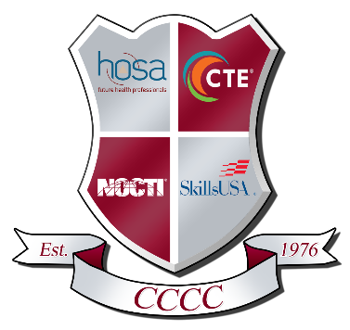

447 Career Lane Shippenville, PA 16254
814.226.4391 Fax 814.226.7350

Strategic Planning Collaboration
Agenda
August 26, 2024
Room 108

- Call Meeting to Order
- Roll Call
- Enrollment 24/25
- Graduate Surveys (22/23 graduates)
- Potential New CTE Programs
  - Survey Results
  - Feasibility Study
  - Process for New Program
- PN Building
- Next Meeting
  - December 17, 2024 6pm
- Adjournment

