Gardeners know all the Dirt
As our natural world changes, we are becoming aware of the need for conservation and sustainability.

Garden Aurora promotes gardening with its positive effects for the individual, the community of Aurora, and the environment.

Since its foundation in 1918, Garden Aurora promotes the joys of gardening.

Garden Aurora offers the community an Annual Plant Sale, Garden Tour, Gardens of Distinction, an Educational Bursary, a Farmers Market Booth. As well as various workshops, and Community Activities.

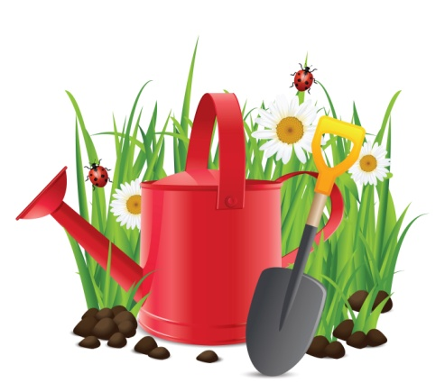

Monthly Meetings include:
Coffee, tea, and snacks
Second hand table
Announcement of Club Activities
Expert Speakers on a wide variety of topics
Flower Show and Competition
Printed Resources Available
Members often bring plants

Guests are welcome free of charge to all of our meetings.
Monthly meetings are held the 4th Wednesday of the month, By Zoom February and March.
In Person April- November (excluding August) at:
The Royal Canadian Legion
105 Industrial Parkway, Aurora, Ontario
(rear door, lower level)
Time: Arrive any time after 7:00 p.m. for coffee and social time, speaker from 8-9 with flower show viewing to follow

Find meeting details at:
www.gardenaurora.ca

Questions? Contact Us
Cindy Scythes 905-713-6660
E-mail: scythes.kavchak@sympatico.camailto:scythes.kavchak@sympatico.ca

Benefits of Membership
- Discount at local nurseries and related businesses
- Resources and education information
- Exchanging of plants with other members
- Meet a diverse group of members with a wide range of experience
- Social opportunities
- Volunteer opportunities to give back to the community
- Entry into floral and design competitions
- Entry into annual photography competition
- Share your passion for gardening; and your challenges
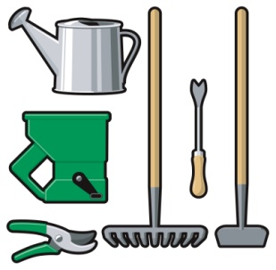

AGHS Membership Application
Please print
Name:_____________________________
Address:___________________________
City/Town:_________________________
Postal Code:________________________
Telephone:_________________________
E-mail:_____________________________
If you agree to receive emails from Garden Aurora, please sign here:_____________________________
How did you hear about Garden Aurora?
__ Friend, neighbour or co-worker
__ Website
__ Community Event
__ Community Advertising or Newspaper

Annual membership runs Jan to Dec
Single………………. $ 25.00
Family……………… $ 30.00

You can register at one of our monthly meetings using cash or cheque.
Or by mail with cheque (P.O. Box 71511, Aurora, ON, L4G 6S9.
Please make cheques payable to:
“Aurora Garden & Horticultural Society”

Aurora Garden & Horticultural Society is a member of OHA District 5



Ontario Horticultural Association (OHA) Affiliate Member of



©AGHS 2025


Also known as: Aurora Garden & Horticultural Society

Rooted in our town since 1918!

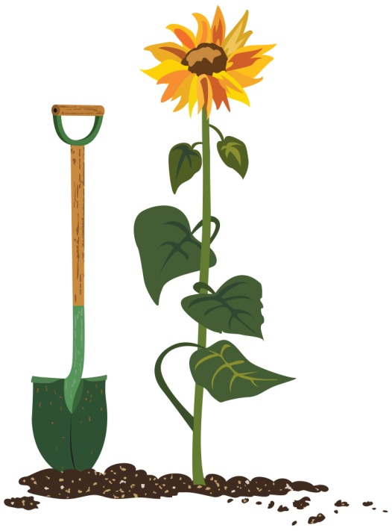

www.gardenaurora.ca

