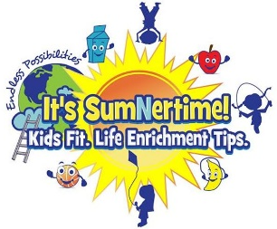
It’s Sumnertime Kids Fit Life Enrichment Tips LLC
2026 Summer camp field trips
TUESDAY’S Regal Movie and Splash Park!
NO SPLASH PARK 6/23, 8/18, or 8/25!
Glenn Dale Splash Park (Outdoor) or Rollingcrest-Chillum Splash Pool (Indoor)

If paying by cash, please seal envelope with the following written on the outside:

Camper’s Full name, week #, and days attending.
Weekly lunch (pizza-$8) must be paid by cash.
If paying Zelle, please include child’s Full name and week #.
Rate: (8:00am-4:00pm) $275 Mon.-Fri. Before Care: (7am-8am)- Additional $25 weekly.
Weekly Rate includes 3-4 weekly field trips. After Care: (4pm-5:30pm)- Additional $25 weekly.
------------------------------------------------------------------------------------------------
-Thursday and Friday Trips
- Week 1- 6/23 (Tuesday) Waugh Chapel Movie and Hyper Kidz in Crofton (Indoor Playground) ​
- Week 1- 6/25 Clemyjontri Park- McLean, VA
Rangers and Rockstars- Scramble in Alexandria
Superheroes and Champions- Immersive Gamebox Arlington
- Week 2- 7/2 Pirate Adventures on the Chesapeake and Mayweather Boxing Fitness
- Week 2- 7/3 CAMP CLOSED FOR HOLIDAY
- Week 3- 7/9 Climb Zone-Laurel and Discovery Community Park
- Week 3- 7/10 Stead Park in NW DC
Rangers and Rockstars- National Children's Museum in NW DC
Superheroes and Champions- Spy Museum in SW DC
​- Week 4​- 7/16 Rangers and Rockstars- Skate Zone- Crofton and Allen's Pond Park
Superheroes and Champions- Skate Zone- Odenton and Allen's Pond Park
- Week 4- 7/17 Rangers and Rockstars- Chuck e Cheese- Kensington and Wells Neighborhood Park
Superheroes and Champions- Activate White Marsh and Angel Park in Perry Hall
- Week 5- 7/23 ​Funbox, Allen's Pond Park, and Mayweather Boxing Fitness
- Week 5- 7/24 Sky Zone- Gambrills and Watkins Park
- Week 6- 7/30 Blandair Regional Park North and Hyper Kidz in Columbia (Indoor Playground)
- Week 6- 7/31 Get Air Trampoline Park in Alexandria, VA
- Week 7- 8/6 Rangers and Rockstars- Be With Me Playseum in Columbia and Watkins Park
Superheroes and Champions- Wonderfly Arena-Arbutus
- Week 7- 8/7 Rangers and Rockstars- Kids Empire and Harmans Park Playground in Hanover
Superheroes and Champions- Dodge Arrows- Annapolis ​
​- Week 8- 8/13 Blandair Park West and Main Event in Columbia
- Week 8- 8/14 Rangers and Rockstars- Play EC in Capitol Heights and Westphalia Community Park
Superheroes and Champions- Mayweather Boxing and Beat the Bomb
- Week 9- 8/18 ​(Tuesday) Watkins Park and Sky Zone- Bowie
- Week 9- 8/20 Fairwood Park and LOL Stations (Laugh Out Loud)- Laser Tag, Skating, Moon Bounces, 360 Tumber, Bumper Cars, Playground, Mini Coaster, VR
- Week 10- 8/25 (Tuesday) ​Hyper Kidz in Columbia (Indoor Playground) and Blandair Park West
- Week 10- 8/27 ​Buddy Attick Lake and Urban Air Trampoline and Adventure Park- Laurel

Please Complete ALL Field Trip Waivers that are needed for your child.

Rangers and Rockstars (Ages 3.5-7)
- Hyper Kidz- Crofton Waivers
- Scramble Waiver | Scramble Play Group
- Climb Zone Waivers
- Funbox Waivers (Use itssumnertime@gmail.com)
- Sky Zone (Crofton-Gambrills) Waivers
- Hyper Kidz-Columbia- Waivers
- Get Air Trampoline Park- Alexandria, VA GetAir Waiver
- Kids Empire Gravity Online Service
- Play EC Waiver
- Sky Zone Bowie Waivers
- Laugh Out Loud Stations- Greenbelt- Liability Waiver - New Guest
- Urban Air- Laurel- Laurel, MD - Urban Air

Super heros and Champions (Ages 8-14)
- Hyper Kidz- Crofton Waivers
- Climb Zone Waivers
- Activate White Marsh Online Waiver
- Funbox Waivers (Use itssumnertime@gmail.com)
- Sky Zone (Crofton-Gambrills) Waivers
- Hyper Kidz-Columbia- Waivers
- Get Air Trampoline Park- Alexandria, VA GetAir Waiver
- Wonderfly Arena -Arbutus Wonderfly Arena Waiver | WaiverFile
- Dodge Arrows https://ewaiverpro.app/s/hMIBCW7k
- Beat the Bomb Waiver - Beat the Bomb
- Sky Zone Bowie Waivers
- Laugh Out Loud Stations- Greenbelt- Liability Waiver - New Guest
- Urban Air- Laurel- Laurel, MD - Urban Air

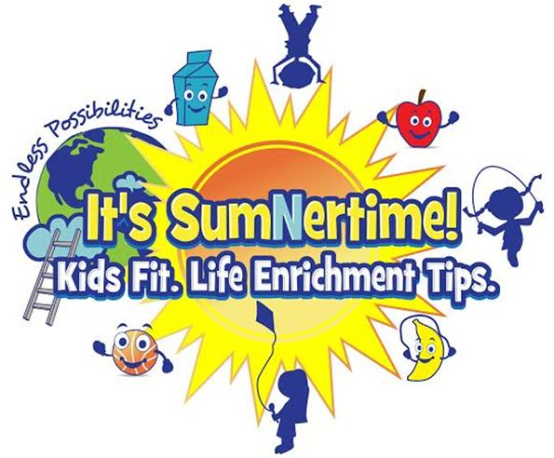
“IT’S SUMNERTIME!”

Name tags: We are on a first-name basis. Respect commands respect. Everyone will receive a nametag on Mondays, or on your first day of camp.

Jewelry: At camp, jewelry should be kept to a minimum, and watches should be waterproof. Primarily, jewelry is unsafe in the camp environment. Earrings should be studs and it is preferred that campers not wear necklaces that could be snapped during play.

Shirts: Every camper will need to purchase a Sumnertime t-shirt ($15.00) to wear on all field trip days.
Shorts: Athletic shorts or loose sweatpants should be worn daily. They should not be torn, cut-off, frayed, too short, or restrict your movement in any way.

Field Trips: We will take 3-4 field trips every week to help your child learn more about the community. Your permission is needed to allow your child to attend the field trip. If your child is not able to attend the field trip, they need to be kept home that day.

Every child will be given a water bottle that must stay at camp. They do not need to bring a water bottle.
Donations: Items that can be donated to the camp are:
Snacks (We are nut free. No peanut butter please)
Popsicles and freeze pops
Clorox wipes and Hand Sanitizer
Case of bottled waters

Our Image

“IT’S SUMNERTIME!”

We are firmly committed to maintaining a safe, secure and wholesome environment for our children. With this in mind, we have established the following Sumnertime Code of Conduct standards. All campers will be expected to adhere to and honor these standards. Please review and discuss the importance of each standard with your child.
- Campers shall treat ALL campers, staff, and volunteers with respect and will value others’ rights and possessions. Any disrespectful, violent or mean behavior, including teasing, taunting, name-calling, or harassment will not be tolerated. Use of obscene language is not tolerated.

- The dress code for all campers must be appropriate for an active program- participants should not wear tight or provocative attire. Modest bathing suits are expected. Preferably two- piece for ages 3-5. Logos depicting violence, inappropriate language or topics, including beer, tobacco, drug or gang references should not be worn. We also discourage wearing any expensive jewelry. All participants are required to wear their Sumnertime t-shirt on field trip days. No body piercing jewelry is allowed.

- Campers shall not possess, consume, or be in the presence of someone using or possessing drugs, alcohol or tobacco (unless prescribed by a physician).

- Participants shall not damage property or equipment (this includes writing graffiti).

- Participants shall not possess or use fire, knives, sharp objects, or anything determined by the Camp Director to resemble a weapon or be considered dangerous.

- If you choose to bring iPods, tablets, kindles, or any other electronic devices to a Sumnertime activity, we will not be held responsible for any loss, damaged, or stolen item. Cellular phones are allowed provided they are turned off during activities and should only be turned on when we have recreational play, free time, or lunch time.

In the event your child fails to meet the above Code of Conduct at any time during summer camp, Sumnertime reserves the right to dismiss a camper and send them home without notice.

Please review this form with your child.
Code of Conduct

