6/24/2017 The Four Horsemen

Harry and the Angelic Visitation

In the early 1980's our family and some other people were involved in a ministry to the poor and needy in downtown Canton, Ohio, operated by our dear friend Pastor David Lombardi. My wife would help with the giving away of food and clothing. Our teenage sons would help with carrying items. I would give a short teaching and pray with people as they assembled to receive the free food and clothing.

An older man named Harry came each Thursday morning to receive some food. Harry was handicapped in a wheelchair. He had volunteered to help with the work, and we gladly accepted his help.

One Thursday morning I taught about the angelic horsemen who walk through the earth and report what they see to YaHuWaH Elohim. The next Thursday when Harry arrived he noticed the white imprint of a horseshoe that was stamped into the carpeting just behind the area where I would stand and preach. Harry asked me where that horseshoe print came from. I told him I didn't know how it got there. Harry was upset about it. It was odd, and I wondered about it also. The horseshoe print in the carpet upset Harry so much that he didn't return to the food and clothing giveaway the next week, or ever again.

The Four Horsemen

Revelation 6:1 And I saw when the Lamb opened one of the seals, and I heard, as it were the noise of thunder, one of the four beasts saying, Come and see.
2 And I saw, and behold a white horse: and he that sat on him had a bow; and a crown was given unto him: and he went forth conquering, and to conquer.
3 And when he had opened the second seal, I heard the second beast say, Come and see.
4 And there went out another horse that was red: and power was given to him that sat thereon to take peace from the earth, and that they should kill one another: and there was given unto him a great sword.
5 And when he had opened the third seal, I heard the third beast say, Come and see. And I beheld, and lo a black horse; and he that sat on him had a pair of balances in his hand.
6 And I heard a voice in the midst of the four beasts say, A measure of wheat for a penny, and three measures of barley for a penny; and see thou hurt not the oil and the wine.
7 And when he had opened the fourth seal, I heard the voice of the fourth beast say, Come and see.
8 And I looked, and behold a pale (Greek "chloros" - green) horse: and his name that sat on him was Death, and Hell followed with him. And power was given unto them over the fourth part of the earth, to kill with sword, and with hunger, and with death, and with the beasts of the earth.

The above is from the King James translation of the bible. The KJV translators translated the Greek word chloros as "pale" instead of green, probably because there aren't any naturally occurring green horses.

The word "green" is hidden for most bible students because of the mistranslation.

The Colors of the Apocalypse

The four angelic horsemen listed in Revelation chapter 6 above are often referred to as the "Four Horsemen of the Apocalypse" who will ride at the end of the age bringing various forms judgment to mankind.

We find the colors of the four messengers, including the hidden green, in the national flags of many Islamic countries.

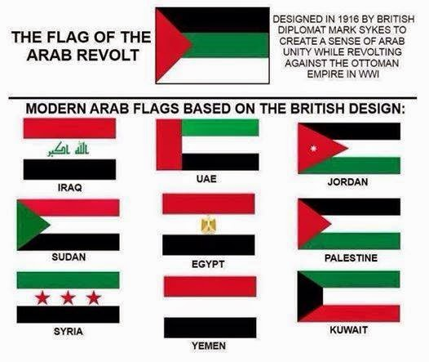
Above: The White, Red, Black, and Green colors of the "Four Messengers of the Apocalypse" reside in many Arab national identifiers (flags).



Above: The four colors of the apocalypse represented by a bloody fist.

The New Iran Countdown Clock

On 6/23/2017 a large digital clock was inaugurated in Tehran, Iran, that indicated 8411 days to the annihilation of the nation of Israel.



Above: The public countdown clock for Israel's total annihilation unveiled in Tehran, Iran, on 6/23/2017. Note the symbolic fist with the colors of the four horsemen on the display.

On 6/23/2017 the future date for Israel's annihilation was listed as 7/3/2040. The date 7/3 rang a bell, as I have been sitting on information concerning 7/3 for about a week waiting for the go-ahead to publish it.

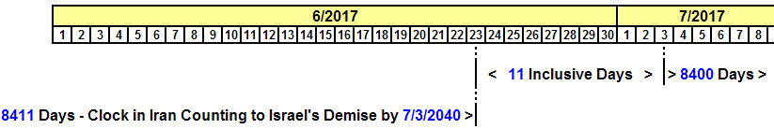

Above: Iran's public countdown clock for Israel's annihilation was inaugurated on 6/23/2017 and was at 8411 days and counting down at that time. 8400 days from 7/3/2017 will be 7/3/2040.

The 84 Months in the Handwriting on the Wall

There is a prophetic period of 42 months, one half of 84 months, mentioned in the book of Revelation, with a prophetic period of 1260 days being mentioned in the very next verse.

Revelation 11:1 And there was given me a reed like unto a rod: and the angel stood, saying, Rise, and measure the temple of YaHuWaH , and the altar, and them that worship therein.
2 But the court which is without the temple leave out, and measure it not; for it is given unto the Gentiles: and the holy city shall they tread under foot forty and two months.
3 And I will give power unto My two witnesses, and they shall prophesy a thousand two hundred and threescore days, clothed in sackcloth.
4 These are the two olive trees, and the two candlesticks standing before the Elohim of the earth.
The 42 months and the 1260 days are related with the prophetic numeric value of 2520 encoded into the "Handwriting on the Wall" event mentioned in Daniel chapter 5.

We know that the months at the time of Noah's flood were each 30 days in length, resulting in a 360 day year.

7 years x 360 days per year= 2520 days

84 months x 30 days per month = 2520 days

42 months (Revelation 11:2 above) x 30 days per month = 1260 days (Revelation 11:3 above)

Seven Years of Years from Cyrus Entering Ancient Babylon

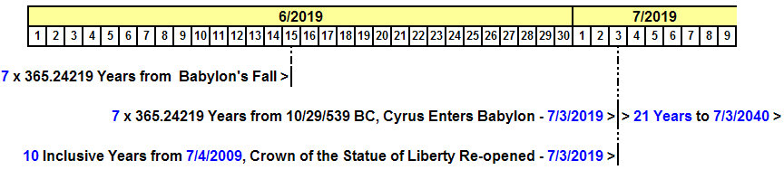

Above: 7 years of years from Cyrus entering ancient Babylon is 7/3/2019. The Statue of Liberty crown was closed on 9/11/2001. 10 inclusive years from the re-opening of the crown of the Statue of Liberty on 7/4/2009 is 7/3/2019.

Note that the graphic above illustrates that there are 21 (7 x 3) complete years from 7/3/2019 to 7/3/2040 and the annihilation of Israel according to the public countdown clock unveiled in Tehran on 6/23/2017.

The Tehran countdown clock fits perfectly with the timing of King Cyrus entering ancient Babylon on 10/29/539 BC, with an additional 21 years being added on to the 7 years of years anniversary date.

10/29/539 BC + 933,813 days = 7/3/2019

7/3/2019 + 21 years = 7/3/2040

7/3/2017 + 8400 days = 7/3/2040

Israel's Elohim will see to it that Israel will continue to exist beyond 7/3/2040 to the dismay of all who wish otherwise.

Zechariah 2:3 And, behold, the angel that talked with me went forth, and another angel went out to meet him,
4 And said unto him, Run, speak to this young man, saying, Jerusalem shall be inhabited as towns without walls for the multitude of men and cattle therein:
5 For I, saith YaHuWaH , will be unto her a wall of fire round about, and will be the glory in the midst of her.

Isaiah 60:15 Whereas thou hast been forsaken and hated, so that no man went through thee, I will make thee an eternal excellency, a joy of many generations.
16 Thou shalt also suck the milk of the nations, and shalt suck the breast of kings: and thou shalt know that I YaHuWaH am thy Saviour and thy Redeemer, the mighty One of Jacob.
17 For brass I will bring gold, and for iron I will bring silver, and for wood brass, and for stones iron: I will also make thy officers peace, and thine exactors righteousness.
18 Violence shall no more be heard in thy land, wasting nor destruction within thy borders; but thou shalt call thy walls Salvation, and thy gates Praise.
19 The sun shall be no more thy light by day; neither for brightness shall the moon give light unto thee: but YaHuWaH shall be unto thee an everlasting light, and thy Elohim thy glory.
20 Thy sun shall no more go down; neither shall thy moon withdraw itself: for YaHuWaH shall be thine everlasting light, and the days of thy mourning shall be ended.
21 Thy people also shall be all righteous: they shall inherit the land for ever, the branch of My planting, the work of My hands, that I may be glorified.

Like the Sun

King Cyrus (Aramaic "Koresh" - meaning "like the sun") and the crown of the Statue of Liberty have this in common: they both represent the sun.

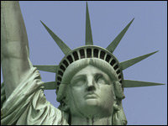

Above: The Statue of Liberty crown with the symbolic rays of the sun radiating from it.

Unfortunately a device also "like the sun", the result of the Manhattan project of WWII, will probably bring about the destruction of modern Babylon the great by fire.

Modern Babylon's Masonic "Ishtar" statue having 7 radiant horns will be shown by YaHuWaH Elohim as lacking the ability to bring salvation, as were the gods of ancient Egypt.

