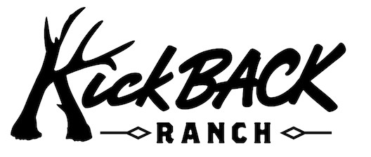

Info@kickbackranchtx.com

2025 Season

WHITETAIL DEER TROPHY FEE

Up to 125 SCI = $3,000

126 – 149 SCI = $4,000

150 – 159 SCI = $6,000

160 – 169 SCI = $7,000

170 – 179 SCI = $8,500

180 – 189 SCI = $9,500

190 – 199 SCI = $11,500

200 – 219 SCI = $14,500

220 – 239 SCI = $16,500

240 – 249 SCI = $20,000

>250+ SCI = $25,000

In addition to the per animal Trophy Fee

3 day/2 night hunt $1000 per Hunter
Standard hunt is Friday afternoon arrival with Sunday afternoon departure

Fee includes 1x1 hunting; care of trophies, including transport to the
KickBACK preferred meat processor and to the KickBACK preferred taxidermist;
Accommodations; Breakfast, Lunch, Dinner, beverages of choice;
game drives, pool area, and other amenities. Non-Hunter daily rate available on request

50% of Daily Rate fees required to hold dates

*Due to the ever-changing wildlife market, all prices are subject to change without notice
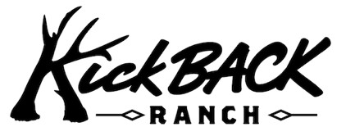
info@kickbackranchtx.com

EXOTIC TROPHY FEES

• Addax $11,000
• Axis $6,000
- Blackbuck $5,000
• Black Hawaiian Rams $4,500 (Over 38 inches $5,500)
- Buffalo $11,000
• Corsican Ram $4,500
(Over 38 inches $5,500)
• Elk $7,500 and Up –
See sliding scale below
• Fallow $8,500
(White, Spotted or Chocolate)
- Gemsbok $11,000

• Hybrid Ibex $5,500
• Kudu $28,000
• Mouflon Ram $5,500
• Nubian Ibex $20,000
• Red Sheep $6,000
• Red Stag $7,000 and Up - See sliding scale below
• Sable $28,000
• Scimitar Horned Oryx $7,500
• Texas Dall Rams $4,500
(over 38 inches $5,500)
- Transcaspian Urial Hybrid $12,000+
dependent on measurement

Elk and Red Stag Trophy Fee based on SCI score

ELK

Management Class up to 319. $10,000
San Angelo Class (320 – 369) $14,000
Eden Class (370 – 399) $18,000
Texas Class (400-440) $23,000
KickBACK Class (441-460) $28,000
Gigantic Class (461-499) $35,000
>500 On Request
RED STAG

Management Class <280 $7,500
San Angelo Class (280 – 360). $11,000
Eden Class (361– 399) $16,000
Texas Class (400 – 440) $22,000
KickBACK Class (441 – 460) $27,000
Gigantic Class (461- 499) $33,000
>500 On Request

*Due to the ever-changing wildlife market, all prices are subject to change without notice

*updated 7/2/2025

