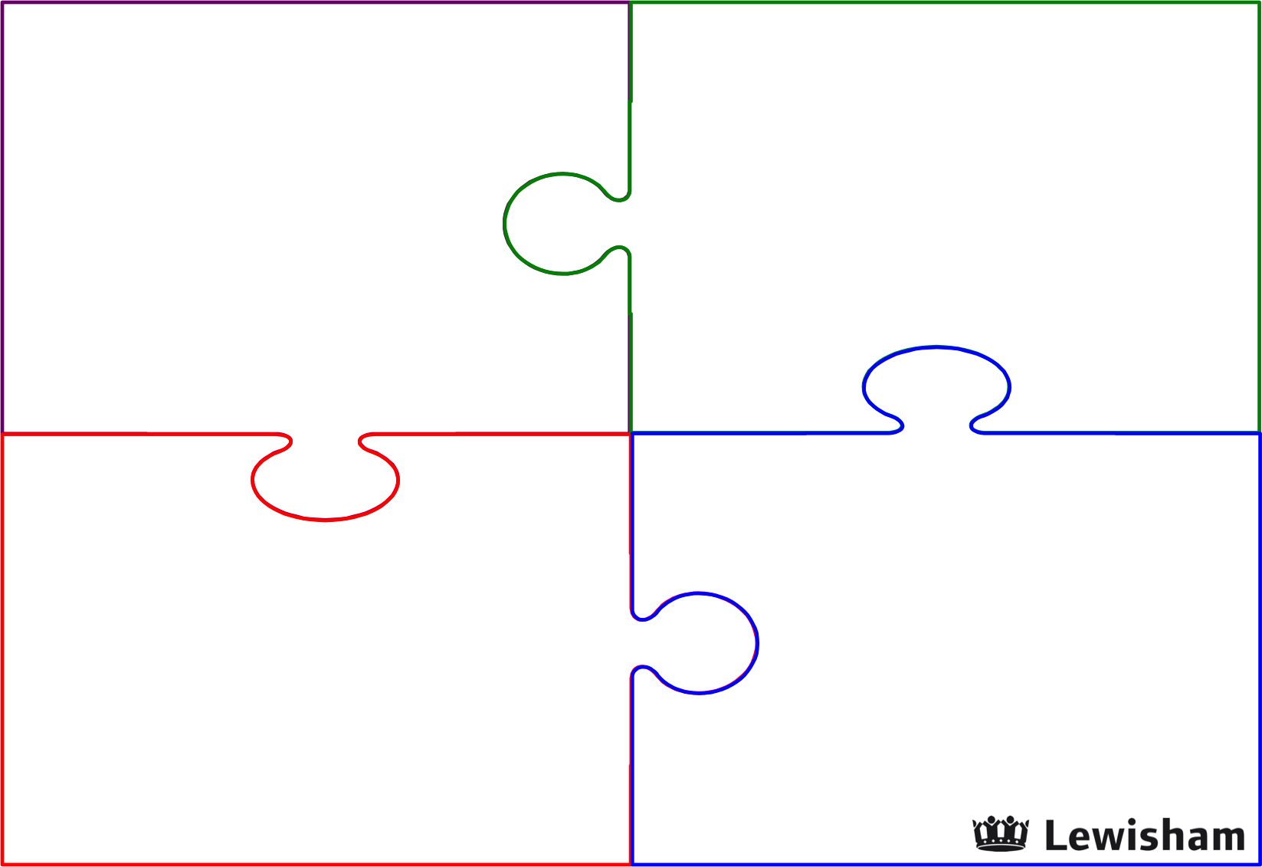
This is me…..
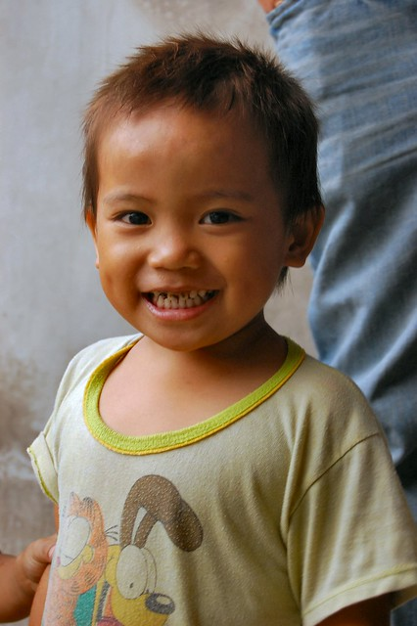

My Name Is
My DOB is
My Home Language is
People Closest to me are

My biggest achievements so far………

My least favourite
things are……..

My favourite things are…….

Things that are challenging for me……..

What I would like to achieve the most……….

The people who help
Me………

How adults support me……..

