CONGRATULATIONS TO LYONS NATIONAL BANK (LNB) !!!

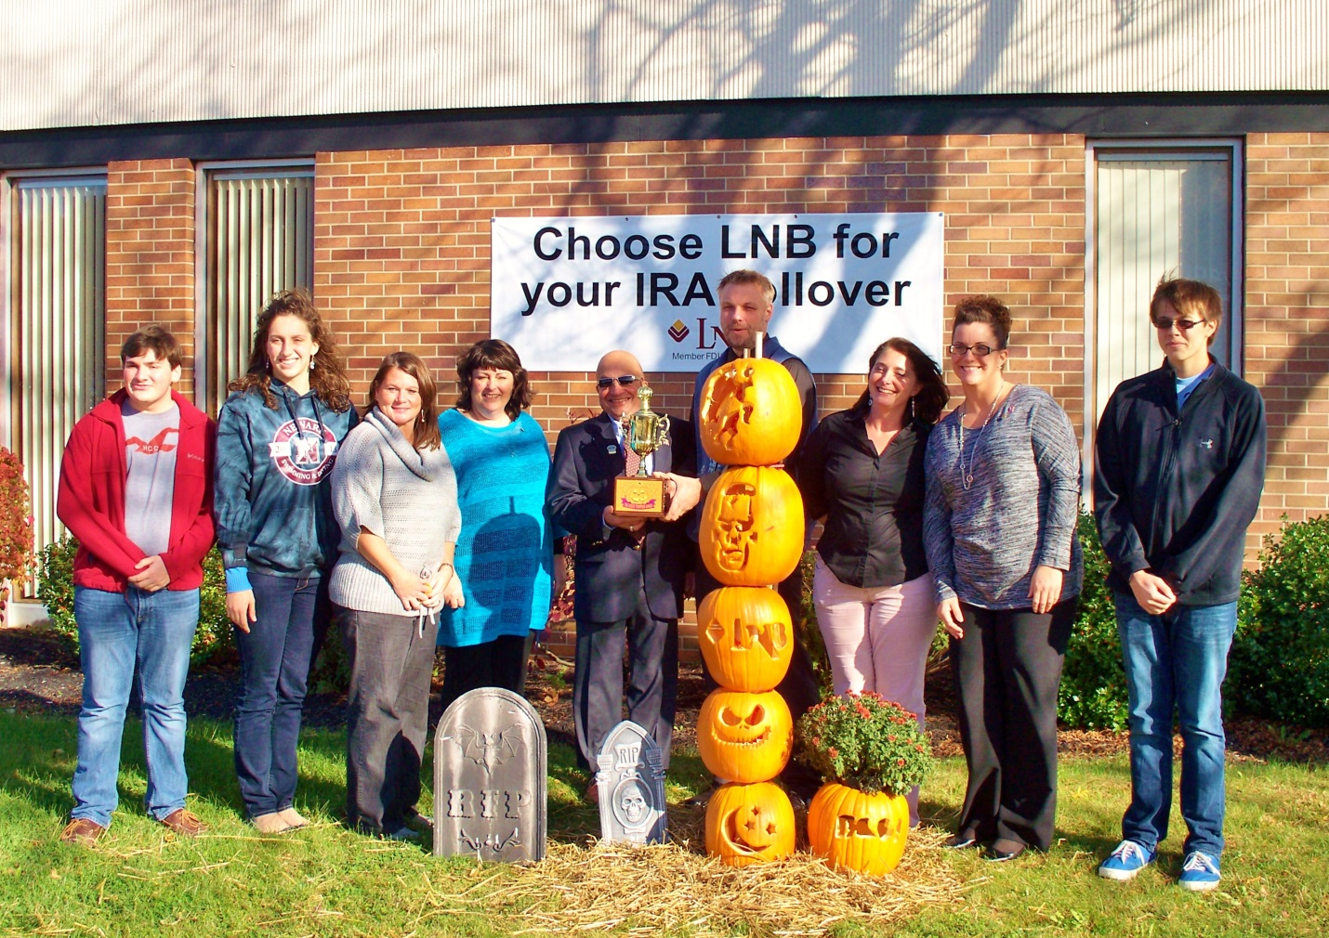

Mayor Blandino and officers of the Rotary Interact Club presented the 2013 “Great Pumpkin” trophy to Lyons National Bank for their creative design.

Local businesses painted, carved, and stacked pumpkins or portrayed a pumpkin creature.
These local businesses also participated…

- Reliant Community Credit Union 205 North Main Street
- Newark Public Library 121 High Street
- Ruffalo’s Appliance Services 217 South Main Street
- Community Bank 710 West Miller Street, Wegman’s Plaza
- Sally Beauty Supply 6768 Route 31 East, Arcadia Shopping Center
- Reed Eye Associates 1105 Driving Park Ave
- The Terrace at Newark 208 Route 88 South
- Vintage Gardens 310 High Street
- Doebler Realty, Inc. 614 South Main Street
- Lyons National Bank 750 West Miller Street

Please scroll down to see honorable mention sculptures…

Reliant Community Credit Union
205 North Main Street

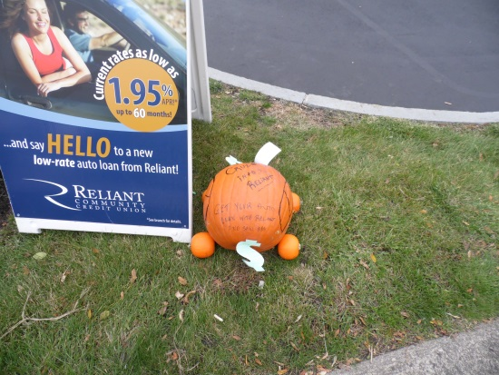

Newark Public Library
121 High Street

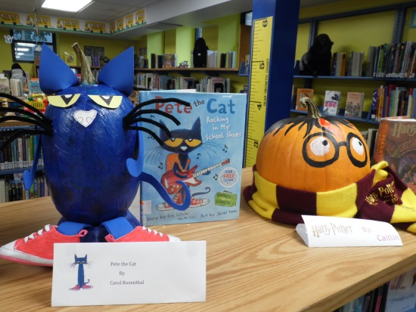

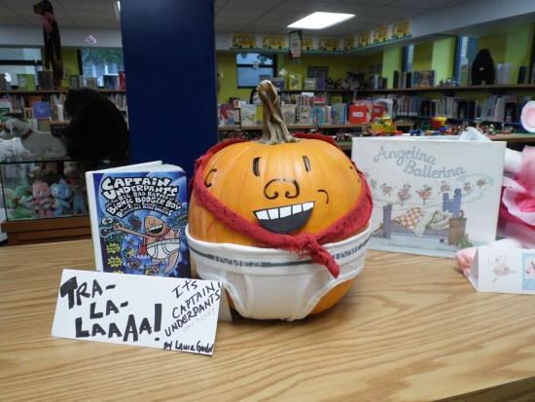

Ruffalo’s Appliance Services
217 South Main Street

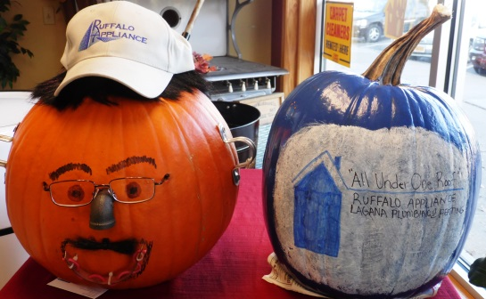

Community Bank
710 West Miller Street, Wegman’s Plaza

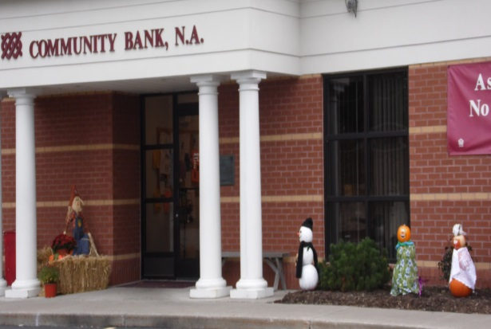

Sally Beauty Supply
6768 Route 31 East, Arcadia Shopping Ctr.

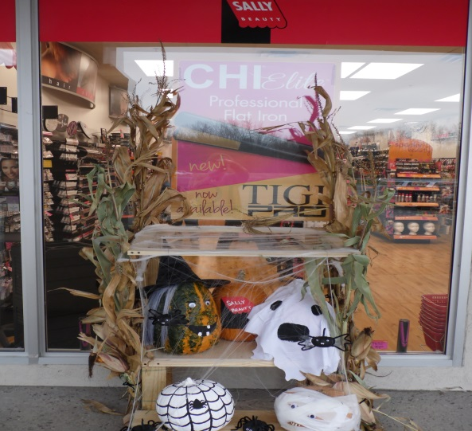
Scroll down for more!
Reed Eye Associates
1105 Driving Park Avenue

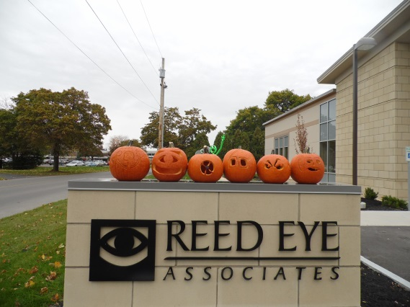

The Terrace at Newark
208 Route 88 South

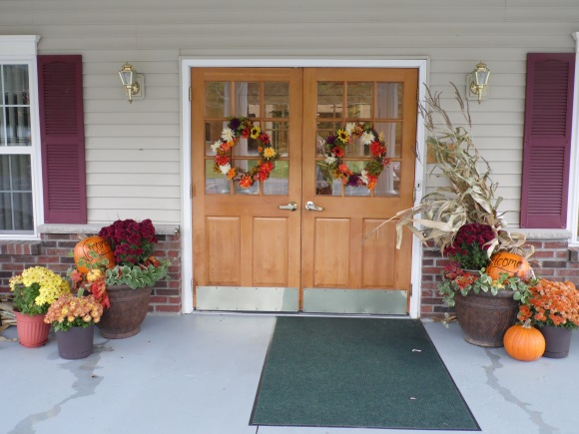

Vintage Gardens Bed and Breakfast
310 High Street

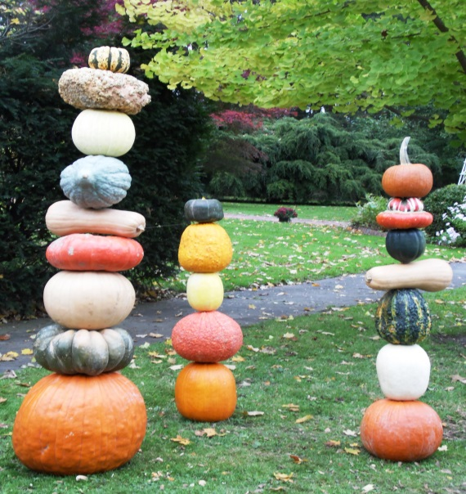

Doebler Realty
614 South Main Street

