From: http://powerfulpalanca.com/some-bunny-loves-you/

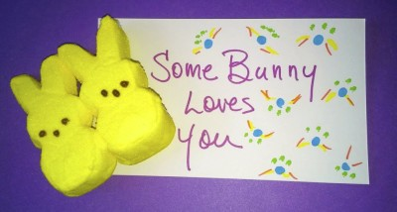Some Bunny Loves You

Materials:
- Index Cards
- Markers or Sharpies
- Bunny Shape Easter Peeps Candy

Instructions:
- Simply decorate the index cards as you choose being as creative and colorful as you’d like
- Lay the peeps candy down on the card
- Include your community name, reunion group name, table name and weekend # if you want

