The Veteran Meditation Retreat

The Life Transition Meditation Center’s current, and perhaps most pressing focus, is our military veterans, who represent a mainly silent and underrepresented group in our country that is in crisis.

There are unique challenges, such as the increased risk of suicide, homelessness, and incarceration, that American veterans face and for which they need support.

Many of these challenges are related to the experiences of long-term Post Traumatic Stress Disorder (PTSD).

Life Transition Meditation Center plans to support a Veteran Meditation Retreat and has a majority-Veteran board of advisors, led by Ralph Steele, who is committed to sharing this evidence-based, potent, yet simple practice.

On October 13-16, 2023, we’re offering a free Veteran’s Retreat at The Clyde Hotel in Albuquerque, where participants can learn these simple, powerful healing tools. No prior meditation experience is necessary.
**All veterans are welcome regardless of discharge status, gender, religion, ethnicity, Two-Spirit, and LGBTQIA+

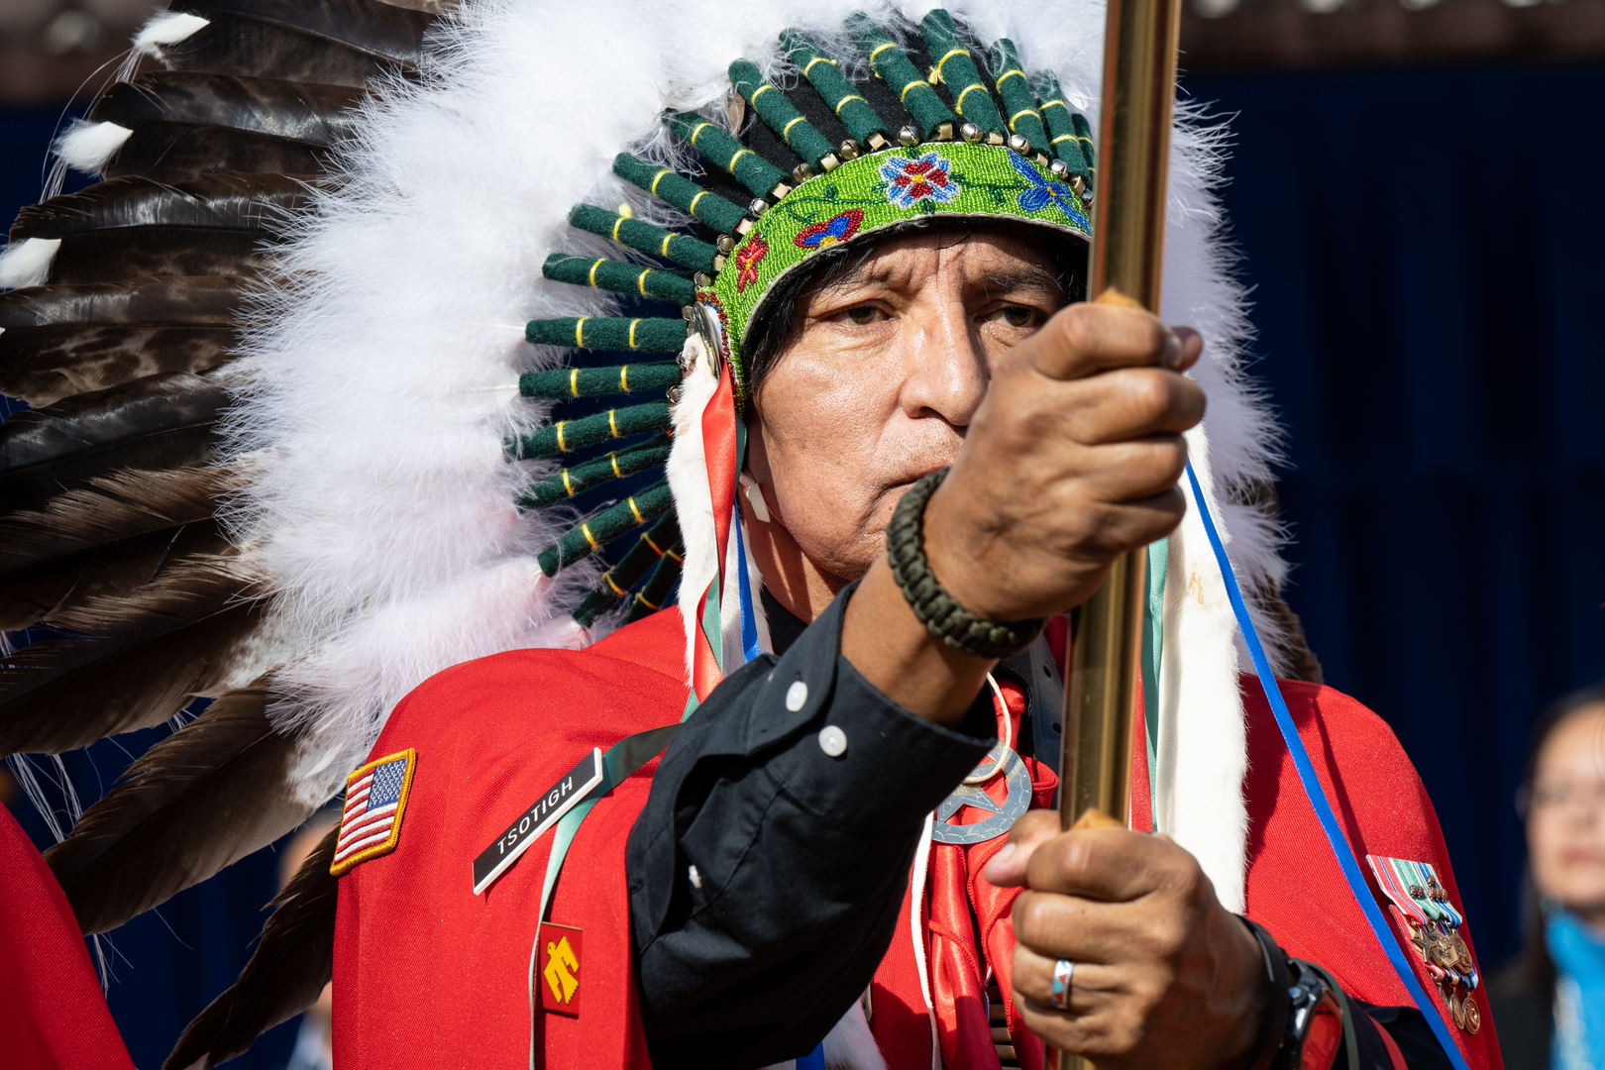
The 2022 Pentagon Native American Heritage Month Celebration with members of the Kiowa Black Leggings Warrior Society and Navajo Nation President Jonathan Nez, highlights and celebrates the diversity in military service. This diversity is equally represented in the more than 33,000 veterans experiencing homelessness daily. (Photo by US Air Force Tech. Sgt. Jack Sanders/ Use of US Defense Department images does not imply DoD endorsement)

