GEN-525 (120V-2500W-6.3kW-60Hz) | Geneforce Emergency Power System
Product Features | 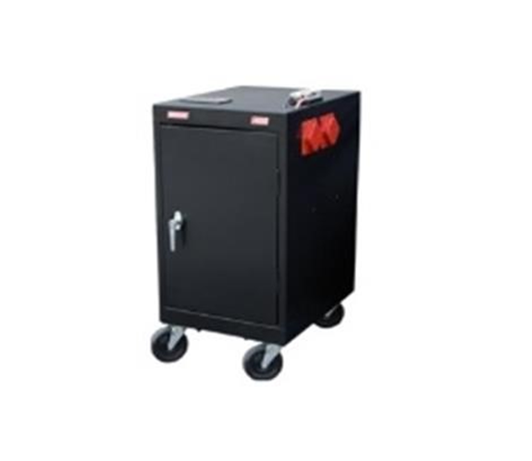
Silent operation.
Safe for indoors. No gas or emissions.
No Installation; No Maintenance; No Permits required
Arrives fully charged and ready to work.
Automatic & one-touch start.
Multi-colored LED displays state of charge, AC input, DC volts and DC amperage, etc...
Overheat Temperature Sensor & Automatic Shutdown feature.
Built-in voltage regulation system for sensitive electronics.
Built-in (120V/30A) Automatic A/C Transfer Switch.
Built-in 30A solar charge controller for solar panel charging.
Electrical Specifications | GEN-525 (120V)
Output power (continuous) | 2,500 W
Surge power (AC amps) | 7,500 W (62.5A)
Output frequency regulation | 60 Hz
Voltage regulation | 120 V +/-5% true RMS
Output wave form | Modified Sine Wave
Service Life (No Maintenance) | 7-8 years
Stored Electrical Energy | 6.3 kW (6,300 Watts)
AC input 1 | One (30A/120V) NEMA L5-30P twist lock plug with 8 ft. cord
AC output 1 | Four (20A/120V) isolated ground receptacles
AC output 2 | One (30A/120V) NEMA L5-30R
Automatic transfer switch | 30 A (included); Transfer time 0.8 milliseconds
Charge rate | 130 A DC
AC input voltage range | 90 - 130 VAC
Geneforce Charge control | 3-stage (Bulk, Acceptance, Float)
Solar Charge Controller | 30 A (~360 W per hour of sunlight)
General Specifications
Optimal operating temperature range | 32°F – 104°F (0°C – 40°C) *derated below 0°C and above 40°C
Monitor | LED Display (reads V, DC amps, Power Share, etc.)
Dimensions (H x W x D) and Weight | (35" x 18" x 24") & (455 Lbs.)
Construction | Strong Steel, Four Casters, Color-Black
Part Number | GEN-525-120-2500
Warranty & Part Number | Two years on components; one year on batteries
Regulatory Approvals & Protection
Safety - UL Listing | Components UL & cUL listed to 458 Standards
Voltage Regulation | Over voltage and under voltage protection
Temperature | Over-temperature protection
Output | Overload Protection
Electrical | Short circuit protection
Price | $5,997
Geneforce Incorporated www.geneforcepower.com (305) 215-5443 email: sales@geneforcepower.com

