2022 TEXAS LADIES RETREAT
Registration Form
Mail to: Union Hill Baptist Church
Attn: Glenda Wallace
P O Box 316 Make checks payable to TX WMA
Brownsboro, TX 75756

$45 per registrant includes Project T-Shirt if received by August 1. After August 1, shirt size or color not guaranteed.
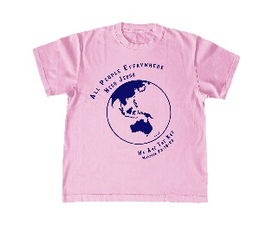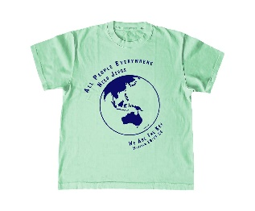
Can you bring items to help fill Christmas Shoeboxes? Contact Diana Morris @ 903-288-7575 or grammydi1013@msn.com to see what you might bring. Remember everyone is working together to fill the boxes.

CHURCH NAME & CITY ______________________________________________________________________________

Name________________________________________________________________Phone #______________________
Please select your color choice and size □ Pink □ Blue □ Mint Green
□Small □Medium □Large □Extra Large □2XL □3XL

Name________________________________________________________________Phone #______________________
Please select your color choice and size □ Pink □ Blue □ Mint Green
□Small □Medium □Large □Extra Large □2XL □3XL

Name________________________________________________________________Phone #______________________
Please select your color choice and size □ Pink □ Blue □ Mint Green
□Small □Medium □Large □Extra Large □2XL □3XL

Name________________________________________________________________Phone #______________________
Please select your color choice and size □ Pink □ Blue □ Mint Green
□Small □Medium □Large □Extra Large □2XL □3XL

