Pleasant Township Board of Trustees Meeting Highlights
Date __August 23, 2022 Next Resolution No.__ 50-----08-23-2022_______

- Call to Order -- The meeting tonight will also be on WebEx. Thank you Grove City IT for getting us up and running.

- Please stand for moment of silence. --Pledge of Allegiance-----Roll Call
- getting Minutes to approve- none

- Financial Reports – Motion to pay expenditures.

- Visitors –
- Hanna Poling with the Southwest Messenger via WebEx.

- Department Reports

- Franklin County Sheriff’s Report- No representative

- Road Department- Superintendent, Robert Bausch

  - Sign grant supplies—received the last shipment of supplies.
  - Drive tile and ditch cleaning Creamer Rd.
  - Tile installation Grassle Rd.
  - Seaman Rd. tile upgrade- road is open
  - Fall Clean Up is September 16th & 17th
  - Notification from the Department of Health that we had West Nile Virus positive test results from mosquitoes caught in the gravid traps set Sunday night (08/15) in the Pleasant Township North and South Zones.
We would like to spray all of Pleasant Township on Wednesday August 24th, 2022 beginning at 8:45 p.m. (weather permitting). Please confirm that this spray date is acceptable.
Upon approval, the planned spray maps will be updated on our website at https://mosquito.myfcph.org/spray-schedule-maps/ for you and the public to view.

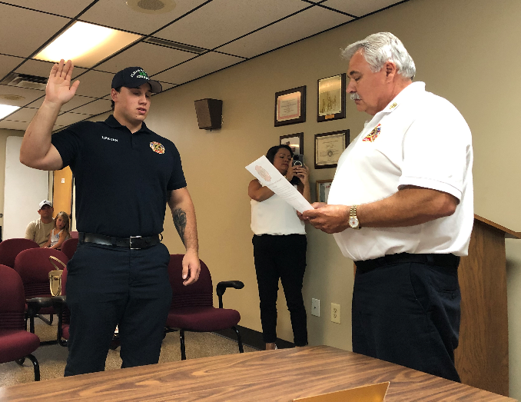
- Fire Dept. – Chief Whiting

- Staffing
  - John Herron Swearing in

- Equipment
  - Received New Thermal Imaging Camera
- Community Risk Reduction
  - Pumping Hydrants
- Miscellaneous
  - Web Ex up and running
  - ESGR-Employers Supporting Guard and Reserves in to make a presentation (J.B. Bott) to honor Chief Whiting for all his excellent work supporting military employees.
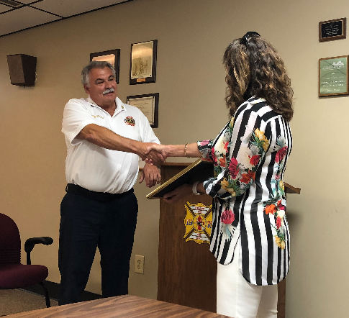
    - ESGR, a Department of Defense office, was established in 1972 to promote cooperation and understanding between Reserve Component Service members and their civilian employers and to assist in the resolution of conflicts arising from an employee's military commitment.

- Old Business-
- New Business –
- The Franklin County Township Association Annual Legislative Meeting is September 15th at the Prairie Township Community Center. Registration and dinner are scheduled to begin 6:00PM. Dinner will be free-of-charge for attendees. Please RSVP for the Legislative Meeting by Friday, September 9^{th.} We received an email with more details.

- Clerk Updates- Paula

- Misc. emails and correspondence

- Speaker Sheets-
  - Questions how to file to a request to repair streets in Timberlake. Robert said he is working on a grant to begin replacing the blacktop in Timberlake.

- Adjourn-

