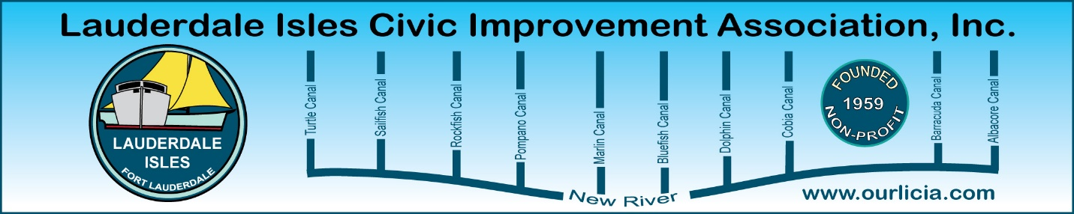

Lauderdale Isles Civic Improvement Association General Meeting May 15, 2025 via ZOOM.
The meeting was called to order by Earl Prizlee at 7:05pm. Earl welcomed everyone to our ZOOM meeting and thanked them for attending. As we had invited guests that could not attend in person, we elected to hold a virtual meeting.
Roll call: Aynsley Geramanis, Jackie Zumwalt and Peny Shea were not in attendance.
FLPD report: Officer Jackson was not able to attend so Geoff Rames reported on her behalf. We had 3 Part 1 crimes since the last report. On the 3900 block of Riverland Road, a car was broken into and purse stolen. On Okeechobee Lane, a wallet and sunglasses were stolen out of an unlocked car and on Cat Cay Lane, a gentlemen resident was out for the night and 2 young ladies took him home as he was intoxicated. They took two $15,000 watches and his phone. On the 2500 block of Flamingo Lane, there was a bullet hole in sheet metal, probably from a gun going off when the resident dropped it. It was reported that the man who crashed into the wall in Lauderdale Isles Landing admitted he was smoking crack.
Earl Prizlee advised he went to Lauderdale Isles Landing and there were 10 lights out at the boat ramp. Sent a letter to Commissioner Sorensen and they immediately put up new light fixtures.
Code Compliance: Matthew Flesher reported there were 7 cases in compliance, 8 closed and 32 pending compliance. There were 7 bulk trash violations, 6 public nuisance cases, 4 for parking on lawn, 4 landscape violations and 3 for exterior maintenance. Update on 2406 Nassau Lane: 3 violations, # of people over acceptable limit, excessive cars/parking, and public nuisance. Asking for a fine up to $15,000. Going to Special Magistrate. Will have another meeting with Special Magistrate to ask to revoke their license.
Guest Speaker: Marie Joseph, Homeless Initiative Coordinator joined us tonight. She explained the purpose of this initiative is to serve those experiencing homelessness and they provide medical and mental health solutions, provide hot meals and showers. If shelter space opens up, they will register these people. House Bill 1365 as of October 1 says Public Encampment is illegal and this is the team that will speak to these people to get them to come meet with them and receive services that are available. FIXIT FTL is the website and app for neighbors to report anyone they believe needs help. Take a picture and make the report. You can remain anonymous. Marie shared the report for the month of April: 73 people sleeping in public, 155 concerns, 3 outreach inquiries and 9 homeless concerns, total of 240. This represents an increase of 6% over March. The number of cases by District: District 1: 20, District 2: 115, District 3: 3 and District 4: 89.

Chief Waterway Officer: Marco Aguilera provided an overview of his new position. He confirmed that between June 1 – October 31, fertilizer should not be used as it ends up in the water and creates algae blooms. Marco talked about the mangrove installation at George English Park and the Living Seawall in the New River.
Other news: Earl provided an update on the Sanitary Lift Station that will be at the Lauderdale Isles Community Center. Earl asked if anyone knows where the Duck Key Lane sign is.
Geoff made the motion to adjourn, and Dawn seconded. The meeting ended at 7:50 pm.

Respectfully submitted by Karen Rames, Secretary

