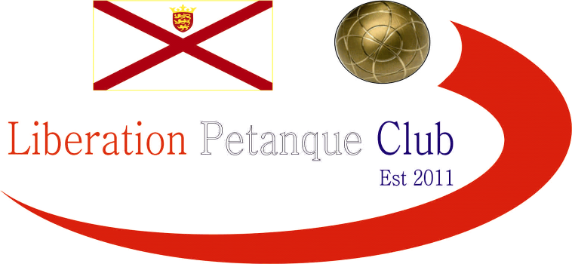

2023
International Triples Open

A record 20 Triples teams took part in day 3 of our International Open weekend, almost double last years entries.

Round one saw defending champions Matt Buesnel, Geoffroy Buffetrille and Laurent Pellaton take on Eliot, Paul and Roger from the England with a good start 13 – 4.

Not quite a s good as Norwegian champions Benny, Eli & Gabriel who beat Leo, Michael & Virgina from Ireland 13 – 0!

Gary, Wendy & Keith started off with a tight win 9 – 6 over England Veterans champions Adrian, Ian and Simon. Another match not making it to 13 as Andrew, Callum & Toby won 12 – 7 over Colin, Lesley & Paula.

Julian, Eric playing with stand in Des beat Clive, Christine & Brian.

Round two, saw another 13 – 0 score as Andrew, Callum & Toby hit top form to hand out a certificate to Andrew, Lorna & Stephen.

Three matches didn’t make it to 13 with Gary, Wendy & Keith getting 9 points again, but unfortunately their opponents Geoffroy, Laurent & Matt scored 10 points. John, Pauline & David also won by one point 9 – 8 over Moira, Mike & Greg.

Stuart, Chris & Carolyn won big 13 – 2 over Clive, Christine & Brian. With Eric, Julian & Des winning 13 – 4 and Myra, Carol & Julie winning 13 – 4.

Round three, saw back to back 13 – 0 wins for Andrew, Callum & Toby, this time over John, Pauline & David.

A huge match saw Benny, Eli & Gabriel play Des, Eric & Julian with the Norwegians taking the match 13 – 6.

Three really close matches saw Leo, Mary & Virginia beat Alex, Cassie & Jean 13 – 12. Sandra, Grant & Clifton won 12 – 11 over Clive, Christine & Brian.

Champions Laurent, Geoffroy & Matt lost their first match against Adrian, Ian & Simon 13 – 6.

Big wins for Andrew, Lorna & Stephen. Mike Moira & Greg. Neil, Ross & James and Mary, Breda & Brian.

Round four, Well after back to back 13 – 0 wins the next match was going to be tougher for Andrew, Callum & Toby as they played Benny, Eli & Gabriel this time losing 13 – 9 in a close match.

Gar, Wendy & Keith yet again failed to reach 13 points in their match as the lost 9 – 8 to Des, Eric & Julian.

Laurent, Geoffroy & Matt lost back to back matches this time to Pauline, John & David 13 – 6. Clive, Christine & Brian finally won their first match and in style 13 – 1 over Liz, Marietta &Mary.

In the final Round to determine the top eight for the Main and the next eight teams for the plate with the bottom four teams missing out.

Benny, Eli & Gabriel topped the rankings with a win over Andrew, Lorna & Stephen who finished sixth in the rankings.

Andre, Callum & Toby lost the second successive match, this time to Adrian, Ian & Simon but still finished fourth with the latter finishing third.

Second place went to Des, Eric & Julian who finished with four wins taking an 11-7 win over David, John & Pauline who still made it through in eighth place.

Gary, Wendy & Keith 13 – 6 win over Myra, Carol & Julie saw them finish sixth and seventh went to Clifton, Sandra & Grant with a big 13 – 3 win over Mike, Moira & Greg.

Champions Geoffroy, Laurent & Matt though missed out by the narrowest of margins after only beating Leo, Michael & Virginia 13 – 12 meaning their points difference of minus 3 to David, Pauline & johns +1.

Final Swiss Rankings

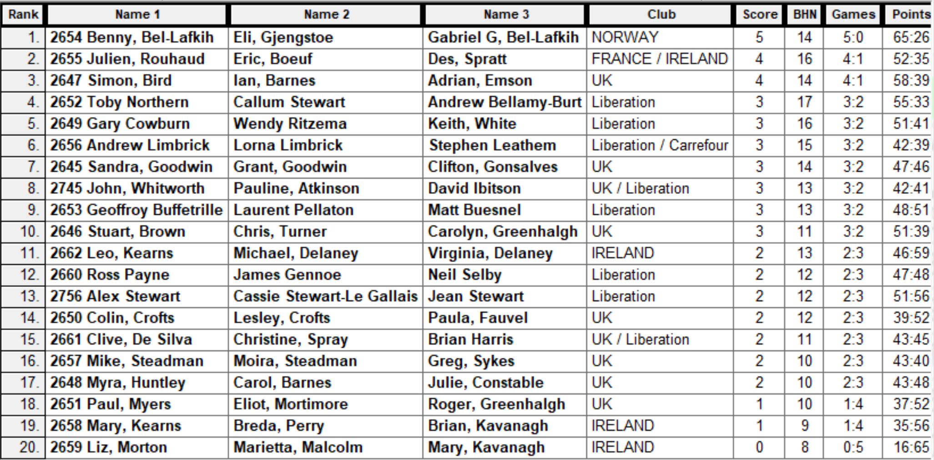

The Plate Competition

Quarter Finals

Wins all around for the top ranked teams in the quarter finals with the closest match between all Liberation players saw James Ross & Neil beat Alex, Cassie & Jean.

Ranked 9th Geoffroy, Laurent & Matt 13 v 4 Mike, Moira & Greg Ranked 16th

Ranked 10th Chris, Stuart & Carolyn 13 v 7 Clive, Christine & Brian Ranked 15th

Ranked 11th Leo, Michael & Virginia 13 v 5 Colin, Lesley & Paula Ranked 14th

Ranked 12th James, Neil & Ross 13 v 9 Alex, Cassie & Jean Ranked 13th

The Plate Competition

Semi Finals

In the Semi-final local rivalry to place as Geoffroy, Laurent & Matt played James, Neil & Ross, with the latter taking the local bragging rights winning comfortably 13 – 4.

A big win also for English team Stuart, Chris, & Carolyn 13 – 2 over Irish team Leo, Michael & Virginia.

Ranked 9th Geoffroy, Laurent & Matt 4 v 13 James, Neil & Ross Ranked 12th

Ranked 10th Chris, Stuart & Carolyn 13 v 2 Leo, Michael & Virginia Ranked 11th

Geoffroy, Laurent & Matt took third place with a win over Leo, Michael & Virginia and the Plate winners finished in style with another big win 13 – 3 over James, Neil & Ross.

2023 – Plate - Winner – Stuart Brown, Carolyn Greenhalgh & Chris Turner

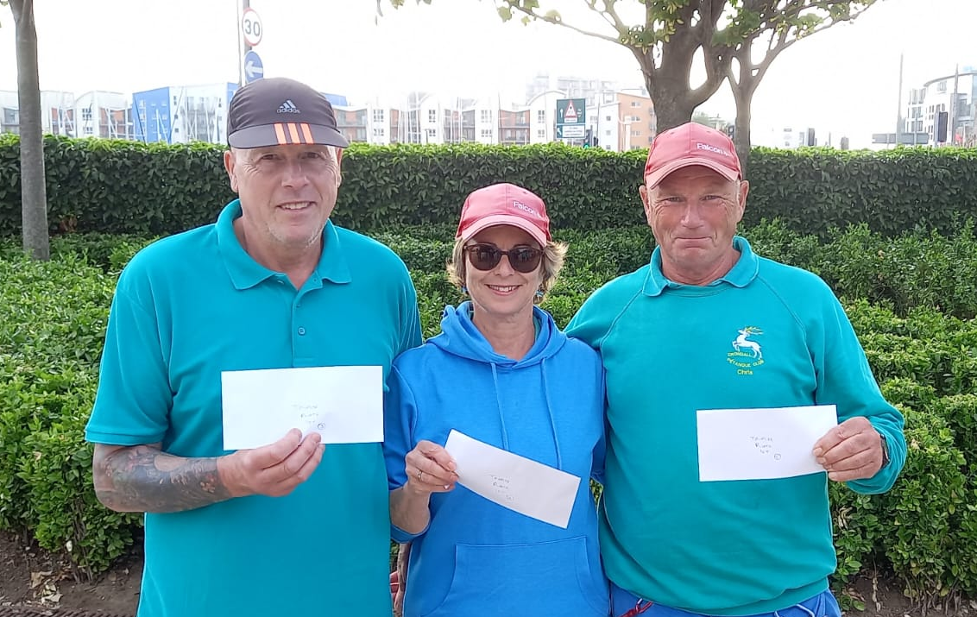

The Main Competition

Quarter Finals

Well not expecting these scores in the Quarter finals as Benny, Eli & Gabriel and Andrew, Callum & Toby both won their matches 13 – 0! A big win also for Des, Eric & Julian 13 – 4 over Clifton, Grant & Sandra but the one that got away was Andrew, Lorna & Stephen who should have won but threw away a great chance to beat Adrian, Ian & Simon but lost 10 – 9!

Ranked 1st Benny, Eli & Gabriel 13 v 0 David, John & Pauline Ranked 8th

Ranked 2nd Des, Eric & Julian 13 v 4 Clifton, Grant & Sandra Ranked 7th

Ranked 3rd Adrian, Ian & Simon 10 v 9 Andrew, Lorna & Stephen Ranked 6th

Ranked 4th Andrew, Callum & Toby 13 v 0 Gary, Wendy & Keith Ranked 5th

The Main Competition

Semi Finals

Another big win for Benny, Eli & Gabriel with Gabriel shooting really well but disappointing from Andrew, Callum & Toby who just didn’t quite hit top gear. So the top two ranked teams made the final as Des, Eric & Julian set up a rematch against Benny, Eli & Gabriel whom they lost 13 – 6 to in Round 3.

Ranked 1st Benny, Eli & Gabriel 13 v 1 Andrew, Callum & Toby Ranked 4th

Ranked 2nd Des, Eric & Julian 13 v 7 Adrian, Ian & Simon Ranked 3rd

Third place went to Andrew, Callum & Toby who got revenge over Adrian, Ian & Simon winning 13 – 6 after losing to them in Round 5, 13 – 8.

The final wasn’t as close as hoped as Benny, Eli & Gabriel ended up conceding just three points and a total of four points in the knockout stages for a well-deserved title.

2023 – Main - Winner – Benny & Gabriel Bel-Lafkih & Eli Gjengstoe

from Norway
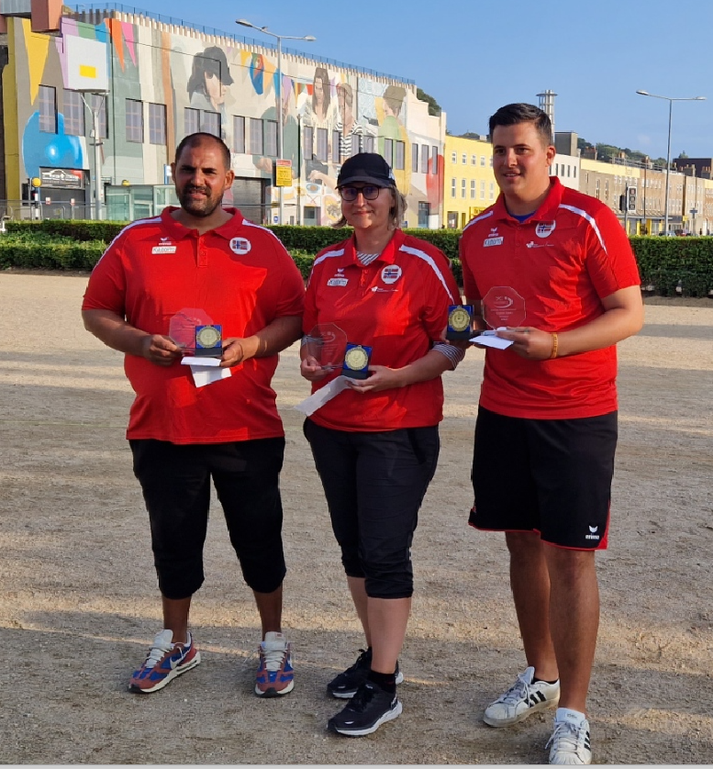

Thanks to all those who helped, especially Dawn Buckley and Elaine Paisnel for umpiring on the day to make it another great competition.

Club email address - liberationpc@gmail.com

Club Website - www.liberationpetanque.co.uk

Kind Regards

Toby Northern

Chairman

Liberation Petanque Club

