9 12 2018 22 and Me

Most people think that abstaining from eating pork, shellfish, and other types of fish and animals was a commandment given only to the Hebrews after leaving Egypt. But that's not the case.

Noah was told to take clean and unclean animals onto the Ark long before the Hebrews left Egypt.

There's a reason for the dietary instructions given by YaHuWaH Elohim to all mankind. It has to do with what went on in Noah's day concerning the animals. The book of Enoch tells us that the Nephilim began to "injure" the animals, to do damage to them.

We also know that man was created a singular being, and then divided into male and female by his Creator Elohim. A part called a rib was taken from the original "Adam" and woman was formed from that part.

We have clues in the bible that let us in on what happened in Noah's day when the animals were "injured". The fallen angels of Noah's day were also "injuring" the human being, damaging the human DNA structure, by mating with human females in order to produce hybrid offspring.

There may be a hidden reason why demons would prefer to enter a herd of pigs when leaving a human at the command of YaHuShua, rather than searching for another human to inhabit.

Matthew 8:30 And there was a good way off from them an herd of many swine feeding.
31 So the devils besought him, saying, If thou cast us out, suffer us to go away into the herd of swine.
32 And he said unto them, Go. And when they were come out, they went into the herd of swine: and, behold, the whole herd of swine ran violently down a steep place into the sea, and perished in the waters.

The pig lends itself to the nurturing of human tissue in modern medical laboratory experiments using the gene editing technology called CRISPR.
Link: https://www.theatlantic.com/science/archive/2017/08/pig-organs-for-humans/536307/

There may be a genetic link between fallen humans and pigs that was specifically placed there by fallen angels in the days of Noah that lends itself to demonic habitation.

The demonic habitation of humans is a mark of end times Babylon the great:

Revelation 18:1 And after these things I saw another angel come down from heaven, having great power; and the earth was lightened with his glory.
2 And he cried mightily with a strong voice, saying, Babylon the great is fallen, is fallen, and is become the habitation of devils, and the hold of every foul spirit, and a cage of every unclean and hateful bird.

22 and Me

You might be familliar with an advertisement on television that mentions "23 and Me". It's about ancestry, DNA, and the 23 pairs of chromosomes of the human DNA structure.

YaHuShua was asked about a woman who had been married to many men. Whose wife would she be in the resurrection?

Matthew 22:29 YaHuShua answered and said unto them, Ye do err, not knowing the scriptures, nor the power of YaHuWaH.
30 For in the resurrection they neither marry, nor are given in marriage, but are as the angels of YaHuWaH in heaven.

What's the current difference between the angels in heaven and human beings?

Science tells us that the 23rd chromosome pair is the sexual chromosome.
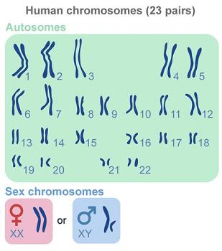
Above: The "ribs" of Adam. The human chomosomes are shaped like ribs. A "rib" was removed from Adam to create a female, also rendering Adam a male being.
YaHuShua tells us in Matthew 22:30 above that angels don't marry. There's no need for sexual reproduction in heaven because the angels are eternal beings.

In the beginning there was no need for the original "Adam" to marry. Adam was not originally a sexual, male and female, being. He had been created in the image of Elohim, as the angels also were created.

To reiterate, Adam was then later divided into male and female by his Creator Elohim.

The Aleph and the Tav, the 22 Pairs

YaHuShua Himself gives us another clue in Revelation 1:8 as to His resurrected status as an eternal Being.

Revelation 1:8 I am Alpha and Omega, the beginning and the ending, saith the Lord, which is, and which was, and which is to come, the Almighty.

The Alpha and Omega, the first and last letters of the of the Greek alphabet, correspond with the Aleph and the Tav of the Hebrew alephbet. There are 22 letters in the Hebrew alephbet.

I wouldn't be surprised if each cell in the eternally living resurrected body of YaHuShua Moshiach contains 22 pairs of chromosomes, not 23. He is as His Father and the angels of heaven.

There is no sexual activity in heaven, and no need for it among eternal beings. There's no need in eternal beings for the 23rd pair of chromosomes.

Matthew 22:29 YaHuShua answered and said unto them, Ye do err, not knowing the scriptures, nor the power of YaHuWaH.
30 For in the resurrection they neither marry, nor are given in marriage, but are as the angels of YaHuWaH in heaven.

Beware

The "injury" or "damaging" of the animals mentioned in the book of Enoch:

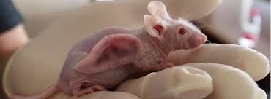

Above: A human ear being grown on a genetically injured mouse.

The mouse is an "unclean" (genetically injured) animal according to the instructions of YaHuWaH Elohim.

Below: A human ear being grown on a rat.

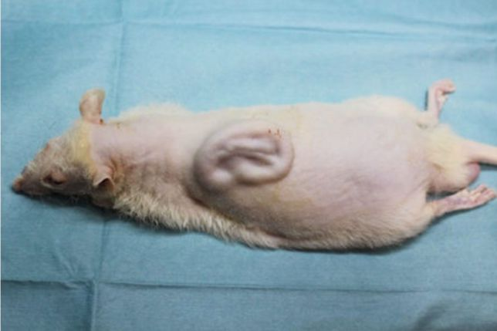

Above: A genetically injured rat growing a human ear

There was a reason that animals were identified as clean and unclean to Noah and later to the Hebrew people.

YaHuWaH Elohim knew what had been done to certain animals by hostile enemies, the angelic beings that came to earth to intentionally pervert and destroy His perfect creation.

The genetic perversion was slowed, but not stopped in Noah's day. A remnant of the unclean animals were allowed to remain alive on the Ark with Noah and his family.

Please follow the dietary instructions of YaHuWaH Elohim. He has a reason for them. His instructions are for our welfare and good.

May YaHuWaH Elohim have mercy on us all.

