**2019**

**Williston Coyote Volleyball**

|  |  |  |
| --- | --- | --- |
| **JV** | | |
| **#** | **Name** | **Grade** |
| 1 | Kaelyn Sime | 10 |
| 6 | Angie Leija | 11 |
| 7 | Megan Shimko | 11 |
| 8 | Anna Isom | 11 |
| 9 | Alicia Beuning | 11 |
| 10 | Hope Mettler | 11 |
| 16 | Emma Solberg | 11 |
| 28 | Kiara Mehlhoff | 11 |

|  |  |  |  |
| --- | --- | --- | --- |
| **Varsity** | | | |
| **#** | **Name** | **Grade** | **Position** |
| 2 | Bryn Bratcher | 12 | ULT |
| 3 | Kiara McIvor | 12 | DS |
| 4 | Macenzie Russell | 11 | S |
| 5 | Emily Jaeger | 12 | DS |
| 12 | Jaden Legg | 12 | ULT |
| 13 | Brooklyn Haug | 12 | RH |
| 15 | Emma Ward | 12 | OH |
| 17 | Erin Powers | 11 | MH |
| 20 | Rachel Anfinson | 12 | MH |
| 22 | Brooklyn Douglas | 12 | OH |
| 23 | Makia Remus | 12 | S |

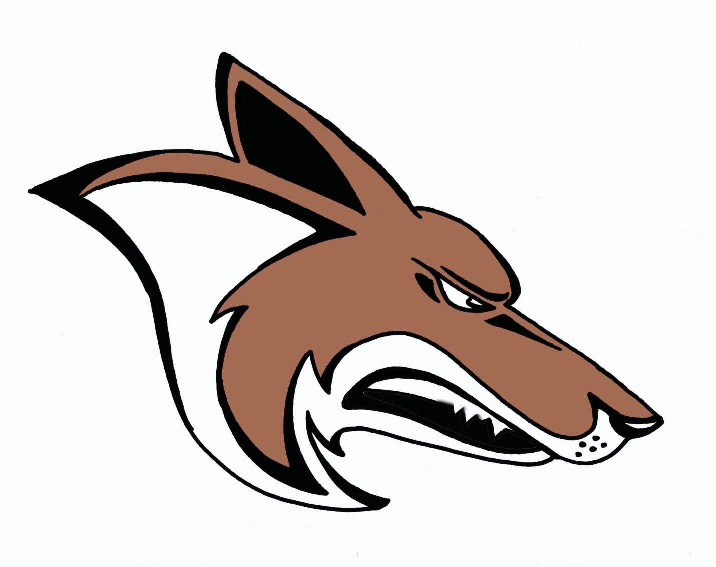

|  |  |  |  |  |  |  |  |  |  |  |  |  |  |  |  |  |  |  |  |  |  |  |  |  |  |  |  |  |  |  |  |  |  |  |  |  |  |  |  |  |  |  |
| --- | --- | --- | --- | --- | --- | --- | --- | --- | --- | --- | --- | --- | --- | --- | --- | --- | --- | --- | --- | --- | --- | --- | --- | --- | --- | --- | --- | --- | --- | --- | --- | --- | --- | --- | --- | --- | --- | --- | --- | --- | --- | --- |
| |  |  |  | | --- | --- | --- | | **Freshmen** | | | | **#** | **Name** | **Grade** | | 1 | Margaret Garbel | 9 | | 2 | Samantha Thome | 9 | | 3 | Londyn Ames | 9 | | 5 | Gracelyn Todd | 9 | | 6 | Maycee Jeanotte | 9 | | 8 | Breck Gendreau | 9 | | 9 | Luna Rubio | 9 | | 10 | Kate Hexom | 9 | | 11 | Kaylee Bybee | 9 | | 13 | Shelby Wills | 9 | | 15 | Alizabeth Krupka | 9 | | 17 | Sophia Jones | 9 | |

|  |  |  |
| --- | --- | --- |
| **Sophomore B** | | |
| **#** | **Name** | **Grade** |
| 4 | Emma Tong | 10 |
| 5 | Chevella Abeyta | 10 |
| 6 | Haley Cote | 10 |
| 8 | Brooke Sickler | 9 |
| 9 | Bailey Weyrauch | 9 |
| 14 | Gabrielle Marks | 10 |
| 17 | Taylor Rath | 9 |
| 20 | Emry Kleven | 10 |
| 21 | Zoe Lautenschlager | 10 |

|  |  |  |
| --- | --- | --- |
| **Sophomore A** | | |
| **#** | **Name** | **Grade** |
| 1 | Kaelyn Sime | 10 |
| 2 | Caleigh Goodman | 9 |
| 7 | Jocelyn Nass | 10 |
| 10 | Rylee Rude | 9 |
| 12 | Savannah Douglas | 10 |
| 13 | Koia Krenz | 9 |
| 15 | Shelby Meyer | 10 |
| 16 | Emma Solberg | 11 |



**Head Coach:** Rachael Hansana   
**Asst. Coaches** Kenzi Brown, Josten Bratcher, Kate Cote, Jaden Lynch, & Cami Collings

**Manager:** Bridget Carvey & McKinzie Kendall  
**Superintendent:** Dr. Jeffrey Thake  
**Principal:** Jason Germundson  
**Assistant Principals:** Audrey Larson, Jonathan Abuhl, & Mark Hannig  
**Athletic Director:** David Mieure

**Assistant Athletic Director:** Colby Simonsen

**School Song:** Williston Fight Song

**School Colors:** Orange & Black

[www.wdasports.org](http://www.wdasports.org)  
www.westerndakotaassociation.org