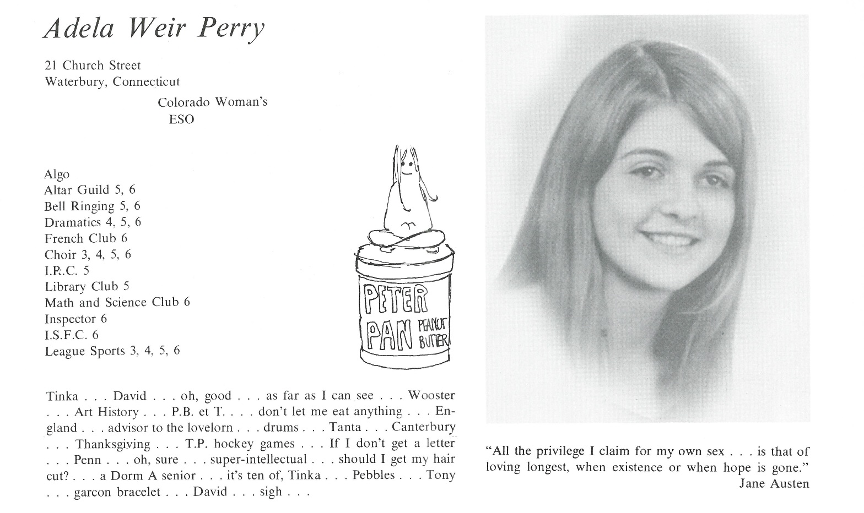

Adela “Tinka” W. Perry

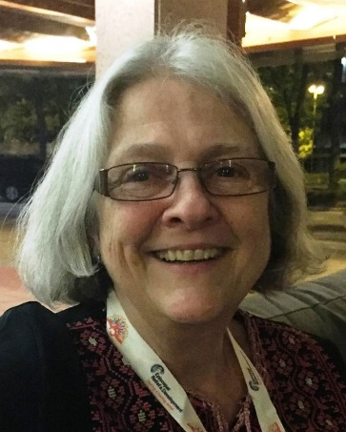So how does one put 50 years into a few sentences when the years went by so fast!

After Kent I went to England for a year as an exchange student, traveling around Europe during vacations … went to Woodstock which will never happen like that again … went to Whittier College in LA, majoring in Art History; didn't do a damn thing with that …

Got married a week after we graduated … lived in Redondo Beach for 15 years, working as a bank teller, one woman office, picture framer, preschool teacher … had two kids, son Ricky and daughter Perry …

Moved to MA in '87 … earned a Master of Divinity in '99, worked in 2 Episcopal Churches as Lay Pastoral Associate, focusing on outreach … divorced in '02 after 30 years … also diagnosed with cardiomyopathy in '99, later had a pacemaker implanted (thank God for modern medicine!) ... 4 grandkids came along from my son's 2 marriages … moved 7 times in 15 years around MA …

For 5 years I have been the Diocesan Coordinator for Episcopal Relief & Development after going on a study tour of Ghana, and later Jordan, Palestine and Israel … I have been an activist for gun safety, Palestinian human rights and other justice issues for several years, especially after 45 arrived on the scene, believing in living into my Baptismal Covenant to seek justice for all persons …

Last year my single daughter asked if I would help her if she chose to have a baby, and I moved to Bristol RI (lots of water for kayaking!) to be with her and help take care of Ezra, due the end of July … I feel like I'm finally in the right place!

'what does the Lord require of us but to do justice, love mercy and walk humbly with your God' … Micah6:8



______________________________________________________________

______________________________________________________________ ______________________________________________________________ ______________________________________________________________ ______________________________________________________________ ______________________________________________________________ ______________________________________________________________ ______________________________________________________________ ______________________________________________________________

Attach Picture in .jpg Format

______________________________________________________________

______________________________________________________________

___________________________________________________________________________________ _________________________________________________________________________________________________________________________________________________________________________________________________________________________________________________________________________________________________________________________________________________________________________________________________________________________________________________________________________________________________________________________________________________________________________________________________________________________________________________________________________________________________________________________________________________________________________________________________________________________________________________________________________________________________________________________________________________________________________________________________________________________________________________________________________________________________________________________________________________________________________________________________________________________________________________________________________________________________________________________________________________________________________________________________________________________________________________________________________________________________________________________________________________________________________________________________________________________________________

___________________________________________________________________________________