**The Day of Pentecost**

**Holy Eucharist**

The Reverend Michael L. Delk, *Celebrant*

The Reverend Allison Caudill, *Preacher*

**THE WORD OF GOD**

**Organ Voluntary “Come Holy Ghost, Lord Christ” D. Buxtehude**

**Processional Hymn “Hail thee, festival Day” Hymnal, 225**

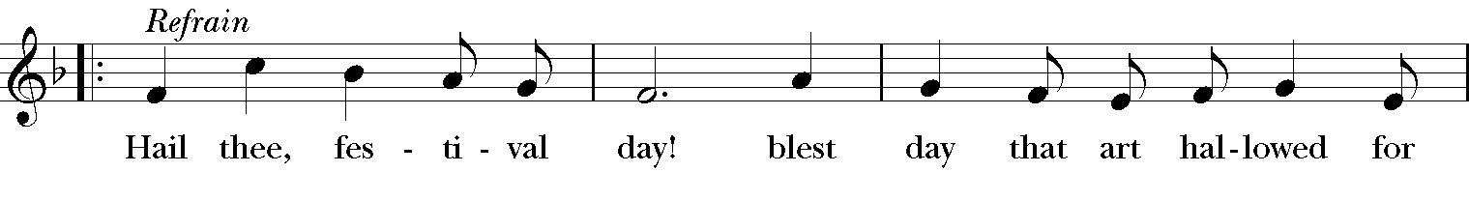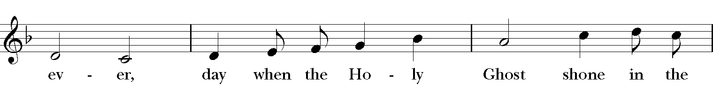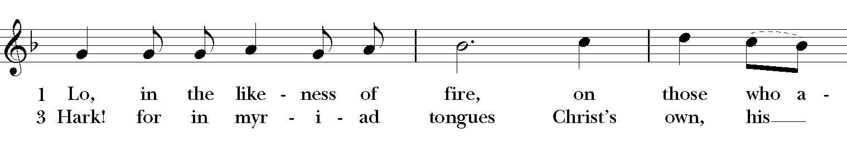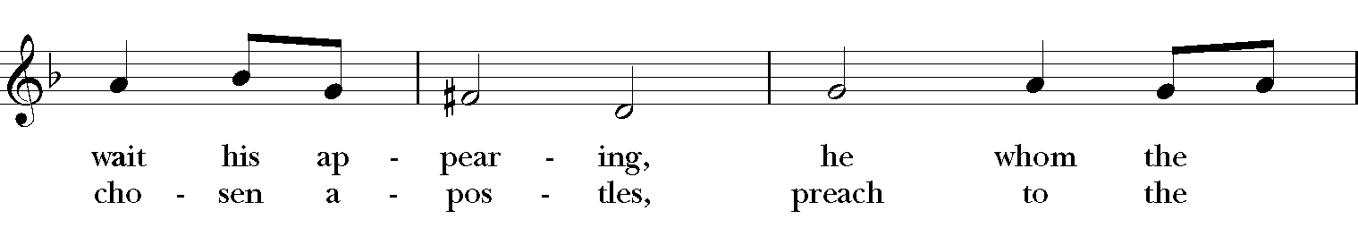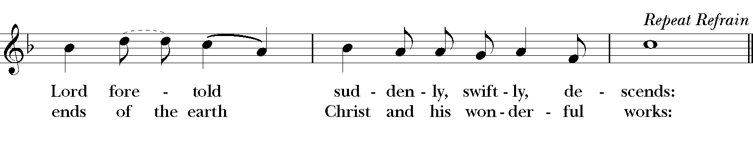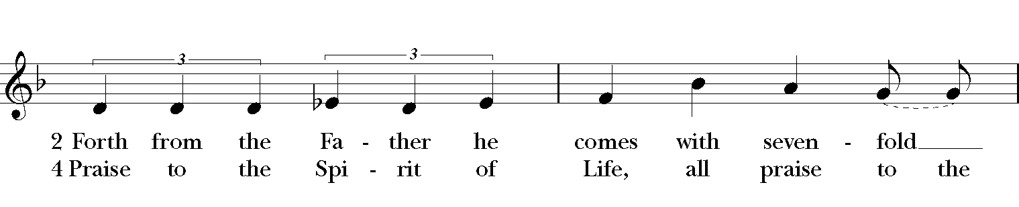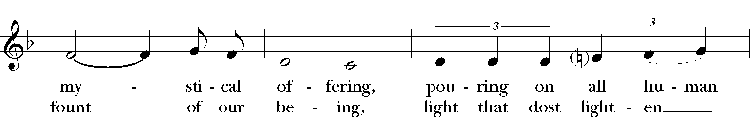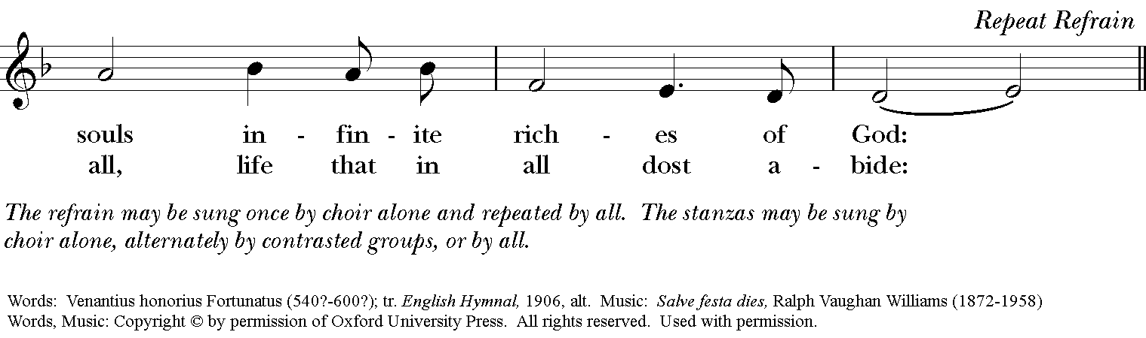

**The Opening Acclamation Page 355**

***Celebrant*** Alleluia. Christ is risen.

***People* The Lord is risen indeed. Alleluia.**

**The Gloria: S-280 in the Hymnal 1982**

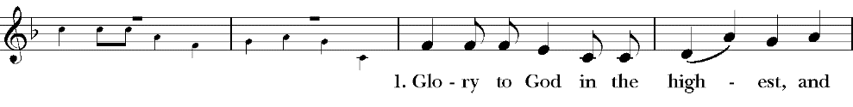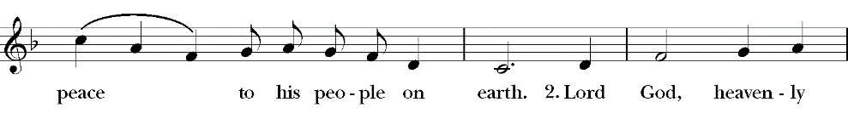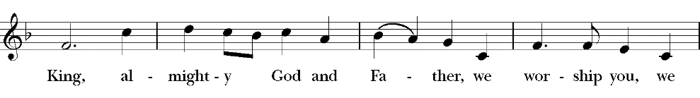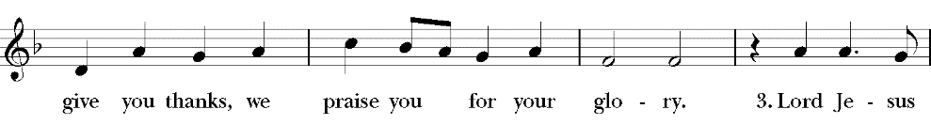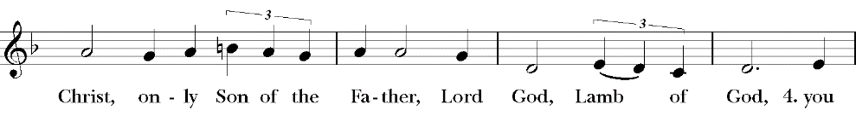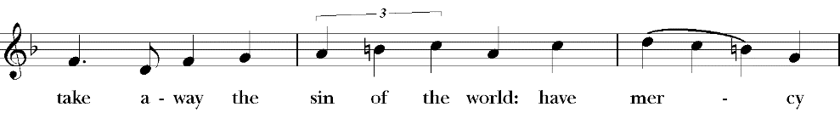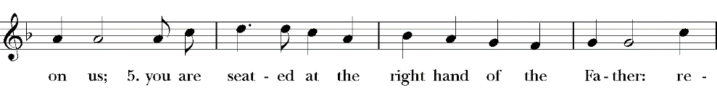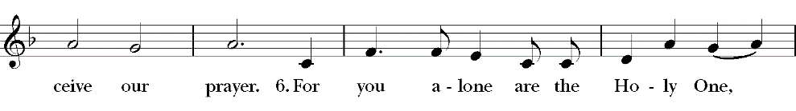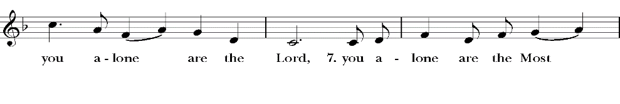

**The Salutation & Collect of the Day Page 357**

***Celebrant*** The Lord be with you.

***People* And also with you.**

***Celebrant*** Let us pray.

Almighty God, on this day you opened the way of eternal life to every race and nation by the promised gift of your Holy Spirit: Shed abroad this gift throughout the world by the preaching of the Gospel, that it may reach to the ends of the earth; through Jesus Christ our Lord, who lives and reigns with you, in the unity of the Holy Spirit, one God, for ever and ever. ***Amen***

**The First Lesson Acts 2:1-21**

When the day of Pentecost had come, they were all together in one place. And suddenly from heaven there came a sound like the rush of a violent wind, and it filled the entire house where they were sitting. Divided tongues, as of fire, appeared among them, and a tongue rested on each of them. All of them were filled with the Holy Spirit and began to speak in other languages, as the Spirit gave them ability. Now there were devout Jews from every nation under heaven living in Jerusalem. And at this sound the crowd gathered and was bewildered, because each one heard them speaking in the native language of each. Amazed and astonished, they asked, "Are not all these who are speaking Galileans? And how is it that we hear, each of us, in our own native language? Parthians, Medes, Elamites, and residents of Mesopotamia, Judea and Cappadocia, Pontus and Asia, Phrygia and Pamphylia, Egypt and the parts of Libya belonging to Cyrene, and visitors from Rome, both Jews and proselytes, Cretans and Arabs--in our own languages we hear them speaking about God's deeds of power." All were amazed and perplexed, saying to one another, "What does this mean?" But others sneered and said, "They are filled with new wine." But Peter, standing with the eleven, raised his voice and addressed them, "Men of Judea and all who live in Jerusalem, let this be known to you, and listen to what I say. Indeed, these are not drunk, as you suppose, for it is only nine o'clock in the morning. No, this is what was spoken through the prophet Joel: 'In the last days it will be, God declares, that I will pour out my Spirit upon all flesh, and your sons and your daughters shall prophesy, and your young men shall see visions, and your old men shall dream dreams. Even upon my slaves, both men and women, in those days I will pour out my Spirit; and they shall prophesy. And I will show portents in the heaven above and signs on the earth below, blood, and fire, and smoky mist. The sun shall be turned to darkness and the moon to blood, before the coming of the Lord's great and glorious day. Then everyone who calls on the name of the Lord shall be saved.'

The Word of the Lord.

***People* Thanks be to God.**

**Psalm 104:25-35, 37 Page 736**

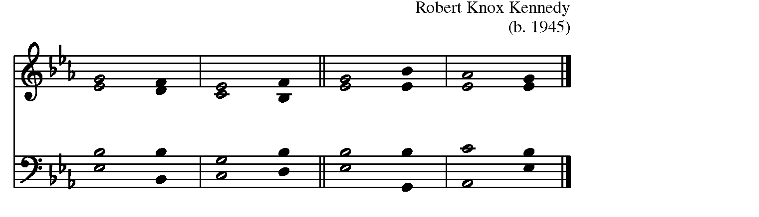

25 O LORD, how manifold are your **works**!  *  
      in wisdom you have made them all; the earth is full of your

**creatures**.

26 Yonder is the great and wide sea with its living things too many to

**number**,  *  
      creatures both small and **great**.

27 There move the ships, and there is that Le-**viathan**,  *  
      which you have made for the **sport of** **it**.

28 All of them look to **you**  *  
      to give them their food in due **season**.

29 You give it to them; they **gather it**;  *  
      you open your hand, and they are filled with good **things**.

30 You hide your face, and they are **terrified;**  *  
      you take away their breath, and they die and return to their **dust**.

31 You send forth your Spirit, and they are cre-**ated**;  *  
      and so you renew the face of the **earth**.

32 May the glory of the LORD endure for **ever**;  *  
      may the LORD rejoice in all his **works**.

33 He looks at the earth and it **trembles**;  *  
      he touches the mountains and they **smoke**.

34 I will sing to the LORD as long as I **live**;  *  
      I will praise my God while I have my **being**.

35 May these words of mine **please him**;  *  
      I will rejoice in the **LORD**.

37 Bless the LORD, O my **soul**.  *  
      Halle-**lujah**!

**The Second Lesson I Corinthians 12:3b-13**

No one can say "Jesus is Lord" except by the Holy Spirit. Now there are varieties of gifts, but the same Spirit; and there are varieties of services, but the same Lord; and there are varieties of activities, but it is the same God who activates all of them in everyone. To each is given the manifestation of the Spirit for the common good. To one is given through the Spirit the utterance of wisdom, and to another the utterance of knowledge according to the same Spirit, to another faith by the same Spirit, to another gifts of healing by the one Spirit, to another the working of miracles, to another prophecy, to another the discernment of spirits, to another various kinds of tongues, to another the interpretation of tongues. All these are activated by one and the same Spirit, who allots to each one individually just as the Spirit chooses. For just as the body is one and has many members, and all the members of the body, though many, are one body, so it is with Christ. For in the one Spirit we were all baptized into one body--Jews or Greeks, slaves or free--and we were all made to drink of one Spirit.

The Word of the Lord.

***People* Thanks be to God.**

**The Sequence “Come down, O Love divine” Hymnal, 516**

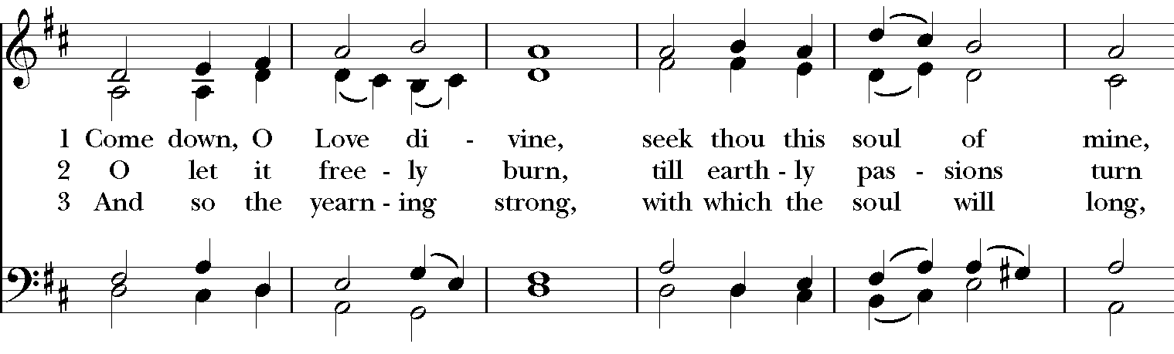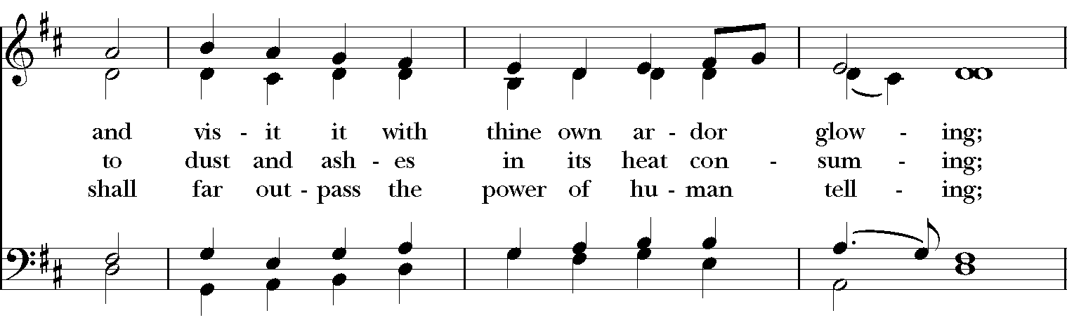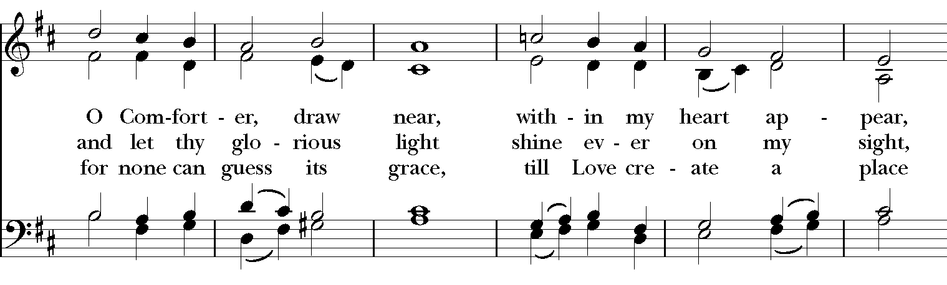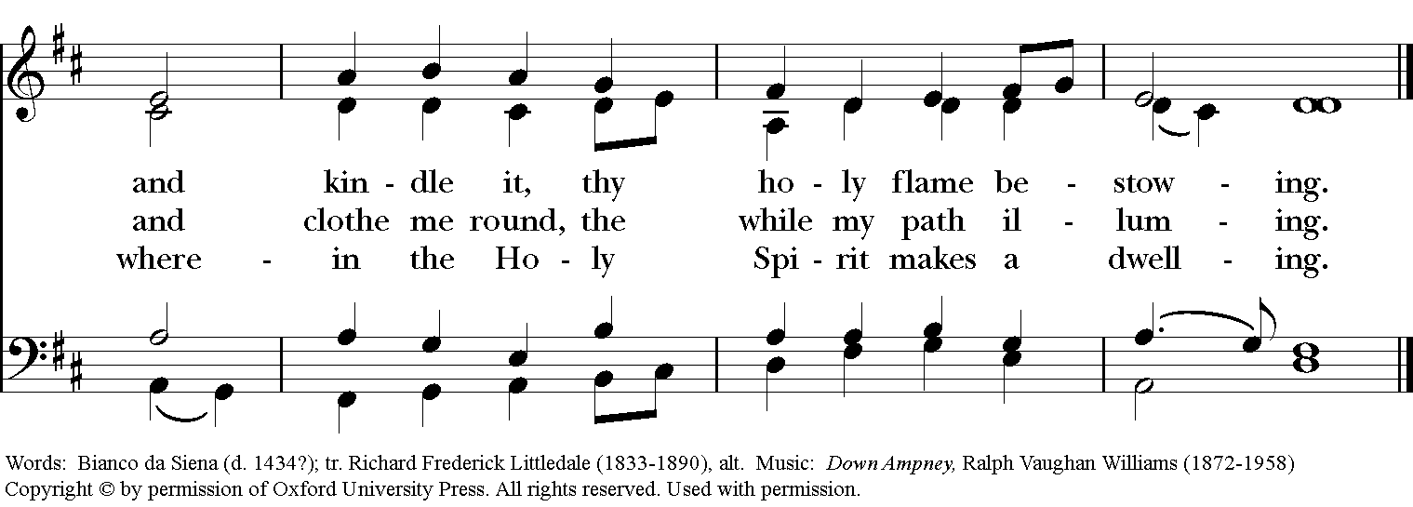

**The Holy Gospel John 7:37-39**

***The people remain standing. The Celebrant says***

The Holy Gospel of our Lord Jesus Christ according to

John.

***People* Glory to you, Lord Christ.**

On the last day of the festival, the great day, while Jesus was standing there, he cried out, "Let anyone who is thirsty come to me, and let the one who believes in me drink. As the scripture has said, 'Out of the believer's heart shall flow rivers of living water.'" Now he said this about the Spirit, which believers in him were to receive; for as yet there was no Spirit, because Jesus was not yet glorified.

***After the reading, the Celebrant says***

The Gospel of the Lord.

***People* Praise to you, Lord Christ.**

**The Sermon**

**The Nicene Creed**

*Said by all, standing*

**We believe in one God, the Father, the Almighty, maker of heaven and earth, of all that is, seen and unseen.**

**We believe in one Lord, Jesus Christ, the only Son of God, eternally begotten of the Father, God from God, Light from Light, true God from true God, begotten, not made, of one Being with the Father. Through him all things were made. For us and for our salvation he came down from heaven: by the power of the Holy Spirit he became Incarnate from the Virgin Mary, and was made man. For our sake he was crucified under Pontius Pilate; he suffered death and was buried. On the third day he rose again in accordance with the Scriptures; He ascended into heaven and is seated at the right hand of the Father. He will come again in glory to judge the living and the dead, and his kingdom will have no end.**

**We believe in the Holy Spirit, the Lord, the giver of life, who proceeds from the Father and the Son. With the Father and the Son he is worshiped and glorified. He has spoken through the Prophets. We believe in one holy catholic and apostolic Church. We acknowledge one baptism for the forgiveness of sins. We look for the resurrection of the dead, and the life of the world to come. Amen.**

**The Prayers of the People, Form III Page 387**

Father, we pray for your holy Catholic Church;  
***That we all may be one****.*

Grant that every member of the Church may truly and humbly serve you;   
***That your Name may be glorified by all people****.*

We pray for all Justin, the Archbishop of Canterbury, for Michael, our Presiding Bishop, Terry, our Bishop, for Michael, Allison, Anne, Art, and Jim, our clergy and bishops, priests, and deacons;  
***That they may be faithful ministers of your Word and Sacraments****.*

We pray for Donald our President, Andy our Governor, and Thomas our Mayor, and all who govern and hold authority in the nations of the world;  
***That there may be justice and peace on the earth****.*

Give us grace to do your will in all that we undertake;   
***That our works may find favor in your sight****.*

Have compassion on those who suffer from any grief or trouble;   
***That they may be delivered from their distress****.*

Give to the departed eternal rest.  
***Let light perpetual shine upon them****.*

We praise you for your saints who have entered into joy;  
***May we also come to share in your heavenly kingdom****.*

Let us pray for our own needs and those of others, especially **Al, Amy, Ann, Beth Ann, Bill, Bud, Christy, Dan, Dave, Diana, Elizabeth, Gene, Helga, Hugh, Ira, Jen, Jerry, Joan, Joe, John, Joyce, Kailee, Kathy, Ken, Lacey, Lee, Linda, Liz, Lynn, Monica, Nancy, Natalia, Natalie, Nina (Nine-ah), Paul, Phil, Rob, Ronald, Steve, Sue, Susie, Tim, Trish, Vicki, Walt, Wynn; for the men and women of our armed forces, especially Alex, Bianca, Casey, Christian, Griffin, Pat, Seth, Steve.**

*Silence*

*The People may add their own petitions.*

*The Celebrant adds a concluding Collect.*

**The Confession of Sin Page 360**

*All pray together*

**Most merciful God, we confess that we have sinned against you in thought, word, and deed, by what we have done, and by what we have left undone. We have not loved you with our whole heart; we have not loved our neighbors as ourselves. We are truly sorry and we humbly repent. For the sake of your Son Jesus Christ, have mercy on us and forgive us; that we may delight in your will, and walk in your ways, to the glory of your Name. Amen.**

**The Absolution**

**The Peace**

***All stand. The celebrant says to the people***

The peace of the Lord be always with you.

***People* And also with you.**

**THE HOLY COMMUNION**

**Offertory Anthem “Create in me” Healey Willan**

**Kathy Regneri, soprano**

**The Great Thanksgiving: Eucharistic Prayer B Page 367**



*Celebrant* It is right, and a good and joyful thing, always and everywhere to give thanks to you, Father Almighty, Creator of heaven and earth.

*Here the Celebrant adds a Proper Preface*

Therefore we praise you, joining our voices with Angels and Archangels and with all the company of heaven, who for ever sing this hymn to proclaim the glory of your Name:

*Celebrant and People*

**Sanctus: S-129 in the Hymnal 1982**

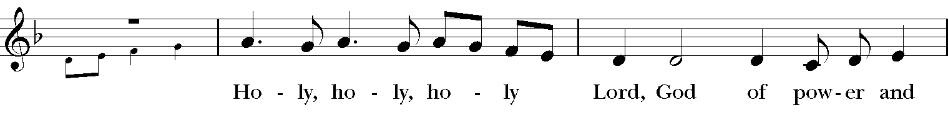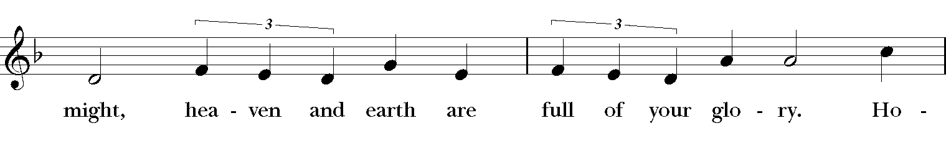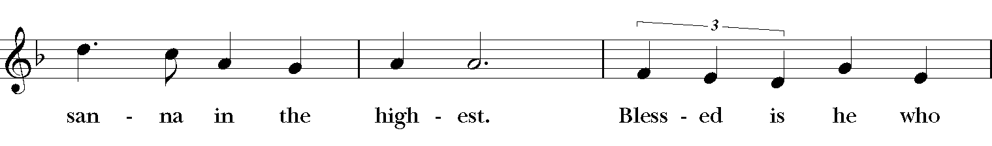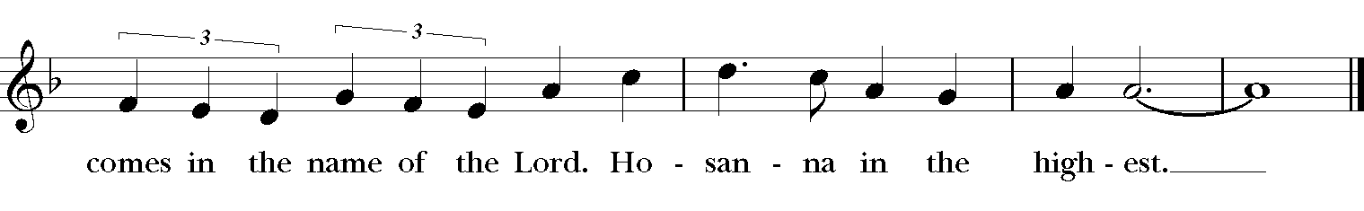

*The people stand or kneel.*

*Then the Celebrant continues*

We give thanks to you, O God, for the goodness and love which you have made known to us in creation; in the calling of Israel to be your people; in your Word spoken through the prophets; and above all in the Word made flesh, Jesus, your Son. For in these last days you sent him to be incarnate from the Virgin Mary, to be the Savior and Redeemer of the world. In him, you have delivered us from evil, and made us worthy to stand before you. In him, you have brought us out of error into truth, out of sin into righteousness, out of death into life.

On the night before he died for us, our Lord Jesus Christ took bread; and when he had given thanks to you, he broke it, and gave it to his disciples, and said, "Take, eat: This is my Body, which is given for you. Do this for the remembrance of me."

After supper he took the cup of wine; and when he had given thanks, he gave it to them, and said, "Drink this, all of you: This is my Blood of the new Covenant, which is shed for you and for many for the forgiveness of sins. Whenever you drink it, do this for the remembrance of me."

Therefore, according to his command, O Father,

*Celebrant and People*

**We remember his death,**

**We proclaim his resurrection,**

**We await his coming in glory;**

*The Celebrant continues*

And we offer our sacrifice of praise and thanksgiving to you, O Lord of all; presenting to you, from your creation, this bread and this wine.

We pray you, gracious God, to send your Holy Spirit upon these gifts that they may be the Sacrament of the Body of Christ and his Blood of the new Covenant. Unite us to your Son in his sacrifice, that we may be acceptable through him, being sanctified by the Holy Spirit. In the fullness of time, put all things in subjection under your Christ, and bring us to that heavenly country where, with [St. Luke, __________ and] all your saints, we may enter the everlasting heritage of your sons and daughters; through Jesus Christ our Lord, the firstborn of all creation, the head of the Church, and the author of our salvation.

By him, and with him, and in him, in the unity of the Holy Spirit all honor and glory is yours, Almighty Father, now and forever. ***Amen****.*

And now, as our Savior Christ has taught us, we are bold to say,

**The Lord’s Prayer**

**Our Father, who art in heaven, hallowed be Thy Name. Thy kingdom come, Thy will be done, on Earth as it is in heaven. Give us this day our daily bread, and forgive us our trespasses, as we forgive those who trespass against us, and lead us not into temptation, but deliver us from evil, for thine is the kingdom and the power and the glory, for ever and ever. Amen.**

**The Fraction Anthem: S-155**

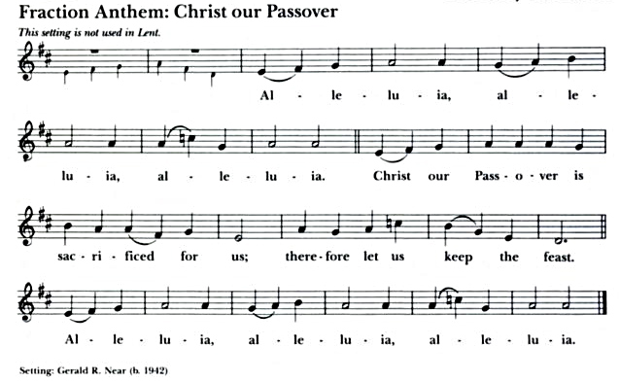

**Communion Anthem “Litany to the Holy Spirit” Peter Hurford**

**Lydia Lewis, soprano**

**A Communion Prayer**

*After the celebrant receives, the congregation prays*

***All* Eternal God, heavenly Father, you have graciously accepted us as living members of your Son our Savior Jesus Christ. Although we cannot be present together as a body, we know that the Spirit’s power makes us one Body. For those of us safely able to receive, we are grateful for the spiritual food of the Sacrament of Christ’s Body and Blood. For those unable to receive the bread and wine, we are grateful for the spiritual union with you that this sacred mystery brings to life. Send us now into the world in peace, and grant us strength and courage to love and serve you with gladness and singleness of heart, through Christ our Lord. Amen.**

**The Blessing**

**The Processional “Holy Spirit, ever living ” Hymnal, 511**

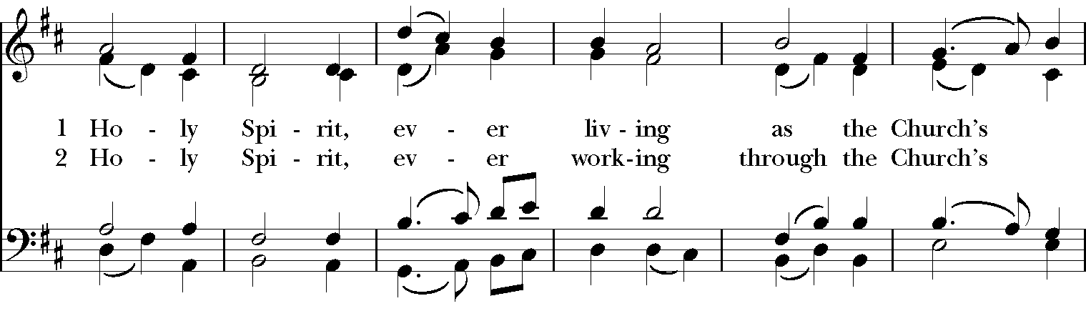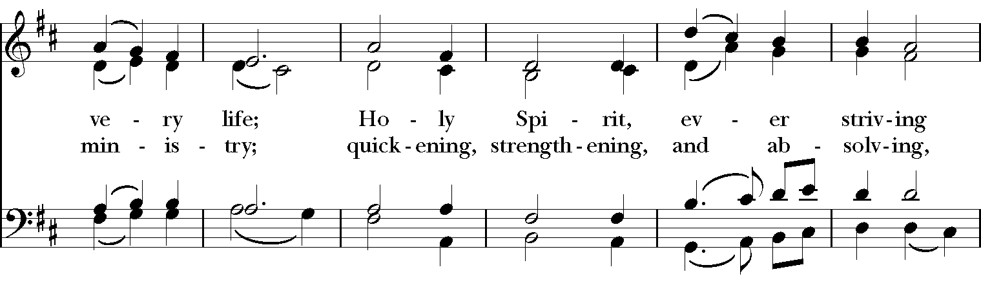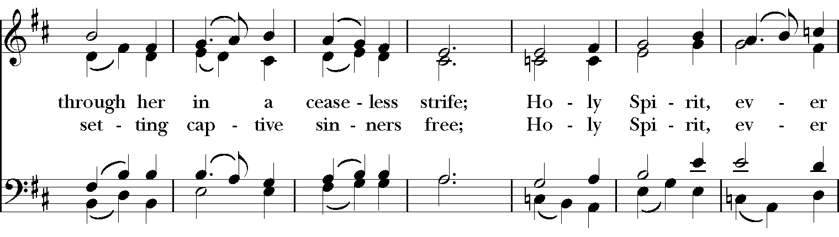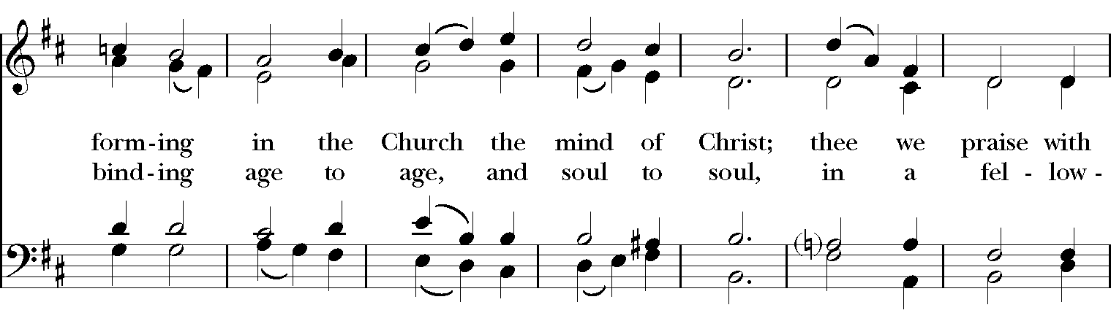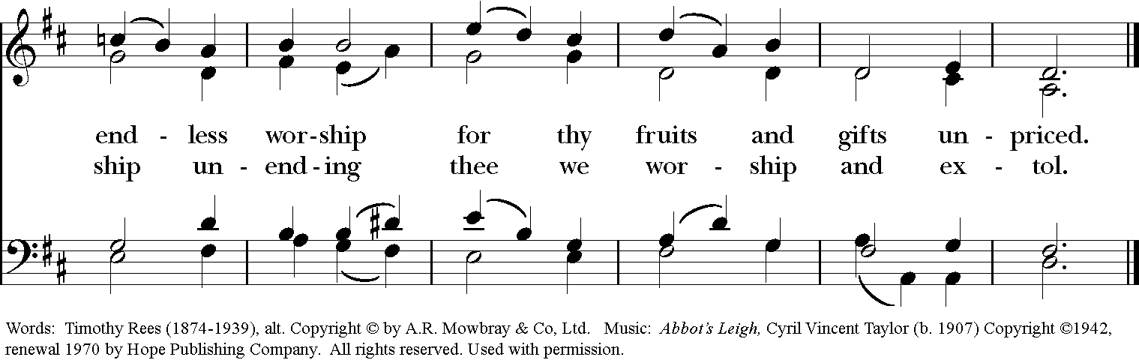

**The Dismissal**

***People* Thanks be to God. Alleluia. Alleluia.**

**Postlude “Abbots Leigh” Richard Proulx**

**ANNOUNCEMENTS**

**Wednesday Morning Bible Study**

Every Wednesday morning, we meet on ZOOM. Our current study is on the Resurrection. The Zoom information for the meeting and the notes will be sent out prior to the regular study time.

**Thursday Night Bible Study**

The Basics of the Bible Study continues on Thursday evenings with Mother Allison! We are using The Path to guide our study, but all you need is a Bible and access to the internet to join us. We are gathering every Thursday evening from 6:45-7:45 on Zoom to discuss the foundational stories of our faith and to explore how these stories connect to our own journeys. Please follow this link on Thursdays at 6:45 to join us! <https://us02web.zoom.us/j/284582639?pwd=bUZFYjRhd1lhUDNmck9sb0VYa1Budz09>

Meeting ID: 284-582-639  
If prompted to enter a password, please enter our parish office phone number - 2458827

**Celtic Christiananity Class**

Sunday morning’s at 9am, Dave Kirchinger will hold a Zoom meet class on Celtic Christiananity. The link to the class is:

[https://us04web.zoom.us/j/75615923261?pwd=ejk2NmhEUDZaU  
VFXNnprbHd0MU8wUT09](https://us04web.zoom.us/j/75615923261?pwd=ejk2NmhEUDZaU)  
Meeting ID: 756 1592 3261  
Password: 6nfVZF

**Centering Prayer**

Centering Prayer has gone from once a month to TWICE a month. Every 2nd and 4th Tuesday, **June 9 and 23, 6pm to 7pm**, on ZOOM until we can all join back in the Lyman Office.

Link to Centering Prayer Group: <https://zoom.us/j/662061797?pwd=RVhkL2FWY3NEc204UHQweVovK3R5Zz09>

Meeting ID: 662-061-797

Plan to join us!!

If prompted to enter a password, please enter our parish office phone number – 2458827

**Birthdays & Anniversaries**

If you've had a birthday or anniversary over the past several weeks, or have one coming up in the weeks ahead, please let Dawn know, [admin@stlukesanchorage.org](mailto:admin@stlukesanchorage.org).

Let her know your birthday, or the date of your wedding anniversary and how many years you've been married, and we will offer a blessing over you during our recorded worship.

**LAY PASTORAL CARE MINISTRY**

Pastoral care is a ministry provided by volunteer parishioners to individuals needing home, hospital, nursing home or rehabilitation facility visitations. Arrangements can be made for communion and meals as requested. All information is confidential unless you give permission to share with others.

**CALL THE CHURCH OFFICE TO LET US KNOW YOUR NEEDS**.

Reminder, if you do go to the hospital, let the hospital know your church affiliation or try to have your caregiver do so. Our ministry is here for you in time of need so remember to call the church office at 245-8827 or e-mail at [admin@stlukesanchorage.org](mailto:admin@stlukesanchorage.org)

Hold Control and hover Left Mouse button

over green button to activate link.

***These Memorials are repeated from April 26***

***due to no plants available that weekend.***

***The Flowers on the Altar*** are given by Rice Brown in loving memory of his brother, Ron Lee Brown.

***Flowers are also given by*** Ron & Jean Grawemeyer in loving memory of their daughter, Jennifer Grawemeyer Jordan.

**In our prayers** . . Al, Amy, Angela, Ann, Annie, Beth Ann, Barry, Bill, Braxton, Bud, Christy, Dan, Dave, Diana, E.J., Elizabeth, Gene, Helga, Hugh, Ira, Jen, Jerry, Joan, Joe, John, Joyce, Kailee, Kathy, Ken, Lacey, Lee, Linda, Liz, London, Lynn, Monica, Nancy, Natalia, Natalie, Nina (Nine-ah), Paul, Phil, Rob, Ronald, Sara, Steve, Sue, Susie, Tim, Tracy, Trish, Ursula, Vicki, Walt, Wynn, and our men and women serving in our armed forces and their families. We offer prayers of blessing and thanksgiving for all men and women serving in the armed services, especially these persons known to us: Alex, Bianca, Casey, Christian, Griffin, Pat, Seth, Steve. We pray that they have safe journeys and know the loving concern of friends and family. May God watch over them and grant them strength and courage to face perils which beset them.

**Readings for:**

**June 6 & 7: Genesis 1:1 – 2:4a; Canticle 13;**

I**I Corinthians 13:11-13; Matthew 28:16-20.**