Mars UP Church

Apostles’ Creed
I believe in God the Father Almighty, Maker of heaven and earth; and in Jesus Christ His only Son our Lord; who was conceived by the Holy Ghost, born of the Virgin Mary, suffered under Pontius Pilate, was crucified, dead and buried; He descended into hell; the third day He rose again from the dead; He ascended into heaven, and sitteth on the right hand of God the Father Almighty; from thence He shall come to judge the quick and the dead. I believe in the Holy Ghost, the holy catholic church; the communion of saints; the forgiveness of sins; the resurrection of the body; and the life everlasting. Amen.

Gloria Patri
Glory be to the Father, and to the Son, and to the Holy Ghost. As it was in the beginning, is now and ever shall be,
world without end.
Amen. Amen.

Come Holy Spirit, Come
Before the Service – Speak to God!
During the Service – Let God speak to you!
After the Service – Speak to each other!

(*Please stand, if able)
Welcome and Mars Messages
*Presentation of the Colors
*Pledge of Allegiance

Prelude

The Call to Worship
Leader: Christ has put the door of eternity ajar;
People: The light of Life streams into every dismal
corner.
Leader: Fear and shame flee like shadows before the
dawn.
People: Arise! Shine! Our Light has come!
Leader: Lift up your eyes and look around!
People: The Lord will be our everlasting light.

*Hymn 793
“For the Beauty of the Earth”

Call to Confession

*Prayer of Confession
Holy God, forgive us. Take away whatever holds us back. Show us the way to confidence and generosity so that we may be known as your people: Repairers of the broken places and Restorers of streets to safety and peace. O God, with your help we can change and bring you glory.
Silent confession.....

The
Lord’s Prayer

Our Father,
who art in heaven,

hallowed be Thy
name,

Thy kingdom come,
Thy will be done,
on earth
as it is in heaven.

Give us this day
our daily bread;

and forgive us
our debts,
as we forgive
our debtors;

and lead us not
into temptation,
but deliver us
from evil.

For Thine
is the kingdom,
and the power,
and the glory,
forever. Amen.

The Doxology

Praise God
from whom
all blessings flow;
praise Him
all creatures
here below;
praise Him above,
ye heavenly host;
praise Father, Son,
and Holy Ghost.
Amen.

*Assurance of Pardon

*Gloria Patri
Children’s Chat

Scripture Isaiah 58:1-12

Morning Message Rev. Brian Hauser
“Fixing the Light”

*Hymn (Screens)
“Keep Changing the World”

Prayers of the People and Lord’s Prayer

Offering
Offertory
*Doxology
*Offering Prayer

*Hymn (Screens)
“Shine, Jesus Shine”

*Retiring of the Colors

*Benediction

*Postlude
Church Staff
Rev. Brian Hauser
Pastor
pastor@mars-up.org
724-689-3412

Mrs. Shelly Bocheff
Administrative Assistant
marsup@mars-up.org

AV TEAM
Alma Staskiewicz, Lisa Barbour, Marie Matthews, Bill Guesman, John Ivory, Mike Bocheff, Herb Wellman

Mars United Presbyterian Church

232 Crowe Ave
PO Box 805
Mars, Pennsylvania 16046
724-625-1365
www.mars-up.org
marsup@mars-up.org

Church Office Hours:
Mon -Thurs from 9 a.m. -2:30 p.m.
MUP Session

Class of 2025 Class of 2024 Class of 2023
John Ivory Alma Staskiewicz Lisa Barbour
Susan Cox Louise Fox Mary Ann Croop
Jay Wilson Marie Matthews Don Lewis
Herb Wellman

Clerk of Session: Herb Wellman

MUP Deacons

Class of 2025 Class of 2024 Class of 2023
Jill Cooper Steve Martin Sharon Gibbs
Robyn Beckwith Marge Nicklas Carol Kopar
Missy Wells Pat Auld Alice Leonberg

Moderator: Steve Martin

MUP Music Committee
Keith Nichols – Chair
Sally Olsen – Clerk
Alma Staskiewicz
John Ivory
Linda Lees
Karl Kennedy

A special thank you to everyone who donated cookies for our first-ever Preschool Open House! Our event had several families through and many of our staff volunteered their time to make the event happen. The cookies were a hit and our students and staff go to enjoy what was left over. Thank you for helping to make My School Preschool such a special place. Love, Heidi Beahm
Morning Worship:
10:00 am

6th Sunday after the Epiphany

Prayer of Preparation
Lord, we come to you today with so many things on our hearts.

You call us to be in relationship of trust and love with you and you offer healing to us for those portions of our lives that are broken and injured.

Help us to be open to your mercy and healing love. For we ask this in Jesus’ Name.
AMEN.

Mars United Presbyterian Church
Welcome!

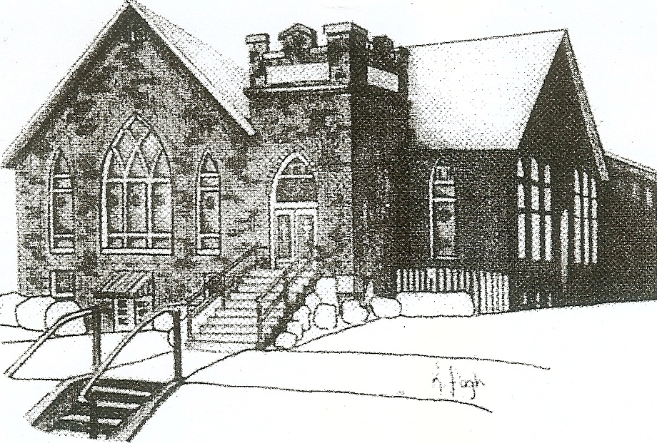
We are your hometown church: Faithful to Tradition, Loving in Fellowship, & Reaching for Tomorrow!

February 12, 2023
Scout Sunday

We welcome you and we are glad you’ve chosen to Worship with us today!

CALENDAR: February 12th – February 19th

Church Office Hours: Monday -Thursday from 9 a.m. – 2:30 p.m.

Today, February 12, 2023
VOLUNTEERS☺

LAST SUNDAY’S In-House ATTENDANCE: 53

LAST SUNDAY’S OFFERING:
Operating Funds: $3646.00
Kindness: $150.00
Mission: $50.00
Per Capita: $131.31
Capital Campaign: $7100.00
Total: $11,077.31

Tarry N Talk Hosts
Worship/Membership Committee

9:00 am Sunday School Hour
10:00 a.m. THE MORNING WORSHIP SERVICE
2:45 pm Girl Scout meeting
Monday, February 13, 2023
6:00pm Cub Scouts 413
7:00pm MSPS Meeting
Tuesday, February 14, 2023
9:00 am A team
7:00 pm AA
7:00 pm Stewardship Meeting
Wednesday, February 15, 2023
9:00 am Material Girls
6:00 pm Cub Scouts 413
Thursday, February 16, 2023
5:00 pm Girl Scout Meeting
7:00 pm Cub Scout Meeting
7:00 pm Session Meeting
Friday, February 17, 2023
Saturday, February 18, 2023
Sunday, February 19, 2023
9:00 am Sunday School Hour
10:00 am THE MORNING WORSHIP SERVICE
1:00 pm Youth Group
Welcome to all who are Worshiping with us today!

Guests
We sincerely hope our service is a blessing to you. We ask that our guests please take a few minutes to complete one of the Connect Cards found in the pew holder.

Should you have questions regarding any aspect of our church, including membership, please contact Pastor Brian or the church office during the week at 724-625-1365. Thank you for being with us today.

PRAYER – JOYS & CONCERNS

Lou Beckwith Paige Lauten
Paige Barbour (daughter of Andrew and Steph Barbour) Sandy Wahl
Reid Christopher Hall (June Stirling’s nephew)
Lindy McCartney (Lisa Barbour’s Sister)

ANNOUNCEMENTS

Bulletins are printed Thursday mornings; let us know if you have an announcement

ASH WEDNESDAY SERVICE Mars UP will provide Walk-In-Communion service
Walk-in communion offers you the chance to begin the season of Lent with a meaningful and personal celebration of Communion. Just drop by the sanctuary anytime between 5:30 pm and 6:45 pm. There will be a handout with a prayer, scripture reading and select hymns. Take the handout and find a seat in the back of the sanctuary to pray and gather your thoughts. Once ready, you’ll be invited to come forward along with those gathered with you to share the bread and the cup. Each service will last approximately 15 minutes, with a new service beginning after each one concludes. This has traditionally been a meaningful time for families and friends in our church to enjoy a more intimate communion. Feel free to invite friends and family.
LENTEN LUNCHES Every Friday at noon, the community is invited to enjoy lunch and a special guest speaker There is no charge for the lunch; however, donations will be received. The Lenten Lunches will begin on February 24th and continue thru and including April 7th (Good Friday). Friday Lenten Lunches include Potato Soup and another Soup, Sandwich, Salad and Dessert. Every week Grilled cheese sandwiches are offered also.
PALM SUNDAY EVENTS At Mars UP Church on April 2nd (Palm Sunday) there will be numerous activities held. During worship we will be entertained by the Children’s Bell Choir with an Easter Egg Hunt following after worship. All are welcome to attend the egg hunt and please bring your basket and a friend. Church is invited to come to the Fellowship Hall for Hot Dogs and other light refreshments. Watch for fliers and more details to follow.
GOOD FRIDAY SERVICE 12:00pm on Good Friday. Mars Ministerial Association will lead the service.

HOLY HUMOR SUNDAY - Join us on Sunday April 16th as we continue to celebrate the joy of the resurrection with Holy Humor Sunday. Jokes and funny anecdotes will be shared throughout the service. Appropriate jokes may be shared by the congregation. It is sure to be a fun and uplifting service in celebration of the Resurrection of Jesus Christ! All are welcome!

