RSAI Position Paper
Transportation Equity: A 2017 Legislative Priority
Background: In the 1950s, Iowa had over 4,000 school districts. Students could walk to their neighborhood school and transportation costs were nonexistent for Iowa school districts. As budgets have tightened and enrollments continue to decline, Iowa now has 333 districts (FY 2017) with varying square miles per pupil and hugely varying transportation costs.
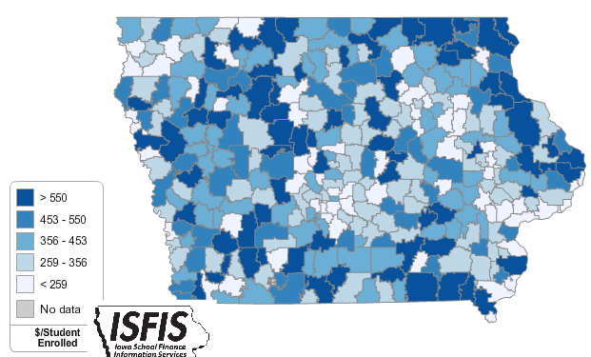
Iowa’s foundation formula does not recognize the sparseness of population, square mileage or route miles for school districts, the number of students transported, or variance in road or geographic conditions. As a result, districts with large transportation costs cover those costs out of the school general fund.
Current Reality: the following statistics describe current transportation inequities today from the DE FY 2015 Transportation Report:
- FY 2015 State cost per pupil was $6,366. There were an estimated 41 Iowa school districts that required at least 10% of that general fund cost per pupil for transportation.
- The range in transportation expenditures varies from a low of $57.82 to a high of $980.87 per student enrolled. Square miles per district range from a low of 2 to a high of 555 square miles, and route miles range from a low of 4,771 to a high of 1,264,105 miles.
- Property tax characteristics, including low valuation per pupil and corresponding higher tax rates, create challenges for districts with low tax capacity to pay for buses out of PPEL or Sales Tax funds, further stressing the general fund budget. When districts have larger transportation costs, both taxpayer and student inequities worsen.
- General fund dollars spent on busing would otherwise be available for staff and teachers (salary, benefits, training, and support), curriculum, programs, technology, and energy. Lack of resources in all of these areas creates an unequal educational opportunity for students in rural districts.
RSAI calls on the Iowa Legislature to address the issue of Transportation Equity: Supports a mechanism that covers school transportation costs that does not unreasonably disadvantage property tax payers in property poor districts or compete with general funds otherwise spent on providing education to students.

