2/3/2018 Midnight and the Hillel Calendar

Concerning the return of YaHuShua, Israel's Messiah King, the best kept secret in the universe:

Matthew 24:36 But of that day and hour knoweth no man, no, not the angels of heaven, but My Father only.

Mark 13:31 Heaven and earth shall pass away: but my words shall not pass away.
32 But of that day and that hour knoweth no man, no, not the angels which are in heaven, neither the Son, but the Father.
33 Take ye heed, watch and pray: for ye know not when the time is.

Many people regard the "not knowing the day or the hour" as directly identifying the Day of Trumpets, the 1st day of the 7th biblical month, as being the day Messiah will return, but the context says something differently.

Angels are intelligent beings. They don't know the day of Messiah's return, and neither does any man. The day of Messiah's return is a closely guarded secret, so much so, that Mark 13:32 above says that even Messiah Himself doesn't know the day.

We're to watch and pray, that's it.

When is Midnight?

Here's a question I received from a reader several days ago:

"I have a question, because I have thinking a lot lately about the
midnight hour, and the parable of the 5 Wise and 5 Foolish virgis.
It is this: When is Midnight? Is it according to Israel's time? We are
asked to pray at Midnight in our country, in my case, South Africa,
which is GMT + 2 hours."

Below is my response to the reader's question, with some graphics and comments added, and with a minor correction concerning the date 992 AD. In my response to the reader I identified the last solar eclipse to cross Jerusalem from memory as being in 992 AD. It was actually 8/20/993 AD.

Israel is also GMT +2hrs as you are there in South Africa. Israel institutes
a daylight savings time change that begins around the end of March each
year.
There are different ways to look at the timing of midnight.
The "spiritual aspect of midnight" is to consider the spiritual darkness of
a society that overtakes a culture when its people depart from the truth.
Minds are blinded by lies and wickedness.
The physical aspect of midnight is probably the time half way between sunset
and sunrise. Timing for the ancient Hebrew day of 2000 years ago began at 0
at sunrise. The daylight part of the day is divided into 12 equal parts,
with the end of the 12th part occurring at sunset.
So the ancient Hebrew day had variable length hours depending on the season,
whether it's summer or winter. The hours in ancient Israel were about 50
minutes long in the winter, with sunrise being around 6:34 AM and sunset
being around 4:39 PM on December 20.
On June 20, sunrise is at 5:34 AM local daylight time in Israel. Sunset is
at 7:48 PM. There are about 14 hours of daylight in Israel on June 20,
resulting in hours that are about 70 minutes long in the summer.
So the ancient hour of the day timing varied from 50 to 70 minutes in
length. Longer hours in the daylight meant shorter hours during the night
time.
Now, considering a day to be 1000 years in length, we can count from the
creation of the heavens and the earth in about 4004 BC according to James
Ussher and find that the 6th 1000 year day ended in about 1996 AD.
If we divide the 1,000 year day into night and day, then we are right now
entering darkness on the 7th 1,000 year day from creation. Sunset was in
1996 and the darkness is getting worse.
We find that sunrise on the 7th 1,000 year day should occur in about 2,500
AD, about 500 years from now.
That means that half way through the darkness of night (midnight) will occur
in about 250 years. It happens that the Jewish Hillel calendar will reach
the year 6,000 on September 30 of the year 2239 AD, 243 years from 1996 AD.
The 243 years from 1996 and the beginning of the calculated beginning of the
7th 1,000 year day from creation is curiously close to the "midnight" of the
7th 1,000 year day from 4,004 BC.
There is another aspect to the year 6,000 on the Hillel calendar. In 2241 a
rare total solar eclipse will pass over Jerusalem. The last time a total
solar eclipse passed over Jerusalem was in 992 AD (correction 8/20/993 AD). History tells us that a great many people were expecting the arrival of Messiah around 1,000 AD.
Below is a graphic showing the path of the 8/20/993 AD rare total solar eclipse that passed over Jerusalem.

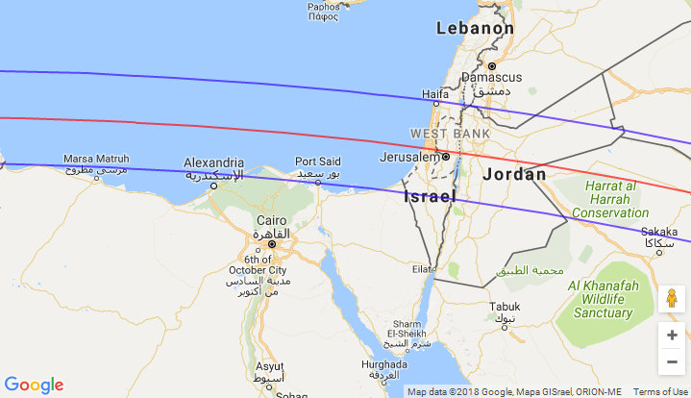
Graphic coutesy Google Maps, NASA, Fred Espenak, and Eclipsewise.com

My added comment:

Because YaHuShua was probably born around 4 or 3 BC, the end of the first 1,000 year day from His birth would have been in about 996AD, just 3 years after the rare Jerusalem total solar eclipse of 8/20/993 AD.

The passing of the eclipse over Jerusalem at that particular time would have caused a lot of attention to be given to the possibility of the return of Israel's Messiah at that time.

Messiah didn't arrive around the year 1,000 AD, and we find that the Inquistion by the Catholic Church began in France in about the year 1250 AD. Link: https://en.wikipedia.org/wiki/Inquisition

Sunset of the 1st 1,000 year day would have been about 996 AD, and the 2nd 1,000 year day would have been starting at that time. Note that the year 1250 AD would have been about midnight of the second 1,000 year day from the birth of Messiah in 3 BC or so.

Luke 12:37-46 tells us that Messiah's followers may begin to beat their fellow servants if the Messiah delays His coming, which is exactly what happened beginning at the midnight hour of the second 1,000 year day, 1250 AD.

An excerpt from Luke 12:37-46:

Luke 12:45 But and if that servant say in his heart, My lord delayeth his coming; and shall begin to beat the menservants and maidens, and to eat and drink, and to be drunken;
46 The lord of that servant will come in a day when he looketh not for him, and at an hour when he is not aware, and will cut him in sunder, and will appoint him his portion with the unbelievers.
My continued response to the reader's question:
I think that the Jewish scholars knew how to calculate solar eclipses in
advance and knew that one would cross Jerusalem in 2241 AD, and that they
may have purposefully timed the Hillel calendar to arrive at the year 6,000
in 2239 AD because of the coming eclipse. According to Jewish scholars, a
solar eclipse is a bad sign for the region it passes over. The actual
arrival of Messiah will indeed be a time of trouble for Jerusalem."

Additional comment:

Below is a graphic showing the path of the rare total solar eclipse that will cross Jerusalem on 8/8/2241 AD.

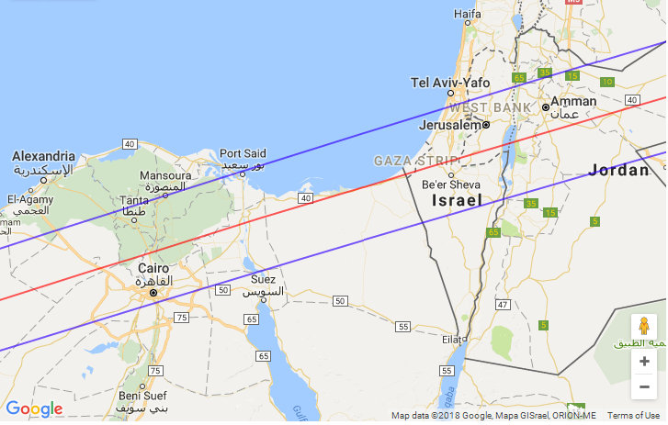
Graphic courtesy Google Maps, NASA, Fred Espenak, and Eclipsewise.com
Note that on its way to Jerusalem, the above total solar eclipse of 8/8/2241 crosses the ancient land of Goshen, the eastern Nile Delta region, which was the home of the children of Israel for 400 years prior to their departure from Egypt.

The total solar eclipse of 8/8/2241 occurs on the Hillel calendar date of 30th Av of the year 6001 about 10 months after the beginning of the 7th 1,000 year day from creation according to Jewish calculations.

Creation to 1000 is the 1st 1,000 year day, 1,000 to 2,000 is the 2nd day, 2,000 to 3,000 is the 3rd day, 3,000 to 4,000 is the 4th day, 4,000 to 5,000 is the 5th day, 5,000 to 6,000 is the 6th day, therefore 6,000 to 7,000 is the 7th day, and a 1,000 year Shabbat.

Question

Was the Jewish Hillel calendar in truth linked to the coming total solar eclipse over Jerusalem in the year 2241 (Hillel calendar 6001) centuries ago, and not to the dates of ancient Persian kings as we are currently told?

Is that the veiled truth behind the Hillel calendar's timing, that it was actually constructed to coincide with the total solar eclipse over Jerusalem in the year 2241?

